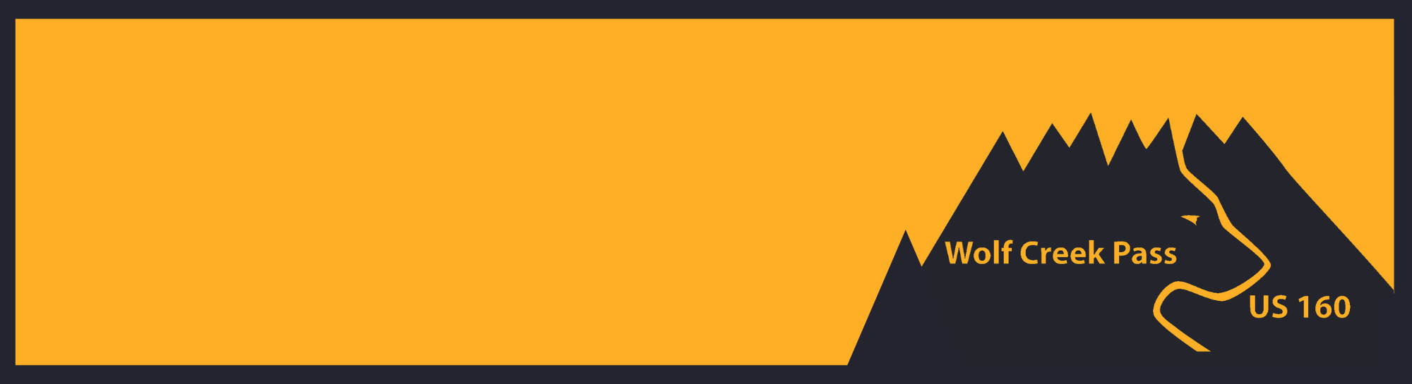

**Trucker Safety on US 160 Wolf Creek Pass**

**You Over Brake It. You Won’t Make It.**

# **Know the Pass**

**Speed Limit:** The posted speed limit for traffic traveling westbound, downhill from the summit varies from 25 to 45 MPH. Commercial trucks must maintain the lower speed of 25 MPH.

**Steep Grade**: The west side of the pass is at a 7% downhill grade.

**Distance from Summit to West Base**: The distance from the summit (near Wolf Creek Ski Area) to the west base of the pass (near treasure falls) is just over eight miles.

**Dangerous Curves**: A dangerous hairpin curve is located six and a half miles from the summit of west Wolf Creek Pass.

**Other Traffic**: A ski area, forest roads and a public scenic lookout are all points of access along US 160 Wolf Creek pass in which truckers may encounter other vehicles attempting to enter or exit the roadway.

**Brake/Chain-Up Stations & Runaway Escape Ramps:**

* Truck drivers should inspect their brakes at the summit, before descending the eight-mile trip down the pass. A wide shoulder area is available to all motorists traveling both west and eastbound. This area can also be used as chain-up station.
* Two runaway ramps are available for out-of-control trucks at mile points (MP) 162.5 and 161.

## 

## **Maintain Control**

* Check brakes before descending the pass.
* Maintain a low speed, in low gear. Use flashers to warn other vehicles of the truck’s low speed.
* Do not “ride” the truck’s brakes. This will cause overheating and possible loss of the brake system.
* Jake Brakes (or compression brakes) can be a useful braking mechanism to help control the speed of a heavy truck. However, the best practice is to remain in low gears to avoid overheating.
* Keep brakes cool by pulling into brake stations or onto the shoulder of the road, if a safe spot can be located.



**Never Hesitate. Runaway Truck Ramps Can Save Lives!**

### **Map of US 160 Wolf Creek Pass located in southwest Colorado that includes locations of runaway ramps, dangerous hairpin curves, scenic overlooks, ski areas and**

### 

## **Runaway Escape Ramps (two ramps on west side)**

* **MP 162.5** – approximately 4.5 miles from the pass summit.
* **MP 161** – approximately 6 miles from the pass summit. **This ramp is a trucker’s last chance!**

**If drivers are forced to use a runaway ramp:**

* + Maneuver the trucks into the far right lane before approaching upgrade ramps.
  + As the truck approaches the runaway ramp, steer straight and try to keep the wheels aligned.
  + Ramps are narrow. Attempt to stay in the center of the ramp to avoid any risk of rolling over.
  + Once the truck is stopped call 911 to report the incident, even if there are not injures associated with the episode.

### **Decorative Image**

### 

### **Information for the Trucking Community:**

**CDOT Website**: [www.codot.gov/travel/commercialvehicles/wolfcreekpass](https://www.codot.gov/travel/commercialvehicles/wolfcreekpass/wolfcreekpass)

**COtrip Website:** [www.cotrip.org/home](https://www.cotrip.org/home)

#### 