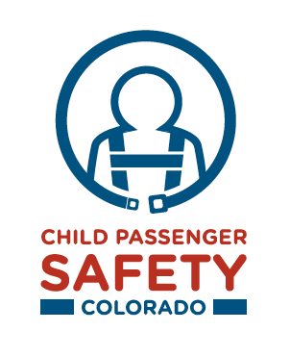

Dear Colorado Child Passenger Safety Team Advocate,

Thank you for your commitment to raising awareness in your community about the importance of properly protecting children with child safety and booster seats.

Earned media can greatly enhance your effectiveness in delivering key messages to your target audiences. This toolkit includes a variety of materials to help you generate favorable regional and local news media coverage of your safety efforts.

This toolkit includes:

Earned Media Tips and Checklist
This document should be used as a reference guide to help you organize your materials. We have outlined all of the things you should be thinking about and doing just before, during and after the event.

News Release Template
The key to generating good press coverage is to give the media something simple and newsworthy to cover through a news release. This News Release Template can be localized and distributed to your media contacts.

Talking Points
Ensure that all of your spokespersons are aware of the key messages to be highlighted at the event. Use these talking points as a guide for preparing your spokespersons in advance of your event.

Sample Letter-to-the-Editor
A very effective way to generate press interest is to submit a letter to the editor to newspapers for publication. This sample letter can be sent to the newspaper’s opinion page editor.

Get Noticed: How to Get a PSA Placed
Call your local radio stations and offer your spokesperson to record a PSA script.
The campaign posters can also work as a PSA for local newspapers. If your local newspaper offers to print a PSA and requires a specific size for the poster, please let us know and we can adjust the poster size to meet the newspaper’s requirements.

If you need additional materials or support, please contact Heather Cobler, heather.cobler@state.co.us.

Sincerely,

Cpl. Heather Cobler
Colorado Passenger Safety Team Colorado
Colorado State Patrol
303-239-4537

