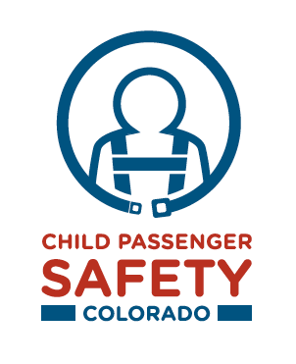
Letter to the Editor

Dear [insert name of editor],

As a Colorado child safety advocate, I work with many families and know that they would do anything for the safety of their children. Unfortunately, many parents are unaware that motor vehicle crashes are a leading cause of death and injury among children. Furthermore, research shows that a majority of child seats are not being used correctly and parents simply don’t have correct information to ensure that their child is properly protected. [Add or replace the following sentence with local statistics if possible]. From 2006–2010, 64 child passengers, ages 0–12 died in traffic crashes in Colorado. Over half (55%) were not using a child safety seat or seat belt, or they were using one improperly.
[Insert name of organization] is helping to put a spotlight on the importance of child passenger safety by providing our community with the resources all families need to protect their children on our roads. It is our goal to make sure parents and caregivers are properly securing all children 15 and under in the correct restraint for their age and size.

[Name of organization] will host a free child passenger inspection event on [Insert date]. At this event, trained staff and technicians will inspect each child seat to ensure that the seat is the right size for the child using it and it is installed correctly. Technicians will also ensure that the seat has not been recalled because of a safety defect. Our staff will be available to answer questions and direct parents to correct information resources. For more information about our event, partners can call us at [phone number] and visit www.carseatscolorado.com.

As members of the community, [name of organization] takes great pride in seeing our children grow up and make great contributions to our community, which is why we are committed to child passenger safety.

Sincerely,

[Name]
[Name of organization]
[Phone number]

