NEWS FROM:
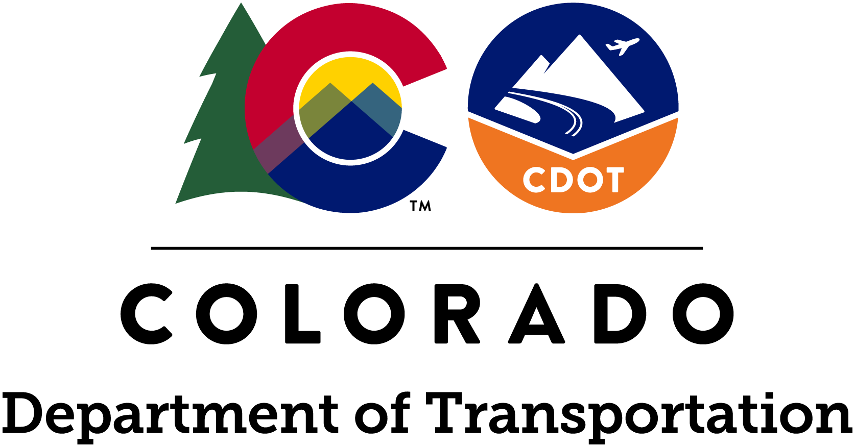

www.codot.gov
www.facebook.com/coloradodot
@coloradodot

Jared Fiel, Region 4 Communications Manager
970.350.2217 Ι jared.fiel@state.co.us

June 11, 2021
FOR IMMEDIATE RELEASE
Northeastern Colorado/CDOT Region 4 – Weld County - CDOT improving US 85 and O Street Intersection by Adding Spur Road and Left Turn Lane
WELD COUNTY — In June the Colorado Department of Transportation will begin construction project work to add a new spur road connecting existing US 85 roadway to O Street in Weld County. Improvements also include widening southbound US 85 to add left turn lane and constructing new drainage culverts and water quality pond. Drivers can expect lane closures, lane shifts and flagging operations until Castle Rock Construction Company of Colorado completes the project in early fall of this year.

PROJECT SCHEDULE
- Work is scheduled from June 14 to September 10, 2021.
- Normal work hours will be from 7:00 a.m. to 5:00 p.m., Monday through Friday.
- In special cases working hours and days may be extended including occasional weekend work.
TRAVEL IMPACTS
- All motorized vehicles should expect travel impacts throughout the duration of this project.
- Flagging operations will be in effect and motorists should be aware of lane closures and lane shifts.
- Speed reductions may come into effect and motorists are strongly encouraged to reduce speeds, support the safety of construction personnel, and watch for equipment in the work zone.
The project is located along US 85 and O Street (Weld County Road 64) in Weld County near Greeley, CO.
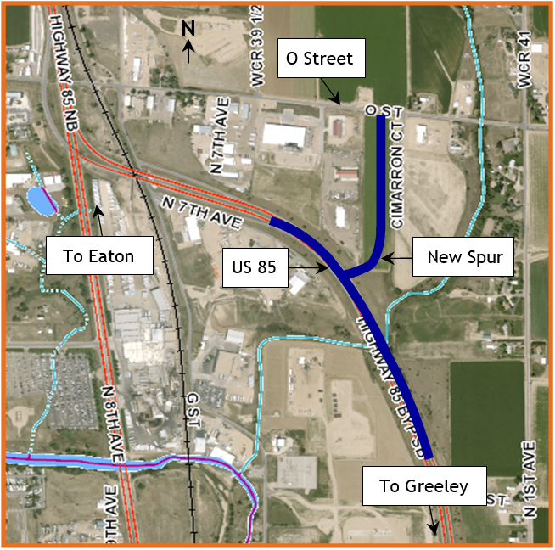

PROJECT CONTACT INFORMATION
- Project Phone Line - (970) 616-4086‬‬‬‬‬‬‬
- Project Email – CDOT.US85andO.2021@gmail.com
- Project Website – TBD

COVID-19
Safe transportation infrastructure is essential for emergency first responders and freight drivers as Colorado navigates the COVID-19 pandemic. With that in mind, road maintenance and construction continues on CDOT projects with social distancing and other health safety measures to reduce COVID-19 exposure on the worksite. The Colorado Department of Public Health and Environment announced guidelines for construction activities. The public is urged to join the campaign for #DoingMyPartCO by practicing social distancing, wearing face masks, staying at home when possible, and avoiding nonessential travel. With fewer vehicles on the roads, CDOT crews will be able to work more efficiently and safely.

REMEMBER: SLOW FOR THE CONE ZONE
The following tips are to help you stay safe while traveling through maintenance and construction work zones.
- Do not speed in work zones. Obey the posted speed limits.
- Stay Alert! Expect the unexpected.
- Watch for workers. Drive with caution.
- Don't change lanes unnecessarily.
- Avoid using mobile devices such as phones while driving in work zones.
- Turn on headlights so that workers and other drivers can see you.
- Be especially alert at night while driving in work zones.
- Expect delays, especially during peak travel times.
- Allow ample space between you and the car in front of you.
- Anticipate lane shifts and merge when directed to do so.
- Be patient!

WHOLE SYSTEM. WHOLE SAFETY.
To heighten safety awareness, CDOT recently announced its Whole System — Whole Safety initiative. This project takes a systematic statewide approach to safety combining the benefits of CDOT’s programs that address driving behaviors, our built environment and the organization's operations. The goal is to improve the safety of Colorado’s transportation network by reducing the rate and severity of crashes and improving the safety of all transportation modes. The program has one simple mission—to get everyone home safely.

ABOUT CDOT
CDOT has approximately 3,000 employees located throughout Colorado, and manages more than 23,000 lane miles of highway and 3,429 bridges. CDOT also manages grant partnerships with a range of other agencies, including metropolitan planning organizations, local governments and airports. It also administers Bustang, the state-owned and operated interregional express service. Governor Polis has charged CDOT to further build on the state’s intermodal mobility options.

# # #

