Research Report Front Matter Instructions
The Final Report Front Matter consists of the Cover Page, General Statement Page, and Technical Documentation Page. A template and instructions for each page appear below and are available on the ARIB website.

Cover page instructions and template
Chose an option of Cover Page with Photo or Cover Page No Photo and select the appropriate template.
Enter the Report title and author information into the template. If using a photo, upload it to the template. Photo requirements are:
Orientation: Landscape
Size:
- Must be at least 7.5” wide and 3.5” in height
- Photo may be cropped

Templates for the Photo and No Photo options appear on the following two pages.

REPORT CDOT-YYYY-XX
MONTH YYYY
Title Title Title Title Title Title Title Title Title Title Title Title Title Title Title Title
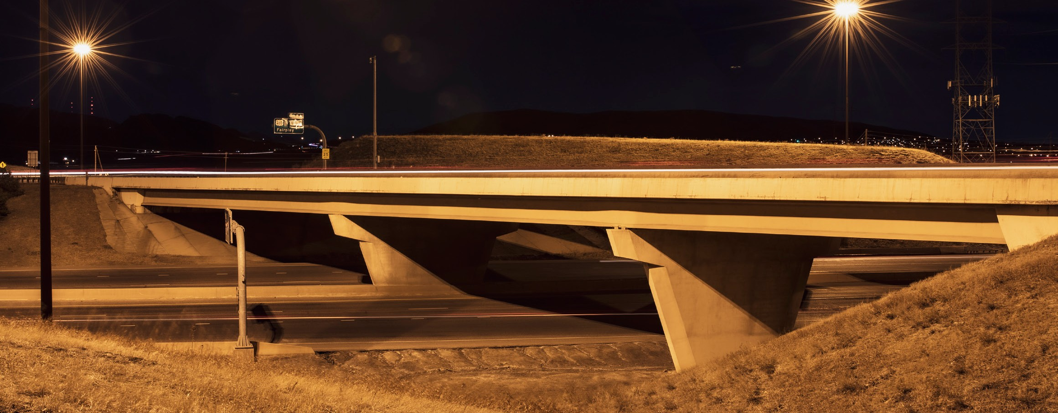

APPLIED RESEARCH & INNOVATION BRANCH
Author First Name Last Name Author First Name Last Name Author First Name Last Name

REPORT CDOT-YYYY-XX MONTH YYYY

Title Title Title Title Title Title Title Title Title Title Title Title Title Title Title Title

APPLIED RESEARCH & INNOVATION BRANCH
Author First Name Last Name Author First Name Last Name Author First Name Last Name

General Statement page instructions and template

The following statement must appear on page 2 of the Final Report. Do not change or add to this statement.
The contents of this report reflect the views of the author(s), who is(are) responsible for the facts and accuracy of the data presented herein. The contents do not necessarily reflect the official views of the Colorado Department of Transportation or the Federal Highway Administration. This report does not constitute a standard, specification, or regulation.
A template for the General Statement page appears on the following page.

The contents of this report reflect the views of the author(s), who is(are) responsible for the facts and accuracy of the data presented herein. The contents do not necessarily reflect the official views of the Colorado Department of Transportation or the Federal Highway Administration. This report does not constitute a standard, specification, or regulation.

Technical Documentation page instructions and template

Every research report must include the technical documentation page. A template appears on the following page. Fill out this page according to the following instructions.

General Formatting
- Use font Times New Roman, size 10
- Type report title in ALL CAPS
- Report title should exactly match the title on the report cover
- Keywords to facilitate a search must be entered in the appropriate box
  - supplement, do not duplicate, words from the title
  - do not capitalize unless they are proper nouns
  - type in a continuous line with commas separating keywords
- Number the Technical Documentation Page page as page i

Box 1 Report No. - Enter as CDOT-YYYY-XX
- CDOT=Colorado Department of Transportation
- YYYY=calendar year
- XX=assigned project number

Box 2, Government Accession No. - Leave blank.

Box 3, Recipient’s Catalog No. - Leave blank.

Box 4, Title and Subtitle - Enter the entire report title, in title case (initial capital letter on significant words); precede subtitles with a colon.
Box 5, Report Date - Enter the month and year the report is published.
Month YYYY ex. September 2020
Box 6, Performing Organization Code - Leave blank.
Box 7, Author(s) - List first name, middle initial if available, and last name of all authors, primary author first; maintain consistent formality across all author names (e.g., all middle initials or none) unless following author preference in name style. Enter the names of the individuals, not the company. First names must be given. ORCIDs* should be obtained and listed. https://orcid.org/
Box 8, Performing Organization Report No. - Leave blank.
Box 9, Performing Organization Name and Address - Enter name and address of the organization that employs the principal investigator (followed by other subcontractor organizations, if applicable).
Box 10, Work Unit No. (TRAIS) - Leave blank.
Box 11, Contract or Grant No. - Study Number Procedure (Assigned by Research Branch):
Study number = (subject area code)(Fiscal Yr)(rank that year) = 114.01

Subject Areas/Subject Area Code:
Environmental, Sustainability, and Water Quality – 100
Structures, Hydraulics, Soils, and Geotechnical - 200
Safety, Operations, and Planning - 300
Pavements and Materials - 400

Box 12, Sponsoring Agency Name and Address - Enter:
Colorado Department of Transportation - Research
2829 W. Howard Place
Denver, CO 80204

Box 13, Type of Report and Period Covered - Enter “Final”, “Interim”, or “Construction” as appropriate.
Box 14, Sponsoring Agency Code - Leave blank.
Box 15, Supplementary Notes - Enter “Performed in cooperation with the Federal Highway Administration.”
Box 16, Abstract - Include a brief (200–250 words) summary of the most significant information contained in the report. The abstract should fit in the box provided in the template.
Box 17, Key Words - Enter terms or short phrases that identify the important topics in the report; use initial caps. Check terms and when possible, choose terms from the Transportation Research Thesaurus. (http://trt.trb.org/trt.asp)
Box 18, Distribution Statement - This document is available on CDOT’s website https://www.codot.gov/programs/research
Box 19, Security Classif. (of this report) - Unclassified.
Box 20, Security Classif. (of this report) - Unclassified.
Box 21, No. of Pages - Leave blank. The Research Branch will calculate at the time of publication.
Box 22, Price - Leave blank.

Technical Report Documentation Page
1. Report No.  CDOT-YYYY-XX | 2. Government Accession No. |  |  |  | 3. Recipient's Catalog No.
4. Title and Subtitle  Insert title |  |  |  |  | 5. Report Date  Month YYYY
 |  |  |  |  | 6. Performing Organization Code
7. Author(s)  First name last name, First name last name, First name last name |  |  |  |  | 8. Performing Organization Report No.
9. Performing Organization Name and Address  Insert information |  |  |  |  | 10. Work Unit No. (TRAIS)
11. Contract or Grant No.
XXX.XX
12. Sponsoring Agency Name and Address  Colorado Department of Transportation - Research 2829 W. Howard Pl.  Denver CO, 80204 |  |  |  |  | 13. Type of Report and Period Covered  Final
 |  |  |  |  | 14. Sponsoring Agency Code
15. Supplementary Notes
Prepared in cooperation with the US Department of Transportation, Federal Highway Administration
16. Abstract
Insert abstract

Implementation (Optional)
17. Keywords  Insert keywords |  |  | 18. Distribution Statement  This document is available on CDOT’s website https://www.codot.gov/programs/research
19. Security Classif. (of this report)  Unclassified |  | 20. Security Classif. (of this page)  Unclassified |  | 21. No. of Pages |  | 22. Price
Form DOT F 1700.7 (8-72) Reproduction of completed page authorized

