TIMP Field Guide

Template

JUNE 2015

|  |  |  |  |
| --- | --- | --- | --- |
|  | Prepared for:  Colorado Department of Transportation  425 C Corporate Circle  Golden, Colorado 80401 | Firm Logo | Prepared by:  Firm Name  Firm Address  City, Colorado ZIP |

# Duties and Responsibilities

All agencies assume the role of Incident Commander or participate in/support Unified Command, as appropriate to the incident. The table below illustrates the stakeholders that may participate in traffic incident management activities and the duties and responsibilities that may be associated with each stakeholder.

| Stakeholder | Duties and Responsibilities | |
| --- | --- | --- |
| Law Enforcement | * Secures incident scene * Performs first responder duties * Assists responders in accessing the incident scene * Establishes emergency access routes * Controls arrival and departure of incident responders * Polices perimeter of incident scene and impact area | * Conducts crash investigation * Performs traffic control * Responds to and assesses incidents involving a hazardous material release * Assumes role of Incident Commander, if appropriate * Conducts criminal investigation * Supports unified command, as necessary |
| Fire and Rescue | * Protects incident scene * Rescues/extricates patients * Extinguishes fires * Responds to and assesses incidents involving a hazardous materials release | * Contains or mitigates a hazardous materials release * Assumes role of Incident Commander, as necessary * Supports unified command, as necessary |
| Emergency Medical Services (EMS) | * Provides medical treatment to patients at the incident scene * Determines destination and transportation requirements for injured patients | * Transports patients for additional medical treatment * Supports unified command, as necessary |
| Emergency Management Agency | * Coordinates government response and resources * Provides technical expertise * Provides evacuation recommendations * Facilitates communication and coordination across jurisdictions | * Coordinates response from local, state and federal agencies * Directs EOC Operations * Supports unified command, as necessary |
| Towing and Recovery | * Recovers vehicles and cargoes * Removes disabled or wrecked vehicles and debris from incident scene | * Mitigates non-hazardous material (cargo) spills * Supports unified command, as necessary |
| Communication Centers | * Receives emergency and  non-emergency calls * Dispatches response agencies to incidents | * Monitors and assists response agencies in communicating * Requests resources, as necessary |
| Transportation agencies, including:   * Highway maintenance * Service patrols * Traffic incident response teams * Transportation management center (TMC) * Highway Incident Commanders | * Protects incident scene * Implements traffic control strategies and provides supporting resources * Monitors traffic operations * Disseminates motorist information * Mitigates incidental, non-hazardous material spill confined to the roadway * Assesses and directs incident clearance activities * May perform first responder duties (service patrol) * Clears minor incident (service patrol) | * Performs incident detection and verification (service patrol/TMC) * Updates VMS boards, cotrip.org and 511 information (TMC) * Distributes mass notifications (email, text, social media, etc.)(TMC) * Develops and operates alternate routes * Assesses and performs emergency roadwork and infrastructure repair * Assumes role of Incident Commander, as necessary * Supports unified command, as necessary |

# Working the Incident

## Incident Classifications

The first responder assesses probable incident class based on operational experience. The Incident Commander (IC) determines incident class based on information provided by the first responder. Update incident classification as necessary during incident mitigation and recovery.

|  |  |  |
| --- | --- | --- |
| **Incident Class** | Expected  Duration | Typical Traffic Impact |
| **Minor** | 0 to 30 minutes | Short druation lane blockages; on-scene responders responsible for traffic control |
| **Intermediate** | 30 minutes to 2 hours | Lane blockages requiring traffic control; short duration closures may be needed |
| **Major** | More than  2 hours | Full or partial roadway closure |

## Size-up

### Initial Radio Report

Initial radio report, sometimes referred to as a windshield report, is a brief description of the scene reported before exiting the vehicle. The report should include basic information such as:

* Location
* Number and types of vehicles involved
* Apparent cause of incident
* Classification of incident (Minor, Intermediate, or Major)
* Potential threats to safety
* Presence of hazardous materials
* Blockages and the need for lane or road closures
* Needed resources

### Follow-up Report

Specific details reported in the 360 evaluation might include:

* Lane(s) impacted
* Tools required
* Position and type of vehicle
* Number and/or condition of patients
* Location of Incident Command Post
* Resources required (equipment, towing, traffic control, detours, etc.)

Size-up is a continuous process. As the scene develops, updated reports should be communicated to dispatch. Update dispatch per your agency’s protocol.

## Traffic Incident Management Area

### Lane Designation Terminology

State, regional, and local responders often use distinct terminology when communicating the location of crashes or response vehicles on roadways. Disparate terminology in communications could potentially lead to confusion on the scene, impact responder and patient safety, and adversely affect emergency response and traffic clearance times.

* Lane: Traffic incident responders use plain English where possible to identify incident location and lane designations. On roadways with 3 or fewer lanes, lanes are named left, center, and right when facing in the direction of traffic flow. [Use when TIMP roadways have fewer than 3 lanes]
* Lane: When roadways have more than 3 lanes in any one direction, the lanes shall be identified and labeled with numbers, starting with the far left lane. When using lane numbers, the far left lane shall be called “Lane 1”. Each lane to the right is numbered sequentially 2 through n. [Use when TIMP roadways have more than 3 lanes]
* Shoulders: Shoulders should be identified using “right/left” and the term “shoulder”; and direction of travel (e.g. “northbound shoulder”).
* Restricted Lanes: Separated, high occupancy vehicle (HOV) or high occupancy toll (HOT), car pool, or bus only lanes that are physically separated shall be designated as HOV1 northbound (NB), HOV2, HOT1, HOT2, etc. as appropriate. [list only if one of the above types of restricted lanes is used in the TIMP area]
* Direction of Travel: Responders should also indicate the relative direction of travel (e.g. northbound or southbound) along with other incident location detail and any specific position assignments.

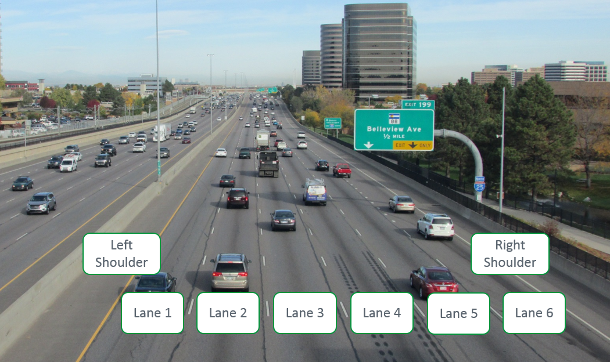

Lane Designation Terminology

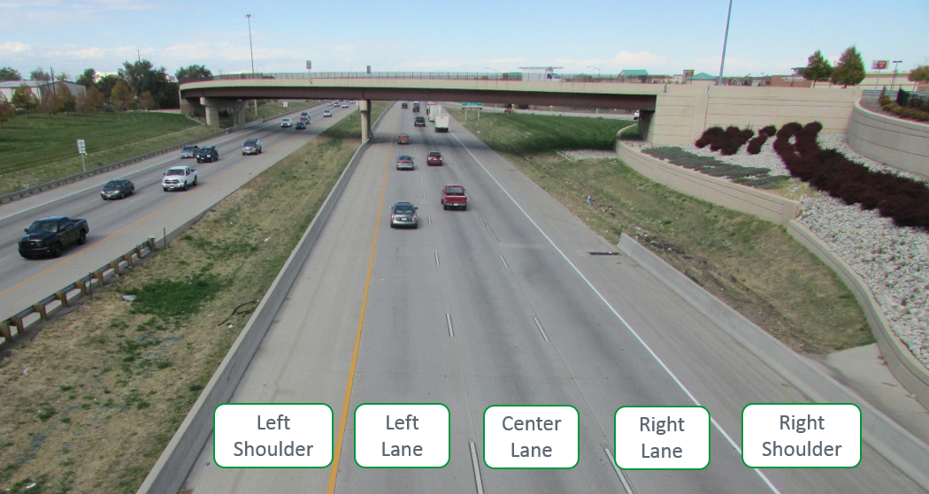

Lane Designation Terminology

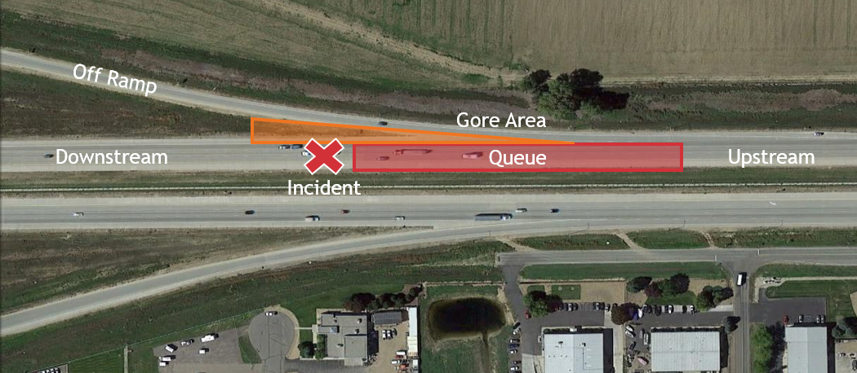

Incident Area Terminology

* Ramp: If the incident is located before the merge point it shall be considered a separate roadway and identified as such, i.e. left hand exit ramp.
* Upstream/Downstream: The term “upstream” is defined as before the incident area. The term “downstream” is defined as past or beyond the incident area when facing in the direction of traffic flow.
* Gore: The physical space that separates the interstate or highway and the off or on ramp.
* Queue: The traffic backup upstream of the incident.

### Response Vehicle Parking Guidelines

* All response vehicles should be parked on the same side of the roadway on which the incident occurred to avoid a split-scene scenario.
* Except for vehicles positioned to protect the incident scene, response vehicles should be parked on the shoulder.
* Fire-fighting vehicles should be parked directly behind or in front of the vehicles involved in the incident.
* Tow trucks and support vehicles should be parked where they can be accessed and moved while not interfering with lane-opening activities.
* Median parking is discouraged.
* Conditions may require adjustments of the positions of response vehicles be adjusted to accommodate a particular incident scene. In all scenarios, response vehicle parking positions should protect the incident scene and responding personnel.
* Where practical, “safe positioning” techniques should be followed including:
  + Placing fend-off vehicles at a 30 degree angle to the travelled way.
  + Positioning the front bumper of a fend-off vehicle at least two feet from the edge of an active traffic lane.
* Locations for helicopter landing zones will be identified and coordinated by the Incident Commander/Unified Command and air ambulance service.

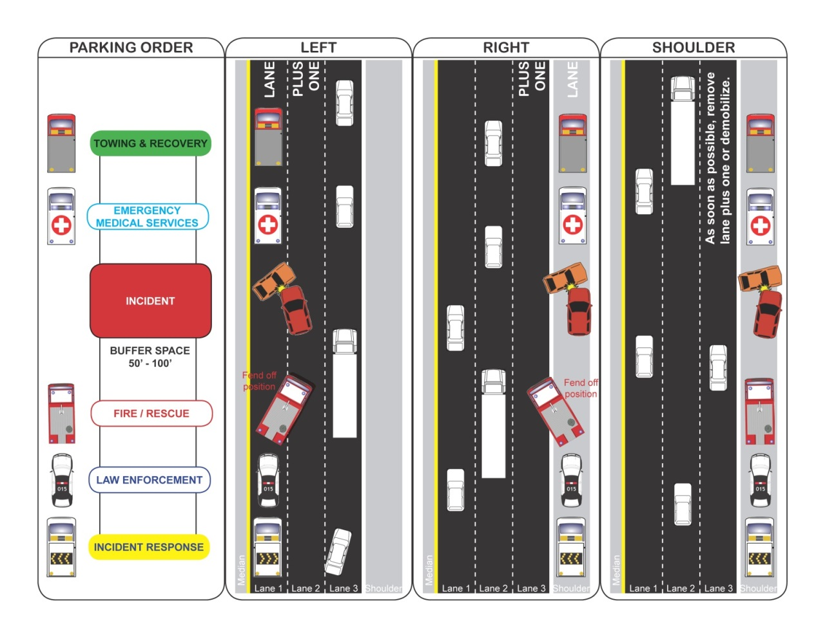

Typical Responder Vehicle Parking

### Flashing/Emergency Lights Guideline

Flashing and emergency lights are generally used to warn the public of the presence of emergency vehicles. However, the presence of multiple vehicles with activated emergency lights can also cause a distraction to motorists resulting in reduced speeds. The following are recommendations about when flashing or emergency lights should be utilized.

Flashing/emergency lights should be active when:

* Traveling through stopped traffic to the incident scene.
* Traveling on the shoulder.
* Working through traffic to remove blocking, disabled vehicles.
* Response vehicles are parked on the shoulder and adjacent traffic is traveling at speeds near or above the posted limit.
* Response vehicles are parked on the shoulder at night.

Flashing/emergency lights should NOT be active when:

* Multiple response vehicles are lined up. In this scenario, only the front and rear response vehicles should have activated overhead flashers.
* Both incident and response vehicles are safely outside of the traveled way. The use of yellow flashers once the response vehicle has parked helps alleviate “rubbernecking” by passing motorists.

### Quick Clearance

Quick clearance is the practice of rapidly and safely removing temporary obstructions from the roadway. Vehicles are moved as soon as practical off the travelled portion, median, ramp or frontage road to the nearest suitable cross street or other suitable location. The Colorado Revised Statutes support this effort in subsection 42-4-1602, Accident involving damage – duty. [If there are specific procedures or designated storage areas identified within the limits of the TIMP, identify in this section.]

### Managing the Queue

Responders arriving at a traffic incident should estimate the magnitude of the traffic incident, the expected time duration of the traffic incident, the expected vehicle queue length based on previous experience, and should set up the appropriate temporary traffic controls for these estimates; typically further upstream from the current end of the queue. Care should also be given to provide planned adequate ingress and egress of emergency vehicles, through the queue.

### Move It or Work It

In support of the quick clearance initiative, property obstructing traffic can also be physically moved off of the roadway, by a law enforcement officer or person appointed by a law enforcement officer, to open up the roadway or reduce impacts to roadway. The Colorado Revised Statutes support this effort in subsection 42-4-1803. Abandonment of motor vehicles - public property.

If the vehicle can be moved, the scene should be marked to preserve evidence for accident reconstruction. At a minimum, all four wheels should be marked with a “T,” direction can be given by connecting the front to the “T” to the stem to create a figure “4.”

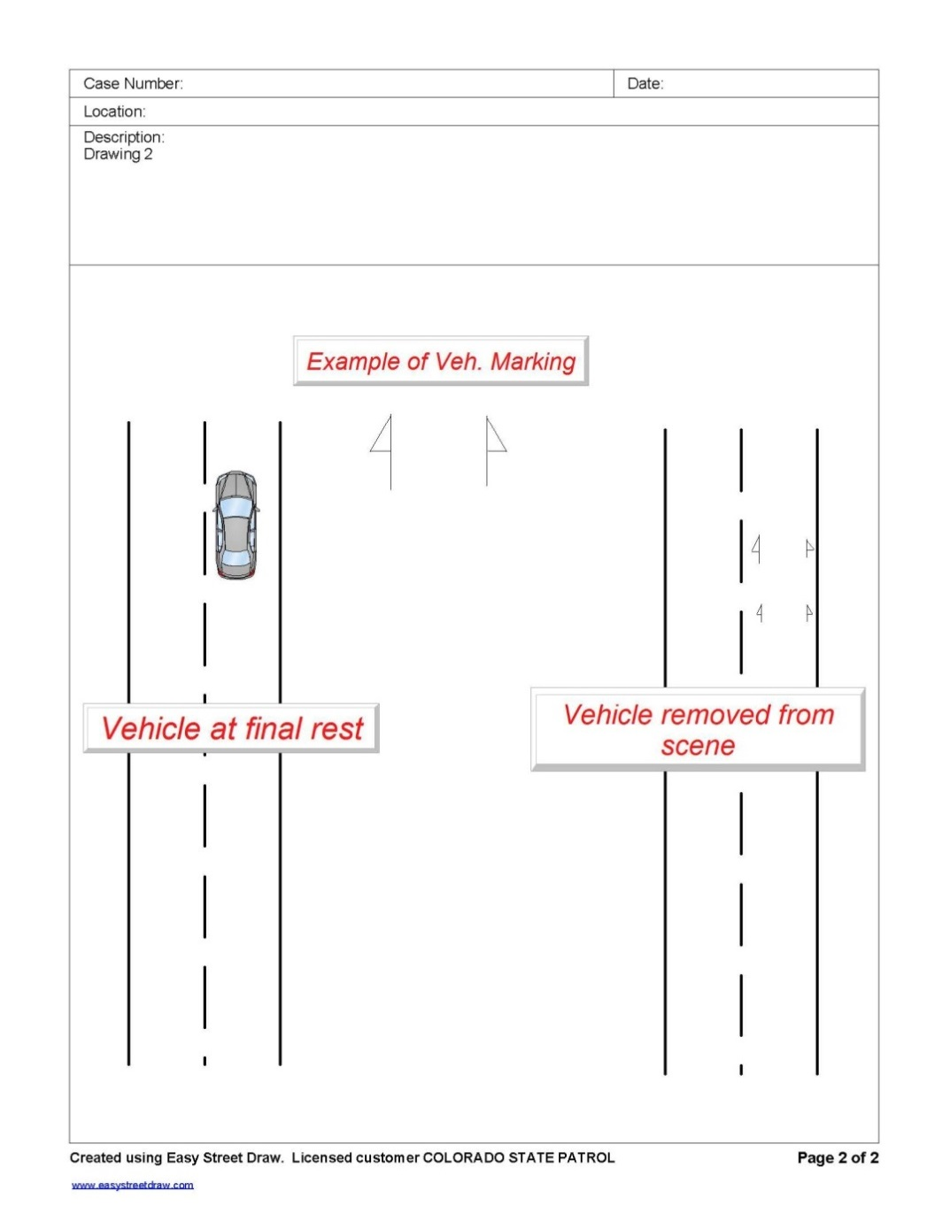When property has been moved out of the traveled way and is not impacting traffic, final removal can be scheduled for a more convenient, off peak time. Benefits of waiting for a more convenient time for removal include reducing first responder exposure and having response assets available for other incidents during peak periods. Delaying the tow or removal of property should be approved by CDOT, CSP and the local agency.

If the initial scene cannot be moved, due to Hazmat or life safety reasons, it must be worked in place. The scene should be re-evaluated as the incident mitigation progresses to identify opportunities to move portions of the incident out of the travel way.

Vehicle Marking Example

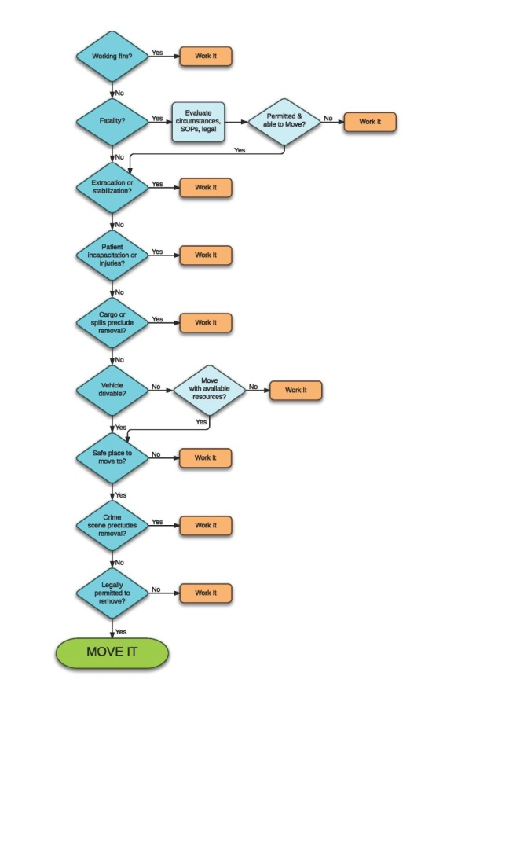

Move It or Work It Decision Workflow

# Communication

# 

Incident Verification Communication

# Alternate Routes

### When to Establish a Local Detour

The establishment of local detours should be considered during Intermediate and Major incidents requiring a closure of one or more lanes. The Incident Commander or Unified Command should make this decision based on the estimated incident duration, traffic demands, and the availability of resources. Before the local detour is implemented, CDOT Maintenance and/or other responding traffic control entity should be consulted to ensure that appropriate signing and barricading can be provided.

### How to Implement a Local Detour

Detour routes have been identified and are included on pages [enter page numbers]. When the primary detour route is restricted or is undesirable, an alternate detour route may be initiated. Before a local detour plan is initiated, Incident Commander/Unified Command should verify that neither construction activities nor maintenance issues are present along the route. Local public works departments should be contacted to confirm the suitability of detour routes, including snow removal schedules during the winter. Given the required setup time, signed detour routes are unlikely to provide great benefit for Intermediate incidents, especially if the route cannot be fully implemented within an hour of incident verification.

When detour signing is implemented:

* Install MUTCD compliant signs.
* Signs should be deployed from the downstream end of the alternate route.
* Fasten signs on poles or erect on portable sign structures. Standard mounting height is 7 feet, if that is not achievable, the signs should be visible above the tops of cars.
* Erect signs on the right side of the roadway at a minimum of two feet from the edge of traveled way.
* Manage the queue.
* Once the incident has been cleared, remove signs immediately.

# alternate routes

Regional Detour Routes &

Hazardous Material Routes

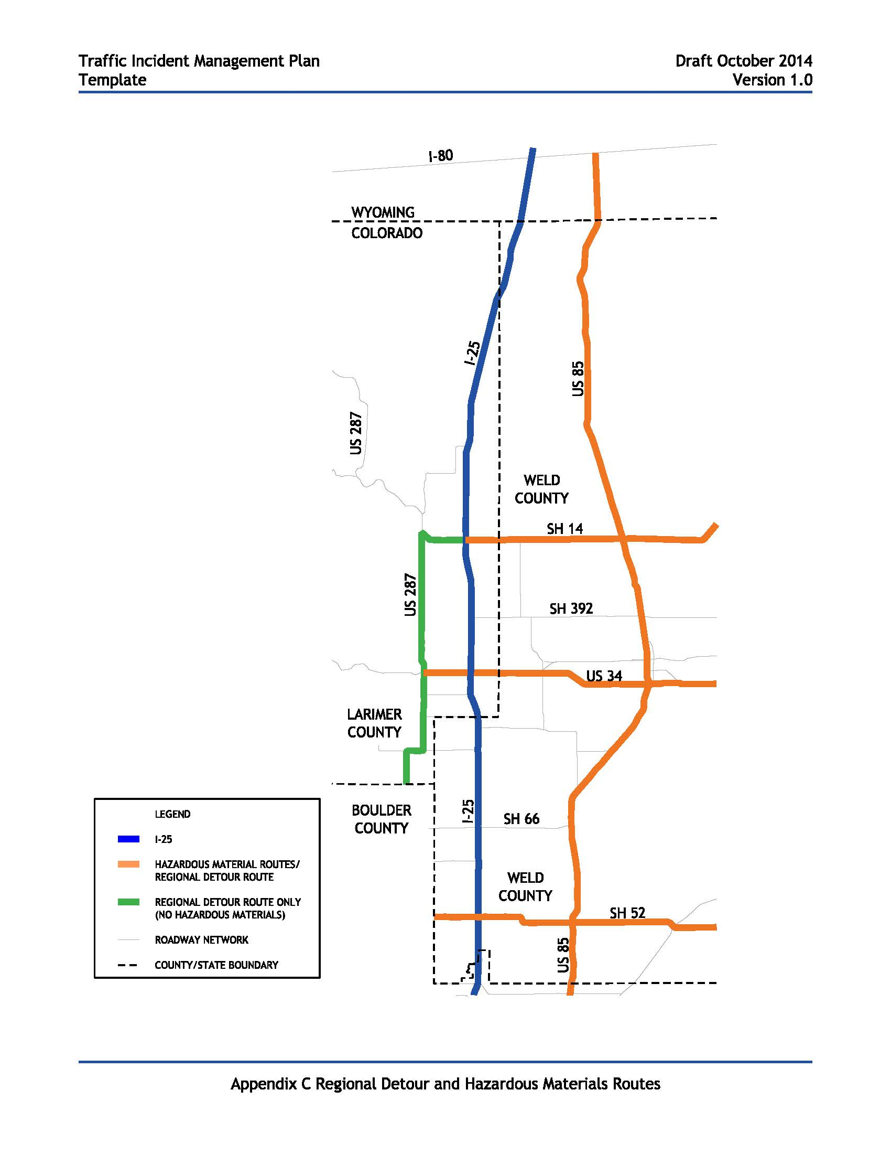

Local Detour Routes

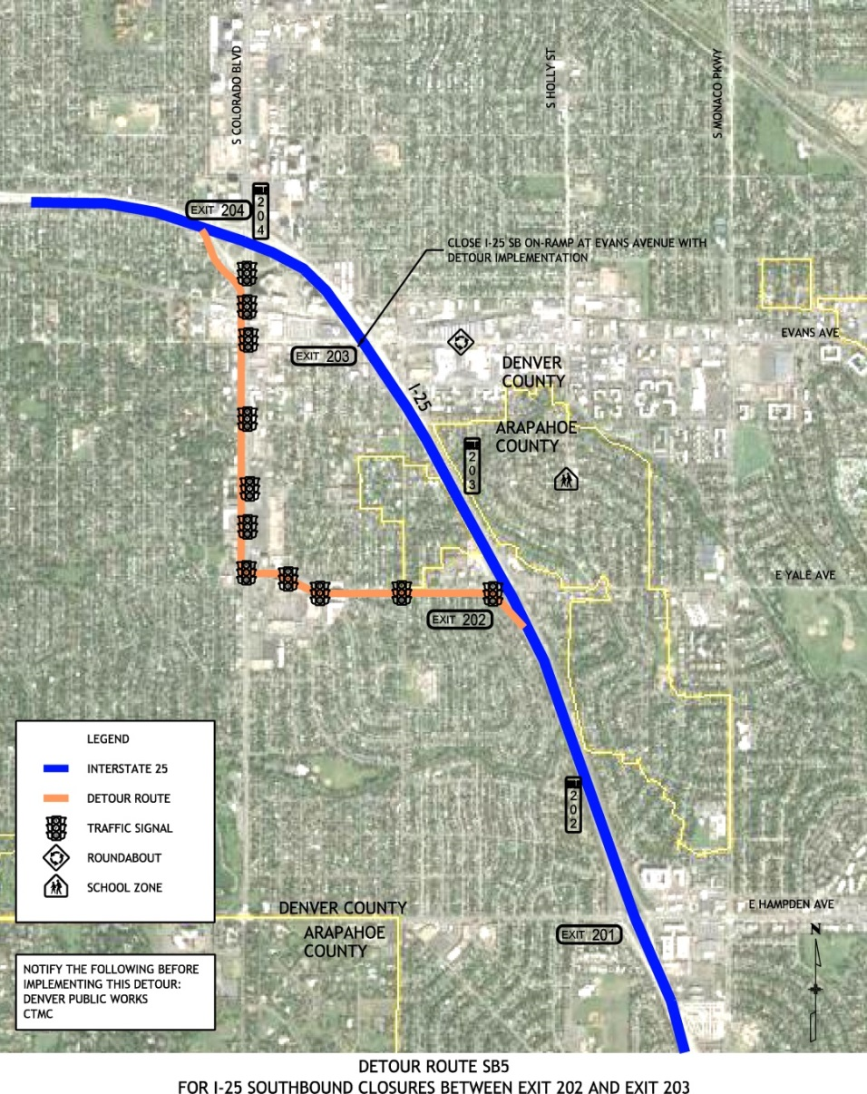

Local Detour Routes

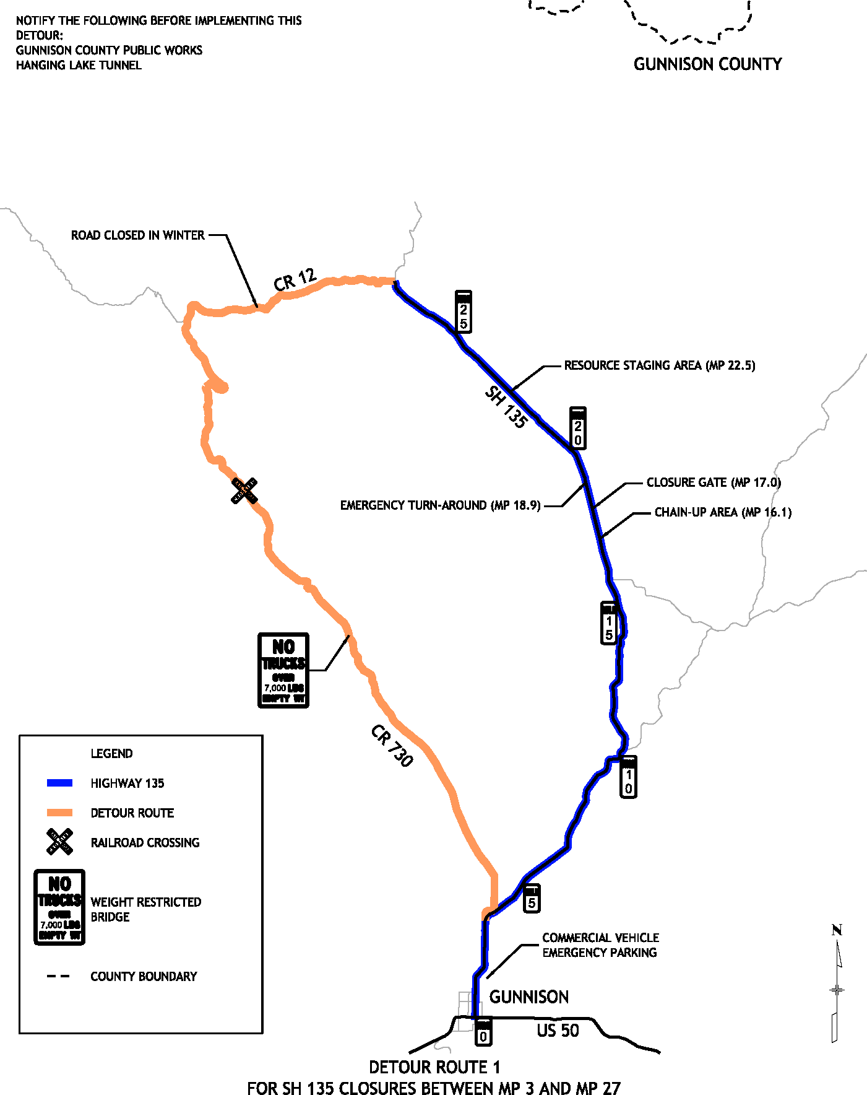

## Post Incident

## Hot Wash

The hot wash is a facilitated discussion held immediately following an incident, it is intended to capture feedback about any issues, concerns, or opportunities for improvements responders may have about incident. The Incident Commander should take notes during the hot wash and include these observations in their analysis. The hot wash should be conducted immediately following the incident, once responder’s vehicles have been cleared from the scene and last no more than 30 minutes. The hot wash does not replace the After Action Review procedure.

List the top 3 Strengths:



List the top 3 Areas for Improvement:



Additional Remarks or Comments:

# Template timp field guide

The [TIMP] is the result of the cooperative effort of representatives from [list fire, law, and other jurisdictions as appropriate] and CDOT.

Copies of the plan and additional information are available by contacting [list CDOT contact] at the address below. In the continued effort to keep this manual up to date and accurate, any comments regarding corrections and necessary changes should be directed to:

Colorado Department of Transportation

Region [Input CDOT Region #], [Contact person’s title]

Attention: [Name]

[Street Address]

[City, State, Zip Code]

Phone: [Phone #]

Email: [Email Address]

This manual is accessible anytime on-line with permission from CDOT. Contact the Colorado Traffic Management Center (CTMC) managed by the CDOT Intelligent Transportation Systems (ITS) Branch at 303-512-5830 for the protocol to access the document.

Refer to the [TIMP] for…(Sections not included in the this Field Guide)

* Standing Program Managemt Team
* After Action Protocol
* Performance Measurers