Page | Page Title | Graphic/Slide Text | Audio Script
Navigating the Supervisor Development Program Curricula
 |  | 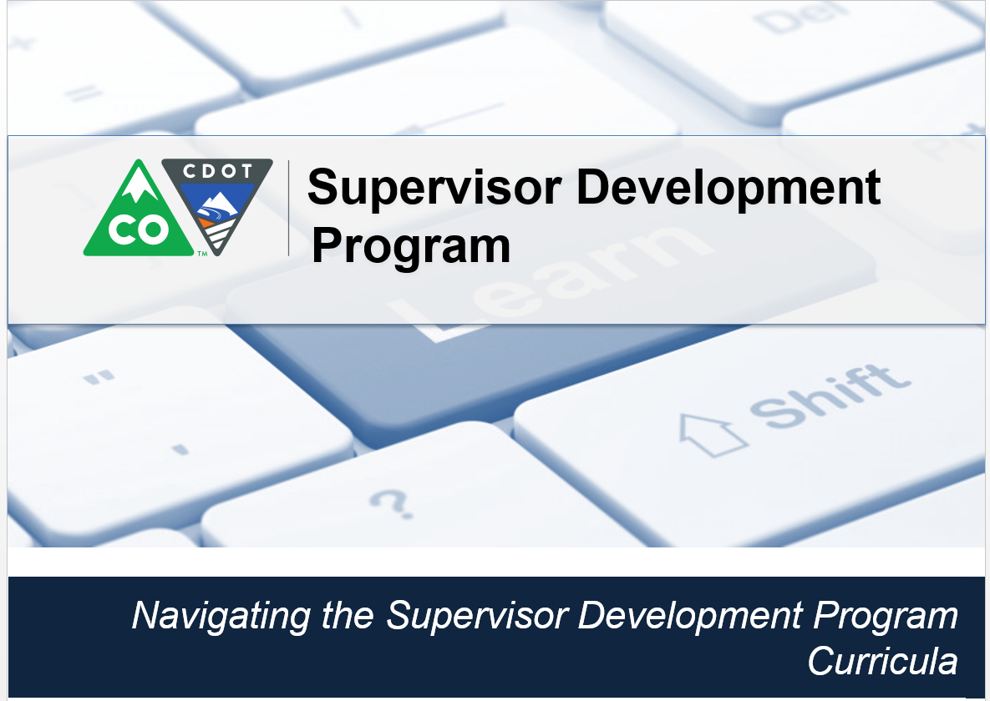 | Welcome! This video is designed to help you navigate the Supervisor Development Program Curricula. The Supervisor Development Program is assigned to all supervisors and can be found in the Learning Management System in SAP.
 |  | 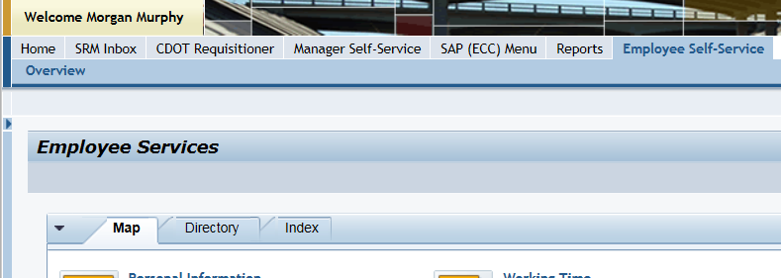 | Let’s start from the Employee Self-Service tab now click on the Learning link located under the Performance and Development.
1 | Learning | 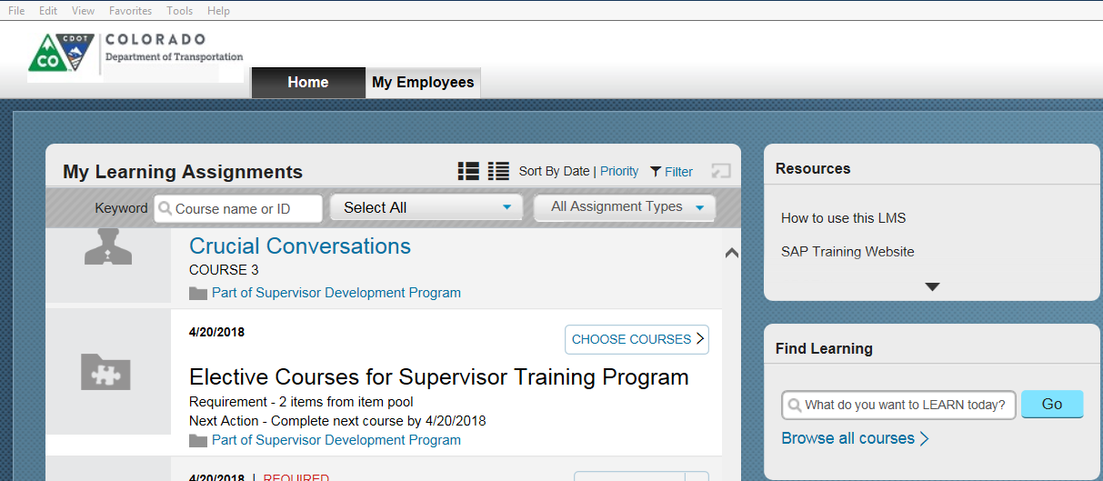 | The Learning page displays. Courses in the My Learning section are listed in order of due date, with those due soonest listed first. We’ll come back to the My Learning section in a minute. First, let’s access the curricula.
2 | My Curricula | 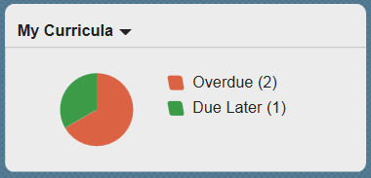 | This is done by double clicking on the circle in the in my Curricula tile. Let’s do that now.
3 | Supervisor Development Program | 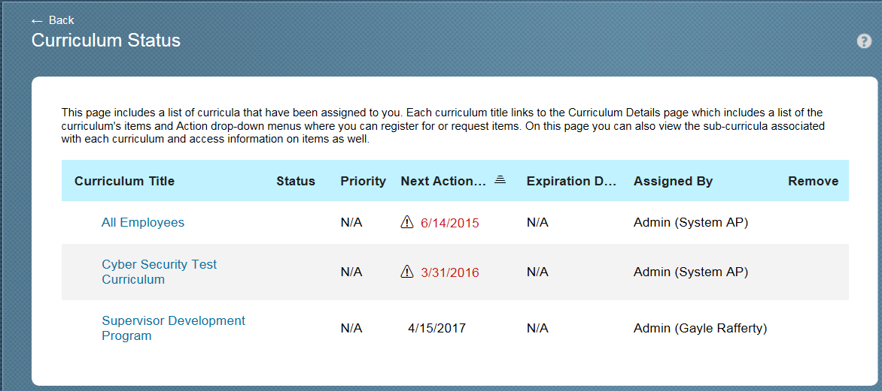 | This takes you to the Curriculum Status page. From here you can see all of the curricula assigned to you. In this cases we want to see the details of the Supervisor Development Program so let’s click on this link.
4 | Supervisor Development Program | 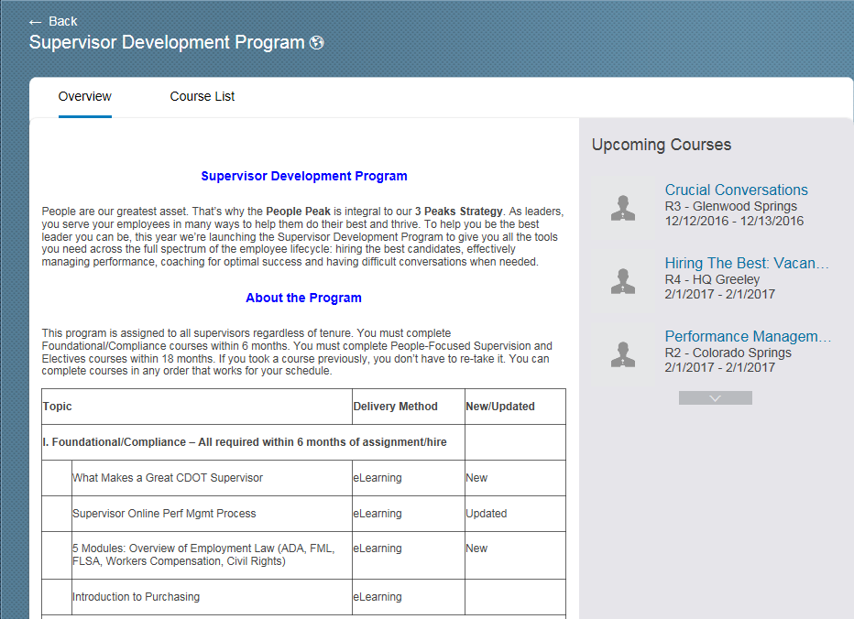 | From here we can see the courses in the Supervisor Development Program. We see that the program is broken out into three different areas, Foundational and Compliance, People-Focused Supervision and Electives. You must complete the Compliance/Foundational courses within six months of assignment. All of them are eLearning so you can take them as your schedule permits. The People-Focused Supervision and Electives must be completed within 18 months of assignment.  The Curriculum “Overview” tab shows you ALL of the courses in a curriculum. But remember, if you have already completed a course on this list, you do NOT need to re-take that course. How can you tell which you have completed? There are two ways. The first is to click the “Course List” view. Let’s do that now.
 |  | 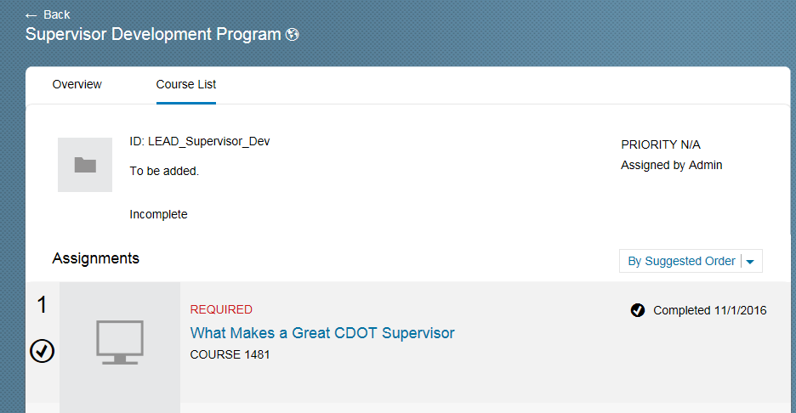 | Great! We can now see all of the courses in the program and which have been completed and which you still need to take. For example, the What Makes a Great CDOT Supervisor course says “Start Course” next to it. This means you still need to take this course.
 |  | 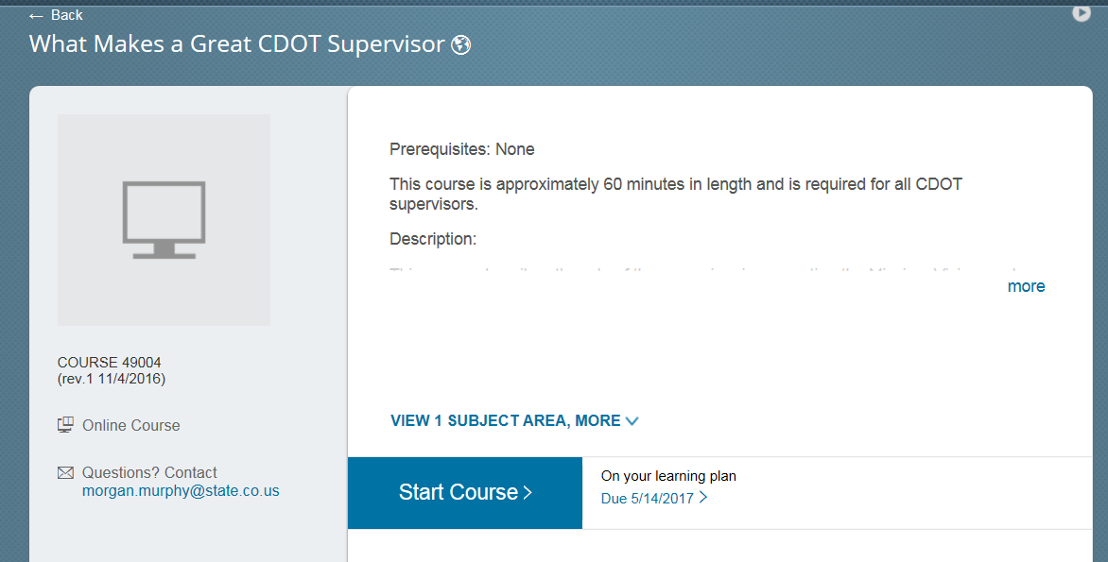
 |  | 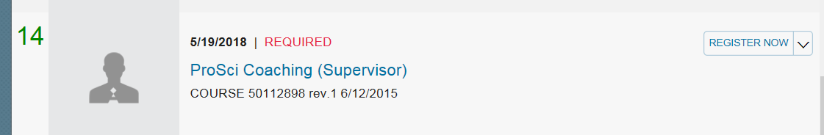 | Now let’s look at next course, Employment Law: American with disability Act. The black check to right of the course indicates the course is complete, so you do not need to take that course.  The second way to see the courses in the curricula that you still need to complete is on the My Learning. So, let’s go back to the My learning page by clicking the My Learning link.
 |  | 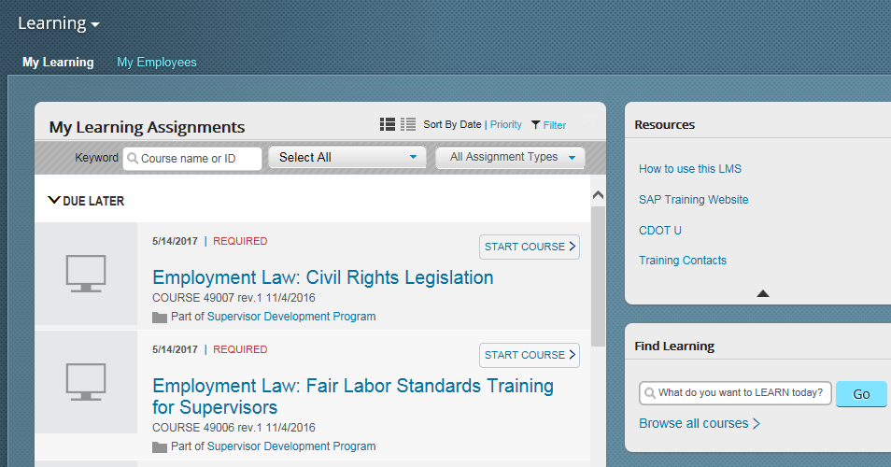 | Now let’s look at the first course, Employment Law: Civil Rights Legislation. This is a required course and must be taken by the date indicated to the left of the word required, which is May 14, 2017. Please note that other required course may display in this area that are not part of the Supervisor Development Program. For example, if you are a new employee to CDOT, you will probably see the New Employee Orientation course and other required compliance courses.
 |  | 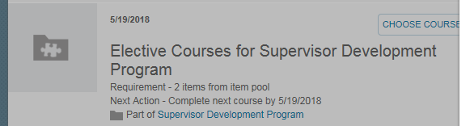 | Now let’s scroll down to the Elective Courses for the Supervisor Development program. The electives are not listed individually on the My Learning. Instead, they show up as one group. Let’s click on the choose Courses button.
 |  | 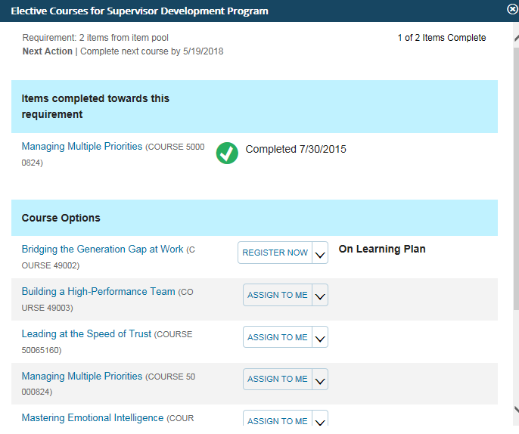 | The Elective Courses for Supervisor Development Program screen displays. From here we can see that the Managing Multiple Priorities course is complete. So, this person has one more elective to complete. They clicked on “Assign to me” for the Generations course, and by doing so, that course will show up on their Learning Plan.  It is important to note that when you finish your two required electives, the electives pool will no longer display on the My Learning Assignments page.
 |  | 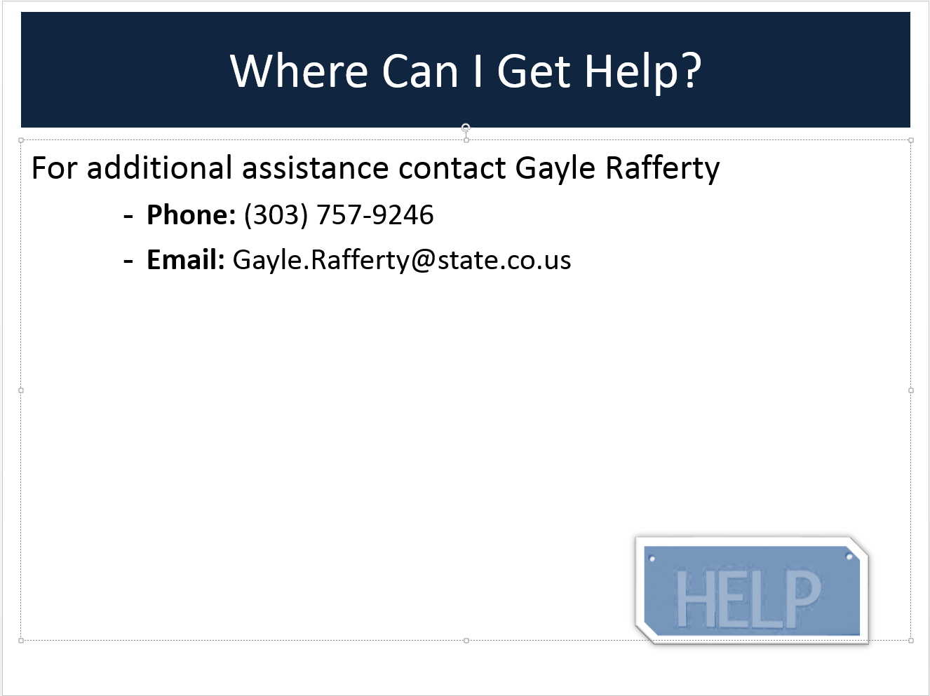 | If you have questions or need additional Assistance about the LMS contact Gayle Rafferty at if you have questions about the Supervisor Development Program contact Morgan Murphy.

