Page | Page Title | Graphic/Slide Text | Audio Script
Navigating the Supervisor Development Program Curricula
 |  | 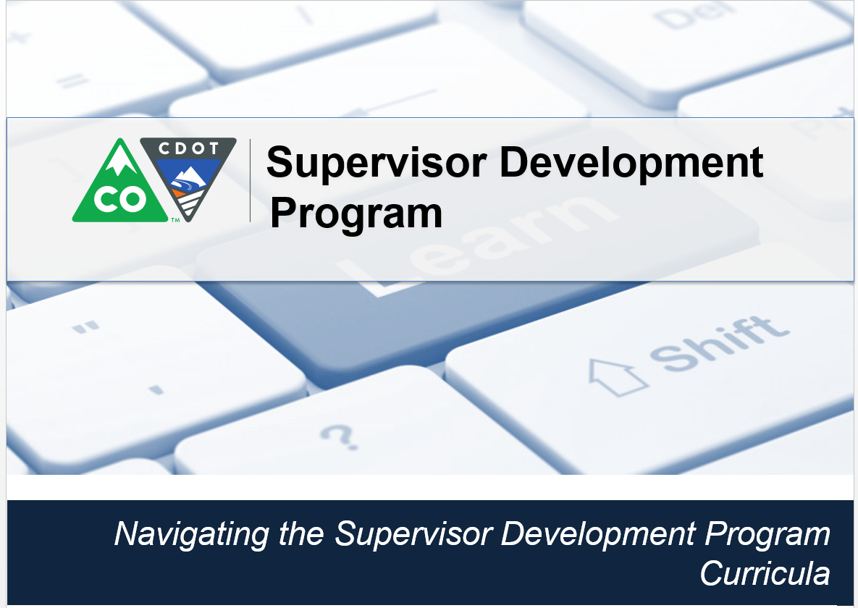 | Welcome! This video is designed to help you navigate the Supervisor Development Program Curricula. The Supervisor Development Program is assigned to all supervisors and must be completed within 18 months from the date it is assigned.
 |  | 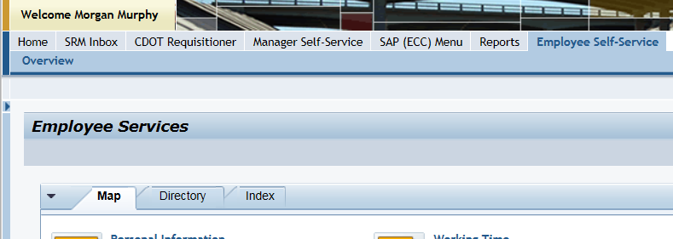 | Let’s start from the Employee Self-Service tab now click on the Learning link located under the Performance and Development.
1 | Learning | 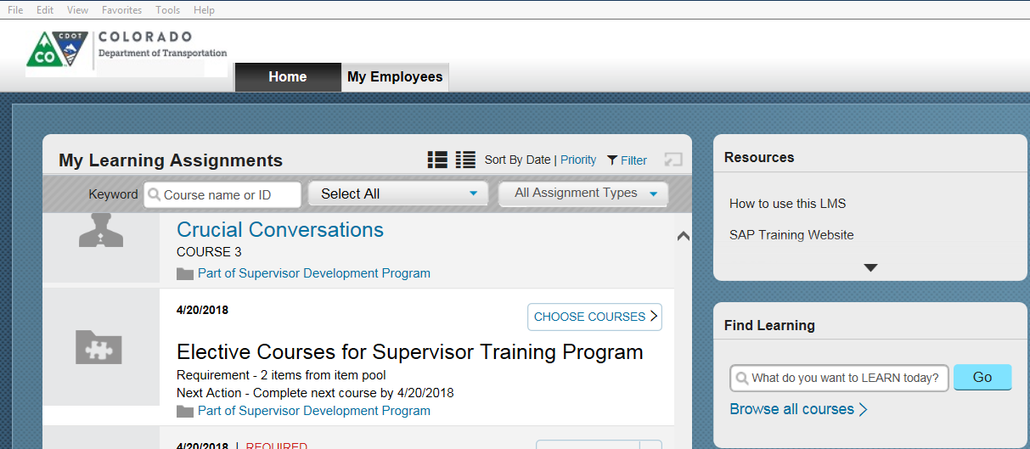 | The Learning page displays. Now all we need to do is to access the curricula.
2 | My Curricula | 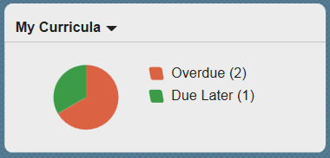 | This is done by clicking on the circle in the in my Curricula tile. Let’s do that now.
3 | Supervisor Development Program | 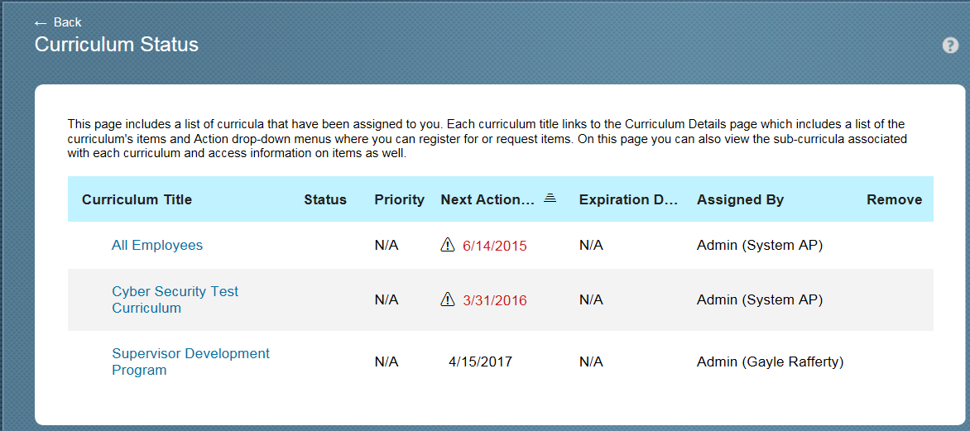 | This takes you to the Curriculum Status page. From here you can see all of the curricula assigned to you. In this cases we want to see the details of the Supervisor Development Program so let’s click on this link.
4 | Supervisor Development Program | 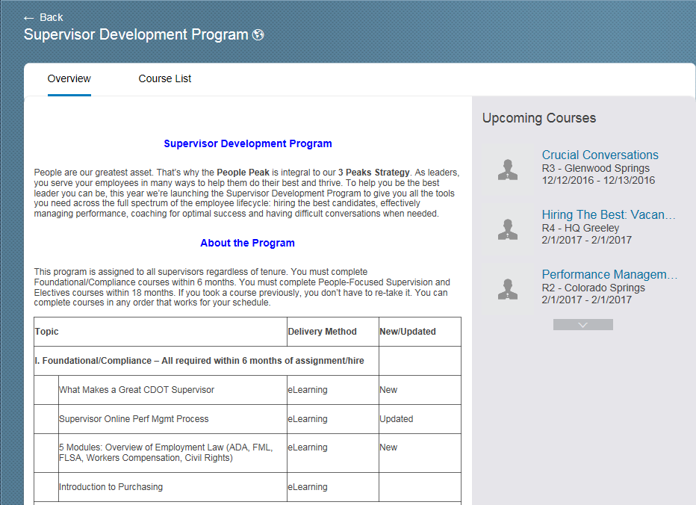 | From here we can see the courses in the Supervisor Development Program are broken out into three different areas, Foundational and Compliance, People-Focused Supervision and Electives. You must complete the People-focused supervision within six months, and all of them are eLearning so you can take them as your schedule permits. You have An additional 12 months to complete the remaining two sections. Now let’s looks at the Course List by clicking on that link now.
 |  | 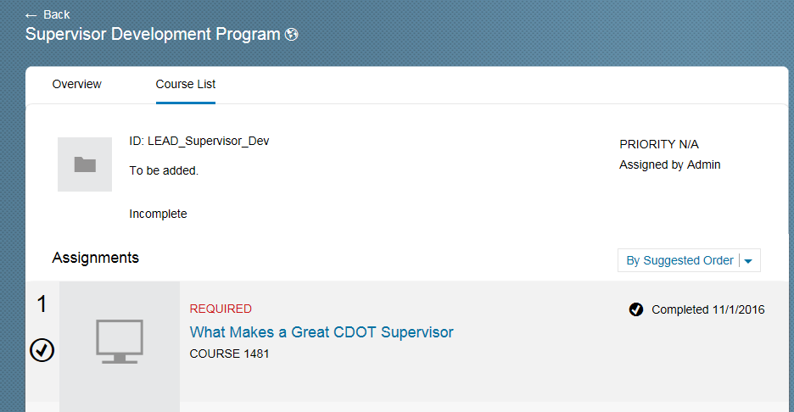 | Great! We can now see all of the courses in the program. Let’s start by looking at the What Makes a Great CDOT Supervisor Course. Just above the title is a date, this is the date it is required. To the right we can see that it is a required course. To right of we can see the start course button. Clicking on this button will take us to the course. Let’s not do that know instead let’s take a look at what this course is about by clicking on the course title.
 |  | 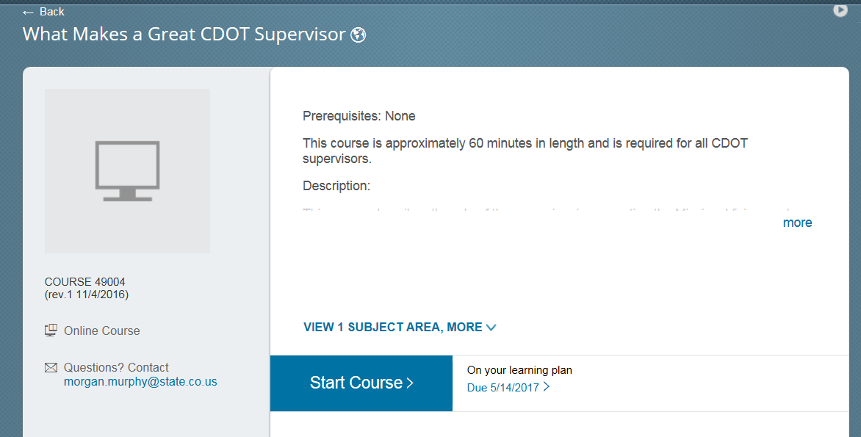 | From here we can see that the course is 60 minutes long. Now let’s click More to display the course description. Great, looks like an interesting course From here we can click the start course button to take the course, but instead let’s click the back button to learn more about the curricula.
 |  |  | Now let’s look at next course, Employment Law: American with disability Act. The black check to right of the course indicates the course is complete and the completion date to there as well. Now Let’ scroll down to the bottom of the page and look at the Course 14 ProSci Coaching. To the right of the course is the register now button. This is different from the other buttons because it is not an eLearning so you have to register for the course.
 |  | 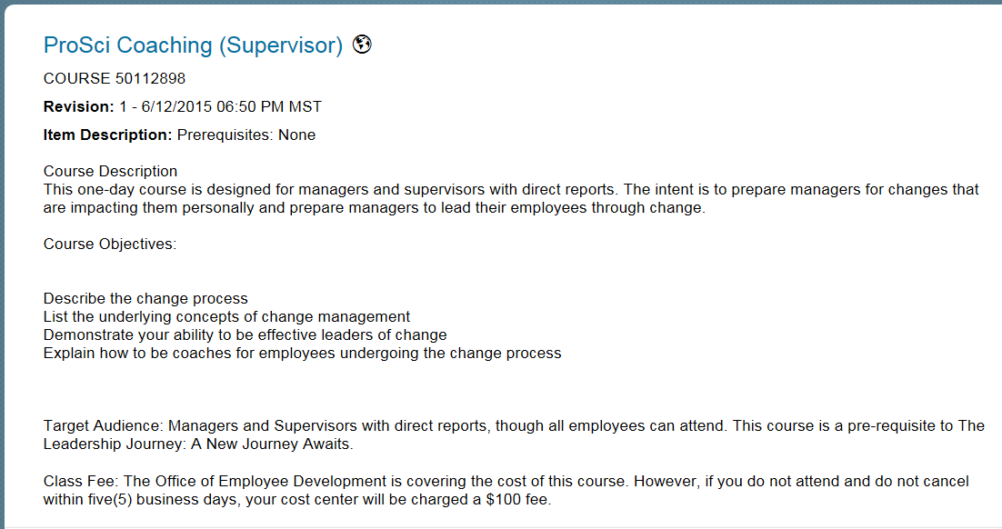 | This takes us to the course page where we can see if there are any prerequisites for the course, a description and the objects. Under the Assignment Information section we can see the number of days remaining to take the course.
 |  | 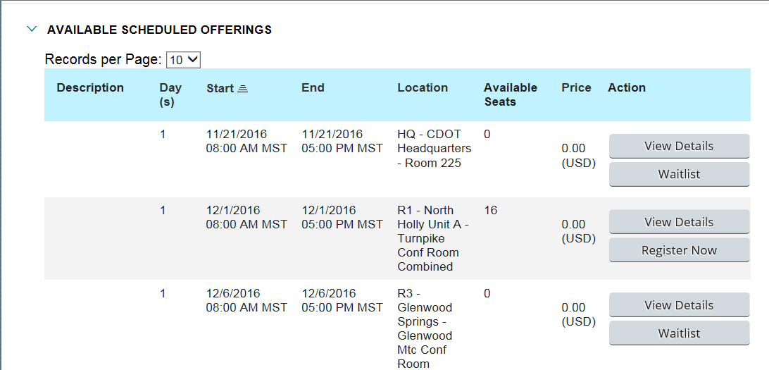 | Now let’s Scroll down the page a bit to see when the course is being offered. In this case there are seven offerings of the course. Be sure to look at the location before you book the course. If the course is full, like the first course, you will see the waitlist button, clicking on this button will add you to the waitlist, and you will be notified if a spot becomes available. At the bottom of the page there is another offering at HQ in May. So let’s sign up for this one, by clicking on the Register Now button.
 |  | 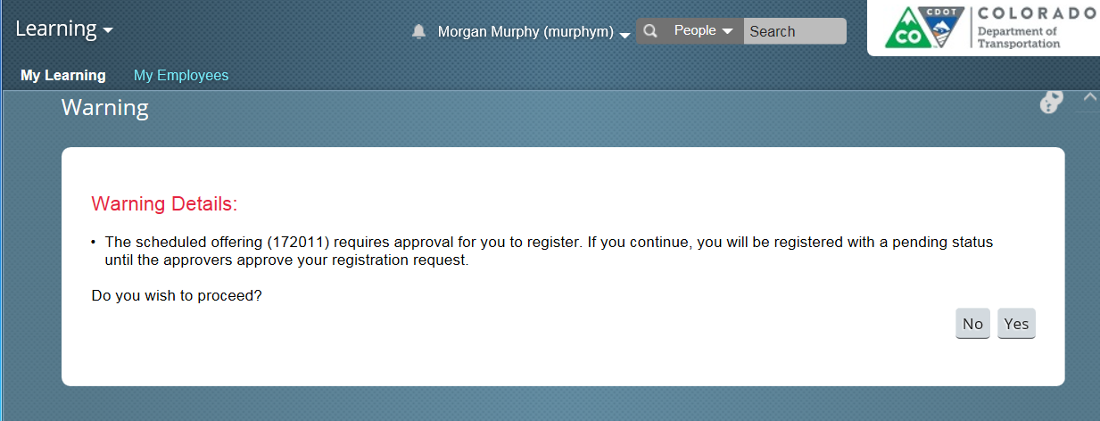 | Jeepers! A warning screen displays. This means you have to have the approval of your supervisor to register for the course. Click the yes button to register and you will be registered for the course.  Figure out where this goes and take it from there
 |  |  | This takes you to the registration
 |  | 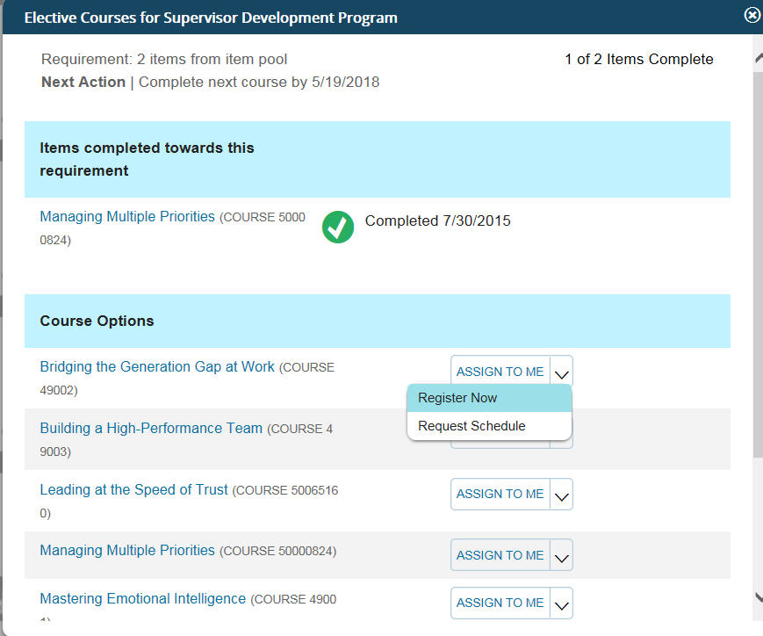 | In addition to the required courses you must take two electives. Let’s access them now. From the Supervisor Development Program page scroll down to the bottom of the page until you see the elective courses for Supervisor Development Program folder. Now select the choose course button located to the right of the title.
 |  | 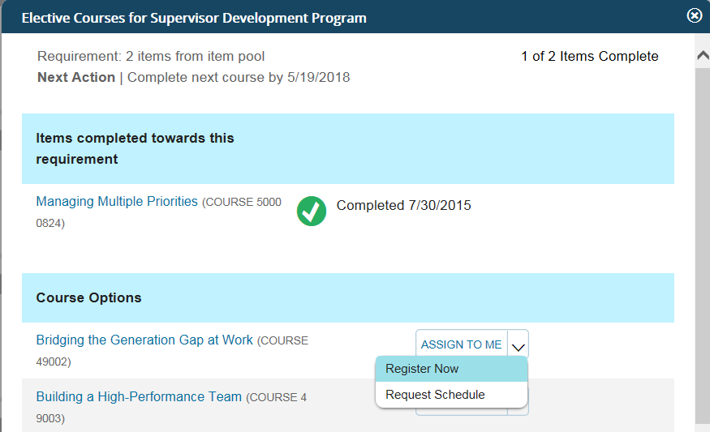 | The Elective Course for Supervisor Development Program window displays. As you can see, the Managing Multiple Priorities has already been assigned and completed. Now let’s add the Bridging the Generation Gap at Work course. To do so let’s start by clicking on the Assign To Me link.
 |  | 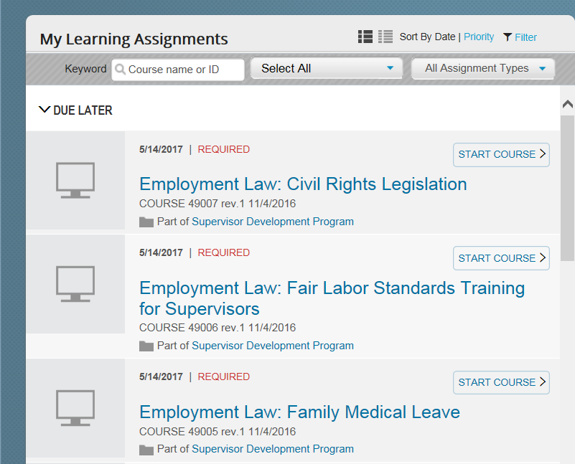 | The window closes and we are returned to the main learning page. To find the course we assigned you scroll down to the bottom of the page. Please not you still need to register for the class, by following the process outlines for the ProSci Coaching course.
 |  | 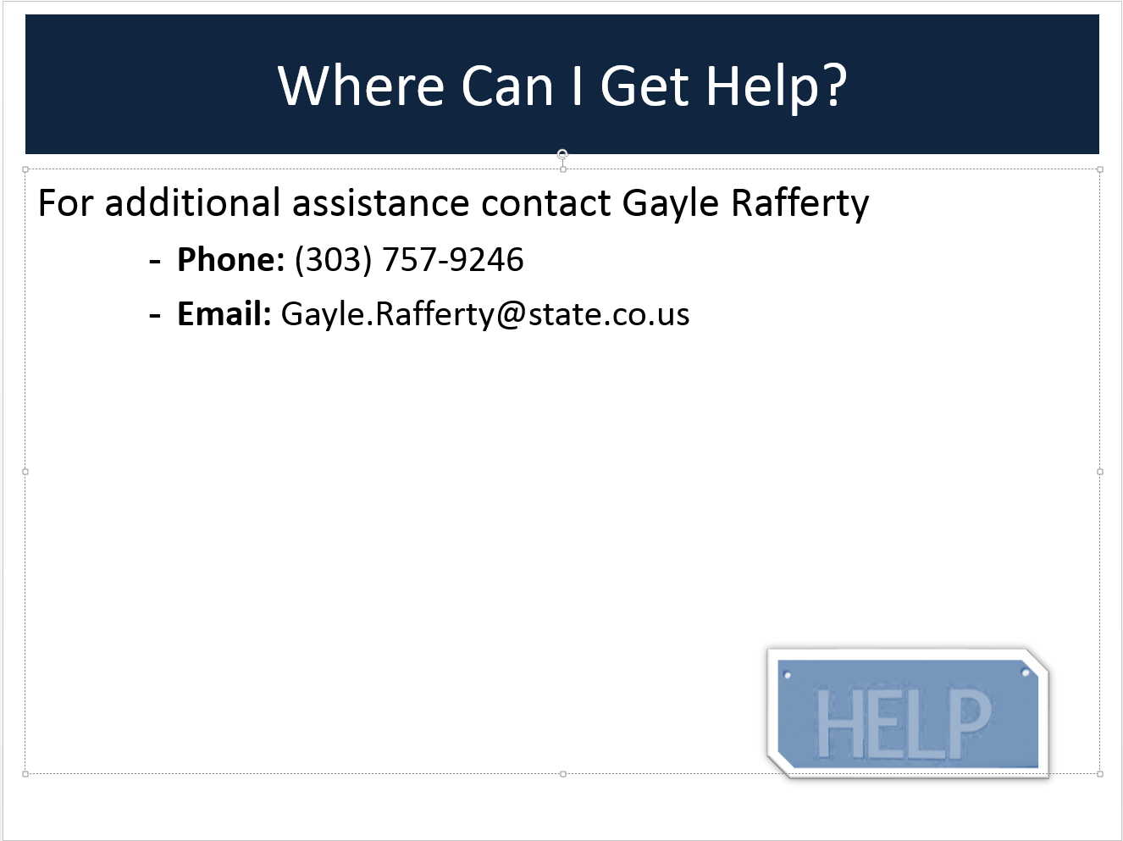 | If you have questions or need additional Assistance contact Gayle Rafferty at 303.757.9246 or email her at Gayle.rafferty@state.co.us.

