Engineering Time Approval
Items: 10 Labels (Including Introduction and Summary)
Duration: 50 seconds

Introduction to Engineering Employees
5 seconds
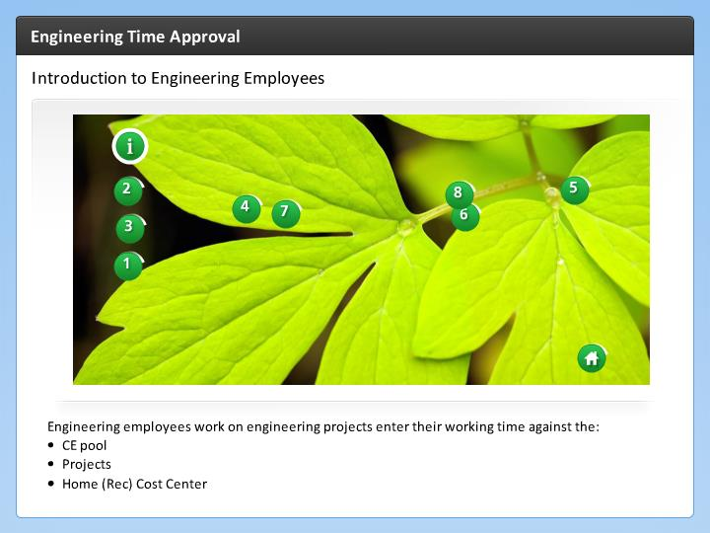

Step Text
Engineering employees work on engineering projects enter their working time against the:
- CE pool
- Projects
- Home (Rec) Cost Center

Narration Script
CDOT Employees in engineering charge their time against their Home Cost Center, CE Pool, and Projects. If an incorrect combination is entered SAP displays an error message, but this does not catch every incorrect combination.
Now let's look at what is required for the Home Cost Center.

Home Cost Center (indirect)
5 seconds
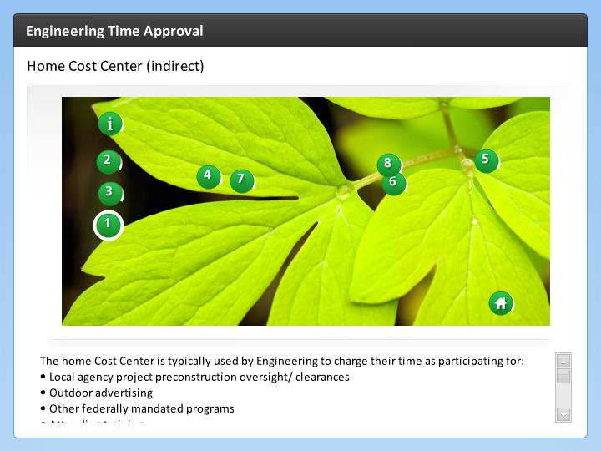

Step Text
The home Cost Center is typically used by Engineering to charge their time as participating for:
- Local agency project preconstruction oversight/ clearances
- Outdoor advertising
- Other federally mandated programs
- Attending training
- Working on committees
- Out-of-state travel
- unit meetings, video conferences and statewide meetings

The Employee must enter the following fields:
- Rec. Cost Center
- Rec. Functional Area
- A/A Type
- Working Hours

Narration Script
When an Engineering Employee uses leave and performs administrative work, their time is entered against their Home Cost Center. When entering time against a home cost center the employee must enter a Receiving Cost Center, Receiving
Functional Area, A/A Type and of course, their working hours.

Now let's look at what's required for CE Pool time entry.

CE Pool Time Entry
5 seconds
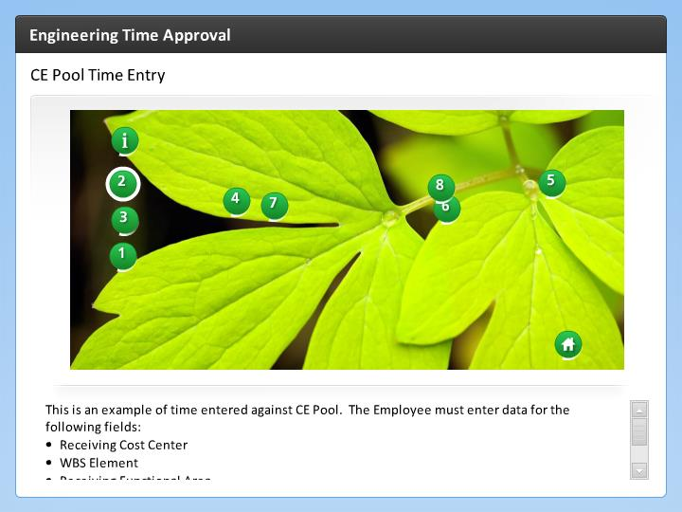

Step Text
This is an example of time entered against CE Pool. The Employee must enter data for the following fields:
- Receiving Cost Center
- WBS Element
- Receiving Functional Area
- A/A Type
- Working Time

Narration Script
The CE Pool entry requires a Receiving Cost Center, a WBS Element, and a Receiving Functional Area, Attendance Absence Type and their working time.

The final area where Engineering Employees will charge their time to is Projects. Let's look at that now.

Projects
5 seconds
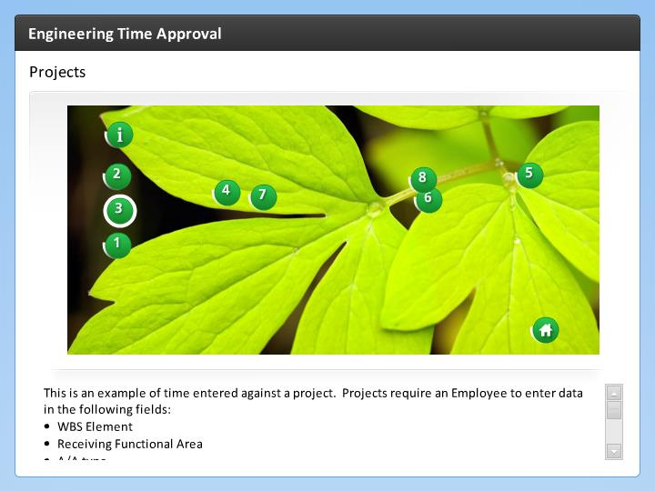

Step Text
This is an example of time entered against a project. Projects require an Employee to enter data in the following fields:
- WBS Element
- Receiving Functional Area
- A/A type
- Working Time

Staff working on a project should charge their time directly to a project or construction engineering project. If the project has not set up the time may be charged to the regional scoping pool.

Narration Script
Projects, require a WBS element and the a Receiving Functional Area. Additionally is requires the working time and A/A type.
Now let's look at the individual columns and what you should be looking for when you approve working time.

Rec. Cost Center
5 seconds
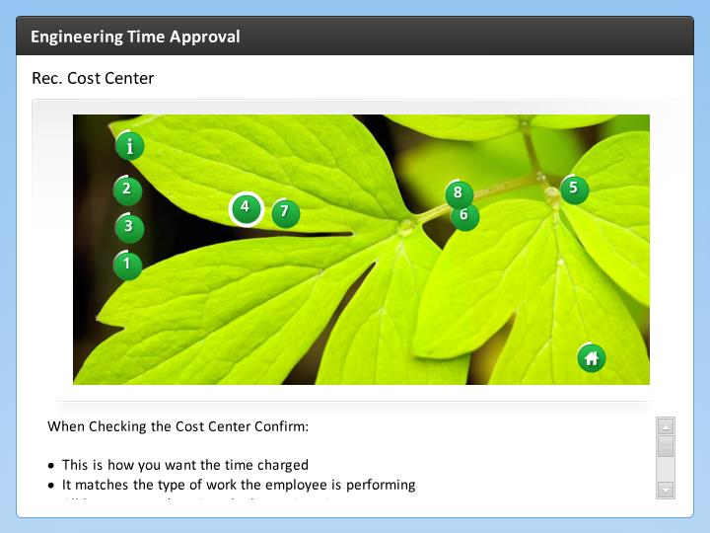

Step Text
When Checking the Cost Center Confirm:

- This is how you want the time charged
- It matches the type of work the employee is performing
- All leave entered against the home Cost Center

Narration Script
When approving time use the Cost Center as a check. The Cost Center is used to report on how funds are spent. This is why you should ask, Is this where I want the time charged? You should also think about the type of work the employee did during the week and use the Cost Center to provided to see if it matches.

Additionally, the home cost center should be used for leave, such as vacation, sick and other leaves not accounted for by CE Pool Time or Projects.

Rec. WBS element
5 seconds
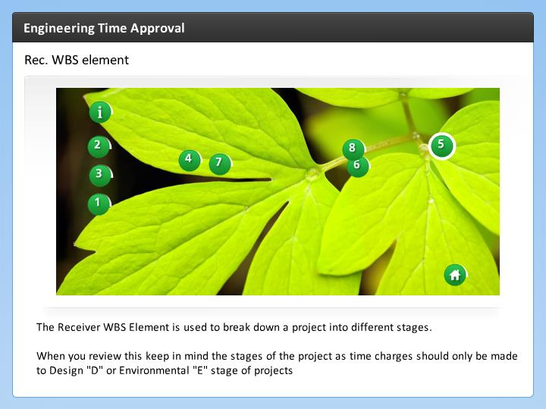

Step Text
The Receiver WBS Element is used to break down a project into different stages.

When you review this keep in mind the stages of the project as time charges should only be made to Design "D" or Environmental "E" stage of projects

Narration Script
The Receiver WBS breaks down projects into different stages. When you review pay particular attention to this field when you are about to enter a new stage of the project.

Date, Hours and Start/End Time
5 seconds
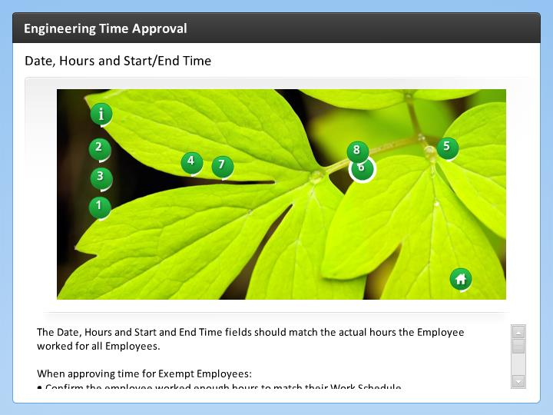

Step Text
The Date, Hours and Start and End Time fields should match the actual hours the Employee worked for all Employees.

When approving time for Exempt Employees:
- Confirm the employee worked enough hours to match their Work Schedule
- Review hours worked outside the Work Schedule for 2nd or 3rd shift differentials
- Confirm all leave taken match with approvals

Non-exempt Employees require additional review in addition to the step listed above:
- Review all hours worked outside the Work Schedule for potential or unapproved overtime

Narration Script
Now let's take a look at the time the Employee worked. The Date, Hours and Start and End Time fields represent the hours the Employee worked during the week.

Remember, as a Supervisor you need to approve and document any changes to the work schedule of you Employees. If the Time sheet does not match with your understanding you need to discuss this with the Employee prior to approving the time.

Receiving Functional Area
5 seconds
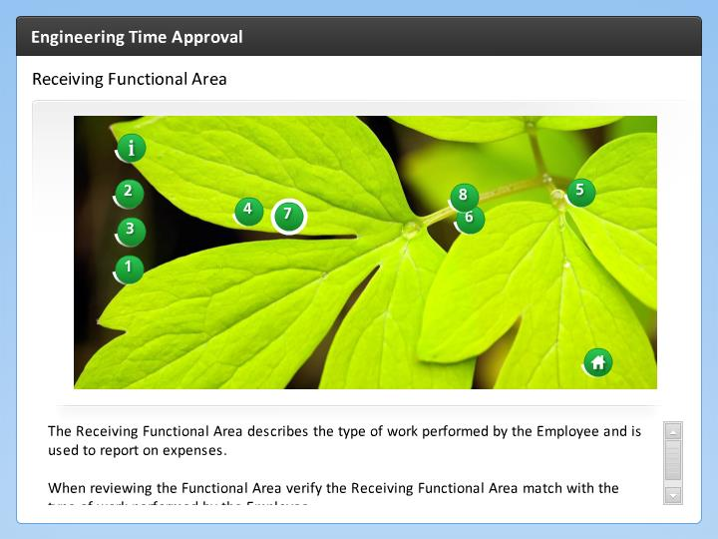

Step Text
The Receiving Functional Area describes the type of work performed by the Employee and is used to report on expenses.

When reviewing the Functional Area verify the Receiving Functional Area match with the type of work performed by the Employee.

Narration Script
The Receiving Cost Center is used to describe the type of work the Employee performed and how it is reported out. Always verify the RFA matches the type of work performed.

A/A Types
5 seconds
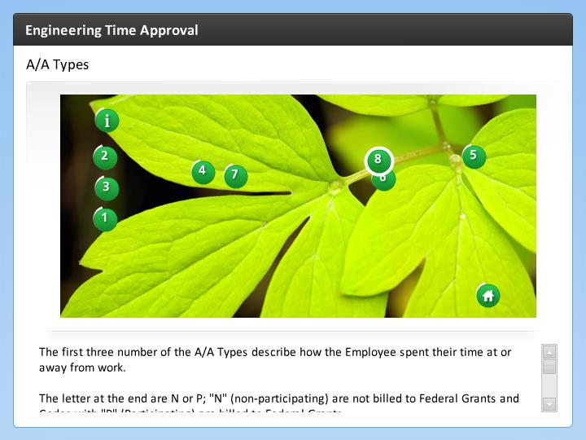

Step Text
The first three number of the A/A Types describe how the Employee spent their time at or away from work.

The letter at the end are N or P; "N" (non-participating) are not billed to Federal Grants and Codes with "P" (Participating) are billed to Federal Grants.

When reviewing check:
- Did the Employee enter the right A/A Type for the work they performed
- Was the time worked "N" non-participating when it should have been "P" participating
- For Participating Employees, does the grant allow for the type of attendance

Click HERE for a list of the A/A Type Descriptions to help with approval

Narration Script
Attendance Absence Types are used to describe how the employee spent their time at work or, what kind of absence they took. This is shown in the chart below. Codes with "N" or "P" indicate if the cost is billed to Federal Grants.

When reviewing A/A Types pay close attention to how the Employee coded the Attendance or absence. It must match up with any approvals you have given for Overtime. Comp Time, or additional working time. Additionally, review if entry to make sure that if the Employee work participating time that it is coded as such. Not doing so leaves Federal Grant funds and may impact your budget.

Summary
5 seconds
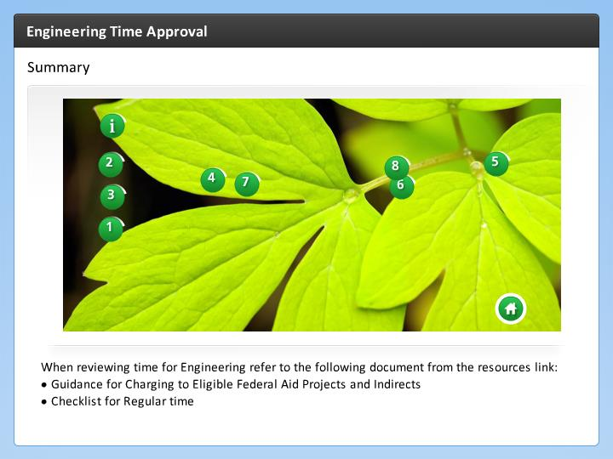

Step Text
When reviewing time for Engineering refer to the following document from the resources link:
- Guidance for Charging to Eligible Federal Aid Projects and Indirects
- Checklist for Regular time

Narration Script
When you are evaluating time, you have two documents to help you with the process. The first is the memo from the Chief Engineer about Guidance for Charging to Time to Eligible Federal Aid Projects and Indirects and the Checklist for Regular Time.

