Page | Page Title |  | Slide Graphic(s) | Slide Text
1 | Time Entry for General Timesheet Profile |  | Slide Graphic:  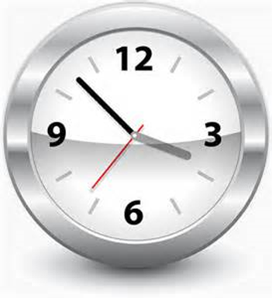 | None
2 | Welcome |  | Slide Graphic:  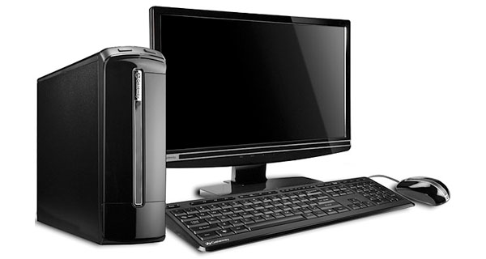 | Welcome to the Time Entry for General Timesheet Profile course. This is the timesheet profile used by employees who do not require maintenance or engineering specific data input.  This course should provide you with the basic knowledge and skills you need to correctly enter your time in SAP. This helps to ensure you are paid correctly and on time.  This course should take you about 1 1/2 hours to complete.
3 | Course Navigation Tools |  | 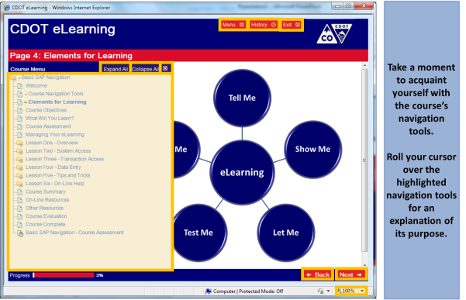  Rollover text:  Menu - Click here to display the course menu (content).  History - Click here to display the viewed lessons and pages.  Exit - Click here to close the course.  Menu Display - Click on menu links to go directly to a course lesson or page. You must click the Menu button to display these links.  Expand All/Collapse All – Click here to display or collapse all course pages and lessons.  Close - Click here to close the course menu.  Back - Click here to go back one page.  Next – Click here to go forward one page.
4 | Elements for Learning |  | Rollover text:  Tell me – Slides which provide you with the knowledge and understanding required to competently complete the tasks.  Show me – Demonstrations of how to complete tasks.  Let me – Exercises which allow you to practice the tasks.  Test me – Knowledge checks and assessments which allow you to verify that you have learned the information.  Help me – Links, tools and resources which can be used after you have finished the course. | This course contains informational slides, demonstrations, exercises, and knowledge checks. Also, it provides you with easy access to websites and documents that can help you do your work.  Roll your cursor over the graphic for a more detailed description of the tools used for each of the elements in your learning process.
5 | Course Prerequisites |  | Slide Graphic: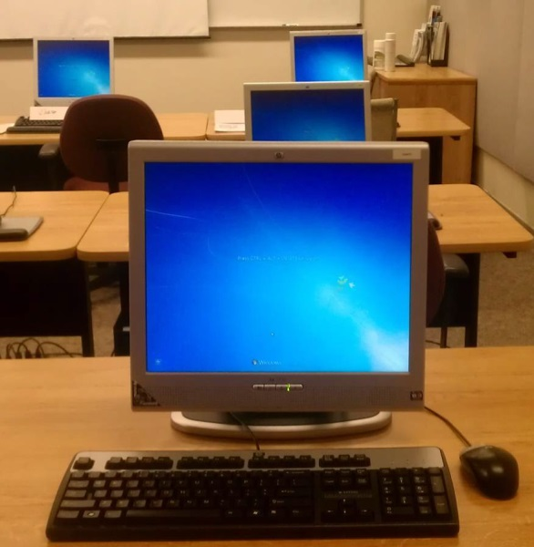 | Before you take this course you must have completed:  - SAP Basic Navigation*  Please complete this course before you continue.  *Click on the link to access the on-line course
6 |  | What Will You Learn? | 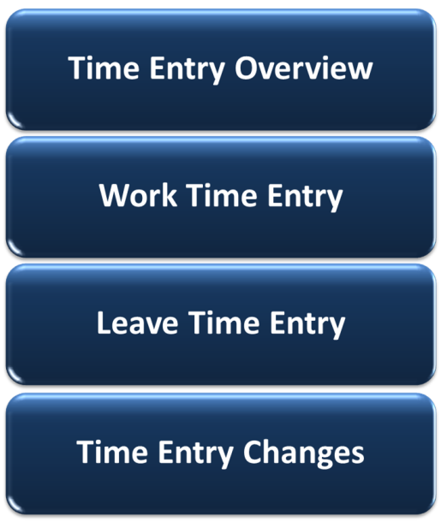 |  | This course contains four lessons.  - Lesson One provides you with an overview of the time entry process at CDOT  - Lesson Two shows you how personnel using the general timesheet profile enter their working time in SAP  - Lessons Three discusses your leave banks and how you enter them in your SAP timesheet  - Lesson Four identifies common changes you may need to make in your timesheet and how you do this
7 | Course Objectives |  |  | Slide Text:  When you complete this course, you should be able to:  - Describe the time entry process for CDOT employees  - Enter and release time in SAP  - Enter and release leave requests in SAP  - Change common time entries in SAP
8 | Managing Your eLearning |  |  | A friendly reminder! If you need to exit the course before you are done, just click the Exit button in the upper right corner. A bookmark is placed in the course.  When you come back to the course, you can choose to start where you left off or return to the beginning of the course.  Please note, if for any reason you "lose" your bookmark, use the Menu button to quickly locate the right spot.
9 | Course Assessment |  |  | And one last thing, at the end of the course there is a course assessment.  The course assessment gives you an opportunity to:  - Test your knowledge  - Verify your understanding of the course material  - Validate that you have completed the course  You’ll need to get at least 70% on the assessment to receive course credit.  You can take the assessment as often as you want until you achieve this score.
10 | Lesson One – Time Entry Overview |  | 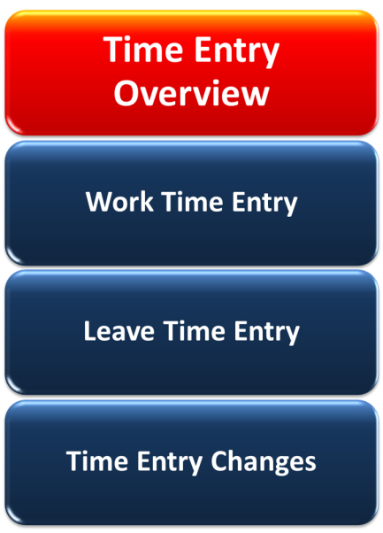 | At the end of Lesson One, you should be able to:  - Explain the time entry process  - Identify the roles and their responsibilities in the time entry process  - Identify your timelines for timesheet entries
11 |  | Time Entry Process – Primary Roles and Responsibilities | 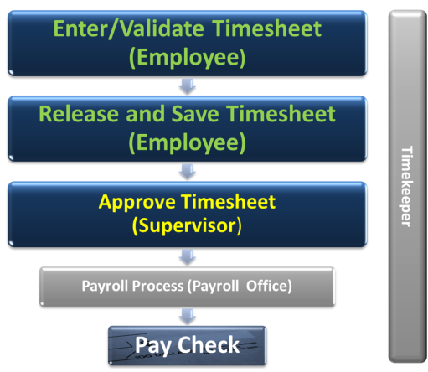 |  | Let’s review how Time Entry works at CDOT. We’ll start by focusing on the primary roles involved in the process – you and your Supervisor.  It’s your responsibility to ensure your SAP timesheet contains ALL of your time, including work and leave time, for the scheduled work week. Once you’ve done that, you release and save it. This “signs” your timesheet and verifies it is correct.  Your Supervisor then reviews and approves your timesheet.  If you do everything correctly, then you get your pay check at the right time for the right amount.
12 |  | Time Entry Process – Secondary Roles and Responsibilities | 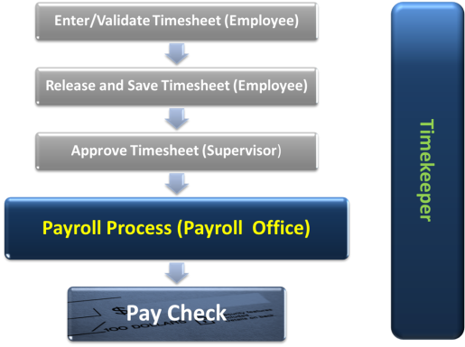 |  | Besides you and your Supervisor, two others play a role in ensuring you are paid correctly and on time. These are your Timekeeper and CDOT’s Payroll Office.  Your Timekeeper helps you with any time entry questions or issues you might have. They also ensure your timesheets have been released and approved by Payroll deadlines. Although it is not their normal responsibility, they can complete your timesheet for you, but this should only be done in urgent or unusual circumstances (i.e. Injury Leave).  Payroll ensures that everyone at CDOT gets paid on time and correctly. When there are issues with payments, they work with you and your Timekeeper to resolve them.
13 |  | Cost Centers and Functional Areas | 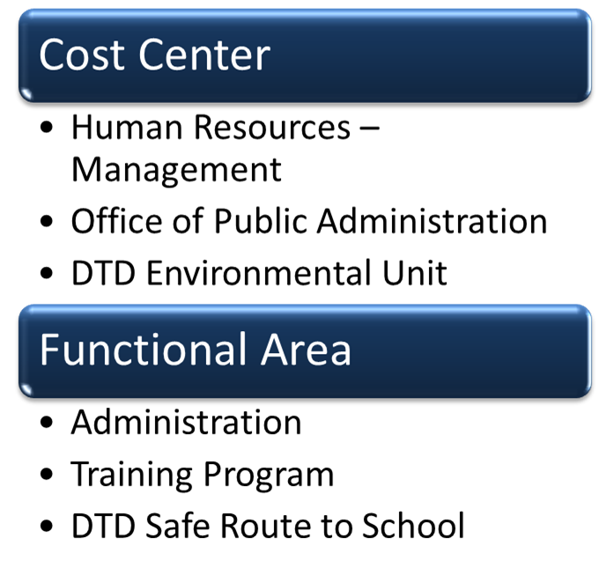 |  | All of the work hours in your timesheet should be charged to a Cost Center and a Functional Area.  Cost Centers identify the budget responsible for your work costs. Your pay check is deducted from this budget.  Functional Areas, on the other hand, collect information on the costs for a work area OR a Federal provider on projects. CDOT uses this information to track how funds are spent.  Review the graphic for examples of Cost Centers and Functional Areas used at CDOT.
14 |  | Timesheet Timelines | 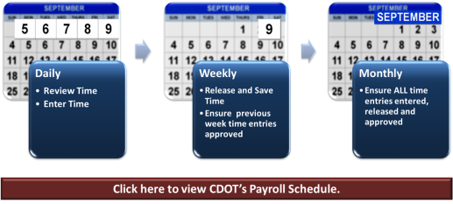  All Bi-Weekly employees must have their time entries released and approved by 5 p.m. on the following Monday forthe previous week |  | How often should you review and release your timesheet? When possible, you should review your timesheet daily. That way you can quickly identify any issues or problems. It also means you can be sure you don’t forget to enter or update any time entries you’ve changed.  Review the graphic to identify the best times to complete your time entry tasks.
15 |  | What Time Do You Enter? |  |  | As a full-time employee at CDOT, you’re required to account for at least 40 hours per work week. This includes both the time you work and the time you’re absent.  You use an SAP code, called the Attendance or Absence (A/A) Type in every time and leave entry. This lets CDOT know how your time was spent.  Regardless of the A/A type you use, the total must ALWAYS be at least 40 hours.
16 |  | Knowledge Check |  |  | Here's your chance to see what you have learned. Complete the following questions. You’re the only person that sees the results.  If you want, use the Menu button to return to the lesson and review the topic.  To check your answers, click the Continue button. This tells you how you did. When you’re happy with your results, click the Next button at the bottom of the page.
17 |  | Time Entry Overview | Who is responsible for validating and releasingyourtimesheet?  You  Your Supervisor  Your Timekeeper  All of the above
18 |  | Time Entry Overview | True or False  All of the work hours in your timesheet should be charged to a Cost Center and Functional Area.  True  False
19 |  | Time Entry Overview | What is the minimum number of hours that should be accounted for in your timesheet?  30  40  50  None of the above
20 |  | Lesson Two – Work Time Entry | 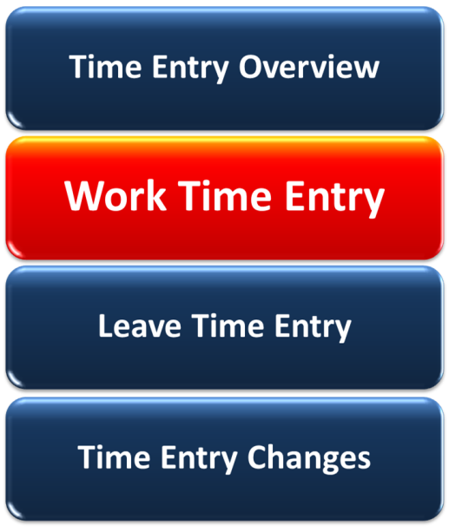 |  | When you finish this lesson, you should be able to:  - Describe work schedules and how they are used at CDOT  - Explain flex schedules  - Identify the data you need for a work time entry  - Define exempt and non-exempt employees  - Distinguish between additional regular hours and overtime payments  - Enter and release work time in SAP
21 |  | Work Schedule | 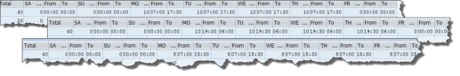 |  | You need to make sure you have the right work schedule, you:  Your work schedule identifies your planned working hours for the week. Most of CDOT work schedules start on the Saturday at 0:00 hours and end on Friday at 24:00. Generally, a ½ hour lunch break is also included.
22 |  | Work Schedule Changes | No graphic |  | If you do not have the right work schedule, you:  - Can’t code sick leave correctly  - Can’t code your overtime or additional regular hours properly (non-exempt employees ONLY)  - Won’t get alternate holidays recorded correctly  Changing your work schedule must be done through your Supervisor.  It’s important to note, changes to your work schedule MUST be done in advance. It cannot be changed retroactively.
23 |  | Flex Schedules | 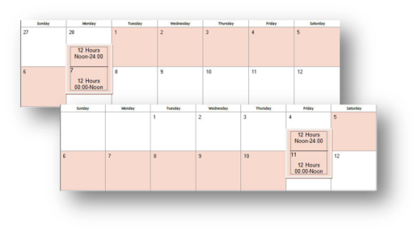 |  | Some employees use a flex work schedule. This schedule allows an employee to work a compressed forty hour work week. They are then compensated with a day “off” every second week. This work schedule must be approved by the Appointing Authority.  Flex schedules start at noon on Monday or Friday and ensure an employee works 40 hours in a consecutive 168 hour period.  You would work with your Supervisor to determine your flex schedule, if it is approved.

24 | Required Work Time Data | 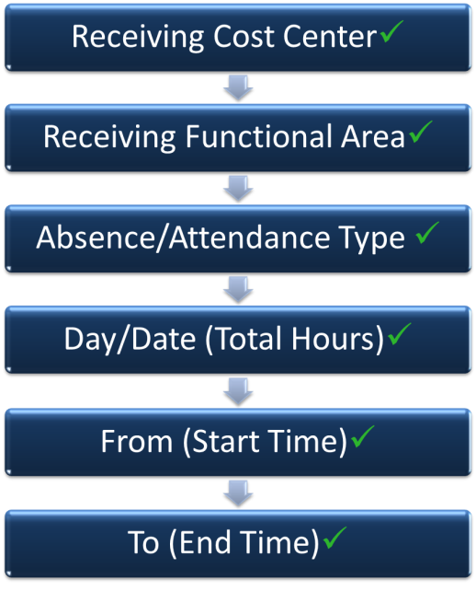  Rollover Text:  Receiving Cost Center Cost center the time is being charged to. It is important you enter the correct cost center. If you don’t then your time may be charged to the wrong budget. Hint: The cost center displays at the top of your timesheet.  Receiving Functional Area – Functional area the time is charged to. Identifies the costs, for reporting purposes, by activity/function OR funds provider.  Day/Date –Identifies total hours worked for this line item.  From – Identifies when the work started. Entered in military time (0:00 – 24:00)  To – Identifies when the work ended. Entered in military time (0:00 – 24:00) | Now let’s prepare to enter your working time in your timesheet.  Entering this information correctly means you’ll be paid correctly and on time for the time you work at CDOT.  You’ll find out more about these entries in the following exercise.  Roll you cursor over each of the timesheet columns for more information on the required data.
25 | Exercise One – Enter and Release Working Time – CAT2 | Steps  - Open CAT2  - Enter time  - Check Time Entry  - Release Time  - Validate 40 hour work week  - Save Time | Let’s take a look at how you enter your regular working time in your timesheet. This example looks at entering your regular working times.
26 | Exempt vs Non-Exempt Employees |  | CDOT’s general employees fall into two categories – exempt and non-exempt.  Non-exempt employees qualify for overtime or additional regular pay when they physically work more than 40 hours in a work week. Exempt employees do not.
27 | Enter Additional Time – Exempt and Non-Exempt | 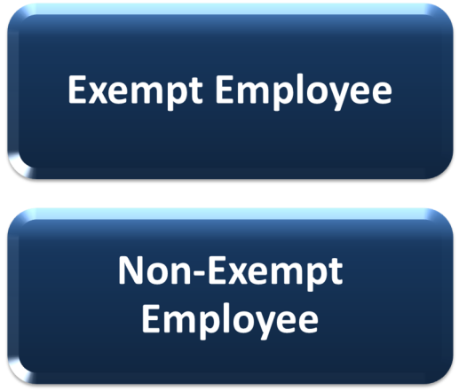  Link to Slide 28 for Exempt  Link to Slide 29 for Non-Exempt | If you are an exempt employee, click on the Exempt Employee button to learn more about how you enter additional time in your timesheet.  If you are non-exempt employee, click on the Non-Exempt Employee button to learn more about how you enter additional hours worked. You’ll also get a chance to practice entering additional time in your timesheet.
28 | Exempt Time Off | Go to Slide 32 from this slide. | Exempt employees cannot earn overtime or extra pay for working more than a 40 hour week.  However, they can be eligible for exempt time off if they have worked significantly extra hours in their work week. This time is awarded before the time is worked at the discretion of the Appointing Authority and is not awarded on an hour for hour basis. It is still important, however, that the additional hours worked are entered in your timesheet as time worked.
29 | Overtime and Additional Regular Hours – Non-Exempt Employees | 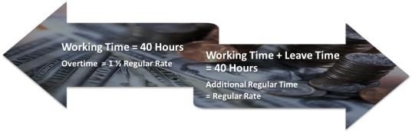 | Additional Regular Hours and Overtime are ONLY available to non-exempt employees. All overtime must be approved by your Supervisor.  To qualify for overtime a non-exempt employee must physically work more than 40 hours in his/her scheduled work week.  To qualify for additional regular hours a non-exempt employee must record more than 40 hours in his/her scheduled work week BUT those hours can include paid leave.
31 | Exercise Two – Non-Exempt - Enter Additional Regular Time and Overtime in Timesheet (CAT2) | Steps:  - Reopen timesheet  - Enter Overtime Hours  - Check Entries  - Release Time  - Save Time | Now let’s practice entering overtime hours into your timesheet. Click on the button below to open the guided exercise. (Set up next step to go to slide 32)
32 | Approval/ Rejection of Time Entries | 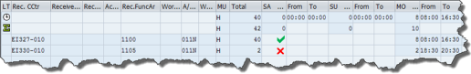  Rollover Text:  You entered the wrong cost center  You entered the wrong functional area  You used the A/A type for overtime when you had NOT physically worked a 40 hour week  Your entered the incorrect number of hours  You entered the wrong times in the From or To fields | Your time MUST be approved by your Supervisor and your Supervisor can ONLY approve time that has been entered and released.  Your Supervisor cannot change or correct your timesheet. If there are errors on your timesheet, then the only action he/she can take is to reject the time entry(ies).  Roll your cursor over the graphic for examples of when a time entry would be rejected.
33 | Knowledge Check |  | Once again, let’s see what you’ve learned about entering time worked.  Answer the following questions.
34 | Work Time Entry | True or False  You can change your work schedule retroactively.  True  False
35 | Work Time Entry | Drag and drop  The following data is required for working time entry in your timesheet.  Receiving Cost Center  Activity  Functional Area  Work Center (5000 number)  A/A Type  Date/Day Total Hours  From/To Time
36 | Work Time Entry | True or False  Only non-exempt employees can enter overtime hours or additional pay.  True  False
37 | Lesson Three – Leave Time Entry | 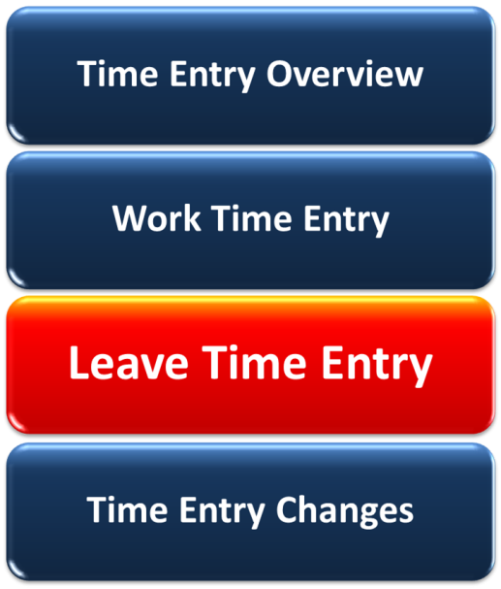 | At the end of this lesson, you should be able to:  - Describe quotas and accruals for the following leave types:  - Annual  - Sick  - Comp Time  - Alternate Holidays  - Enter and release leave time in SAP, including:  - Annual Leave  - Sick Leave  - Comp Time Used  - Alternate Holidays
38 | Common Leave Types | No Graphic | Although there are many leave types available at CDOT, this lesson focuses on those you’ll use the most.  We’ll explain, how you can earn and when you can use the following leave types:  - Annual Leave  - Sick Leave  - Alternate Holidays  - Compensatory Time Off (non-exempt)  If you need further information about these or other leave types, work with your Timekeeper.
39 | Quotas or Leave Banks |  | You earn and deposit leave time in multiple leave banks. Where that deposit goes and how much it is depends on how the leave is earned.  Annual and sick leave are earned automatically. For each week you work, you earn a set amount of annual and sick leave. This earned leave time is then available for you to use at a later date.  You can also earn and deposit additional leave times in other banks. Alternate holiday time can be earned by both exempt and non-exempt employees.  Compensatory, or comp time, can be earned by both exempt and non-exempt employees. Exempt employees, however, do not have a specific leave bank to draw from. Refer back to Lesson Two for more information on exempt comp time.
40 | Annual Leave |  | Every week you work at CDOT you earn annual leave. The rate at which you earn this leave depends on how long you’ve been working for the State of Colorado.  Once you earn this leave you can use it as you please. However, you always need to get your Supervisor’s approval for any requested time off. Remember to discuss your leave plans with your Supervisor so he/she can plan for your absence.  At the end of each fiscal year, you can carryover a specific amount of your existing annual leave. Once again, this is determined by your length of service.  To identify your carryover and potential leave losses, review your “Use it or Lose it” Report on the SAP Portal. This report lets you know potential annual leave that may be lost at the end of the fiscal year.
41 | Sick Leave |  | Just like annual leave, you earn and deposit sick leave for every week you work at CDOT. This rate varies depending on your date of hire. All employees hired after as of July 1, 1988 earn 6.66 hours per month.  Sick leave can be used for your health needs AND the health needs of your spouse, children, parent or legal dependent.  When possible, request it in advance. Your Supervisor can ask for documentation verifying the nature of the sick leave.  If sick leave is required for more than three consecutive days, work with your Timekeeper to identify the right leave entry type.  Just a note, like annual leave, you can carryover sick leave from one year to the next. The maximum carryover is 360 hours.
42 | Alternate Holiday Time |  | You can also earn additional leave time when your work on a state holiday as part of your scheduled work week.  When this is the case, you receive eight hours of banked leave time for the day that you work.  If you have the day off, then SAP automatically enters this time. If you worked on the holiday, you’ll need to enter this time into your timesheet. You can use this at a later time for any purpose.  It’s important to note, you can’t use this time until AFTER it has been worked and approved by your Supervisor in SAP.
43 | Non-Exempt Compensatory (Comp) Time | 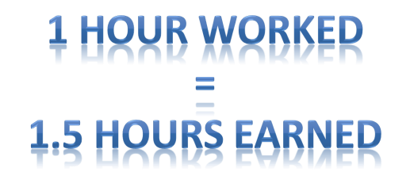 | Non-exempt employees can earn and bank comp time.  Before it can be earned, you must have a signed and recorded agreement with CDOT. Once the agreement is in place, for every hour of comp time worked you get credit for one and half times that amount in leave.  As a non-exempt general employee, you cannot accrue more than 60 hours of comp time leave. When you reach this amount, you’ll be requested to use your comp time to reduce the amount to less than 60 hours.  You’ll use A/A type 031N to record comp time worked.
44 | Leave Balance Report | 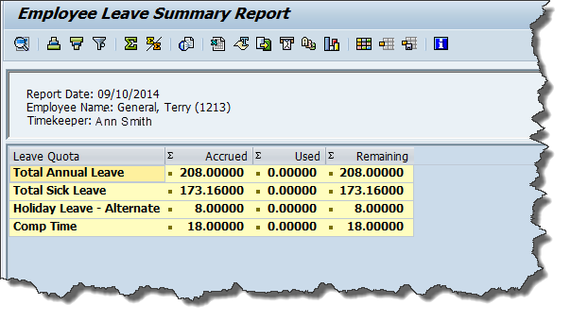 | Your Leave Balance report is available on the SAP Portal. You can use it to see what’s available in your leave banks.  The graphic displays a Leave Balance Report for an engineering employee. Let’s review what it tells you.  This person has a total of 208 hours in their annual leave bank, 173.16 hours of sick leave, eight hours of alternate holiday leave and 18 hours of comp time leave available at the time that the report was run.
45 | Leave Request Process | 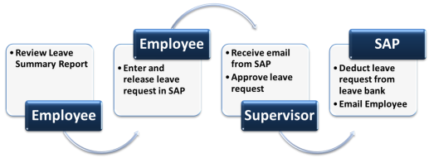 | Now that we’ve talked about how you earn your common leave times, let’s look at how you can use them.  Like all other time entries types, you enter your leave times in your timesheet (CAT2). SAP will not let you record and save any leave times that don’t have enough “deposits” in your leave bank. In other words, there’s no overdraft function here.  Just a note, when taking personal time, it is recommended that you use both alternate holiday times and comp times before you use your annual leave. This is because these times do not carry over to the next fiscal year.  Review the graphic to identify the stages and the roles in the leave request process.
46 | Required Leave Entry Data | 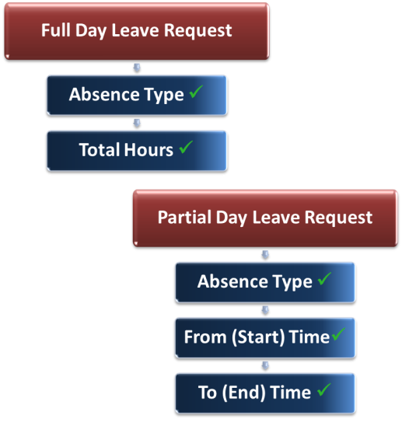 | What data do you need when requesting leave? Not as much as you need for your time entries.  You need the A/A type:  - 130P – Annual Leave  - 120P – Sick Leave  - 141P – Holiday – Alternate  - 110P – Use Comp Time  And the leave hours requested – either the From (Start)/To (End) time or the total hours. In all cases, these times must be within your scheduled working hours.
47 | Supervisor Approval | 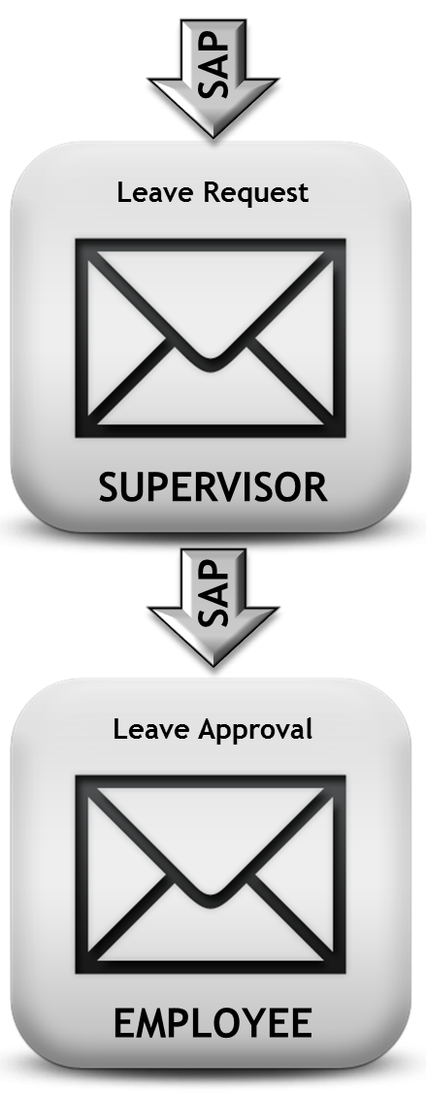 | As indicated above, like all your time entries, your leave time must be approved by your Supervisor. Whenever possible, be sure to discuss it with him/her prior to entering the request in your timesheet.  Once you release and save your leave time entry, SAP sends an email to your Supervisor notifying him/her of your leave request.  Once your Supervisor approves it, SAP sends you an email and lets you know it’s been approved.
48 | Additional Leave Types | 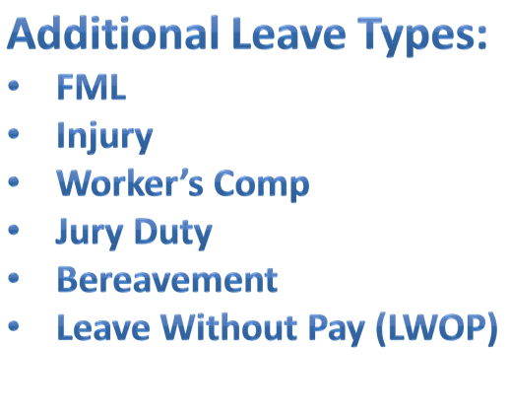 | CDOT has many other leave types available to employees. Often these require additional activities to be completed before the leave can be entered and approved.  If you find that you have a leave request that does not fit into the ones we’ve discussed, talk to your Timekeeper as to the steps you should take.
50 | Exercise Three – Enter Leave Time - Exempt in CAT2 – Exempt Employee | Steps:  - Add Sick Leave Request  - Add Annual Leave Request  Go to Slide 52 | Let’s take a look at how you would enter a leave request in SAP. Click on the button below.
51 | Exercise Three – Enter Leave Time - in CAT2 | Steps:  - Add Sick Leave Request  - Add Annual Leave Request  Go to Slide 52 | Although exempt and non-exempt employees may have slightly different information to enter, the basic steps are the same. In this example, we’ll look at how a non-exempt employee would enter their leave requests in SAP.
52 | Knowledge Check |  | Check what you’ve learned about leave time entry. Answer the following questions.
53 | Leave Time Entry | What are the four common leave type entries?  Annual Leave  Jury Duty  Comp Time Used  Sick Leave  Alternate Holiday  Bereavement Leave
54 | Leave Time Entry | True or False  SAP notifies you by email when your leave time is approved.  True  False
55 | Leave Time Entry | What data is required for a leave time entry?  Cost Center  A/A Type  Functional Area  Hours worked and/or Total Hours
56 | Lesson Four – Time Entry Changes | 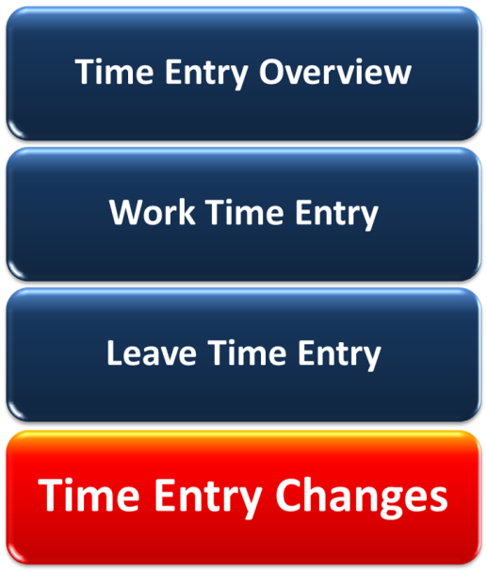 | And here’s the final lesson in this eLearning. When you have completed this lesson, you should be able to:  • Identify common timesheet errors and how to correct them  • Explain the process for time entry changes and deletions  • Change an approved timesheet
57 | Common Time Entry Issues | No Graphic | What are common timesheet errors that you’ll need to be aware of?  Common ones that you’ll be dealing with are:  - Time collisions  - Incorrect overtime entries (non-exempt)  - Under 40 hours coded in your timesheet  Let’s examine each of these in more detail.
56 | Collisions | 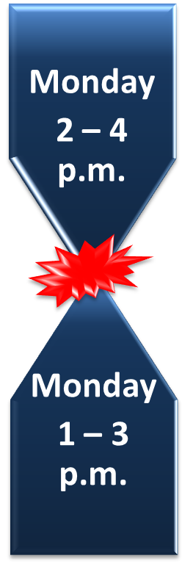 | Collisions occur when two time entries attempt to “live” in the same time period on your timesheet.  For example, you entered time in your timesheet for sick leave. You later deleted, or zero’ed out”, this time, but your supervisor failed to approve the change. Therefore SAP still sees the time in your timesheet.  If you don’t catch a time collision at the timesheet level, your Supervisor and Timekeeper are notified of the collision error. They contact you to ensure that it gets corrected.  What you need to remember is, if you don’t resolve a collision error, it may impact your special pay AND/OR your leave balances.
57 | Under 40 Hours Entered |  | Another common problem is that you have not entered time for all of your work week’s target hours. Once again, your Timekeeper receives a report of timesheets that don’t meet this requirement.  When this happens, you’ll need to re-open your timesheet and ensure that you have regular time entries for all of the hours identified in your work schedule.
58 | Overtime Errors |  | For non-exempt employees, Sometimes you may have an issue with the way your overtime has been entered in SAP. Your Timekeeper receives a report when there are overtime errors in a timesheet. This report identifies both times when overtime should AND should not have been entered.  If you have 40 hours of physically worked time entered in your scheduled work hours, then any additional hours worked should be entered as overtime.  If there is an overtime issue with your timesheet it's your responsibility to enter your 40 hours of physically worked time or change the coding on those hours you have identified as overtime.  Just a note for non-exempt employees, you CANNOT use Comp Time Used as part of your 40 hours of regular time when you are coding overtime.
59 | Timesheet Change Process | 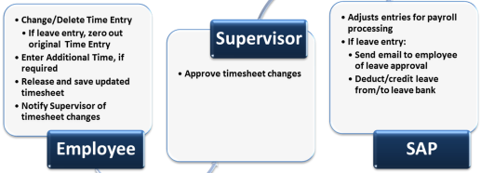 | The status and type of time entry determines how you change entries in your timesheet.  Regardless of the entry type, if the time entry has NOT been approved you can just change the time entry in your timesheet. Then, as usual, release and save your timesheet.  If the time entry HAS been approved, then you’ve got a few more steps.  - If you’re changing an approved leave entry, you need to “zero” out the approved entry  - Make your changes or additions, as required  - Release and save your timesheet  - Notify your supervisor that you’ve changed approved times
60 | What Can You Change and When? | No graphic | You should make your changes to your timesheet as soon as possible.  When can changes be made?  - You can go back in your timesheet and make changes up to five weeks back  - Your Timekeeper can go back and make changes up to 12 weeks back  What can you change? You can:  - Add or delete time  - Correct the coding  - Change your leave entries  If your changes are more complex or outside this timeline, work with your Timekeeper to get them done.
61 | “Zero Out” Leave Time |  | When you are changing leave time entries, it is important that you “zero out” this entry before making changes.  By “zeroing out” the existing approved leave entry you ensure:  - There is record of the change and change approval  - Your Supervisor is automatically notified of the timesheet change  - The time is credited back to your leave bank once it has been approved by your Supervisor
62 | Approval of Time Changes |  | In all cases, when you make a change to your timesheet these changes MUST be approved by your Supervisor.  Be sure you contact your Supervisor and let him/her about the changes you have made so that they can approve them in a timely manner.
63 | Exercise Four – Change Approved Time | Steps:  - View approved leave  - Zero out approved annual leave  - Enter sick leave  - Release/Save timesheet | And here’s the last exercise in the course. This is your chance to practice “zeroing out” an approved leave and adding a new leave request. Click below to launch the exercise.  Once again, whether you are exempt or non-exempt, you would follow the same steps to make your changes.
64 | Knowledge Check |  | So what did you learn in this lesson. Take a moment and answer the following questions.
65 | Time Entry Changes | What reports does your Timekeeper receive about timesheet issues?  Overtime Errors  Incorrect Comp Time  Under 40 Hours  All of the above
66 | Time Entry Changes | How many weeks back can you make changes to your timesheet?  2 weeks  5 weeks  6 weeks  12 weeks
67 | Time Entry Changes | Why should you “zero out” you changes to approved leave time entries?  Provides a record of the change and change approval  Notifies your Supervisor of the timesheet change  Credits time back to your leave bank  All of the above
68 | Time Entry Changes | True or False  You should notify your Supervisor when you make changes to approved time entries.  True  False
69 | Course Summary | 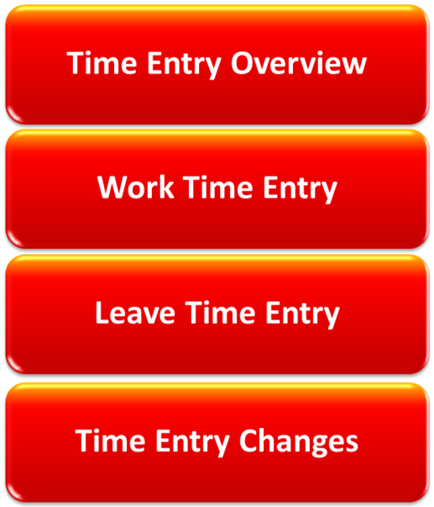  Rollover text:  Click here to return to Lesson One – Time Entry Overview  Click here to return to Lesson Two – Work Time Entry  Click here to return to Lesson Three – Leave Time Entry  Click here to return to Lesson Four – Time Entry Changes | Now that you've finished this course, you should be able to:  - Describe the time entry process for CDOT employees  - Enter and release time in SAP  - Enter and release leave requests in SAP  - Change common time entries in SAP  If you want to review a topic, click on the graphic to return to the lesson.
70 | On-Line Resources | Slide Graphic One  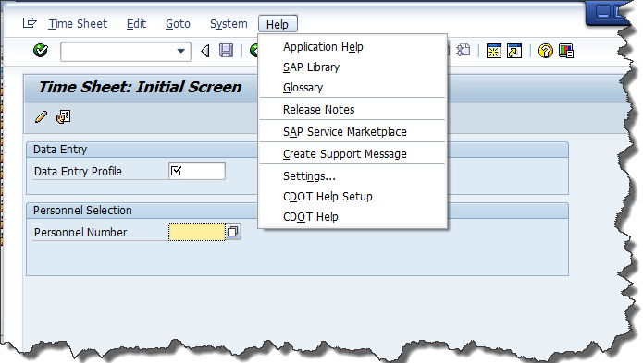  Slide Graphic Two  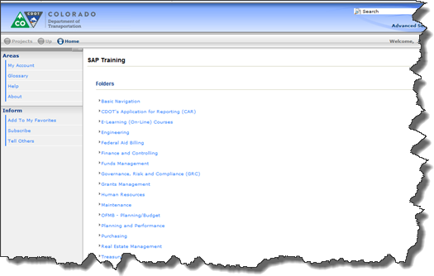 | Don't forget, CDOT has its own On-Line Help tool. You can use this tool to get instructions and information on your SAP tasks.  You can access on-line Help:  - Directly from SAP  - Through CDOT’s Intranet, at http://saptraining  Click here to open the SAP Training Website.
71 | Other Resources |  | In addition to the on-line SAP Help, CDOT offers you the following support:  - Your Power User or Regional Super User. To find your Power User or Regional Super User, click here.  - Your SAP Support Team at dot_SAPSupport@state.co.us. To email your SAP Support Team, click here.
72 | Course Evaluation |  | Please help the SAP Support Team by completing the course evaluation.  Your feedback ensures that CDOT continues to deliver meaningful, high-quality learning tools that meet the needs of the employees and the business.  Click here to access the course evaluation.  We welcome your comments and suggestions for improvement.
73 | Course Complete |  | Congratulations, you've completed CDOT’s Time Entry for General Timesheet Profile course!!!  To confirm that you have finished the course, complete the following assessment.  For course credit, you must achieve a score of at least 70%. Please remember, you can retake the assessment as many times as you want until you achieve this score.  Just a note, once you have achieved a passing score, you can no longer retake the assessment.
74 | Course Credit | 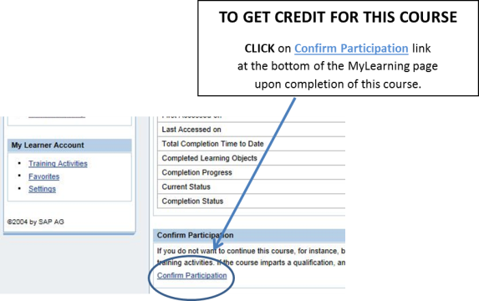 | No Audio
75 | Time Entry for General Timesheet Profile Assessment | 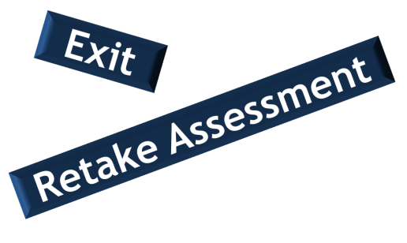 | To start the assessment, click the Continue button at the bottom of this page.  If you have successfully completed the assessment, click the Exit button displayed at the top of the screen.  Don't forget - once you complete the assessment; click the Confirm Participation link on your My Learning page. This ensures the course displays in the Completed Courses section.
76 | Assessment Question TBD

