Page | Page Title |  | Slide Graphic(s) | Slide Text
37 |  | Lesson Three – Leave Time Entry | 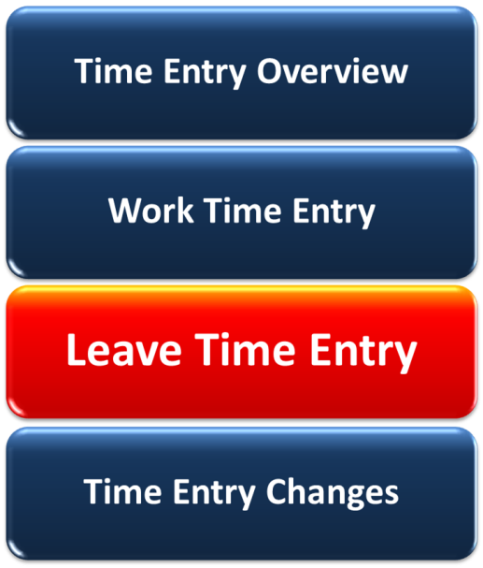 |  | At the end of this lesson, you should be able to:  - Describe quotas and accruals for the following leave types:  - Annual  - Sick  - Comp Time  - Alternate Holidays  - Enter and release leave time in SAP, including:  - Annual Leave  - Sick Leave  - Comp Time Used  - Alternate Holidays
38 |  | Common Leave Types | No Graphic |  | Although there are many leave types available at CDOT, this lesson focuses on those you’ll use the most.  We’ll explain, how you can earn and when you can use the following leave types:  - Annual Leave  - Sick Leave  - Alternate Holidays  - Compensatory Time Off (non-exempt)  If you need further information about these or other leave types, work with your Timekeeper.
39 |  | Quotas or Leave Banks |  |  | You earn and deposit leave time in multiple leave banks. Where that deposit goes and how much it is depends on how the leave is earned.  Annual and sick leave are earned automatically. For each week you work, you earn a set amount of annual and sick leave. This earned leave time is then available for you to use at a later date.  You can also earn and deposit additional leave times in other banks. Alternate holiday time can be earned by both exempt and non-exempt employees.  Compensatory, or comp time, can be earned by both exempt and non-exempt employees. Exempt employees, however, do not have a specific leave bank to draw from. Refer back to Lesson Two for more information on exempt comp time.
40 |  | Annual Leave |  |  | Every week you work at CDOT you earn annual leave. The rate at which you earn this leave depends on how long you’ve been working for the State of Colorado.  Once you earn this leave you can use it as you please. However, you always need to get your Supervisor’s approval for any requested time off. Remember to discuss your leave plans with your Supervisor so he/she can plan for your absence.  At the end of each fiscal year, you can carryover a specific amount of your existing annual leave. Once again, this is determined by your length of service.  To identify your carryover and potential leave losses, review your “Use it or Lose it” Report on the SAP Portal. This report lets you know potential annual leave that may be lost at the end of the fiscal year.
41 |  | Sick Leave |  |  | Just like annual leave, you earn and deposit sick leave for every week you work at CDOT. This rate varies depending on your date of hire. All employees hired after as of July 1, 1988 earn 6.66 hours per month.  Sick leave can be used for your health needs AND the health needs of your spouse, children, parent or legal dependent.  When possible, request it in advance. Your Supervisor can ask for documentation verifying the nature of the sick leave.  If sick leave is required for more than three consecutive days, work with your Timekeeper to identify the right leave entry type.  Just a note, like annual leave, you can carryover sick leave from one year to the next. The maximum carryover is 360 hours.
42 |  | Alternate Holiday Time |  |  | You can also earn additional leave time when your work on a state holiday as part of your scheduled work week.  When this is the case, you receive eight hours of banked leave time for the day that you work.  If you have the day off, then SAP automatically enters this time. If you worked on the holiday, you’ll need to enter this time into your timesheet. You can use this at a later time for any purpose.  It’s important to note, you can’t use this time until AFTER it has been worked.
43 |  | Non-Exempt Compensatory (Comp) Time | 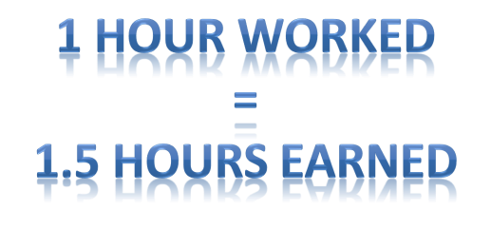 |  | Non-exempt employees can earn and bank comp time.  Before it can be earned, you must have a signed and recorded agreement with CDOT. Once the agreement is in place, for every hour of comp time worked you get credit for one and half times that amount in leave.  As a non-exempt engineering employee, you cannot accrue more than 60 hours of comp time leave. When you reach this amount, you’ll be requested to use your comp time to reduce the amount to less than 60 hours.  You’ll use A/A type 031N to record comp time worked.
44 |  | Leave Balance Report | 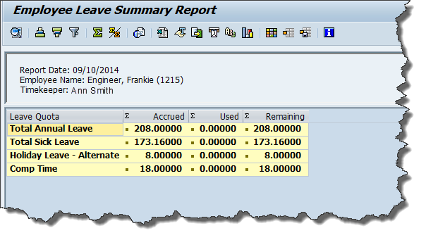 |  | Your Leave Balance report is available on the SAP Portal. You can use it to see what’s available in your leave banks.  The graphic displays a Leave Balance Report for an engineering employee. Let’s review what it tells you.  This person has a total of 208 hours in their annual leave bank, 173.16 hours of sick leave, eight hours of alternate holiday leave and 18 hours of comp time leave available at the time that the report was run.
45 |  | Leave Request Process | 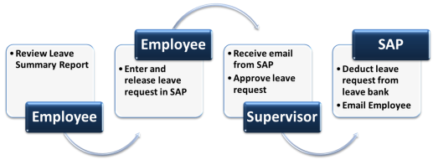 |  | Now that we’ve talked about how you earn your common leave times, let’s look at how you can use them.  Like all other time entries types, you enter your leave times in your timesheet (CAT2). SAP will not let you record and save any leave times that don’t have enough “deposits” in your leave bank. In other words, there’s no overdraft function here.  Just a note, when taking personal time, it is recommended that you use both alternate holiday times and comp times before you use your annual leave. This is because these times do not carry over to the next fiscal year.  Review the graphic to identify the stages and the roles in the leave request process.
46 |  | Required Leave Entry Data | 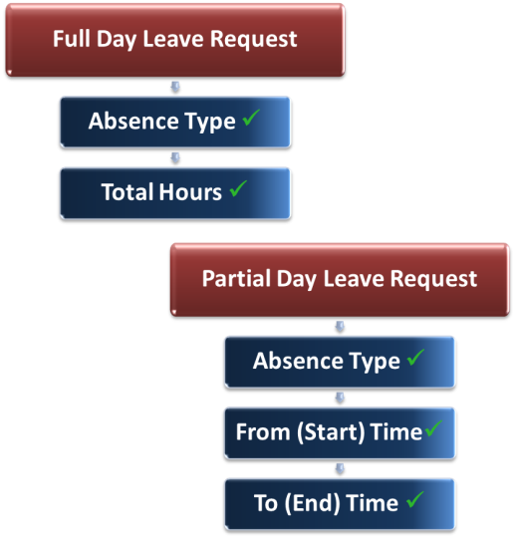 |  | What data do you need when requesting leave? Not as much as you need for your time entries.  You need the A/A type:  - 130P – Annual Leave  - 120P – Sick Leave  - 141P – Holiday – Alternate  - 110P – Use Comp Time  And the leave hours requested – either the From (Start)/To (End) time or the total hours. In all cases, these times must be within your scheduled working hours.
47 |  | Supervisor Approval | 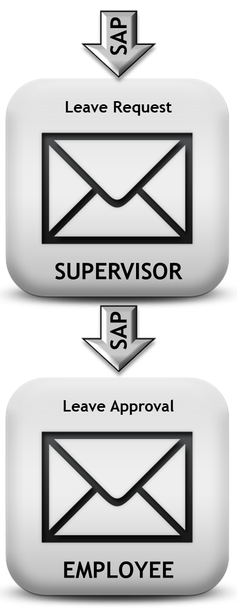 |  | As indicated above, like all your time entries, your leave time must be approved by your Supervisor. Whenever possible, be sure to discuss it with him/her prior to entering the request in your timesheet.  Once you release and save your leave time entry, SAP sends an email to your Supervisor notifying him/her of your leave request.  Once your Supervisor approves it, SAP sends you an email and lets you know it’s been approved.
48 |  | Additional Leave Types | 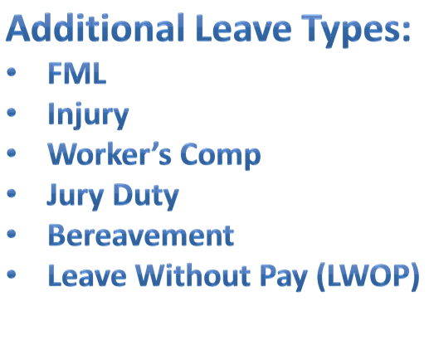 |  | CDOT has many other leave types available to employees. Often these require additional activities to be completed before the leave can be entered and approved.  If you find that you have a leave request that does not fit into the ones we’ve discussed, talk to your Timekeeper as to the steps you should take.
50 |  | Exercise Three – Enter Leave Time | Steps:  - Add Sick Leave Request  - Add Annual Leave Request |  | Let’s take a look at how you would enter a leave request in SAP. Click on the button below.
52 |  | Knowledge Check |  |  | Check what you’ve learned about leave time entry. Answer the following questions.
53 |  | Leave Time Entry | What are the four common leave type entries?  Annual Leave  Jury Duty  Comp Time Used  Sick Leave  Alternate Holiday  Bereavement Leave
54 |  | Leave Time Entry | True or False  SAP notifies you by email when your leave time is approved.  True  False
55 |  | Leave Time Entry | What data is required for a leave time entry?  Cost Center  A/A Type  Functional Area  Hours worked and/or Total Hours
56 |  | Lesson Four – Time Entry Changes | 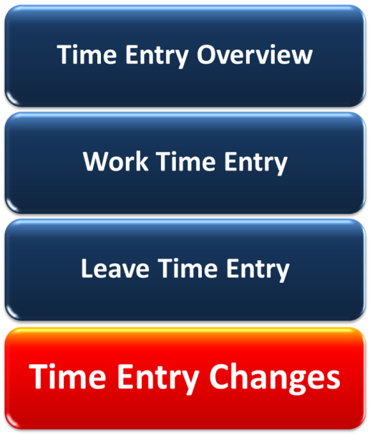 |  | And here’s the final lesson in this eLearning. When you have completed this lesson, you should be able to:  • Identify common timesheet errors and how to correct them  • Explain the process for time entry changes and deletions  • Change an approved timesheet
57 |  | Common Time Entry Issues | No Graphic |  | What are common timesheet errors that you’ll need to be aware of?  Common ones that you’ll be dealing with are:  - Time collisions  - Incorrect overtime entries (non-exempt)  - Under 40 hours coded in your timesheet.  Let’s examine each of these in more detail.
56 |  | Collisions | 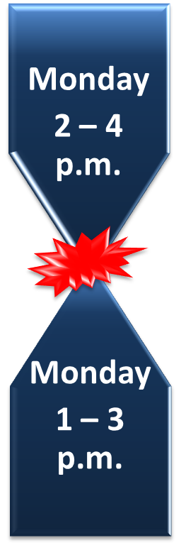 |  | Collisions occur when two time entries attempt to “live” in the same time period on your timesheet.  For example, you entered time in your timesheet for sick leave. You later deleted, or zero’ed out”, this time, but your supervisor failed to approve the change. Therefore SAP still sees the time in your timesheet.  If you don’t catch a time collision at the timesheet level, your Supervisor and Timekeeper are notified of the collision error. They contact you to ensure that it gets corrected.  What you need to remember is, if you don’t resolve a collision error, it may impact your special pay AND/OR your leave balances.
57 |  | Under 40 Hours Entered |  |  | Another common problem is that you have not entered time for all of your work week’s target hours. Once again, your Timekeeper receives a report of timesheets that don’t meet this requirement.  When this happens, you’ll need to re-open your timesheet and ensure that you have regular time entries for all of the hours identified in your work schedule.
58 |  | Overtime Errors |  |  | For non-exempt employees, Sometimes you may have an issue with the way your overtime has been entered in SAP. Your Timekeeper receives a report when there are overtime errors in a timesheet. This report identifies both times when overtime should AND should not have been entered.  If you have 40 hours of physically worked time entered in your scheduled work hours, then any additional hours worked should be entered as overtime.  If there is an overtime issue with your timesheet it's your responsibility to enter your 40 hours of physically worked time or change the coding on those hours you have identified as overtime.  Just a note for non-exempt employees, you CANNOT use Comp Time Used as part of your 40 hours of regular time when you are coding overtime.
59 |  | Timesheet Change Process | 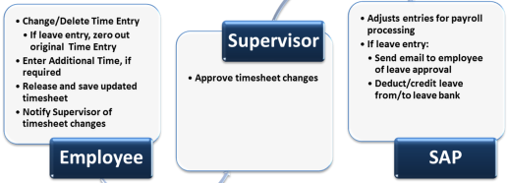 |  | The status and type of time entry determines how you change entries in your timesheet.  Regardless of the entry type, if the time entry has NOT been approved you can just change the time entry in your timesheet. Then, as usual, release and save your timesheet.  If the time entry HAS been approved, then you’ve got a few more steps.  - If you’re changing an approved leave entry, you need to “zero” out the approved entry  - Make your changes or additions, as required  - Release and save your timesheet  - Notify your supervisor that you’ve changed approved times
60 |  | What Can You Change and When? | No graphic |  | You should make your changes to your timesheet as soon as possible.  When can changes be made?  - You can go back in your timesheet and make changes up to five weeks back  - Your Timekeeper can go back and make changes up to 12 weeks back  What can you change? You can:  - Add or delete time  - Correct the coding, including cost center, WBS element and A/A types  - Change your leave entries  If your changes are more complex or outside this timeline, work with your Timekeeper to get them done.
61 |  | “Zero Out” Leave Time |  |  | When you are changing leave time entries, it is important that you “zero out” this entry before making changes.  By “zeroing out” the existing approved leave entry you ensure:  - There is record of the change and change approval  - Your Supervisor is automatically notified of the timesheet change  - The time is credited back to your leave bank once it has been approved by your Supervisor
62 |  | Approval of Time Changes |  |  | In all cases, when you make a change to your timesheet these changes MUST be approved by your Supervisor.  Be sure you contact your Supervisor and let him/her about the changes you have made so that they can approve them in a timely manner.
63 |  | Exercise Four – Change Approved Time | Steps:  - View approved leave  - Zero out approved annual leave  - Enter sick leave  - Release/Save timesheet |  | And here’s the last exercise in the course. This is your chance to practice “zeroing out” an approved leave and adding a new leave request. Click below to launch the exercise.  Once again, whether you are exempt or non-exempt, you would follow the same steps to make your changes.
64 |  | Knowledge Check |  |  | So what did you learn in this lesson. Take a moment and answer the following questions.
65 |  | Time Entry Changes | What reports does you Timekeeper receive about timesheet issues?  Overtime Errors  Incorrect Comp Time  Under 40 Hours  All of the above
66 |  | Time Entry Changes | How many weeks back can you make changes to your timesheet?  2 weeks  5 weeks  6 weeks  12 weeks
67 |  | Time Entry Changes | Why should you “zero out” your changes to approved leave time entries?  Provides a record of the change and change approval  Notifies your Supervisor of the timesheet change  Once approved, it credits time back to your leave bank  All of the above
68 |  | Time Entry Changes | True or False  You should notify your Supervisor when you make changes to approved time entries.  True  False
69 |  | Course Summary | 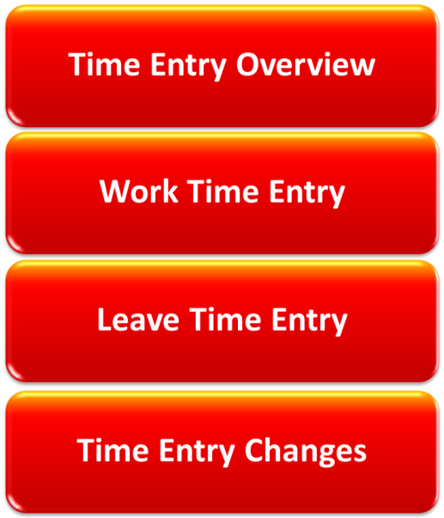  Rollover text:  Click here to return to Lesson One – Time Entry Overview  Click here to return to Lesson Two – Work Time Entry  Click here to return to Lesson Three – Leave Time Entry  Click here to return to Lesson Four – Time Entry Changes |  | Now that you've finished this course, you should be able to:  - Describe the time entry process for CDOT employees  - Enter and release time in SAP  - Enter and release leave requests in SAP  - Change common time entries in SAP  If you want to review a topic, click on the graphic to return to the lesson.
70 |  | On-Line Resources | Slide Graphic One  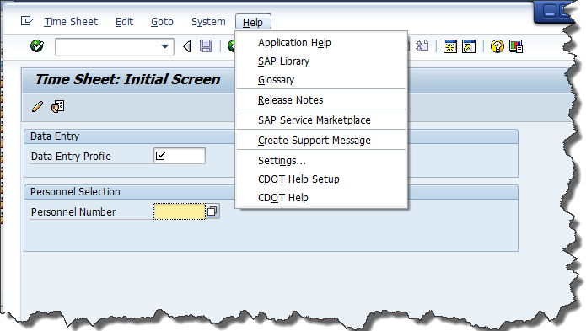  Slide Graphic Two  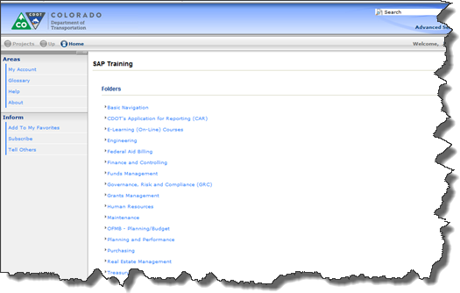 |  | Don't forget, CDOT has its own On-Line Help tool. You can use this tool to get instructions and information on your SAP tasks.  You can access on-line Help:  - Directly from SAP  - Through CDOT’s Intranet, at http:\\saptraining  Click here to open the SAP Training Website.
71 |  | Other Resources |  |  | In addition to the on-line SAP Help, CDOT offers you the following support:  - Your Power User or Regional Super User. To find your Power User or Regional Super User, click here.  - Your SAP Support Team at sapsupport@dot.state.co.us.
72 |  | Course Evaluation |  |  | Please help the SAP Support Team by completing the course evaluation.  Your feedback ensures that CDOT continues to deliver meaningful, high-quality learning tools that meet the needs of the employees and the business.  Click here to access the course evaluation.  We welcome your comments and suggestions for improvement.
73 |  | Course Complete |  |  | Congratulations, you've completed CDOT’s Time Entry for Engineering course!!!  To confirm that you have finished the course, complete the following assessment.  For course credit, you must achieve a score of at least 70%. Please remember, you can retake the assessment as many times as you want until you achieve this score.  Just a note, once you have achieved a passing score, you can no longer retake the assessment.
74 |  | Course Credit | 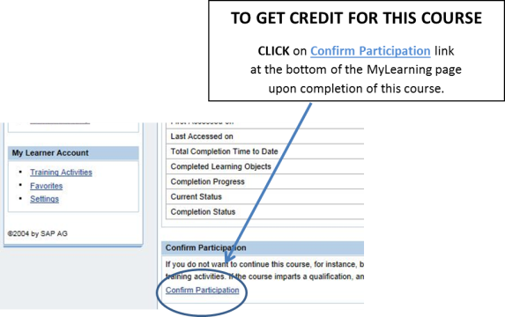 |  | No Audio
75 |  | Time Entry for Engineering | 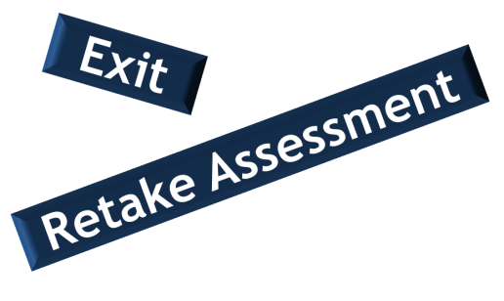 |  | To start the assessment, click the Continue button at the bottom of this page.  If you have successfully completed the assessment, click the Exit button displayed at the top of the screen.  Don't forget - once you complete the assessment; click the Confirm Participation link on your My Learning page. This ensures the course displays in the Completed Courses section.
76 |  | Assessment Question TBD

