Page | Page Title |  | Slide Graphic(s) | Slide Text
1 | Time Entry for Engineering |  | Slide Graphic:  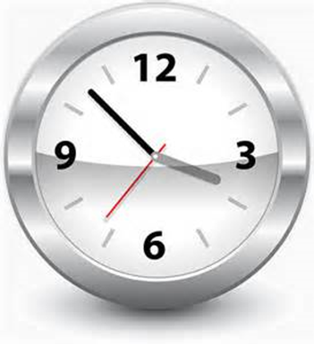 | None
2 | Welcome |  | Slide Graphic:  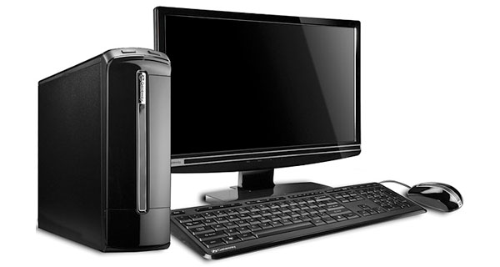 | Welcome to the Time Entry for Engineering course.  This course should provide you with the basic knowledge and skills you need to correctly enter your time in SAP. This helps to ensure you are paid correctly and on time.  This course should take you about 1 1/2 hours to complete.
3 | Course Navigation Tools |  | 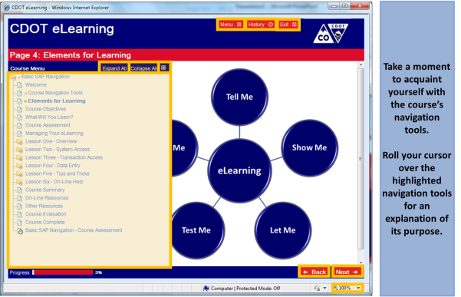  Rollover text:  Menu - Click here to display the course menu (content).  History - Click here to display the viewed lessons and pages.  Exit - Click here to close the course.  Menu Display - Click on menu links to go directly to a course lesson or page. You must click the Menu button to display these links.  Expand All/Collapse All – Click here to display or collapse all course pages and lessons.  Close - Click here to close the course menu.  Back - Click here to go back one page.  Next – Click here to go forward one page.
4 | Elements for Learning |  | Rollover text:  Tell me – Slides which provide you with the knowledge and understanding required to competently complete the tasks.  Show me – Demonstrations of how to complete tasks.  Let me – Exercises which allow you to practice the tasks.  Test me – Knowledge checks and assessments which allow you to verify that you have learned the information.  Help me – Links, tools and resources which can be used after you have finished the course. | This course contains informational slides, demonstrations, exercises, and knowledge checks. Also, it provides you with easy access to websites and documents that can help you do your work.  Roll your cursor over the graphic for a more detailed description of the tools used for each of the elements in your learning process.
5 | Course Prerequisites |  | Slide Graphic: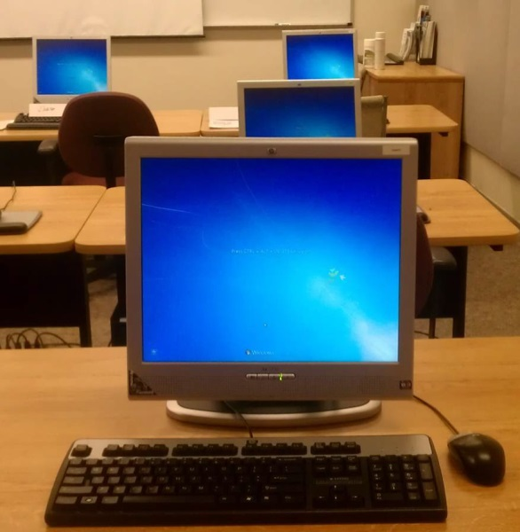 | Before you take this course you must have completed:  - SAP Basic Navigation*  Please complete this course before you continue.  *Click on the link to access the on-line course
6 |  | What Will You Learn? | 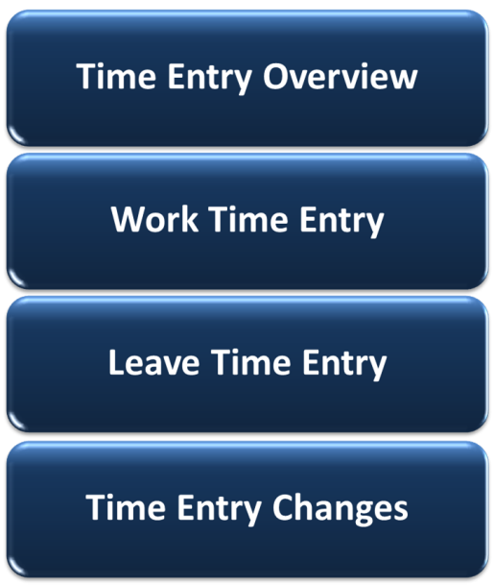 |  | This course contains four lessons.  - Lesson One provides you with an overview of the time entry process at CDOT  - Lesson Two shows you how engineering employees enter their working time in SAP  - Lessons Three discusses leave banks and how to enter leave time in your SAP timesheet  - Lesson Four identifies common changes you may need to make in your timesheet and how you do this
7 | Course Objectives |  |  | Slide Text:  When you complete this course, you should be able to:  - Describe the time entry process for CDOT employees  - Enter and release working time in SAP  - Enter and release leave requests in SAP  - Change common time entries in SAP
8 | Managing Your eLearning |  |  | A friendly reminder! If you need to exit the course before you are done, just click the Exit button in the upper right corner. A bookmark is placed in the course.  When you come back to the course, you can choose to start where you left off or return to the beginning of the course.  Please note, if for any reason you "lose" your bookmark, use the Menu button to quickly locate the right spot.
9 | Course Assessment |  |  | And one last thing, at the end of the course there is a course assessment.  The course assessment gives you an opportunity to:  - Test your knowledge  - Verify your understanding of the course material  - Validate that you have completed the course  You’ll need to get at least 70% on the assessment to receive course credit.  You can take the assessment as often as you want until you achieve this score.
10 | Lesson One – Time Entry Overview |  | 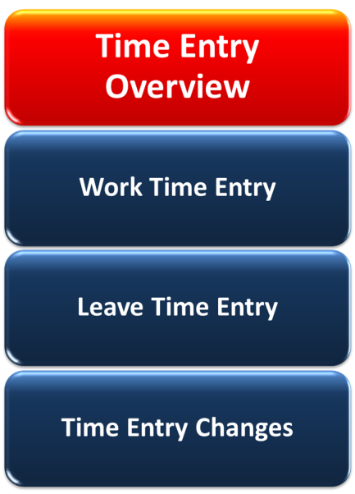 | At the end of Lesson One, you should be able to:  - Explain the time entry process  - Identify the roles and their responsibilities in the time entry process  - Identify your timelines for timesheet entries
11 |  | Time Entry Process – Primary Roles and Responsibilities | 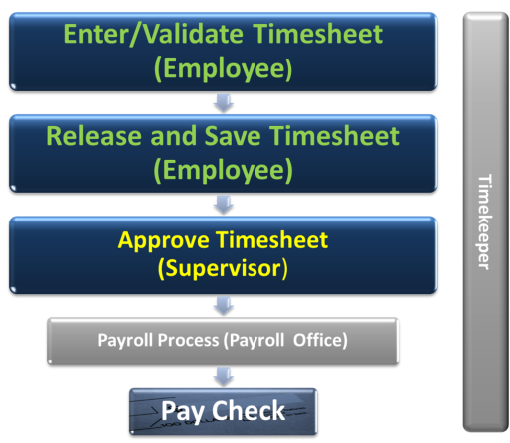 |  | Let’s review how Time Entry works at CDOT. Start by focusing on the primary roles involved in the process – you and your Supervisor.  It’s your responsibility to ensure your SAP timesheet contains ALL of your time, including work and leave time, for the scheduled work week. Once you’ve done that, you release and save it. This “signs” your timesheet and verifies it is correct.  Your Supervisor then reviews and approves your timesheet.  If you do everything correctly, then you get your pay check at the right time for the right amount.
12 |  | Time Entry Process – Secondary Roles and Responsibilities | 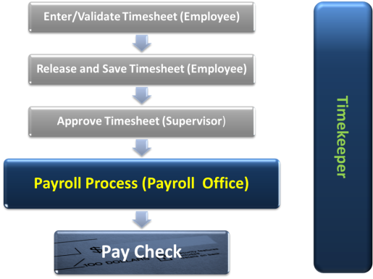 |  | Besides you and your Supervisor, two others play a role in ensuring you are paid correctly and on time. These are your Timekeeper and CDOT’s Payroll Office.  Your Timekeeper helps you with any time entry questions or issues you might have. They also ensure your timesheets have been released and approved by Payroll deadlines. Although it is not their normal responsibility, they can complete your timesheet for you, but this should only be done in urgent or unusual circumstances (i.e. Injury Leave).  Payroll ensures that everyone at CDOT gets paid. When there are issues with payments, they work with you and your Timekeeper to resolve them.
13 |  | Attendance Entries for Engineering | 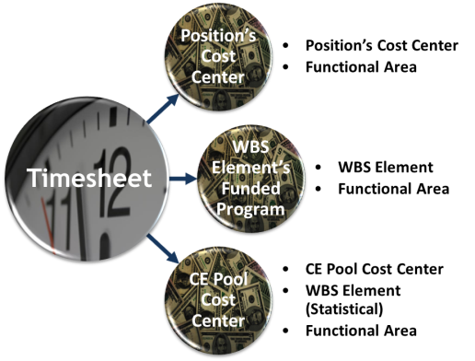  Rollover Text:  Cost Center – You’ve attended training all day on Monday. Charge your time to your home cost center.  WBS Element – You are in the design phase of a project. This phase has been budgeted. Charge your time to the WBS element for this phase.  CE Pool Cost Center – You are a project inspector in Region 5. You inspected some work for a bridge coating project. Charge your time to your region’s CE Pool and the Construction statistical WBS Element. |  | Engineering employees have three ways charge their working time.  They can charge time to a:  - Cost Center  - Project Phase (WBS Element)  - CE Pool Cost Center  Roll your cursor over the graphic for an example of each type of work time entry.
14 |  | Cost Centers and Functional Areas | 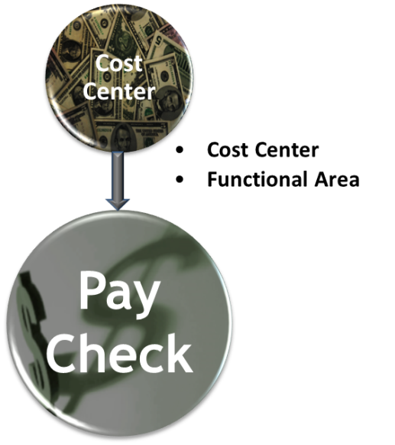 |  | Work hours in your timesheet can be, and generally are, charged to a Cost Center and a Functional Area.  Cost Centers identify the budget responsible for your work costs. The cost of your pay check is deducted from this budget. Normally, you use the cost center attached to your position.  Functional Areas, are used to collect information on the costs for a work area OR a Federal provider on your time entries. CDOT uses this information to track how funds are spent.
15 |  | WBS (Work Breakdown Structure) Element | 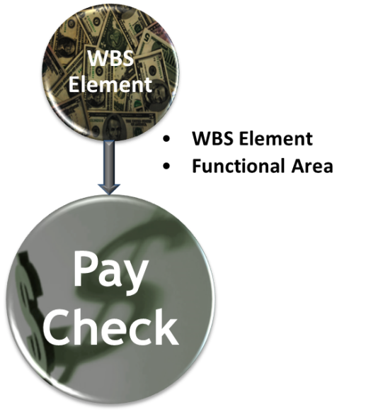 |  | Engineering working time can also be charged directly to a project’s WBS (Work Breakdown Structure) element.  When a project is created in SAP, it identifies stages as WBS elements. When a project is created, each WBS element is assigned to a funded program.  When you enter time directly to a WBS element, then the costs are charged to the funded program created for the WBS element.  Functional Areas are used, once again, to track the work area OR Federal provider for your time entry.  Please note, the WBS element must be released and ready to receive time entries for you to use it.
16 |  | CE Pool Cost Center | 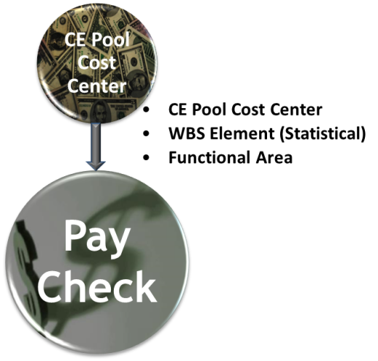 |  | CE Pool Cost Centers are used for construction projects that are charged to a Regional pool.  When you are working on a CE Pool project, your time is paid from the CE Pool Cost Center. CDOT uses the Statistical WBS Element to track what projects accrued these costs. These Statistical WBS Elements ALWAYS end with “20.20.  Please note, adding a Statistical WBS Element to these time entries is optional. Ask your Supervisor for direction on how he/she wants this information recorded.  As with all your time entries, the Functional Area is used to track the work area or Federal provider.
17 |  | Timesheet Timelines | 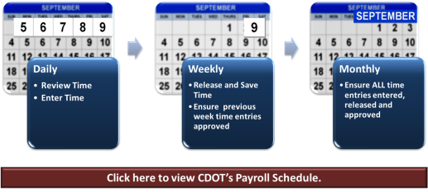  Note: All Bi-Weekly employees must have their time entries released and approved by 5 p.m. on the following Monday forthe previous week |  | Now that you know about how engineers can charge their time, let’s look at how often should you review and release your timesheet?  When possible, you should update your timesheet on a daily basis. That way you can quickly identify any issues or problems. It also ensures you don’t forget to enter or update any time entries that need to be changed.  Review the graphic to identify the best times to complete your time entry tasks.
18 |  | What Time Do You Enter? |  |  | As a full-time employee at CDOT, you’re required to account for at least 40 hours per work week. This includes both the time you work and the time you’re absent.  You use a SAP code, called the Attendance or Absence (A/A) Type in every time and leave entry. This lets CDOT know how your time was spent.  Regardless of the A/A type you use, the total must ALWAYS be at least 40 hours.
19 |  | Knowledge Check |  |  | Here's your chance to see what you have learned. Complete the following questions. You’re the only person that sees the results.  If you want, use the Menu button to return to the lesson and review the topic.  To check your answers, click the Continue button. This tells you how you did. When you’re happy with your results, click the Next button at the bottom of the page.
20 |  | Time Entry Overview | Who is responsible for validating and releasingyourtimesheet?  You  Your Supervisor  Your Timekeeper  All of the above
21 |  | Time Entry Overview | True or False  All of the work hours in your timesheet should be charged to a Cost Center/WBS Element and Functional Area.  True  False
22 |  | Time Entry Overview | True or False  Engineers can charge their time directly to a cost center, directly to a WBS element and to a CE Pool Cost Center.  True  False
23 |  | Time Entry Overview | What is the minimum number of hours that should be accounted for in your timesheet each week?  30  40  50  None of the above
24 |  | Lesson Two – Work Time Entry | 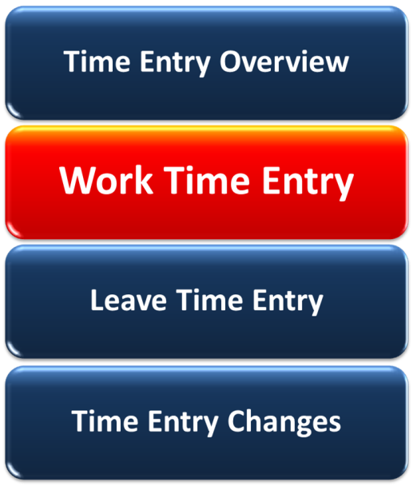 |  | When you finish this lesson, you should be able to:  - Describe work schedules and how they are used at CDOT  - Explain flex schedules  - Identify the data you need for a work time entry  - Define exempt and non-exempt employees  - Distinguish between additional regular hours and overtime payments  - Enter and release work time in SAP
25 |  | Work Schedule | 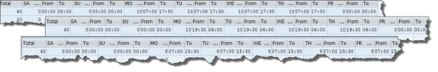 |  | You need to make sure you have the right work schedule in your timesheet.  Your work schedule identifies your planned working hours for the week. Most of CDOT work schedules start on the Saturday at 0:00 hours and end on Friday at 24:00. Generally, a ½ hour lunch break is also included.
26 |  | Work Schedule Changes | No graphic |  | If you do not have the right work schedule, you:  - Can’t code sick leave correctly  - Can’t code your overtime or additional regular hours properly (non-exempt employees ONLY)  - Won’t get alternate holidays recorded correctly  Changing your work schedule must be done through your Supervisor.  It’s important to note, changes to your work schedule MUST be done in advance. It cannot be changed retroactively.
27 |  | Flex Schedules | 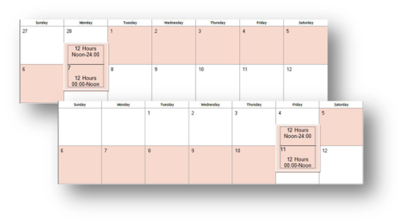 |  | Some employees use a flex work schedule. This schedule allows an employee to work a compressed forty hour work week. They are then compensated with a day “off” every second week. This work schedule must be approved by the Appointing Authority.  Flex schedules start at noon on Monday or Friday and ensure an employee works 40 hours in a consecutive 168 hour period.  You would work with your Supervisor to determine your flex schedule, if it is approved.

28 | Required Work Time Data | 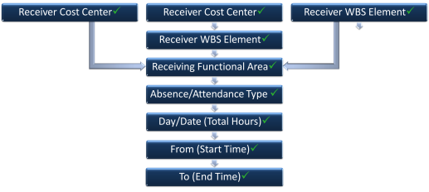  Rollover Text:  ReceiverCost Center Time is charged to the cost center identified in the timesheet. Hint: Your cost center displays at the top of your timesheet.  Receiver WBS Element: - For direct bill projects, the time is charged to a particular stage in a project. The responsible funded program is identified in the WBS Element.  For CE Pool projects, the Statistical WBS Element tracks the costs for the stage in the project.  Receiver Functional Area – Time is recorded against thefunctional area identified in the timesheet. Identifies the costs, for reporting purposes, by activity/function OR funds provider.  Day/Date –Identifies total hours worked for this line item.  From – Identifies when the work started. Entered in military time (0:00 – 24:00)  To – Identifies when the work ended. Entered in military time (0:00 – 24:00) | Now let’s prepare to enter your working time in your timesheet.  Entering this information correctly means you’ll be paid correctly and on time for the time you work at CDOT.  You’ll find out more about these entries in the following exercise.  Roll you cursor over each of the timesheet columns for more information on the required data.
29 | Participating vs Non-Participating Attendance  Types |  | When entering your attendance time you’ll find two options – “P” and “N”.  “P” stands for Participating time entries. These entries are eligible for federal re-imbursement.  “N” stands for Non-Participating A/A types. These entries are not eligible for federal re-imbursement.  Generally, engineering attendance time entries are “P” entries. If you are not sure what you should enter here, speak with your Supervisor or Timekeeper.
30 | Exercise One – Enter and Release Working Time – CAT2 | Steps  - Open CAT2  - Enter time to Cost Center  - Enter time to WBS Element  - Enter time to CE Pool Cost Center  - Check Time Entry  - Release Time  - Save Time | Let’s take a look at how you enter your regular working time in your timesheet using all three of the time entry formats. This example looks at entering your regular working times.
31 | Exempt vs Non-Exempt Employees |  | CDOT’s engineering employees fall into two categories – exempt and non-exempt.  Non-exempt employees qualify for overtime or additional regular pay when they physically work more than 40 hours in a work week. Exempt employees do not.
32 | Enter Additional Time – Exempt and Non-Exempt | 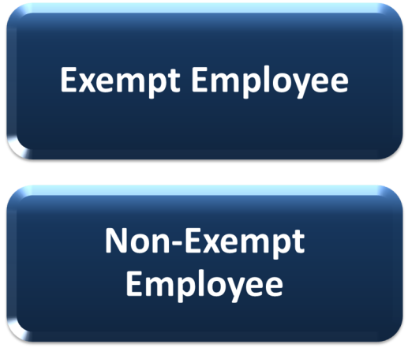  Link to Slide 33 for Exempt  Link to Slide 34 for Non-Exempt | If you are an exempt employee, click on the Exempt Employee button to learn more about how you enter additional time in your timesheet.  If you are non-exempt employee, click on the Non-Exempt Employee button to learn more about how you enter additional hours worked. You’ll also get a chance to practice entering additional time in your timesheet.
33 | Exempt Time Off | Go to Slide 36 from this slide. | Exempt employees cannot earn overtime or extra pay for working more than a 40 hour week.  However, they can be eligible for exempt time off if they have worked significantly extra hours in their work week. This time is awarded before the time is worked at the discretion of the Appointing Authority and is not awarded on an hour for hour basis. It is still important, however, that the additional hours worked are entered in your timesheet as time worked.
34 | Overtime and Additional Regular Hours – Non-Exempt Employees | 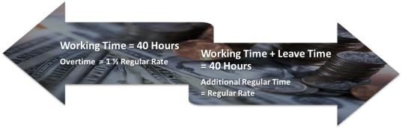 | Additional Regular Hours and Overtime are ONLY available to non-exempt employees. All overtime must be approved by your Supervisor.  To qualify for overtime a non-exempt employee must physically work more than 40 hours in his/her scheduled work week.  To qualify for additional regular hours a non-exempt employee must record more than 40 hours in his/her scheduled work week BUT those hours can include paid leave.
35 | Exercise Two – Non-Exempt - Enter Additional Regular Time and Overtime in Timesheet (CAT2) | Steps:  - Reopen timesheet  - Enter Additional Regular Time  - Enter Overtime Hours  - Check Entries  - Release Time  - Save Time | Now let’s practice entering overtime hours into your timesheet. Click on the button below to open the guided exercise. (Set up next step to go to slide 36)
36 | Approval/ Rejection of Time Entries | 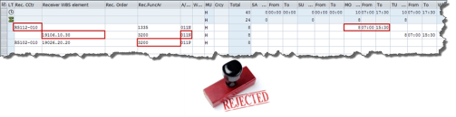  Rollover Text:  You entered the wrong cost center  You entered the wrong functional area  Your entered the wrong WBS Element  You used the wrong A/A type  Your entered the incorrect number of hours or work times | Your time MUST be approved by your Supervisor and your Supervisor can ONLY approve time that has been entered and released.  Your Supervisor cannot change or correct your timesheet. If there are errors on your timesheet, then the only action he/she can take is to reject the time entry(ies).  Roll your cursor over the graphic for examples of when a time entry would be rejected.
37 | Knowledge Check |  | Once again, let’s see what you’ve learned about entering time worked.  Answer the following questions.
38 | Work Time Entry | True or False  You can change your work schedule retroactively.  True  False
39 | Work Time Entry | Drag and drop  The following data is required for a non-CE Pool working time entry in your timesheet.  Receiving Cost Center or Receiving WBS Element  Activity  Functional Area  Work Center (5000 number)  A/A Type  Date/Day Total Hours  From/To Time
40 | Work Time Entry | True or False  Only non-exempt employees can enter overtime hours or additional pay.  True  False

