Presentation Details:
Slides: 44
Duration: 02:16:05
Filename: C:\Users\princej\Desktop\00 Time Entry\Manager Time Approval Course.pptx
Description:

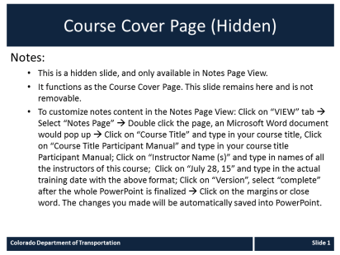

Slide 1  Manager Time and Leave Approval Course  Duration: 00:03:20  Advance mode: Auto | 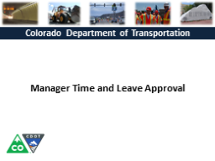 | Notes:  Notes:  Welcome to the Manager Time and Leave Approval Course! This course is designed to help you understand the nuances of time and leave approval.  The course will take you about one and half to two hours to complete. If you do not have this much time don’t worry about it you are able to stop this course at anytime and return to you left off. Now let’s get started.
Slide 3  Course Agenda  Duration: 00:03:20  Advance mode: Auto | 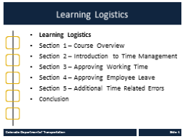 | Notes:  This course is broken out into the learning logistics, five course sections and the conclusion. In the learning logistics section you will learn how to navigate the course, use the glossary and resources available to you to support your learning.  In the Course Overview, you will be introduced to learning objectives of the course and why time entry and approval is important as well as the consequences for late or inaccurate time approval.  The Introduction to Time Management section provides you with the foundation you for the rest of the course and provides an overview of the time and leave process, your roles as a supervisor and what you need to know to begin approving time including where to go if you need help.  The Approving Working Time section explains the process of approving time in detail and how to review the timesheets of you employees for accuracy using available resources.  Approving Employee leave covers the different types of leave an employee is able to take and what to review when approving leave.  The final section covers some of the less common time related errors you may encounter less frequently.  The course ends with the conclusion of what you have learned and where you can go if you need additional help.
Slide 5  Prerequisites  Duration: 00:03:20  Advance mode: By user | 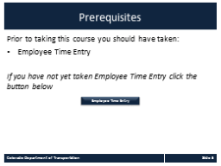 | Notes:  This course is designed for supervisors who approve time. The understanding of how time is entered by employees is vital to understanding the concepts of this course. If you have not already done so, take the employee time entry course before continuing this course.
Slide 6  Resources and Glossary  Duration: 00:10:30  Advance mode: Auto | 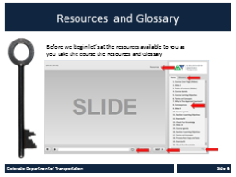 | Notes:  As you go through the course there are a couple of items you can use to help you learn. The first is the Resources link as indicated the red arrow. This contains copies of all of the documents referenced in this course. From this link you are able to view or download the files onto to your computer. When you click on the Resources link, the course will pause while review the document.  Clicking on the glossary link displays an alphabetical list of terms that are used throughout the course. Anytime you are uncertain about a term, this is the best place to look. Note, unlike the resources link clicking on the glossary does not pause the course.  If you want to navigate to a different slide within the course there are two ways to do so. You can click on the Previous of Next button to go by slide by slide or you can use the menu.  The course has been set move automatically to the next slide, if you want to navigate the course use can use the previous or next buttons or simply click on the slide you want to navigate to under the menu tab. There is also a key search located at the bottom of the Menu tab that brings up all of the slides with your search.  The Seek bar allows you view the progress within a slide and play or pause the course.  If for any reason, you need to close the course before you have completed it you will be returned to the page you were on once you log back in. Now let’s go to the Course Overview.
Slide 7  Section One Course Overview  Duration: 00:03:20  Advance mode: Auto | 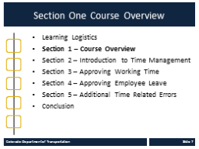 | Notes:  In the Course Overview section you will be presented with the learning objectives of the course, why time entry and approval is important and the consequences of not reviewing and approving time promptly.
Slide 8  Course Learning Objectives  Duration: 00:03:20  Advance mode: Auto |  | Notes:  Upon completing this course you should have a understanding of the objectives on this slide. Please take a minute to review these before you continue. When you are done click the next button.
Slide 9  Why is Time Approval Important?  Duration: 00:00:25  Advance mode: By user | 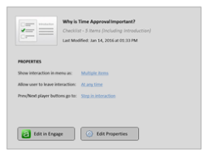 | Notes:
Slide 10  Consequences  Duration: 00:03:20  Advance mode: Auto | 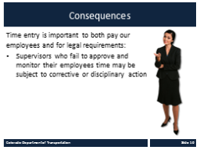 | Notes:  As mentioned on the previous slide, time approval is very important to CDOT. Both to pay our employees for the work they do and as a legal requirement. It is for this reason, that supervisors who fail to approve and monitor their employees time may be subject to corrective or disciplinary action. That being said, this course is designed to help you make the process of approving time easier and provides you with the knowledge and tools you need to make approval easier.
Slide 11  Section Two Introduction to Time Management  Duration: 00:03:20  Advance mode: Auto | 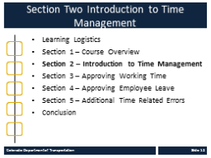 | Notes:  Before we start with how to approve time,
Slide 13  Section 2 Learning Objectives  Duration: 00:03:20  Advance mode: Auto | 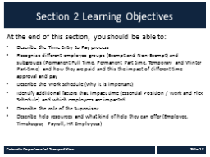 | Notes:  Upon completing this section you should have a understanding of the objectives on this slide. Please take a minute to review these before you continue. When you are done click the next button.
Slide 14  Time Entry to Pay Process  Duration: 00:00:30  Advance mode: By user | 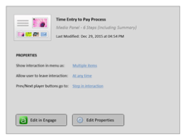 | Notes:
Slide 15  Exempt and Non-Exempt  Duration: 00:03:20  Advance mode: Auto | 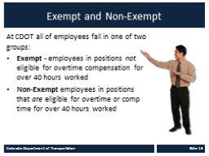 | Notes:  There are a variety of factors that impact the time entered by the employee. Let’s start with Exempt and Non-exempt and why this is important to understand when approving time. Exempt employees and Non-exempt employee are different based on their ability to receive overtime compensation based on over 40 hours worked.  Because Exempt employees do not receive overtime they do not have the ability to enter overtime codes on their timesheet. They can, and should however, enter their actual hours worked.  Non-Exempt employees are also required to enter the times they worked. When they work over forty hours they receive overtime for the hours over forty worked. Because of the additional labor cost the employee must notify you prior to working overtime. When you receive the request you need to save it and compare it to the employee’s timesheet. Additionally, some non-exempt employees are eligible for shift differentials, on-call and essential pay all of which are entered on their timesheet for approval.  This is important for you to know as a supervisor because you are required to approve overtime hours. Additionally, Non-exempt employees may also be eligible for shift differential, on call and essential where exempt employees are not.
Slide 16  Additional Employee Groups  Duration: 00:00:25  Advance mode: By user | 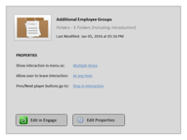 | Notes:
Slide 17  Type of Employees  Duration: 00:00:20  Advance mode: By user | 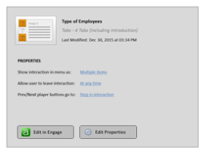 | Notes:
Slide 18  Essential Position / Work  Duration: 00:03:20  Advance mode: Auto | 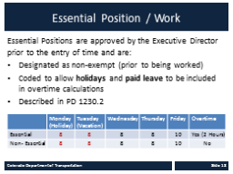 | Notes:  For a position to have been designated by the Executive Director as essential to achieving the mission of CDOT and must have a job assignment that is critical to the health, safety and welfare of the citizens of Colorado. This designation must occur before the work is performed and cannot be done retroactively and are only for non-exempt positions.  Now let’s take a look at Essential Positions and work. As a rule, CDOT employees are not able to use their holiday and paid leave towards overtime. Coding a position as essential, allows the employee to include holidays and paid leave towards overtime. Take a look at the hours worked on the slide for a full-time employee. The employee worked a five work week that included a holiday on Monday, and vacation on Tuesday and 2 extra hours on Friday. For essential positions, because holidays and leave are treated the same so they are included in the calculation towards overtime and are called essential work. For the non-essential employee, the above calculation would only 26 hours worked so the 2 extra hours on Friday are not counted as overtime.
Slide 19  Check Your Knowledge  Duration: 00:03:20  Advance mode: By user | 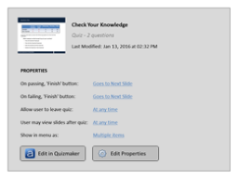 | Notes:
Slide 21  Work Schedule And Time Entry  Duration: 00:03:20  Advance mode: Auto | 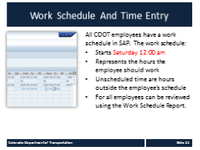 | Notes:  Now let’s talk about the Work Schedule. All employees at CDOT have an assigned work schedule that is loaded into SAP. The work schedule starts Saturday 12:00am, except for employees who are on flex schedules. It represents the time the employee is supposed to be at work or account for using leave. When an employee works outside of their work schedule, and they are not exempt, they may become eligible for overtime or a shift differential. As a supervisor, it is your responsibility to understand how this impacts your budget prior to approving overtime. If you are uncertain of you employee’s work schedule, click on the Resources tab and select the Work Schedule Report.
Slide 22  Flexday  Duration: 00:03:20  Advance mode: By user | 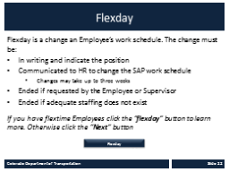 | Notes:  Now let’s take a look at Flex Schedules. There are about 300 employees in CDOT who work a flex schedule. Flexday is an agreement between the Employee and the Supervisor to change start and end time of the Employee. There are three options for Flex time. They are four 10-hour days, 4.5 workdays consisting of four 9-hour days and one half-day of four hours or a 5/4 over a two week period. Flexday must be a formal agreement between the Employee and the Supervisor and submitted to HR to change the work schedule in SAP. The agreement may be ended at any time by the Employee or the Supervisor. A link to the Flexday Agreement Form can be found in the Resources link.  If you do not have any employee who a on flex schedule click the next button. If you do, click the More on Flexday button.
Slide 23  Flextime  Duration: 00:00:30  Advance mode: By user | 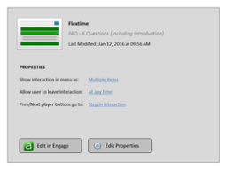 | Notes:
Slide 24  Check Your Knowledge - Flextime  Duration: 00:03:20  Advance mode: By user | 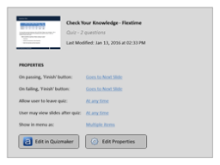 | Notes:
Slide 25  Supervisor Responsibilities  Duration: 00:03:20  Advance mode: Auto | 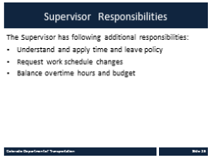 | Notes:  Outside of the review of Employee time by the payroll deadline. First, you are responsible for understanding and applying State and Federal laws as they relate to time entry. To help you they can be found by clicking on the resource link. Secondly, if one of your employees’ work schedule has changed or is incorrect you must let your timekeeper know so that this can be corrected. Thirdly, you need to review the timesheet cost elements for impacts to CDOT’s project budgets. Now let’s look at the people who can help you if you have difficulties carrying out you responsibilities.
Slide 26  Help Resources  Duration: 00:03:20  Advance mode: Auto | 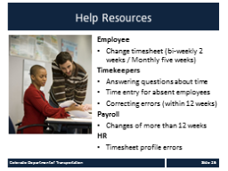 | Notes:  There are many resources to help you with the time process. The first resources is the employee who are able to make changes to their time if it is within the window of 2 weeks for bi-weekly employees or five weeks for monthly employees.  The Timekeeper role is to answer any questions you may have about time. They are also able to help you with time entry when an employee is absent and correcting errors on the timesheet if they have occurred within twelve weeks. Click on the resources link for a list of timekeepers in the work schedule report.  Payroll is also available to help. Payroll works with your timekeeper to resolve timesheet issues, answering questions about pay. The Click on the resources link to go to their webpage. If you have not already done so, you can bookmark this site by clicking “control D”. The site contains Frequently asked questions, the leave without pay process, monthly and biweekly pay schedules, and details about the how to make timesheet revisions.  In some case you may need to contact HR for help, but this would more likely be done by the timekeeper or by payroll on your behalf. HR is able to help you if the Timesheet profile is not set up correctly. Now let’s take a quick quiz to see what you have learned so far. This quiz is not graded and servers only for your review.
Slide 27  Section Two Check Your Knowledge  Duration: 00:03:20  Advance mode: By user | 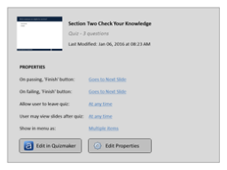 | Notes:
Slide 28  Section Three Approving Working Time  Duration: 00:03:20  Advance mode: Auto | 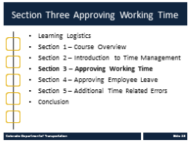 | Notes:
Slide 30  Section 3 Learning Objectives  Duration: 00:03:20  Advance mode: Auto | 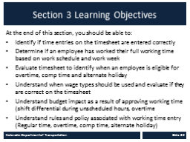 | Notes:  Upon completing this section you should have a understanding of the objectives on this slide. Please take a minute to review these before you continue. When you are done click the next button. Remember you can use the menu to the right to navigate back to a section or a specific slide within a section.
Slide 31  Regular Time  Duration: 00:03:20  Advance mode: Auto | 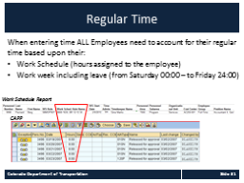 | Notes:  All employees need to account for their regular working time based on their Work Schedule and their work week. The Work schedule represents the hours the employee is assigned to work. In the example, below you can see the work schedule is from 08:00 to 16:30 Monday through Friday with half hour lunch from 12 to 12:30. Because the employee is a full-time employee they must account for 40 hours a week.  The work week for all Employees, except Flexday Employees, is from midnight Saturday to Friday at 11:59 Friday. This means the employee must account for 40 hours during this week as the employee in this example has done. The work week is important because occasionally the employee may work time outside their work schedule that counts as regular time. For example an exempt employee askes to come into work an hour late because of an appointment and then works an hour latter.
Slide 32  Regular Time  Duration: 00:03:20  Advance mode: Auto | 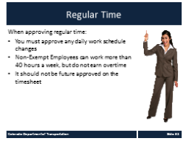 | Notes:  Not let’s look at regular time in a little more detail. When working with regular time you must approve any daily work schedule changes. This is done because this may have an impact on your budget if the employee is paid a shift differential. When approving time be aware that non-exempt employees cannot earn overtime. Finally employees should only enter the hours they have worked on their timesheet and you should only approve hours the employee has actually worked.  Now let’s practice on how to approve regular time.
Slide 33  Section Three Check Your Knowledge  Duration: 00:03:20  Advance mode: By user | 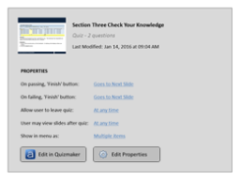 | Notes:
Slide 34  Section Four Approving Employee Leave  Duration: 00:03:20  Advance mode: Auto | 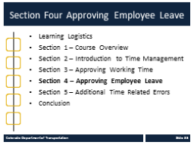 | Notes:
Slide 36  Section 4 Learning Objectives  Duration: 00:03:20  Advance mode: Auto |  | Notes:  Notes:
Slide 37  Section Four Check Your Knowledge  Duration: 00:03:20  Advance mode: By user | 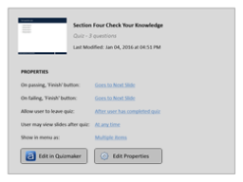 | Notes:
Slide 38  Conclusion  Duration: 00:03:20  Advance mode: Auto | 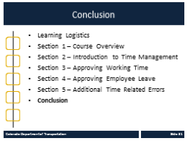 | Notes:  Notes:  Now that you have complete the course you should be able to describe the process for approving time and leave for your employees. Now let’s review what you have learned.
Slide 40  Course Summary  Duration: 00:03:20  Advance mode: Auto | 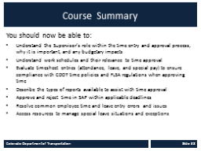 | Notes:  Notes:  Take a minute to review what you have learned in the course. If there is anything that is unclear, you can use the menu to navigate to the section. Now let’s look at the resources available to help you.
Slide 41  Where Can I Get Help – People?  Duration: 00:03:20  Advance mode: Auto |  | Notes:  Notes:  - If you run into technical problems or have policy questions, contact Rachel. Now lets look at who can help you with the time entry and payroll related questions.
Slide 42  Other CDOT Help Resources  Duration: 00:03:20  Advance mode: Auto | 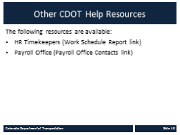 | Notes:  Notes:  Remember, you are not alone in the time entry process. If you need help, or are uncertain on how to proceed, contact your HR Timekeeper or the Payroll office. The list of timekeepers can be found in the Work Schedule Report under the Resources link. For Payroll related question, use the Payroll Office Contact link, which is also located in the resources tab. If you have not already done so it would be a good idea to bookmark these resources before you continue.  Now let’s look at what you need to do to get credit for the course.
Slide 43  Course Complete  Duration: 00:03:20  Advance mode: By user |  | Notes:  Congratulations on completing the Manager Time Approval Course! The final step of the course is for you to get credit for this course. You must get a score of at least 70% to pass and you can take it as many times as you like. Good Luck!
Slide 44  Course Assessment  Duration: 00:00:05  Advance mode: By user |  | Notes:

