Maintenance Time Approval
Items: 3 Labels
Duration: 15 seconds

Work Order Time Approval
5 seconds
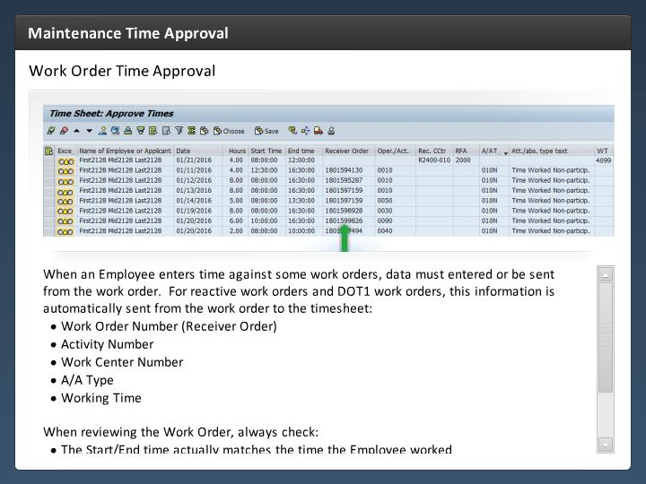

Step Text
When an Employee enters time against some work orders, data must entered or be sent from the work order. For reactive work orders and DOT1 work orders, this information is automatically sent from the work order to the timesheet:
- Work Order Number (Receiver Order)
- Activity Number (Oper/Act)
- Work Center Number (work ctr)
- A/A Type
- Hours
- Start Date
- End Date

When reviewing the Work Order, always check:
- The Start/End time actually matches the time the Employee worked
- The A/A Type has been entered correctly
- The correct work order and activity is populated

Narration Script
As you can see by the timesheet the work order requires entry in the Work Order Number, Activity Number, Work Center Number, A/A Type and of course the Working time. This is done automatically for reactive and DOT1 work orders.

When you review time against a Work Order, always check the time the Employee Worked against their Work Schedule to make sure this matches with the time you know the Employee worked. It is also a good idea to confirm the A/A Type is correct.

Now let's look at when an Employee doesn't enter time against the work order.

Cost Center Approval
5 seconds
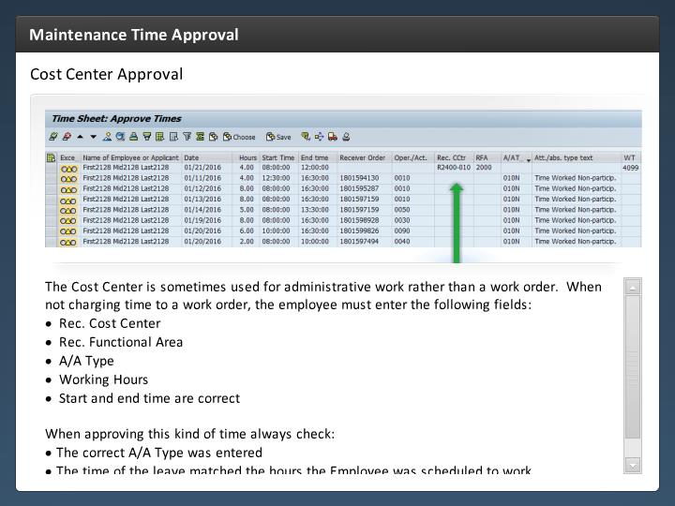

Step Text
The Cost Center is sometimes used for administrative work rather than a work order. When not charging time to a work order, the employee must enter the following fields:
- Rec. Cost Center (Rec. CCtr)
- Rec. Functional Area (RFA)
- A/A Type
- Hours
- Start Time
- End Time

When approving this kind of time always check:
- The correct A/A Type was entered
- The time of the leave matched the hours the Employee was scheduled to work
- The Cost Center is correct and funded for the type of work the employee is doing
- The working time should not be coded to a work order instead
- The Functional Area accurately describes the type of work being completed

Narration Script
The Cost Center is sometimes used by the Employee when they need to enter time for administrative work, such as participation in a training class.

When you approve this type of time entered against a cost center, always check the time against the Work Schedule, and verify the time was accounted for by the employee for all administrative time.

Now let's look at On Call time approval.

On Call Time Approval
5 seconds
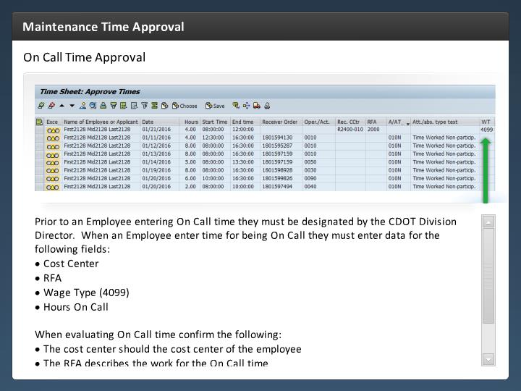

Step Text
When an Employee enters time for being On Call they must enter data for the following fields:
- Rec. Cost Center (Rec. CCtr)
- receiving Functional Area (RFA)
- Wage Type (WT) is always 4099
- Hours
- Start time
- End time

When evaluating On Call time confirm the following:
- The cost center should the home cost center of the employee

- The Wage Type is 4099

Refer to PD 1230.2 under the resources link to review the policy for on call.

Narration Script
When an Employee is On Call they must enter the Cost Center, RFA, Wage Type (4099) and Hours on call. No A/A Type is required. If the employee is called in while on call, the correct working time entry should be entered for the time worked.

When evaluating On Call time for approval, verify the home cost center of the employee is entered. The wage type is always 4099 and the hours should be the hours the Employee was On Call.

If you are uncertain of how to approve On Call time refer to PD 1230.2.

