Overview:
The following are the changes to the PSH sound files using Audacity. To changes the sound you apply each of the settings on the Effects. The effects must also be applied in the order in fall in this document or the sound will not be the same as the existing sound files. The changes to the sound files are only applicable to the presenter of this course.
Assumptions:
- Files are pulled from Captivate
- The presenter is the same
- The order of each of the effects is applied in the same order as the existing overview
- Noise reduction sample is taken from a section of the
Effects:
Order | Screen Shot of Effect
Noise Reduction | 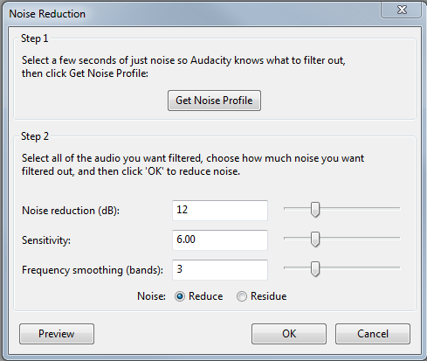
Reverb | 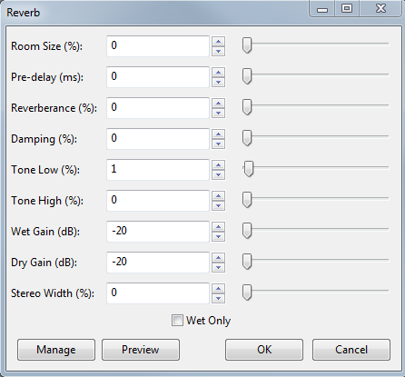
Bass/Treble | 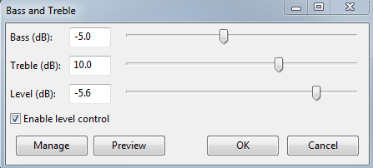
Change Tempo | 