UAT Outline 2/25

Group 1
 | Name | Role | Username | Password
 | Mary PE II | Manager | msstest777
 | Linda Eng tech | Employee | 00006571
 | James 1 PE III | Div Mgr | msstest8
 | Appointing Authority | AA | 00001783

Group 2
 | James PE III | Div Mgr | msstest8
 | Donna PE II | Manager | 00002279
 | Appointing Authority | AA | 00001783

Group 3
 | Victor Foreman | Manager | Username | Password
 | Barbara Thomas | Employee | 00002336
 | Suzie Senior | 2nd level Manager | 00002777
 | Jerry Deputy | 3rd level Manager | 00003414
 | Dennis Super | Div Mgr | 00003372
 | Appointing Authority | AA | 00001783

Performance Management Plan 2014
A Performance Management Plan is a formal document required by the State of Colorado. The Plan allows supervisors and employees to maintain bidirectional communication during the performance year. Provides constructive feedback for improvement as well as recognition. Documents performance in clear, consistent, and meaningful manner. The System Admin starts the form by creating the goals, the performance document and routing the document to correct step based on the performance quarter. The supervisor enters the goals and behavioral expectations for competencies for the quarter. The employee acknowledges the plan. The plan moves back and forth between the supervisor and employee throughout the performance year.
The form “due” date has been set to 5/1/2015. Route steps have been set as the 2nd Friday following the close of each quarter. Email notifications will be sent for route step due dates, when the plan moves to a new person’s performance inbox and upon close (completion) of the plan.

Quarter 1
Supervisor and employee meet | Create goals and comments | Comment and Acknowledge
 | Supervisor | Employee

Quarter 2
Supervisor and employee meet | Enters ratings, create goals and comments | Comment and Acknowledge
 | Supervisor | Employee

Quarter 3
Supervisor and employee meet | Enters ratings, create goals and comments | Comment and Acknowledge
 | Supervisor | Employee

Quarter 4
Supervisor and employee meet | Enters ratings, create goals and comments | Comment and Acknowledge
 | Supervisor | Employee

Final form signatures
Final rating recommendation | Reviewer Comments and Signs | Comments and Signs | Comments and Sign | Sent to Completed Inbox
Supervisor | 2nd Level Manager | Supervisor | Employee | Employee  Supervisor

Goals
Managers are required to create one to two goals for each quarter. The goal is entered by the Supervisor (SF calls this position Manager). Completion of goals and the rating contribute to 60% of the final overall performance rating.
Manager can create goals in two places. The goal plan or the Performance Management Plan
Goals can be created at the unit level and cascaded to groups of people.
Step | Action | Result
 | Supervisor
1 | From the Home pulldown menu, Click the click the word Goal
2 | Click Create New Goal Button
3 | Click Personal Goal
4 | Select the Quarter dropdown
5 | Type the SMART Goal
6 | Type the Measurement
7 | Save

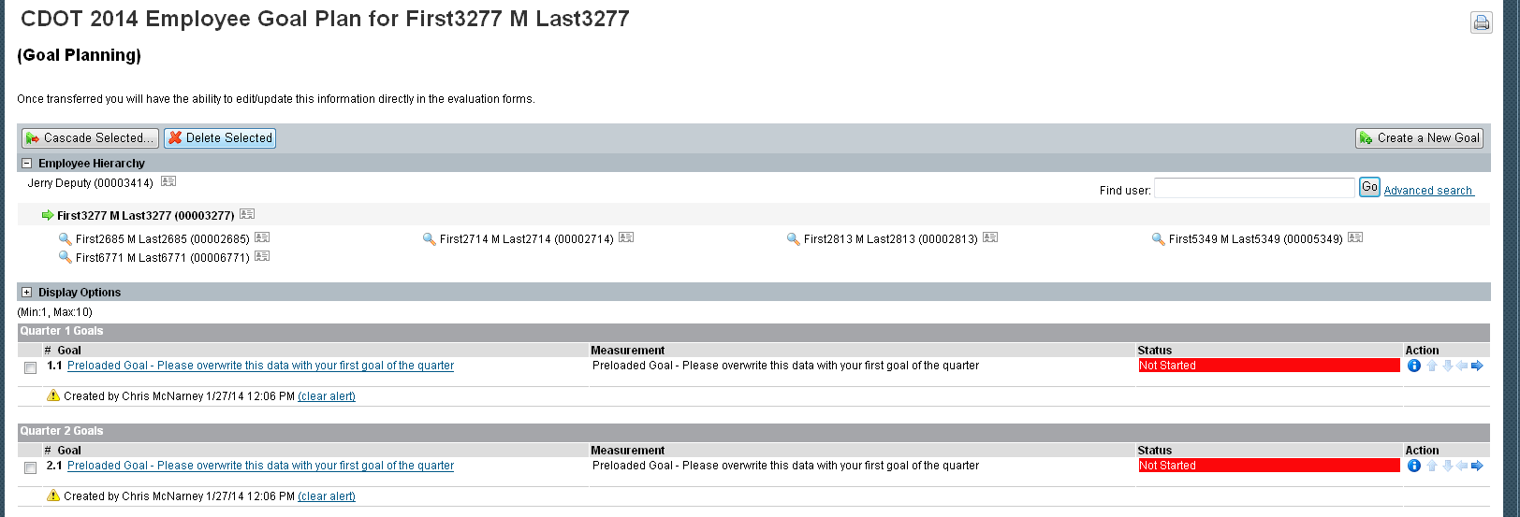

Cascade to your employee group
Step | Action | Result
 | Supervisor
1 | Check the box next to the goal that you want to cascade
2 | Check the box next to the names of the employee who should have the goal
3 | Select Next
4 | You can choose to edit the goal language for each specific person
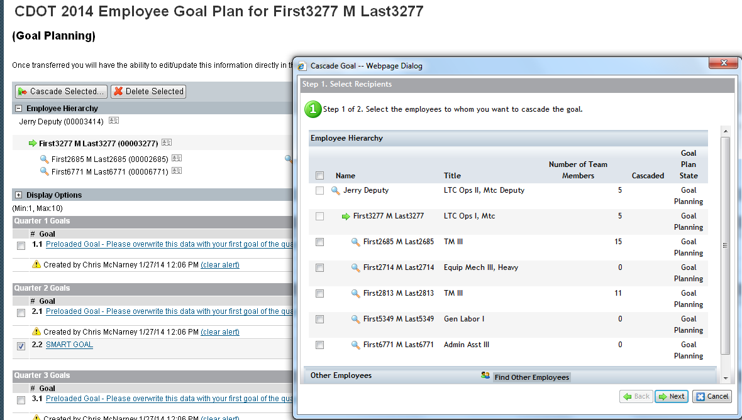

Goals on the Plan Document
- Quarterly goals are enabled on the Performance Management Plan during the quarter that they are assigned.
- During the rating period, the goal can be edited to adjust for changes that happened throughout the quarter. An email will be sent to the employee notifying them that the goal has changed.
- Comment on the goal during the plan and rating period.

Competencies
Competencies, their definition and the behaviors are standard across CDOT. Discuss examples of ways the employee should demonstrate the behavioral expectations while performing job duties.
Completion of competencies and the rating contribute to 40% of the final overall performance rating.
If a CDOT employee does not work lead or supervisor, please type N/A in the comments section at the time the Plan is started each quarter. At the end of each quarter, this competency will be rated as.

Professional Development
Professional development goals are listed for an employee to communicate his or her career goals in order to get support from the management team. Entering these goals is encouraged and not mandatory. Goal(s) can extend throughout the year, or even expand across multiple years if desired. Professional goals are not rated and included in the final overall performance rating.
Manager or Employee
- Add the goal
- Add the measurement
- Check the applicable competencies
- Keep scrolling to the bottom of the box
- Select the purpose
- Select the start date
- Select the due date
- Result
- Enter comments; employees should enter the comments as progress is made throughout the year.

Reports
The performance and competency dashboard is available to all supervisors. The dashboard presents SF defined metrics. The supervisors have access to their direct and indirect employees. The Dashboard settings allow the supervisor to filter to display on the People, Forms, and organizational information.

Dashboard – Performance and Competency

- Filter the report to change the display on the right.
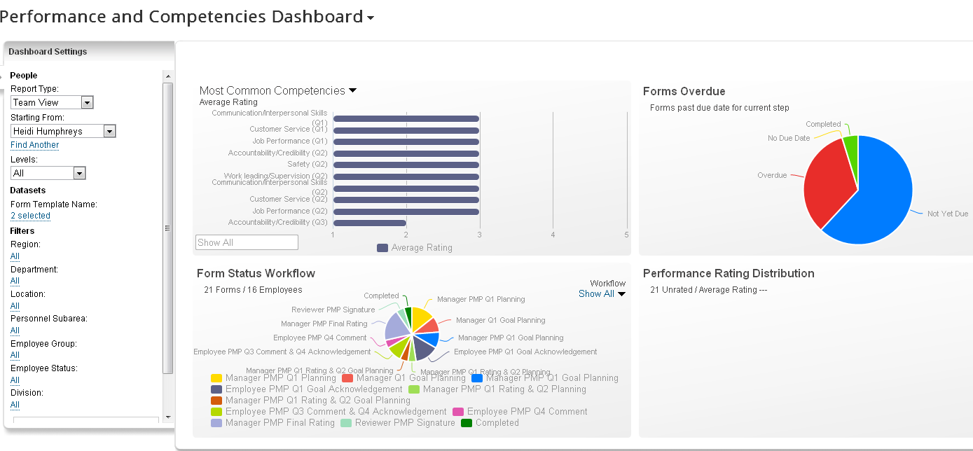

Step | Action | Result
1 | Reports
Filter the report display
2 | Report Type: Team View
3 | Starting From: Pick a Manager
4 | Levels: How many levels do you want to see?
5 | Form Template Name: Select CAP and PMP
6 | Further filters are making the data set smaller.
7 | Be sure to navigate to the bottom of the filter box to click the update button.
8 | The display on the right will refresh based on what was selected
Competency display: shows the quarterly competencies from the PMP and the rating distribution – will eventually show competencies from succession
9 | Select the graph on the far left
10 | Click on one of the bars
11 | The bottom half of the screen delivers the details of the chart
Forms Overdue: The CAP, Dispute 1 and 2, PIP and PMP have due dates. The graph will display the status of the form based on the system due date.
12 | Select the second graph from the far left
13 | When the graph displays, select a slice of the pie chart
14 | The bottom half of the screen delivers the details of the chart, employee name, document id and due date
15 | Click on the Document ID number in one of the rows
16 | A web based version of the form will display
17 | Close the pop-up window
Form Status Workflow: Each form has its own electronic workflow, moving from one person to the next. The graph displays where the forms are in the process.
18 | Select the third graph from the far left
19 | When the graph displays, select a slice of the pie chart
20 | The bottom half of the screen delivers the details of the chart, employee name, document id and due date
21 | Click on the Document ID number in one of the rows
22 | A web based version of the form will display
23 | Close the pop-up window
Performance Rating Distribution: When the first level supervisor provides the final manual performance rating, the data in this chart is viewable.
24 | Select the graph from the far fright
25 | When the graph displays, select the 1, needs improvement or the 3 exceptional to see the rating
26 | The bottom half of the screen delivers the details of the chart, employee name, document id and due date
27 | Click on the Document ID number in one of the rows
28 | A web based version of the form will display
29 | Close the pop-up window

AdHoc Report pushed to you from HR
Step | Action | Result
1 | Reports
2 | Analytics
3 | Ad Hoc Reports
4 | Find Report Name and click the drop down arrow
5 | Run the Report
6 | Click the Run Online radio button
7 | Click Generate Report
8 | Report results display
9 | After the report results display, Click the PDF button
10 | PDF File Download Process, open
11 | PDF window opens with the report
12 | Close the PDF window
13 | Close the generated report window

Team Overview
The display is grouped by route map. Your display contains the employees whom you have a role in the review process (Supervisor, 2nd level manager, Div Mgr, AA)
The columns on the form display the steps of the Performance Cycle. The manager can see where the form is in the process. The rating number will remain blank until the manager completes the final rating on the form. The unrated and rating is the same number across the document regarding of the quarterly ratings.

Ask for Feedback
Team view allows you to ask for feedback from another person through a formal email process. The Ask for Feedback appears when the 2014 Plan is created and will continue to allow you to request feedback until the final performance rating.
When the person responds, the contents of the email will be stored in the employee’s notes section of their Performance Management Plan.

Signature for the PMP

2nd level manager can sign all of the Final Ratings from the Team Overview page. The comments that are saved in the pop up box are not saved on the form.
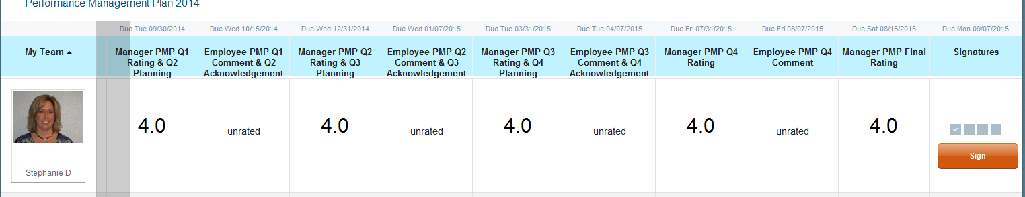

Notes
Supervisors can write notes to themselves about the performance of one of their direct and indirect reports. There are three different places that the note can be created.
- My Team view on the home page
- People Search
- Org chart display
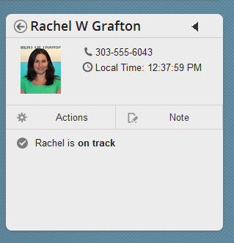
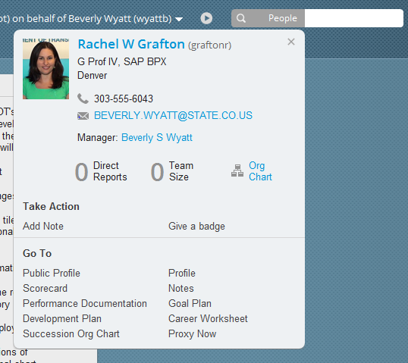
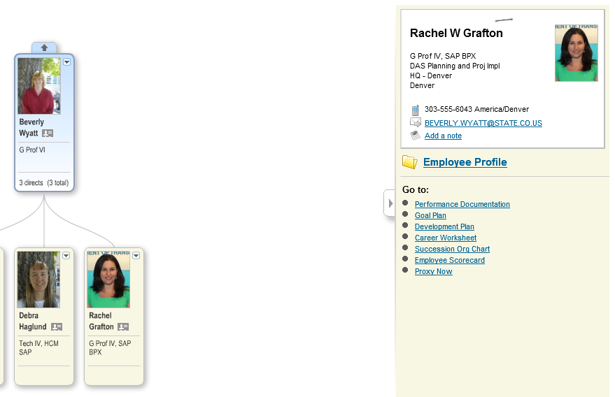

Review your notes at the top of the employee’s Performance Management Plan in the pod called Supporting Information.

Badges
Similar to the concept of the Employee Council High Five Cards, Supervisors can give any employee in CDOT a Badge. If you are a supervisor, Badges can be given from the People Search or from the employee’s profile page.
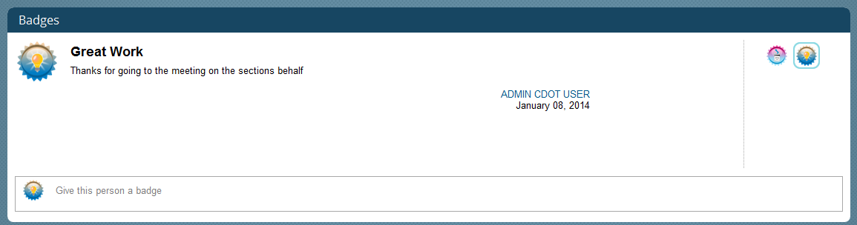

Step 1 PMP Dispute Resolution (Informal)
This form is to be completed by a CDOT employee to start the dispute resolution process. Employees select the reason for the dispute, elaborate on the situation, and document the desired solution. Email notifications will be sent when the form reaches the performance inbox and upon the close (completion) of the form.
Creator | Comment and Signature | Sent to Completed Inbox
Employee | 2nd level Manager | Employee  Supervisor  2nd level Manager

Step 1 PMP Dispute Resolution (Informal)

Step | Action | Result
 | Employee
1 | From the Home pulldown menu, Click the click the word Performance
2 | Click Create New Form Button
3 | Click the Step 1 PMP Dispute Resolution (Informal) Link
4 | Click the Self - name
5 | Click Create and Open button (these are the due dates of the form, not changeable)
6 | Check the box for the reason for the dispute
7 | Scroll to the next section
8 | Enter in the reason for the dispute
9 | Scroll to the next section
10 | Enter in the desired outcome for your dispute
11 | Scroll to the bottom of the document
12 | Click the Send to Reviewer
13 | In the pop up box --enter an optional comments
14 | Click Send to Reviewer button
 | Reviewer (2nd level manager)
15 | In the TO DO list on the SF home page – Click the link Reviewer Step 1 Dispute (Informal) Comments and Signature
16 | Scroll to the Signature section
17 | Enter in comment in the text box, how or if the dispute is going to be handled.
18 | Scroll to the bottom of the document
19 | Click Complete button
20 | In the pop up box – write optional comments before signing and completing the plan
21 | Click Sign button

Step 2 PMP Dispute Resolution (Formal)
If the employee is dissatisfied with the result of the informal resolution process and wishes to advance the dispute to Step 2, he or she should complete the Step 2 PMP Dispute Resolution. Employees select the reason for the dispute, elaborate on the situation, and document the desired solution. Email notifications will be sent when the form reaches the performance inbox and upon the close (completion) of the form.
Creator | Comment and Signature | Completed document
Employee | Appointing Authority | Employee  Supervisor  Appointing Authority

Step | Action | Result
 | Employee
1 | From the Home pulldown menu, Click the click the word Performance
2 | Click Create New Form Button
3 | Click the Step 2 PMP Dispute Resolution (Formal) Link
4 | Click the Self - name
5 | Click Create and Open button (these are the due dates of the form, not changeable)
6 | Check the box for the reason for the dispute
7 | Scroll to the next section
8 | Enter in the reason for the dispute
9 | Scroll to the next section
10 | Enter in the desired outcome for your dispute
11 | Scroll to the bottom of the document
12 | Click the Send to Appointing Authority
13 | In the pop up box --enter an optional comments
14 | Click Send to Appointing Authority button
 | Appointing Authority (Div Mgr’s Manager)
15 | In the TO DO list on the SF home page – Click the link Reviewer Step 2 Dispute (Formal) Comments and Signature
16 | Scroll to the Signature section
17 | Enter in comment in the text box, how or if the dispute is going to be handled.
18 | Scroll to the bottom of the document
19 | Click Complete button
20 | In the pop up box – write optional comments before signing and completing the plan
21 | Click Sign button

Performance Document
A Performance Document is an informal document between a supervisor and his or her employee. The document can be used to record either positive or negative behaviors. The document is started by the immediate supervisor. The performance issue and expected future behavior should be recorded. There are no form “due” dates. Email notifications will be sent when the document moves to a new person’s performance inbox and upon close (completion) of the plan.
Creator | Comments and Sign | Comments and Sign | Sent to Completed Inbox
Immediate Supervisor | Employee | Supervisor | Employee  Supervisor

Step | Action | Result
 | Supervisor
1 | From the Home pulldown menu, Click the click the word Performance
2 | Click Create New Form Button
3 | Click the Performance Document Link
4 | Click the name of the employee who will get the document
5 | Click Create and Open button (these are the due dates of the form, not changeable)
6 | Select the dropdown option: Congratulations or Needs Improvement
7 | Scroll to the next section
8 | Check the box for the applicable competency
9 | Scroll to the next section
10 | Enter the details of the event
11 | Check the box if other people observed the event
12 | Enter the names of the folks who observed the event
13 | Scroll to the next section
14 | Suggestions for future behavior
15 | Scroll to bottom of the form
16 | Click Send to Employee button
17 | In the pop up box --enter a comment to the employee
18 | Click Submit to Employee
 | Employees
19 | From the Home pulldown menu, Click the click the word Performance
20 | Click the Performance Document Link
21 | Read through the document
22 | Scroll to the Signature section
23 | Enter in comment in the text box
24 | Scroll to the bottom of the document
25 | Click Sign button
26 | In the pop up box --enter an optional comment
27 | Click Sign button

Performance Improvement Plan
A Performance Improvement Plan is an informal step to improve employee behavior. The plan is started by the immediate supervisor. The performance issue, the expected improvement and a timeframe should be documented on the plan. The form “due” date has been set to at 30 days after the creation of the form. Email notifications will be sent when the plan moves to a new person’s performance inbox and upon close (completion) of the plan.
Creator | Comments and Sign | Comments and Sign | Sent to Completed Inbox
Immediate Supervisor | Employee | Supervisor | Employee  Supervisor
An email is sent to the employee when the supervisor starts the PIP.
An email is sent to the supervisor when the employee comments
An email is sent to the employee when the supervisor completes the document
Step | Action | Result
 | Supervisor
1 | From the Home pulldown menu, Click the click the word Performance
2 | Click Create New Form Button
3 | Click the Performance Improvement Plan Link
4 | Click the name of the employee who will get the document
5 | Click Crete and Open button (these are the due dates of the form, not changeable)
6 | Select the corresponding check box for the Reason for Performance Improvement
7 | Scroll to the next section
8 | Enter the Problem Description
9 | Scroll to the next section
10 | Enter the Improvement Actions Required
11 | Repeat in the next two sections if necessary.
12 | Scroll to the bottom of the document
13 | Click Submit for Employee Action button
14 | In the pop up box --enter a comment to the employee
15 | Click Submit for Employee
 | Employee
16 | In the TO DO list on the SF home page – Click the link Employee PIP Comments & Signature
17 | Read and discuss document with Supervisor | None of the fields are editable by the employee
18 | Scroll to the Signature section
19 | Enter in comment in the text box
20 | Scroll to the bottom of the document
21 | Click Sign button
22 | In the pop up box --enter an optional comment
23 | Click Sign button
 | Supervisor
24 | In the TO DO list on the SF home page – Click the link Manager PIP Comments & Signature
25 | Scroll to the Signature section | None of the fields are editable by the employee
26 | Enter in comment in the text box, how has performance improved or what are the next steps
27 | Scroll to the bottom of the document
28 | Click Complete button
29 | In the pop up box – write optional comments before signing and completing the plan | We are working on removing the delete form button on the left.
30 | Click Sign button

Corrective Action Plan
A Corrective Action Plan is the start of progressive discipline. This plan is started by the immediate supervisor. The plan includes the background of the event, expectations for improvement, time frame and deadlines, and consequences if expectations are not met. The form “due” date has been set to at 30 days after the creation of the form. Email notifications will be sent when the plan moves to a new person’s performance inbox and upon close (completion) of the plan.
Creator | Edit/delete/approve | Comments and Signs | Comments and Sign | Sent to Completed Inbox
Supervisor | Division Manager | Employee | Supervisor | Employee  Supervisor  Division Manager

Who should use
- Supervisors/Division Managers who have the delegated authority to issue corrective
Region 1 | Region 3 | Region 4
Region 5 | DAS | Aeronautics
Gov Relations | Communications | Audit
HPTE | DTR | Office of Major Projects
- Appointing Authorities of the smaller Divisions

Step | Action | Result
 | Supervisor
1 | From the Home pulldown menu, Click the click the word Performance
2 | Click Create New Form Button
3 | Click the Corrective Action Plan Link
4 | Click the name of the employee who will get the document
5 | Click Create and Open button (these are the due dates of the form, not changeable)
6 | Enter the Background of the Event
7 | Scroll to the next section
8 | Enter the Required Behavioral Correction
9 | Scroll to the next section
10 | Enter the Improvement Required with time frame and deadlines
11 | Scroll to the next section
12 | Enter the consequences of the behavior not being corrected
13 | Scroll to the bottom of the document
14 | Click Send to Division Manager button
15 | In the pop up box --enter a comment to the employee
16 | Click Submit to Division Manager
 | Division Manager
17 | In the TO DO list on the SF home page – Click the link Manager CAP Comments & Signature
18 | Enter the Background of the Event
19 | Scroll to the next section
20 | Enter the Required Behavioral Correction
21 | Scroll to the next section
22 | Enter the Improvement Required with time frame and deadlines
23 | Scroll to the next section
24 | Enter the consequences of the behavior not being corrected
25 | Scroll to the bottom of the document
26 | Click Send to Employee button
27 | In the pop up box --enter a comment to the employee
28 | Click Submit to Employee
 | Employee
29 | In the TO DO list on the SF home page – Click the link Employee CAP Comments & Signature
30 | Read and discuss document with Supervisor | None of the fields are editable by the employee
31 | Scroll to the Signature section
32 | Enter in comment in the text box
33 | Scroll to the bottom of the document
34 | Click Sign button
35 | In the pop up box --enter an optional comment
36 | Click Sign button
 | Supervisor Finalize form after behavioral correction has occurred
37 | In the TO DO list on the SF home page – Click the link Manager CAP Comments & Signature
38 | Scroll to the Signature section | None of the fields are editable by the employee
39 | Enter in comment in the text box, how has performance improved or what are the next steps
40 | Scroll to the bottom of the document
41 | Click Complete button
42 | In the pop up box – write optional comments before signing and completing the plan | We are working on removing the delete form button on the left.
43 | Click Sign button

AA Issued Corrective Action Plan
A Corrective Action Plan is the start of progressive discipline. This plan is started by the Division Manager for anyone in his or her Division. The plan includes the background of the event, expectations for improvement, time frame and deadlines, and consequences if expectations are not met. The form “due” date has been set to at 30 days after the creation of the form. Email notifications will be sent when the plan moves to a new person’s performance inbox and upon close (completion) of the plan.
Creator | Edit/delete/approve | Comments and Signs | Comments and Sign | Sent to Completed Inbox
Division Manager | Appointing Authority | Employee | Appointing Authority | Employee  Supervisor  Division Manager  Appointing Authority

Who should use
- Appointing Authority
- Appointing Authorities creating a CAP for any direct report (HR Admin can start the form, if necessary)

Region 2 | Staff Branches | DTD
DAF | Safety | TSMO

Step | Action | Result
 | Division Manager
1 | From the Home pulldown menu, Click the click the word Performance
2 | Click Create New Form Button
3 | Click the Corrective Action Plan Link
4 | Click the name of the employee who will get the document
5 | Click Create and Open button (these are the due dates of the form, not changeable)
6 | Enter the Background of the Event
7 | Scroll to the next section
8 | Enter the Required Behavioral Correction
9 | Scroll to the next section
10 | Enter the Improvement Required with time frame and deadlines
11 | Scroll to the next section
12 | Enter the consequences of the behavior not being corrected
13 | Scroll to the bottom of the document
14 | Click Send to Appointing Authority button
15 | In the pop up box --enter a comment to the employee
16 | Click Submit to Appointing Authority
 | Appointing Authority
17 | In the TO DO list on the SF home page – Click the link Manager CAP Comments & Signature
18 | Enter the Background of the Event
19 | Scroll to the next section
20 | Enter the Required Behavioral Correction
21 | Scroll to the next section
22 | Enter the Improvement Required with time frame and deadlines
23 | Scroll to the next section
24 | Enter the consequences of the behavior not being corrected
25 | Scroll to the bottom of the document
26 | Click Send to Employee button
27 | In the pop up box --enter a comment to the employee
28 | Click Submit to Employee
 | Employee
29 | In the TO DO list on the SF home page – Click the link Employee CAP Comments & Signature
30 | Read and discuss document with Supervisor | None of the fields are editable by the employee
31 | Scroll to the Signature section
32 | Enter in comment in the text box
33 | Scroll to the bottom of the document
34 | Click Sign button
35 | In the pop up box --enter an optional comment
36 | Click Sign button
37 | Division Manager Finalize form after behavioral correction has occurred
38 | In the TO DO list on the SF home page – Click the link Manager CAP Comments & Signature
39 | Scroll to the Signature section | None of the fields are editable by the employee
40 | Enter in comment in the text box, how has performance improved or what are the next steps
41 | Scroll to the bottom of the document
42 | Click Complete button
43 | In the pop up box – write optional comments before signing and completing the plan | We are working on removing the delete form button on the left.
44 | Click Sign button

