Rec. | Screen | Script
001 | 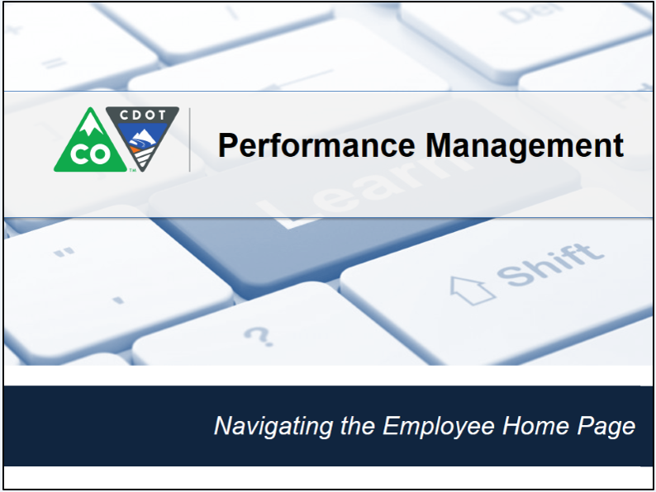 | This video shows you how to complete a dispute resolution form.
002 | 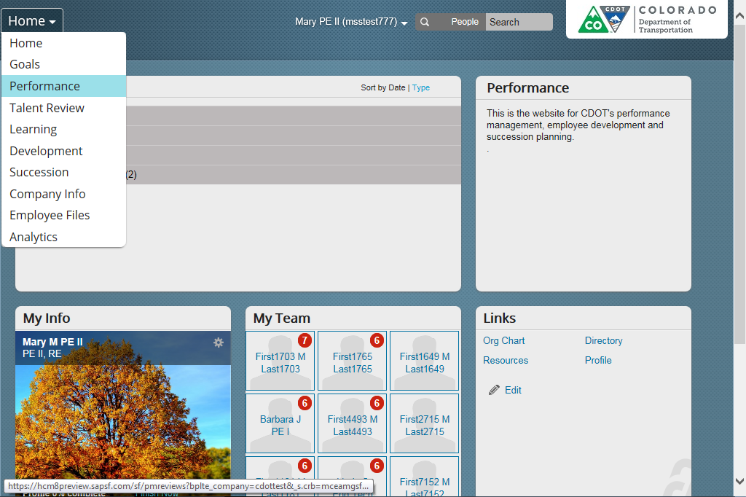 | Before you create a dispute form, you should know what you are three things you can dispute. First you can dispute your performance plan (or lack of one) second you are able to dispute your final performance rating or lack of a rating. And lastly you can dispute the application of CDOTs performance management program, policies or processes for your own performance plan.  If your dispute falls within one of these three categories you have five working days from the date of your meeting to dispute it. For more information, go to the main performance page on CDOT’s Intranet and select disputes to learn more.  Now let’s get started by clicking on the Home screen drop-down and selecting Performance from the drop-down menu.
003 | 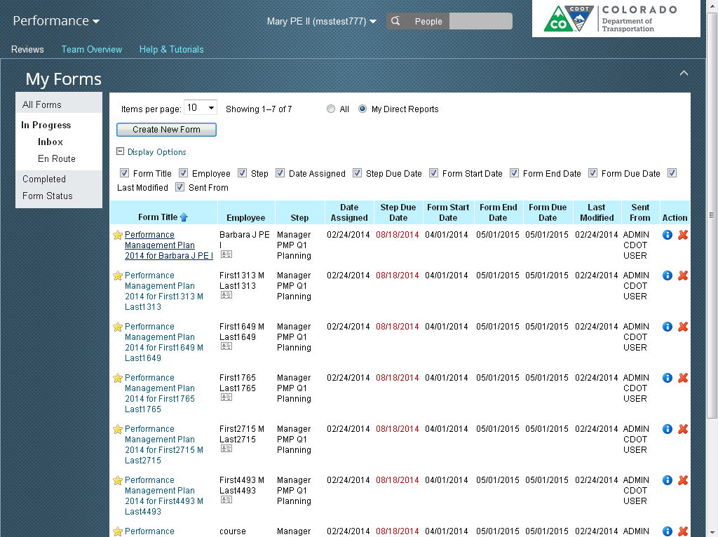 | The Performance screen displays. From here select the Create New Form button.
004 | 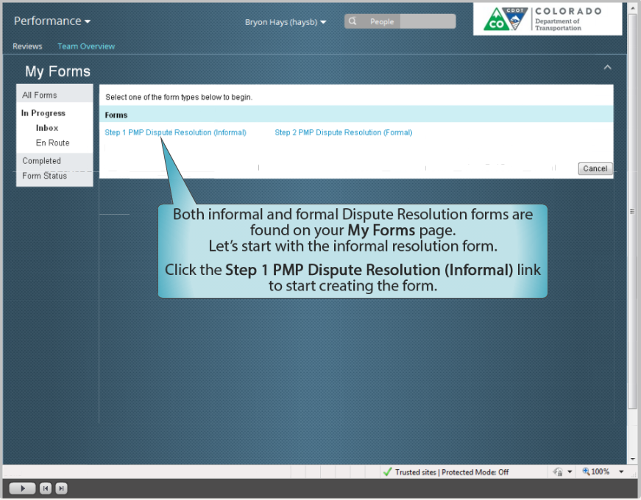 | The Forms screen displays. From here you are able to access both the informal and the formal dispute resolution forms. You should always start with step 1 (informal). But there are two exceptions where you would use level 2. The first exception is that you have already gone through level one. The second is that your manager is the Appointing Authority. If this is not the case, then you should always start at level one. For the purpose of this example, let’s start with level one and click on the Step 1 PMP Dispute Resolution (informal) link.
005 |  | Click on the link with the words Self and your name to go the next screen.
006 | 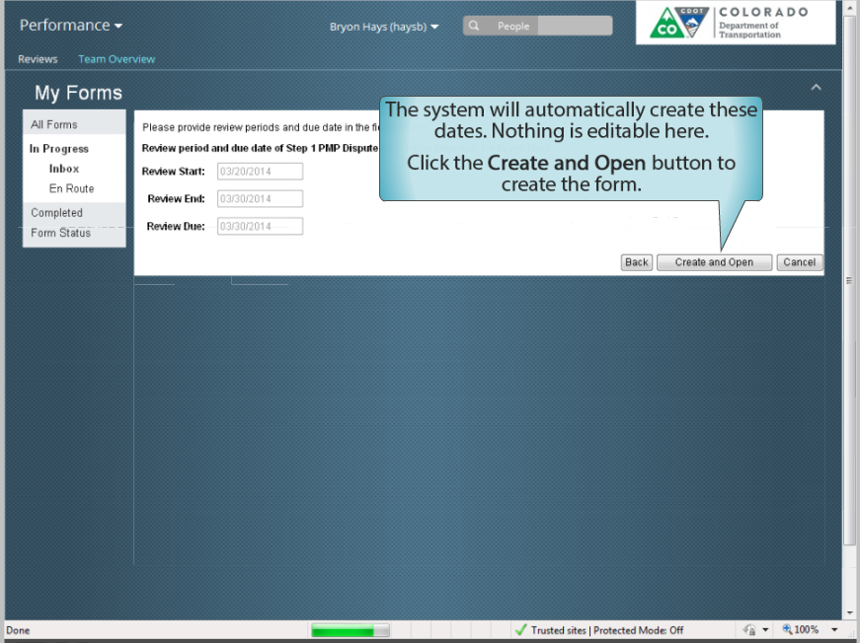 | This takes you to the “Dates” page. You are not able to change the dates listed on this page. Now, click on the Create and Open button to go to the PMP Dispute form.
007 | 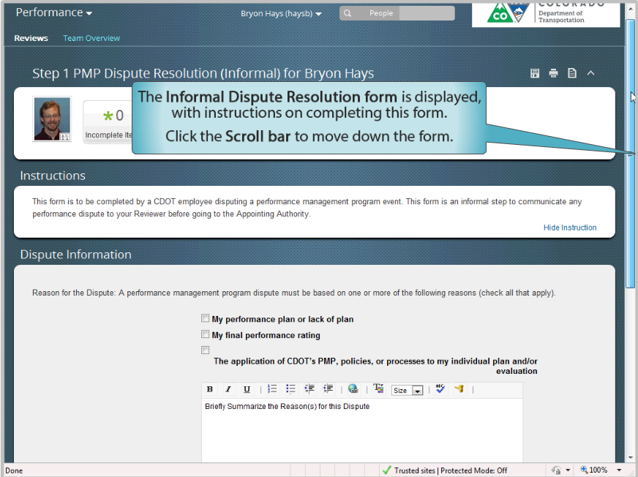 | When the PMP Dispute Resolution (informal) form with your name displays. The first step is to select the check box with the reason for the dispute. Please note, you are only able to select one reason and if it is not for one of these three reasons then form will be rejected.  Now click on the first open text field located at the bottom of the page and replace the text in the field with the reason for the dispute. In this example, “A performance plan was not created for me by my supervisor before they left CDOT.” was selected. Remember, you should provide enough detail so the person reading the form understands the basis for the complaint.
008 | 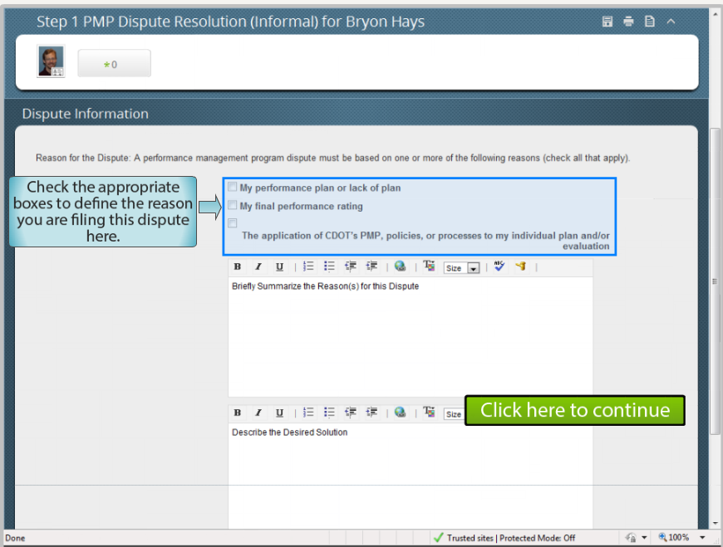 | Now go to the second text field and replace the text how you would like to see the dispute resolved. In this example, “I would like not to be evaluated for the one month period where I did not have a performance plan.” was entered as the solution.
009 | 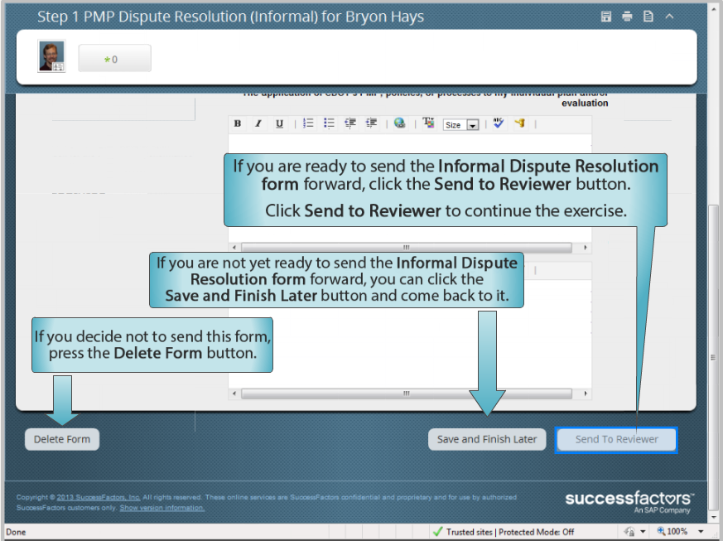 | The last step on this page is to click on the send to reviewer button.
009A | 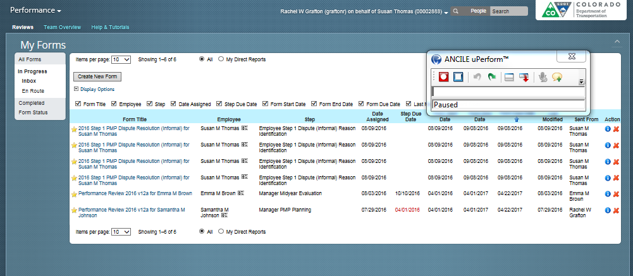 | Great! Now all you have to do is to enter any comments you have of the reviewer, for example, “please review ASAP.” and click the Send to Reviewer button. This returns you to the forms page. Your completed PMP Dispute Resolution form has been sent.
010 | 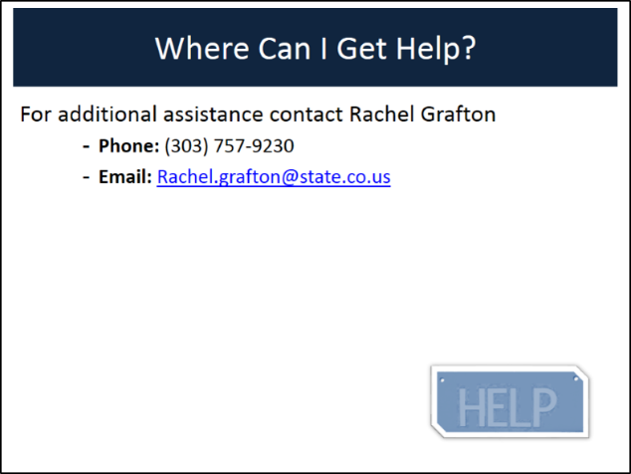 | You have completed the process of submitting a level one dispute. If you have any questions about the process contact Rachel Grafton at (303) 757-9230 or email her at Rachel.grafton@state.co.us.

