Screen | Script
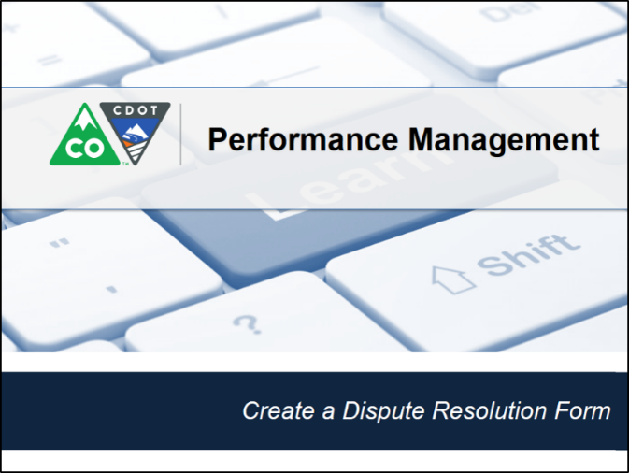 | This video shows you how to create a badge to recognize an employee for exemplary performance.
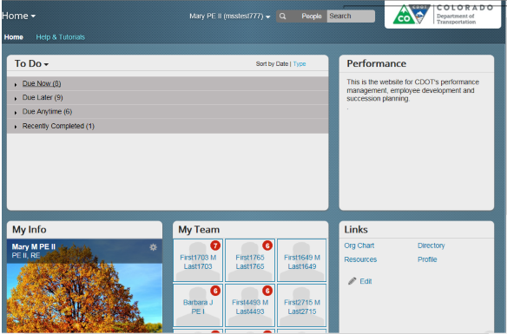 | Badges can be given by a supervisor to any employee for the following reasons, great work, team player, amazing, leader, nice person, team work, thank you and welcome. In this example, a badge is being awarded to Barbara for great work by her supervisor. From the Home screen, let’s get started by finding Barbara. Click on the search field and enter the name of the employee in this case, Barbara. As you type the name of the employee a drop-down list of people are suggested, we can see that the first name on the list is the one we want so let’s select it by clicking on it.
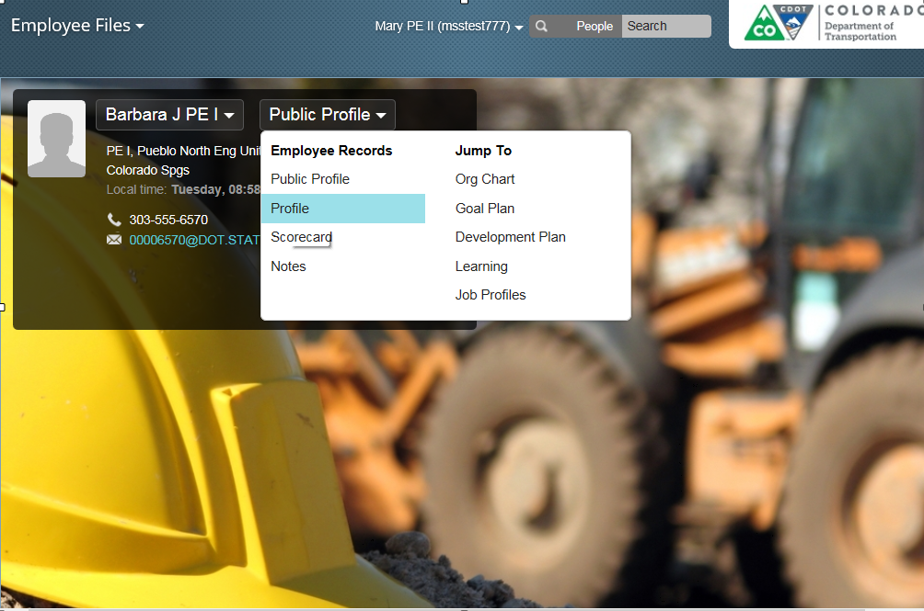 | The Employee Files screen displays with the selected employee’s file, in this case Barbara’s. Now click on the Public Profile drop-down and select Profile from the menu.
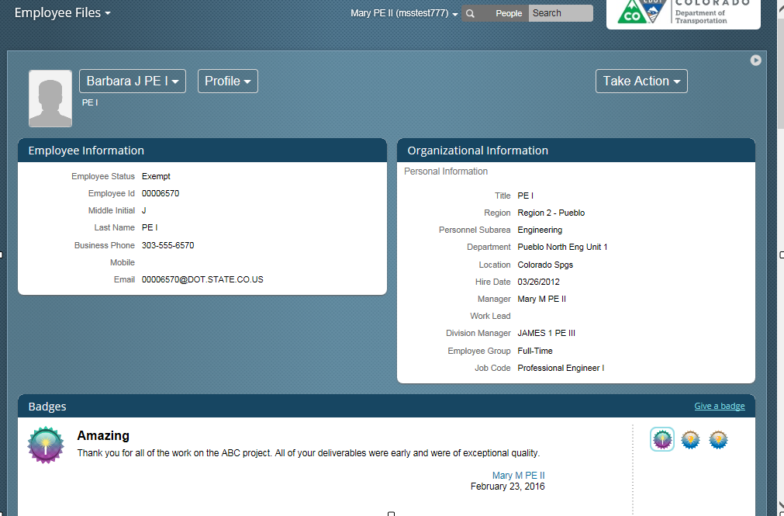 | The Profile screen for Barbara displays. Now all we have to do is give the badge. Click on the Give a badge link located in the bottom right of the page to display a list of badges.
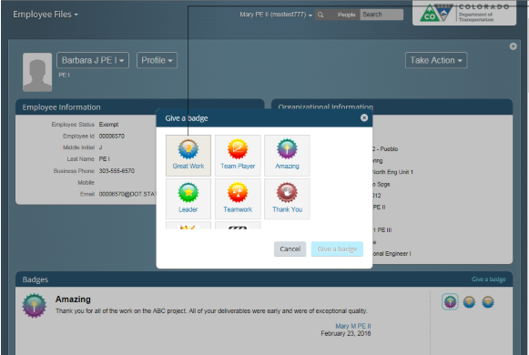 | Perfect, the list of badges displays. From here you can assign any of the badges you see displayed here. In this example, the badge we are going to assign is the great work badge. Now all you need to do is to left click on the badge.
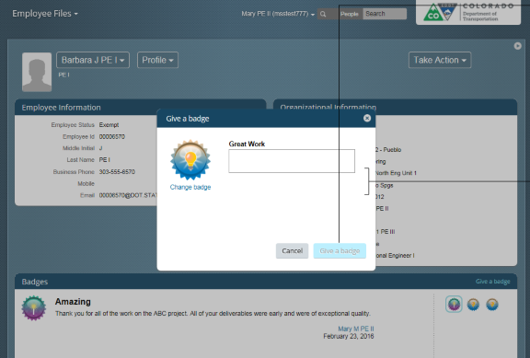 | The screen updates and now you are able to enter a reason you a awarding the badge. In this example, you want to award the badge for Barbara’s work on the ABC project. When you provide feedback be sure to let the person know what they did right. Let’s do so now by entering, “Thank you for all of the work on the ABC project. All of your deliverables were delivered early and were of exceptional quality!” Now all you have to do is to click the Give a Badge button.
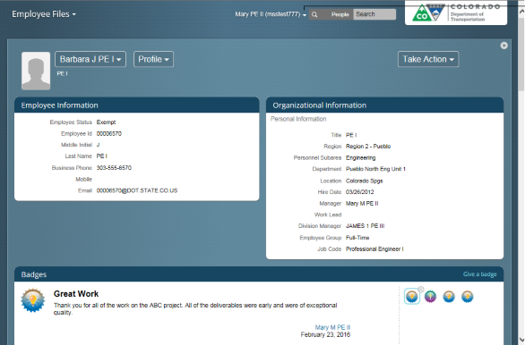 | The Give a badge screen closes and the profile page for Barbara displays along with the badge you have given to her.
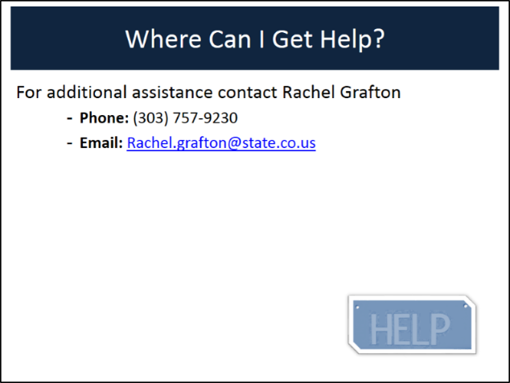 | You have completed the process of submitting a Badge. If you have any questions about the process contact Rachel Grafton at (303) 757-9230 or email her at Rachel.grafton@state.co.us.

