Screen | Script
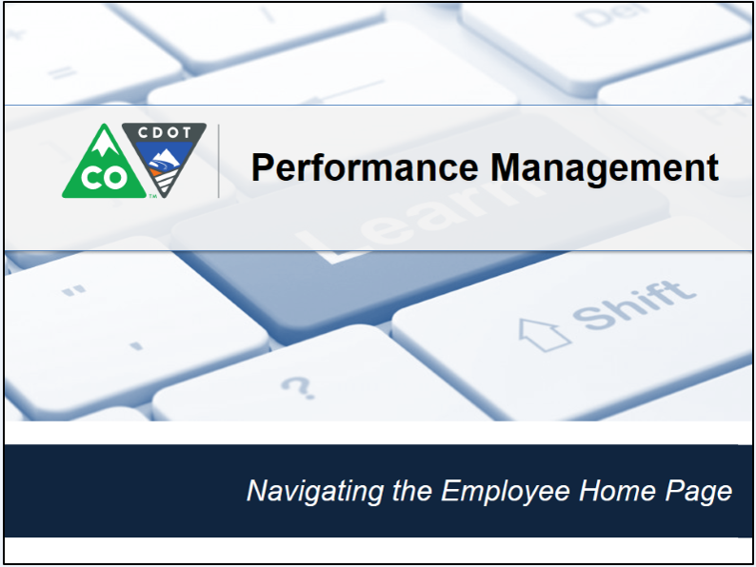 | This video shows you how to acknowledge a goal plan that has been sent to you by you manager.
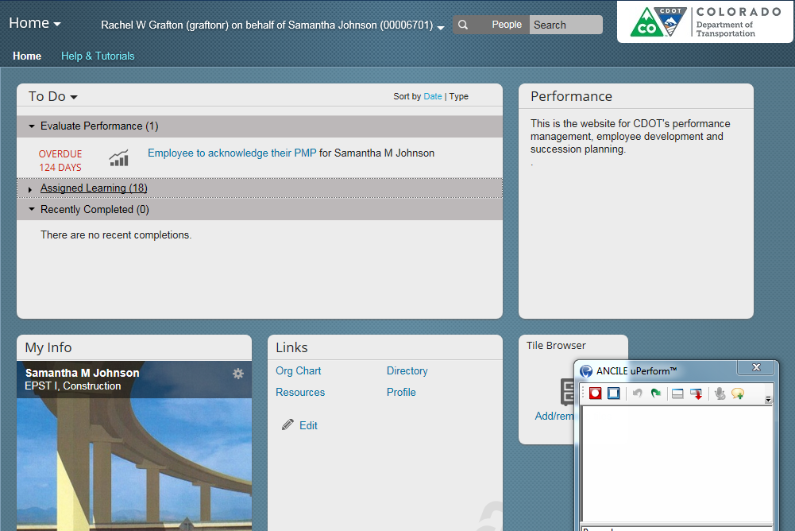 | Typically you have one week to review and acknowledge your goals. The dates you must acknowledge the goals by are April 8th and October 17th. Now let’s get started. The acknowledgement displays in the To Do tile under the Due now section of the screen. Don’t worry if it does not match exactly, what is on this screen. Now click on the link titled Employee to acknowledge their PMP followed by your name. This takes you to the Performance page.
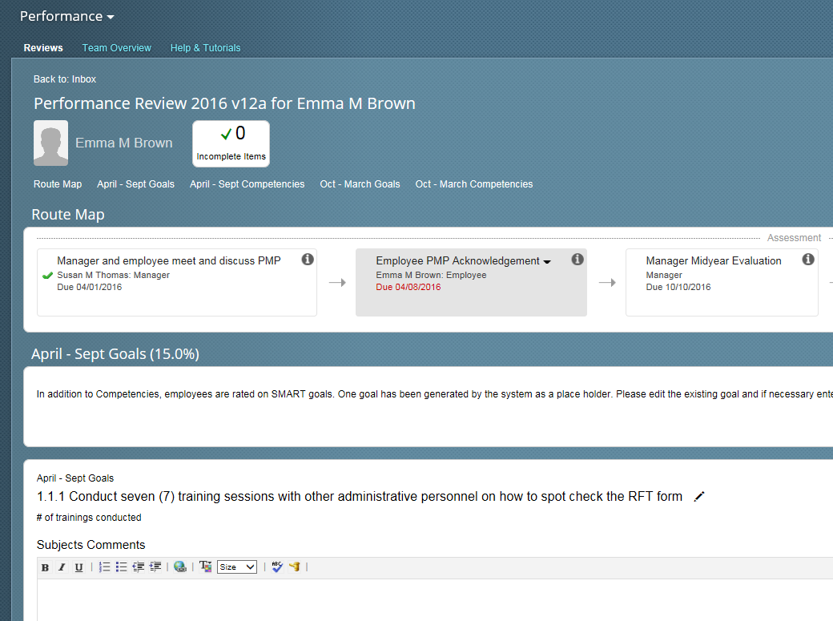 | Before we acknowledge the goal let’s take a look at a couple of things on the screen. The first is the route map this shows you what has been completed, and what needs to be done. In this example, there is a check showing that you and the manager have met to discuss the PMP. Also you can see that you acknowledgement is due by April 8th.
 | Now let’s scroll down to the first goal. If you want you can use the subjects Comments section to comment.
 | Now let’s scroll down to the April to September competencies. Each of the competences display, and like the goals, you can add comments to the form.
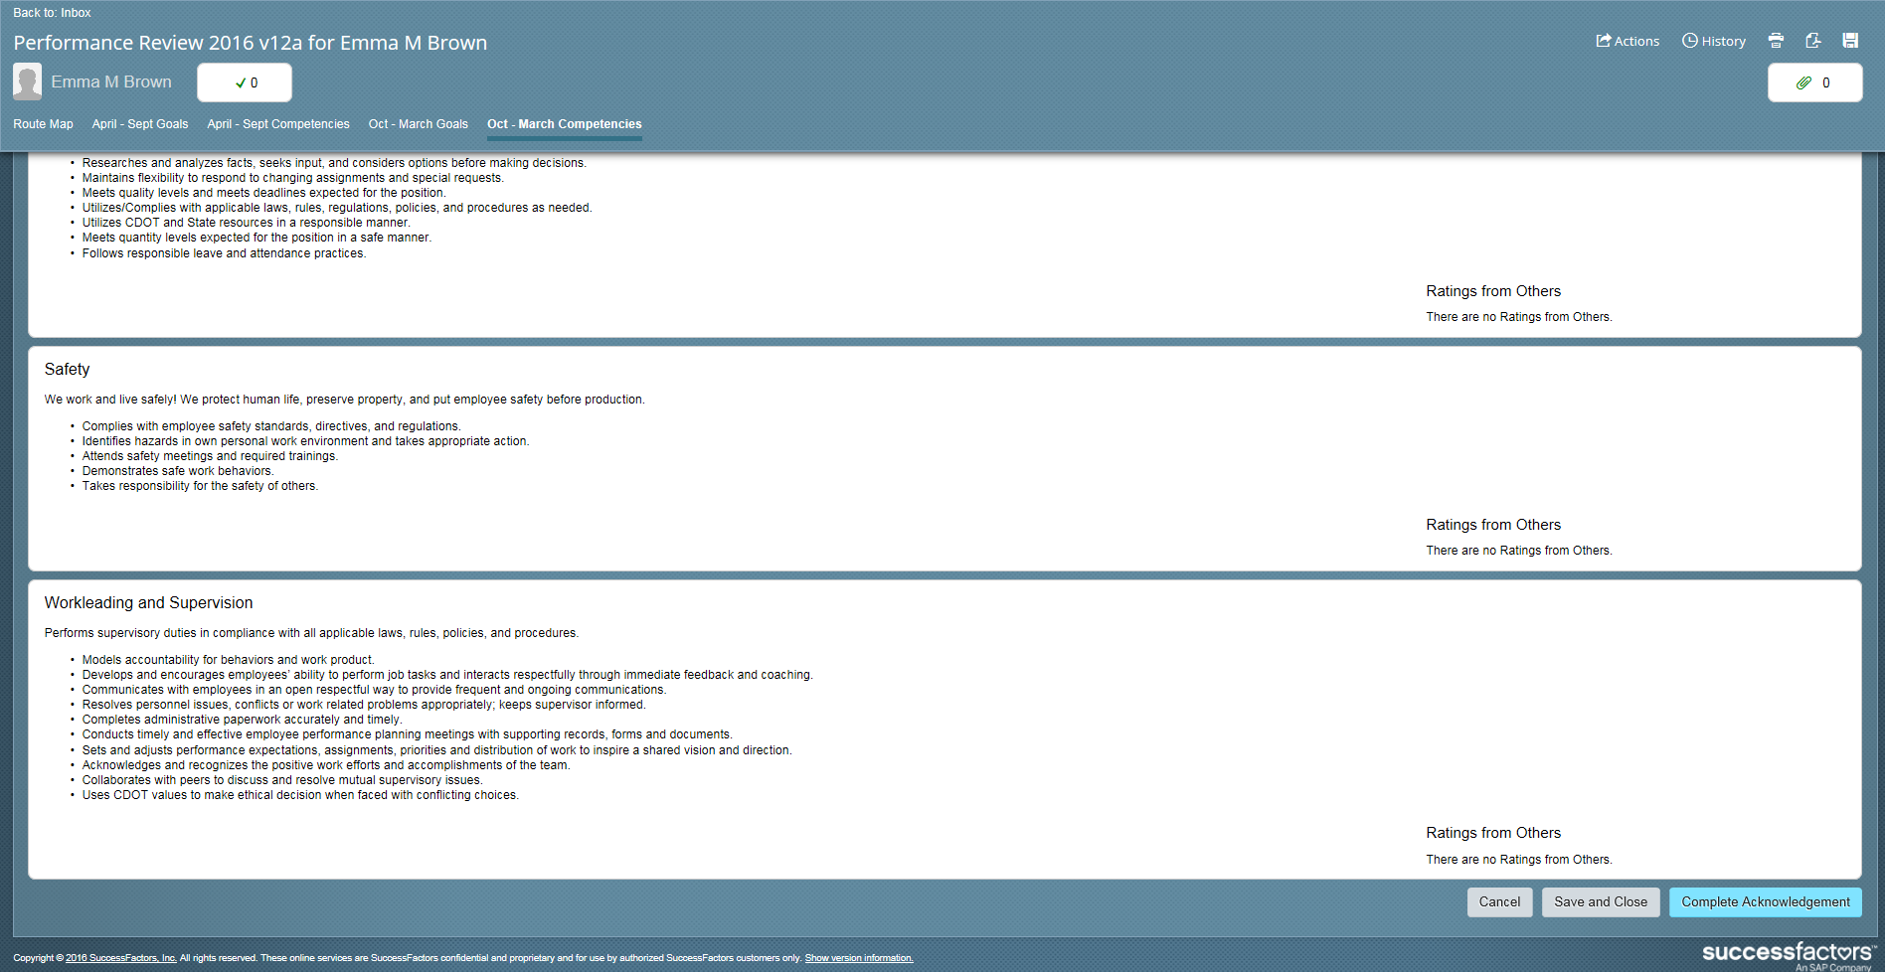 | Now let’s go through the process of acknowledging the performance plan. Scroll down to the bottom of the form. Select the blue complete acknowledgement button the lower right hand corner of the screen. The screen updates and you are taken to the Performance Review page for the year.
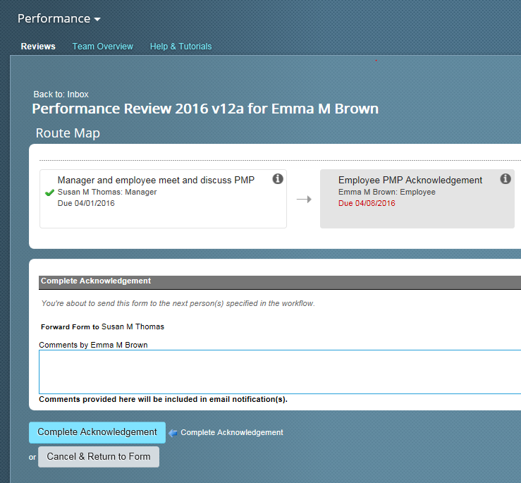 | Under the complete acknowledgement section you can enter any comments you have about the form in the comments section. For example, “I look forward to working on this with you”. Now select the Complete Acknowledgment form button.
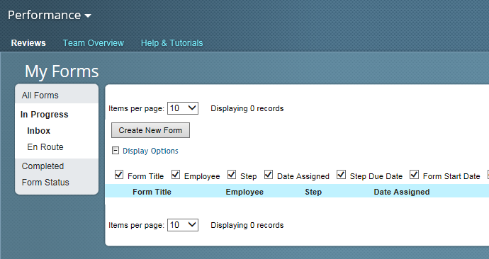 | This takes you back to the My Forms section and the form no longer displays because it is En Route to your manager. Now let’s look at how to see where the form is located. To display where the form is click on the En Route button
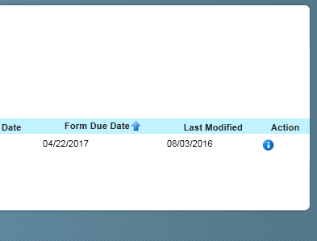 | The screen updates and you can see who the form is currently with. In this example it is with Susan Thomas. To display the form all you need to do is click on the title of the form. Let’s do that now.
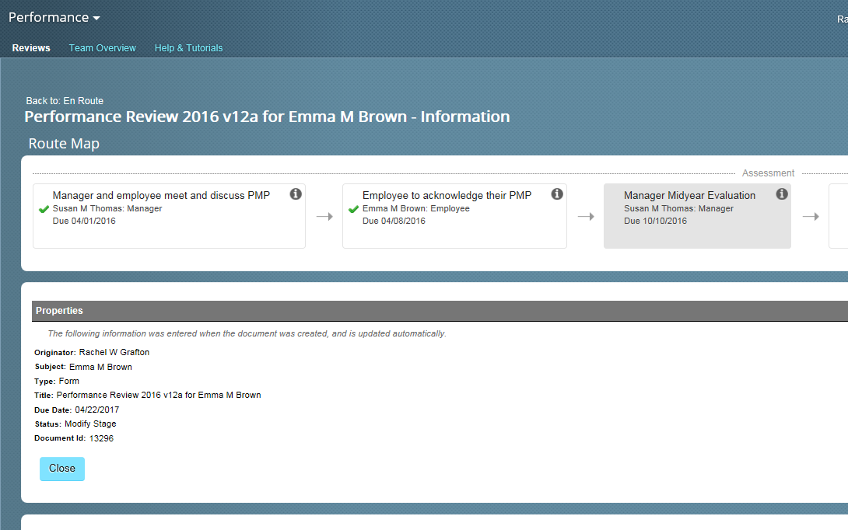 | The performance review form displays. The route map displays where the form is and also when it is due. In this case it is with Susan and is due back on October 10th.
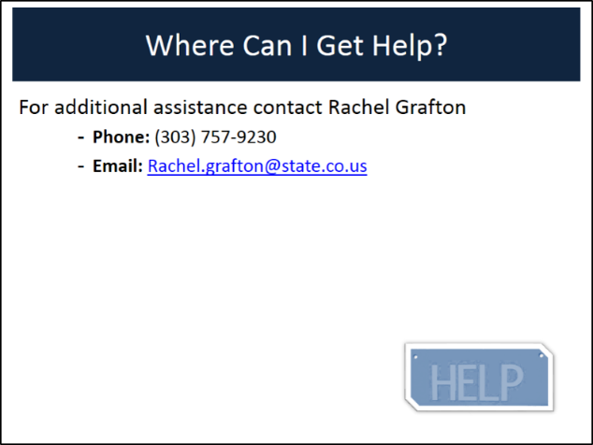 | You have completed the process of acknowledging a goal and displaying the form. If you have any questions about the process contact Rachel Grafton at (303) 757-9230 or email her at Rachel.grafton@state.co.us.
Start at 1:20 to replace. | Great, Now select the blue complete acknowledgment button in the lower right hand corner of the screen. The screen will update and you will be taken to the performance review page for the year.

