Screen | Script
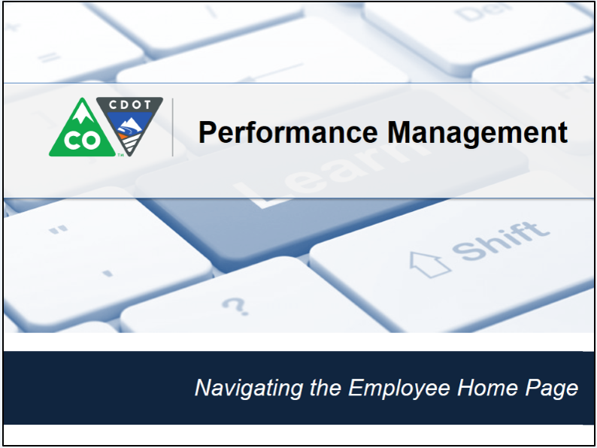 | This video shows you how to navigate the SuccessFactors home page.
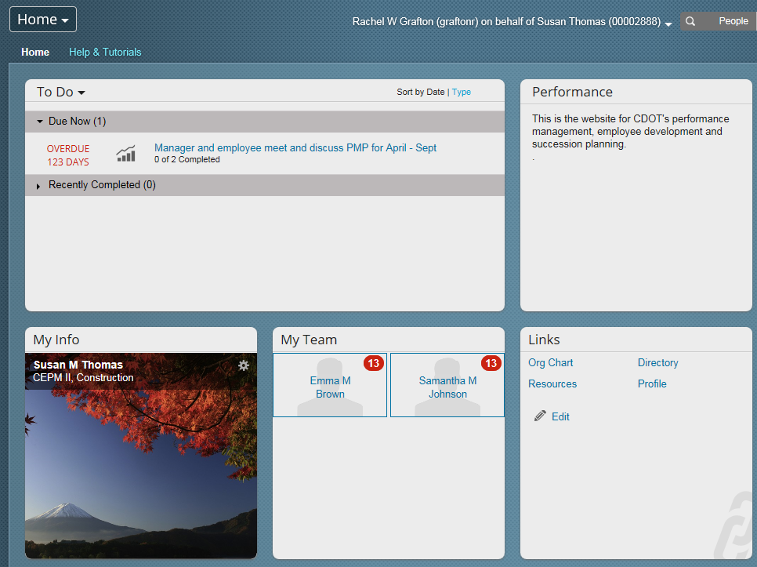 | Let’s start from the performance management home page this can be accessed through the SAP Portal. In the top left corner of the screen is a triangle next to the word home. Let’s click on it now. From here you can access other performance management pages. The most common are Goals and Performance. Goals will take you to your own goals and Performance will take you to your (performance inbox where you can view your performance form) Now let’s look at the rest of the page.
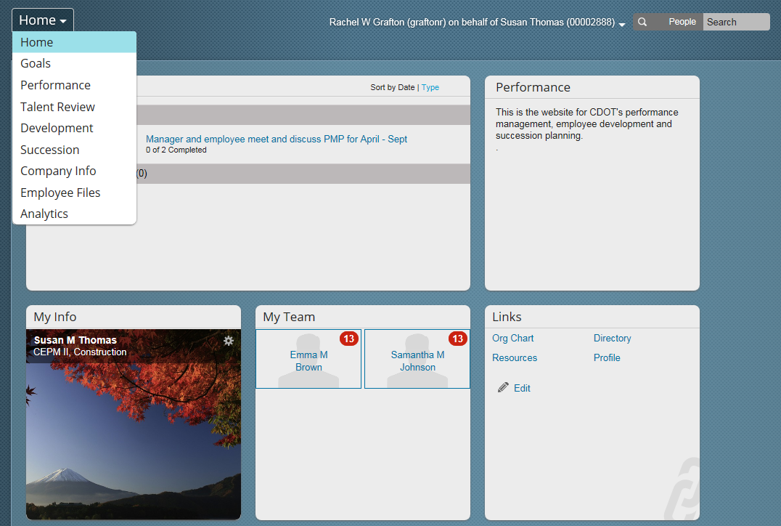 | In the top left corner of the screen is a triangle next to the word home. You can click here to access the other performance management pages. The most common are Goals and Performance. Goals will take you to your own goals and Performance will take you to your (performance inbox where you can view your performance form) team’s goals, if you are a supervisor. Now let’s look at the rest of the page.
 | The Home page is broken out into tiles. Tiles are like folders and are used to group like information. The tiles can be expanded or shrunk by hovering over the right hand corner of the tile and then left clicking. Let’s practice this by reducing the size of the My info tile by hovering over the right hand corner. When the icon displays you can then shrink the tile. To expand it, hover over the right corner of the tile and right click on the icon that displays. The tile returns to the size it was originally.
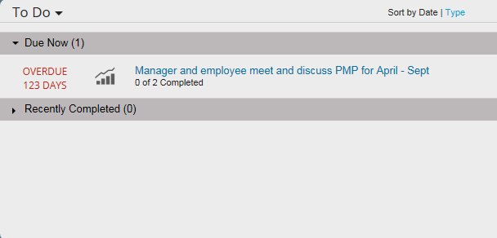 | Now let’s look at the functionality of the tiles. The To Do tile displays the actions that you need to take that are currently due. It also displays the actions you have recently completed. You can use the triangles to the left of the words to display or hide information.
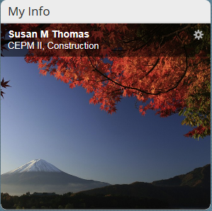 | My Info displays your name and position. Clicking on the cog icon, allows you to access you profile and other pages, such as your goal plan and organizational Chart.
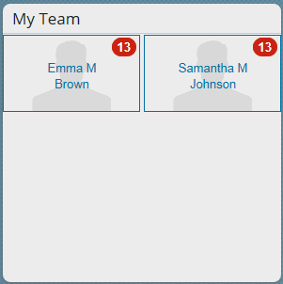 | Now, let’s take a look at the My Team tile which contains the employees you supervise, if you are a supervisor. From this tile you can click on tile of the employee to see the tasks that are due. This is also where you are able to write out notes and send a reminder using nudge.
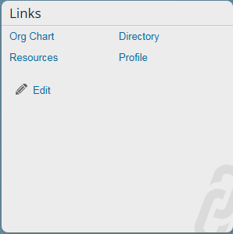 | The last tile is the Links tile. This contains links to the most common action you would typically perform. If you are a supervisor, the last tile is the Performance form status, which provides the completion percentage for your direct reports, but this is not displayed on this screen.
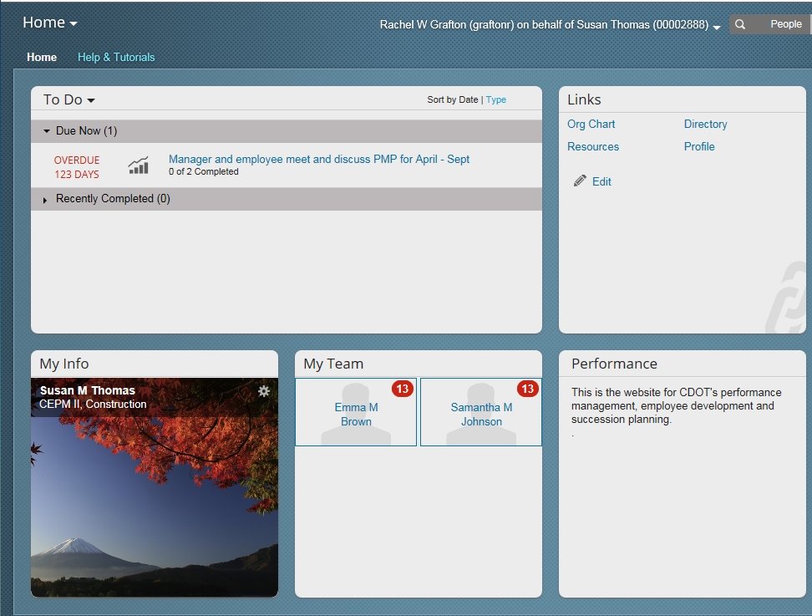 | Now let’s look at how you can customize the screen. To move a tile all you need to do is left click and hold on the top of the tile. Let’s practice this by moving the links tile.to where the performance tile currently is. As you can see the positon of the tiles has switched.
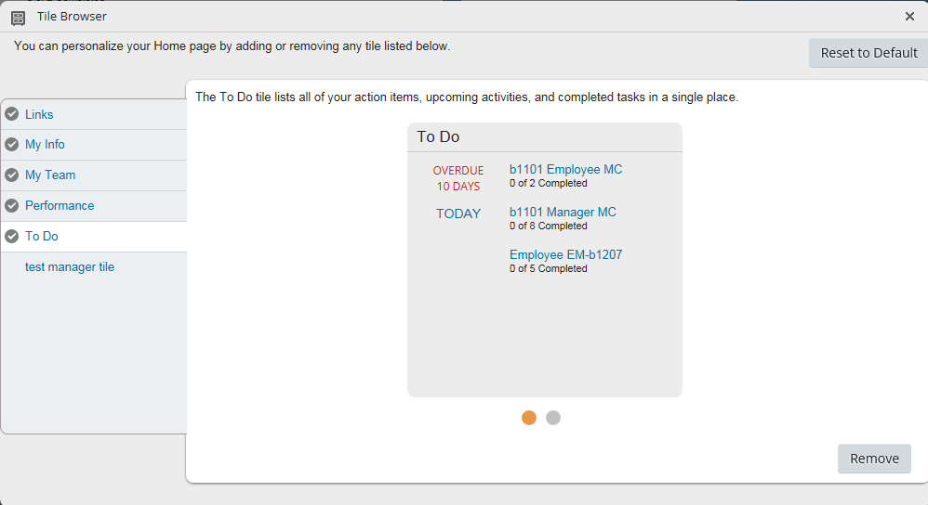 | In addition to moving tiles you can also add or remove them by using the tile browser tile. The tiles you see are depend on your roles and they can be added or removed by clicking the checkmarks. And one last thing, you can reset you tile bowser by clicking on the reset to default button in the upper right corner of the screen of the open Tile browser screen.
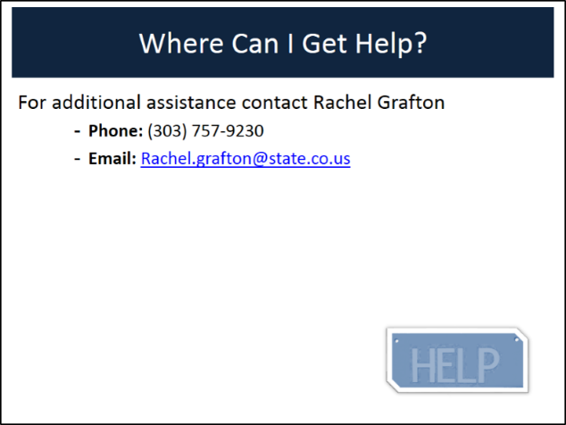 | You have completed the process of navigating SuccessFactors. If you have any questions about the process contact Rachel Grafton at (303) 757-9230 or email her at Rachel.grafton@state.co.us.

