Reviewer Approve the Final Recommended Rating
Step | Action
 | You will get a system generated email when the supervisor has selected the final recommended rating and has sent it.
A | Sign into the system  (Copy and paste this URL into an Internet Explorer Browser) http://sapprdep.dot.state.co.us:50000/irj/portal/sfprofile
 | Review the performance rating of all employees within your area
B | Click the home drop-down button
C | Select the Performance option 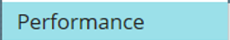 from the drop-down menu.
D | Click the Team Overview option from the menu. 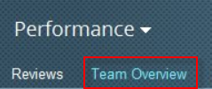
E | Click the My Team drop-down button to sort the employees in order of the performance ratings 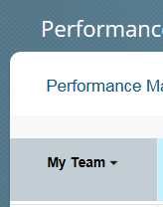
F | Review the distribution and decide if you agree or disagree with the final ratings.  The name of the employee is to the far left.  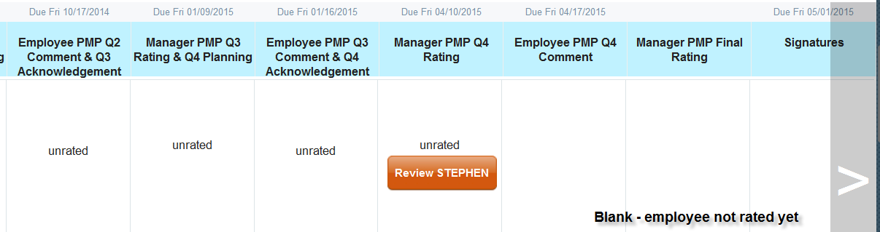  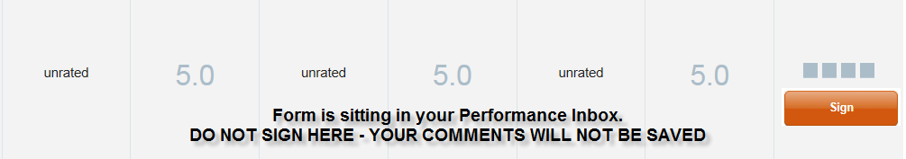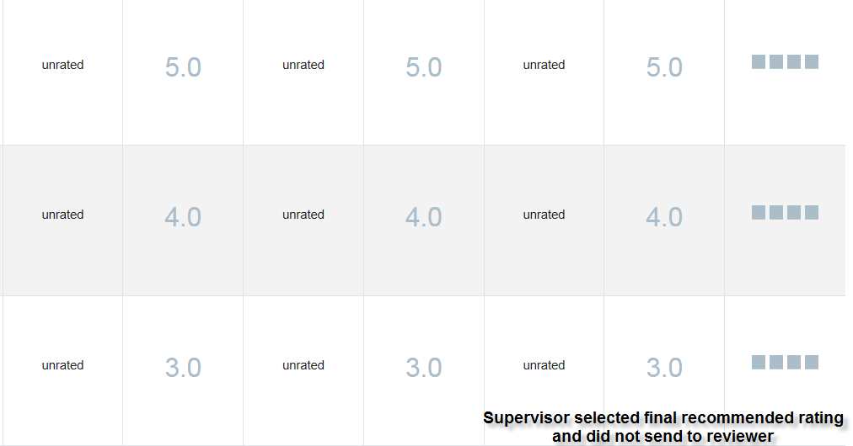
 | You are now ready to sign the performance forms
1 | Click the home drop-down button.
2 | Select the Performance option from the drop-down menu.
3 | Click the Reviews option from the menu  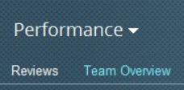
4 | Click on the link to the employee’s performance management plan.  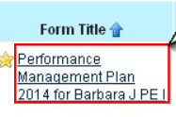
5 | Use the vertical scroll bar to move to the Final Rating Section (very bottom of the form).
6 | Review the Final Rating section of the screen.  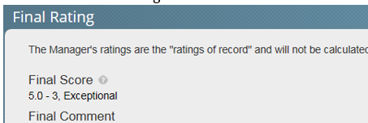
7 | Click in the comment box and enter your comments regarding the final rating.  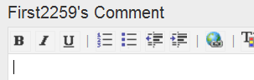
8 | If you do not agree with the rating, click on the Return to Evaluation button  If you agree with the rating, OR click on the Sign button.
9 | Click the Sign & Send To Division Manager field to enter a note sent to the supervisor via email an email.  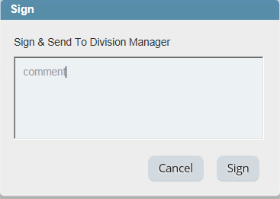
10 | Click Sign button. 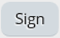
11 | To logout, click the drop-down button next to your user ID and then select the logout from the drop-down field.

