Employee Signs and Approves PMP Ratings
Step | Action
1 | Sign into the system.  (Copy and Paste this URL into an Internet Explorer browser)  http://sapprdep.dot.state.co.us:50000/irj/portal/sfprofile
2 | Click on the work item (blue link) in the Due Now section of the Performance home page.
3 | Select your name to continue to the PMP ratings for the quarter.
4 | Use the vertical scroll on the right side of the screen to move to the Final Rating sections of the screen.
5 | Scroll down to the Final Rating section to review your final score and comment for the performance year.  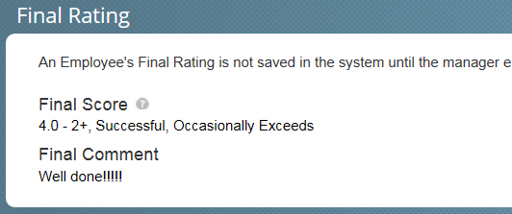
6 | Scroll down to the Signatures section to review the comment made by the Reviewer and your Supervisor.  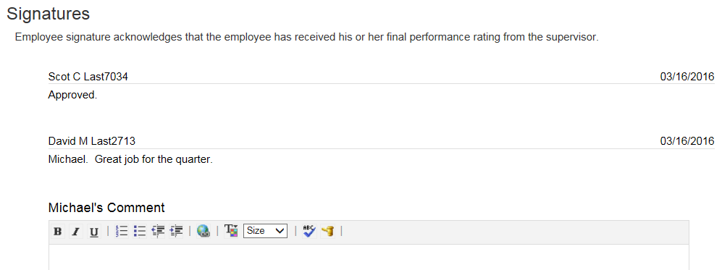
7 | Click on the Your Name Comment field and enter your comments on the rating for the Performance Plan year.
8 | Click Complete Review .
9 | Enter comments you want to be sent to the supervisor in the Complete Comments field.  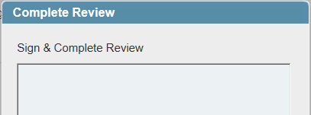
10 | Click Complete Review .
11 | To logout, click the drop-down button next to your user ID and then select the logout from the drop-down field.

