Employee Acknowledge Performance Goals and Ratings
Step | Action
1 | Sign into the system.  (Copy and Paste this URL into an Internet Explorer browser)  http://sapprdep.dot.state.co.us:50000/irj/portal/sfprofile
2 | Click on the work item (blue link) in the Due Now section of the Performance home page.
3 | Select your name to continue to the PMP ratings for the quarter.
4 | Use the vertical scroll on the right side of the screen to move to the first action item.
5 | Goal: Click on the area on the right of the screen by the word goal.  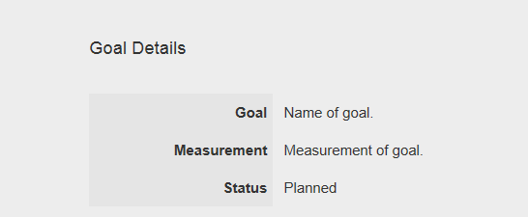
6 | Goal: Click Other Rating to display your goal rating and the supervisor’s comments.  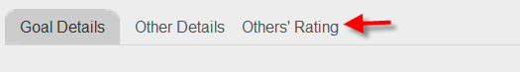
7 | Goal: Click on the Comment Box to the left of your rating to comment on your goal rating and completion.  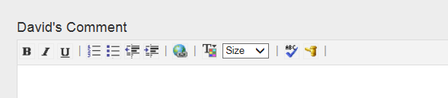
8 | Goal: Complete this process for each additional goal.
9 | Competencies: Scroll down to the first competency.
10 | Competencies: Click on the area on the right of the screen to display the competency rating and supervisor’s comment.  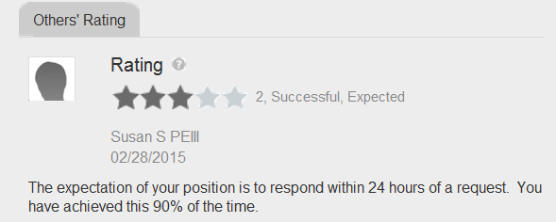
11 | Competencies: Click on the Comment Box to the left of your rating to comment on your competency rating and completion.
12 | Competencies: Repeat this process for each rated competency.  - Accountability/Credibility  - Communication/Interpersonal Skills  - Customer Service  - Job Performance  - Safety  - Work leading/Supervision
13 | Use the vertical scroll bar to move through the form to the very bottom to find the Complete Comments.
14 | Click Complete Comments .
Enter comments you want to be sent to the supervisor in the Complete Comments & Acknowledgements field.
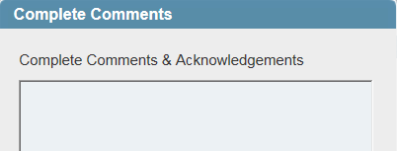
15 | Click Complete Comments .
16 | To logout, click the drop-down button next to your user ID and then select the logout from the drop-down field.

