Screen | Script
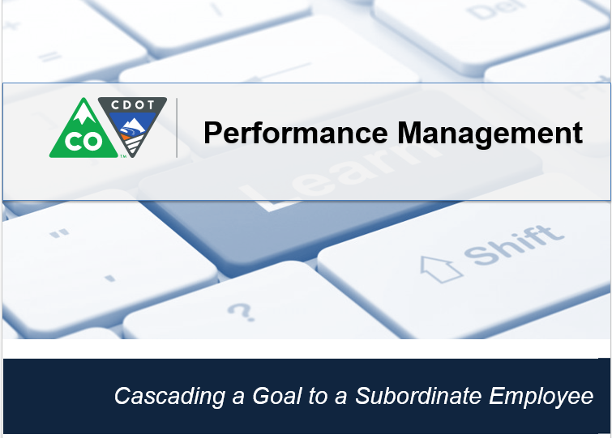 | This video shows you how to cascade a goal to the Performance Management Plan to a subordinate employee
In this example, you are a manager with new employee who supervises. To simplify the goal creation you are assigning one of your goals to Barbara, the new Supervisor. This is known as cascading a goal. When you cascade a goal you can assign the goal to multiple people.

Let’s get started by clicking on the Home screen drop-down and select Goals from the drop-down menu.
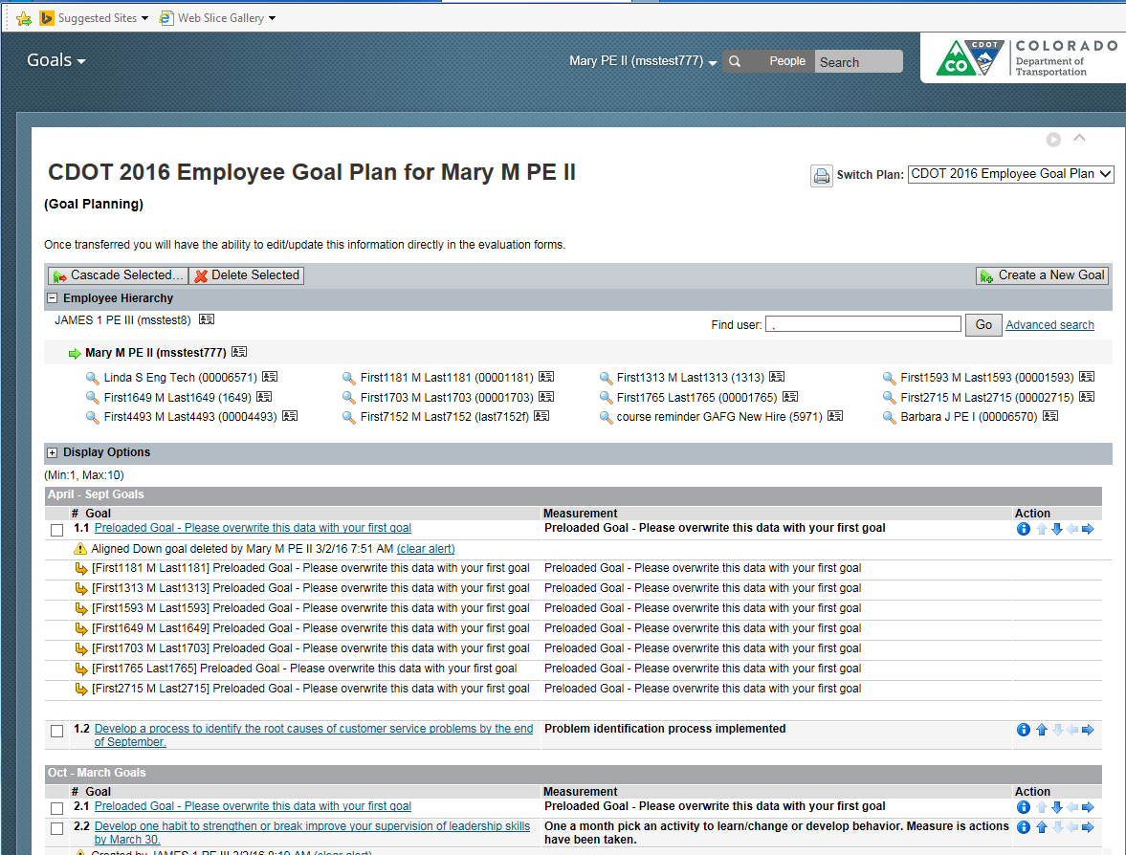 | The Goals screen displays. From here select the checkbox of the Goal you want to cascade to the new supervisor. If you do not see the goal in your list, you can add it by using the Create a new goal button. In this example the goal, “Develop or break one habit to strengthen and improve your supervision or leadership skills by September 30th” is there. Don’t worry if it is not perfect, you are able to make modifications to the goal later. Now select the button called Cascade Selected.
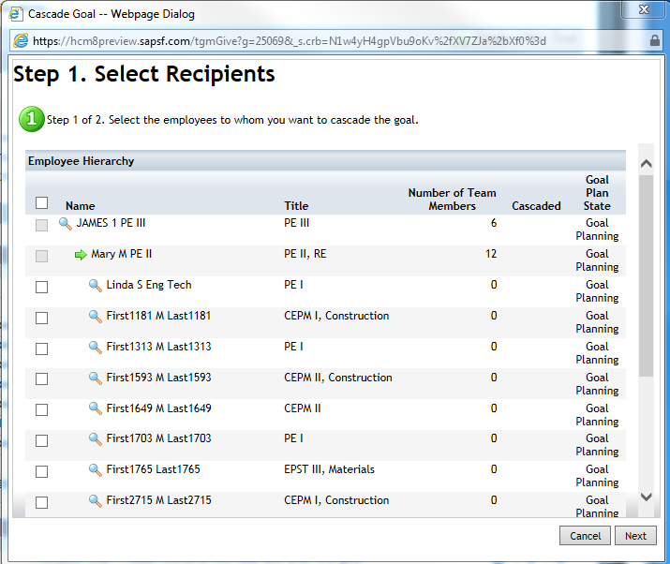 | The Select Recipients screen displays. Now all we have to do is to select any employees you are assigning the goal. In this example it is only Barbara. So let’s select the check box by her name and then the next button.
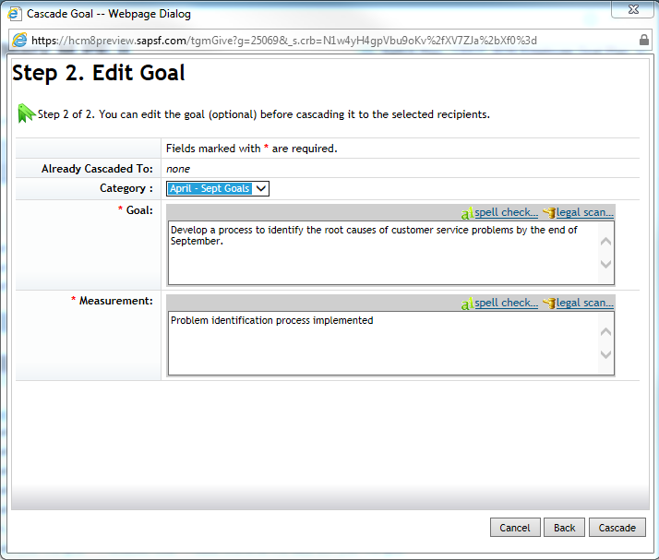 | The edit goal screen displays. From here you can change the goal and the measurement. But this is a mandatory goal for all supervisors so it needs to be sent as is. Click the cascade button to assign the goal to the new supervisor.
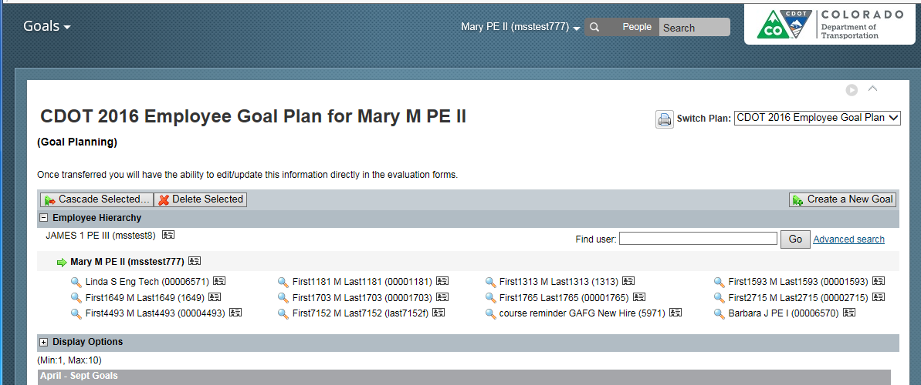 | The goal has been cascaded. Now let’s check to make sure it is has been cascaded to Barbara by clicking on the magnifying glass next to Barbara’s goal plan
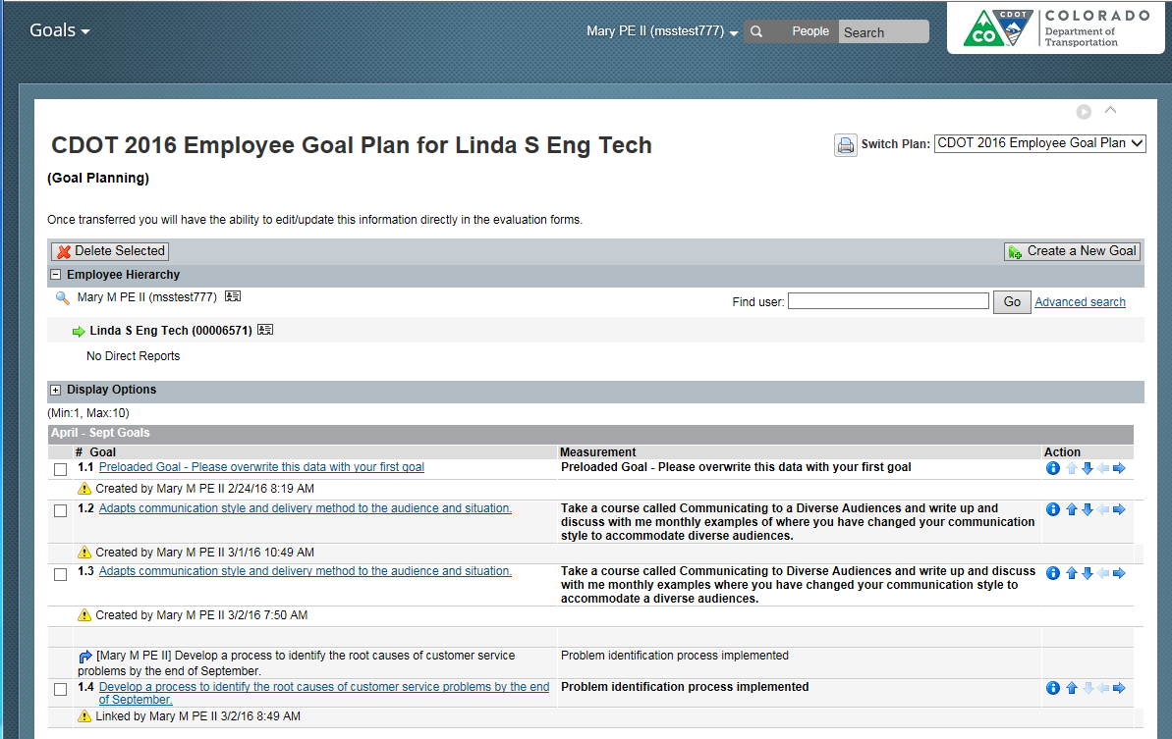 | The Goal plan for Barbara displays. The goal now displays in April to September section of her goal plan. Now let’s learn about who to contact if you need help.
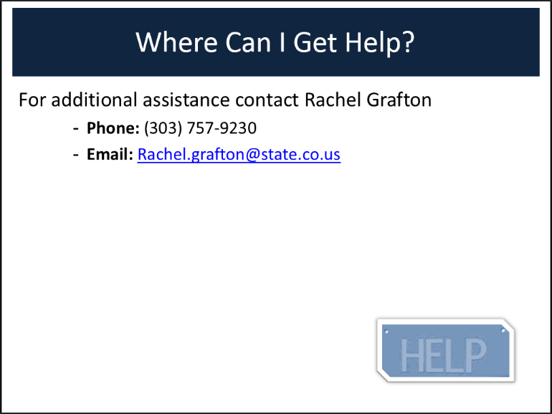 | For assistance contact Rachel Grafton at 303-757-9230. This concludes this presentation.

