Screen | Script
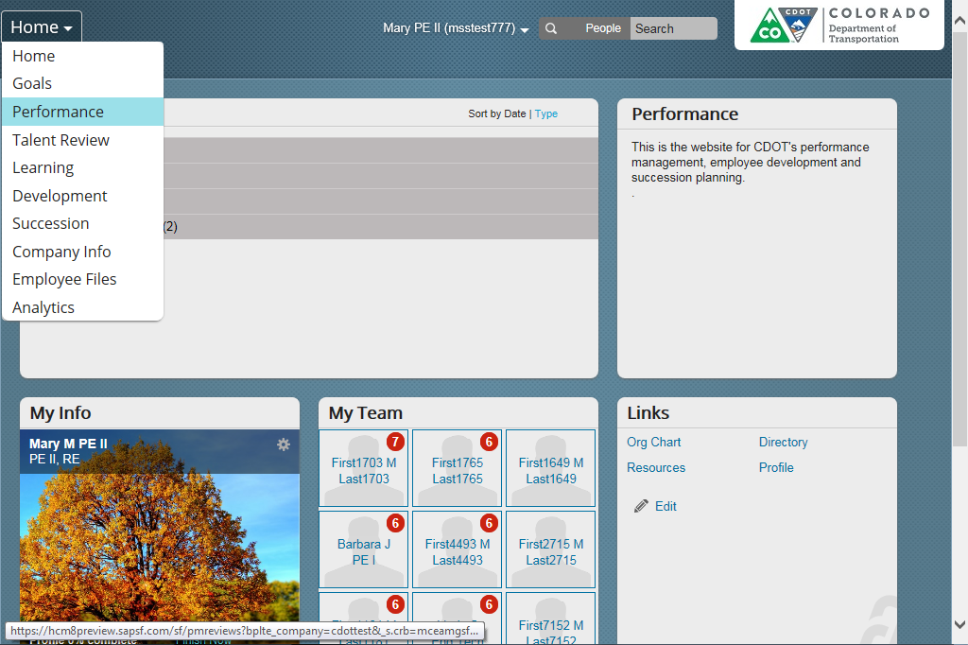 | This video shows you how to add a library goal to the Performance Management Plan.  A library goal is a goal that has been created for you to use as is or to modify and assign. These goals were written in alignment with CDOT’s Performance Program. To add a Library goal, start with the employee’s Performance Management Plan. In this case, its Barbara, so let’s start by navigating to her Performance Management Plan.  Click on the Home screen drop-down and select Performance from the drop-down menu.
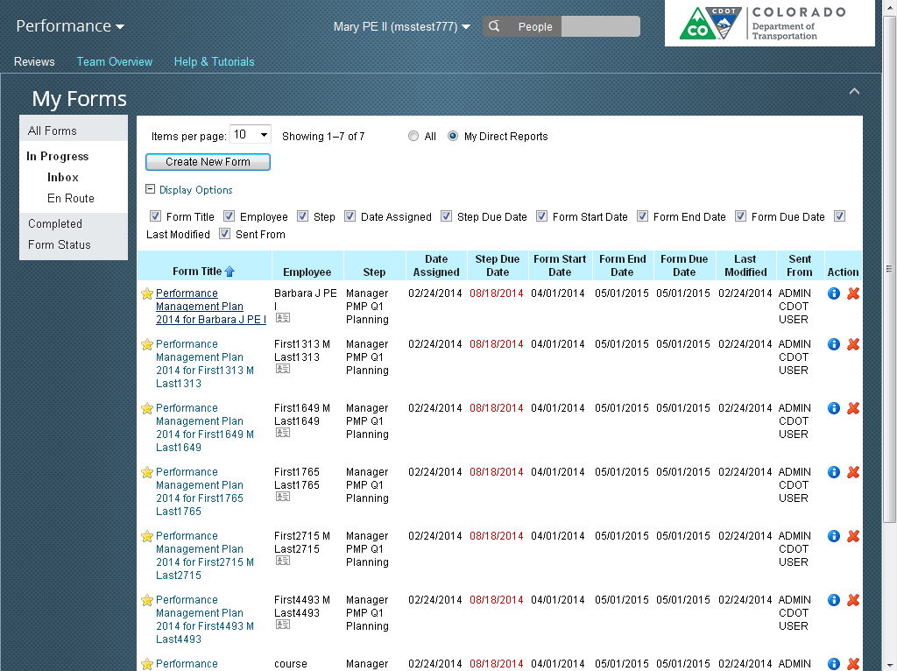 | The Performance screen displays. From here select the Performance Management Plan of the Employee you want to add a Library goal. We already know it’s Barbara, so let’s select her PMP.
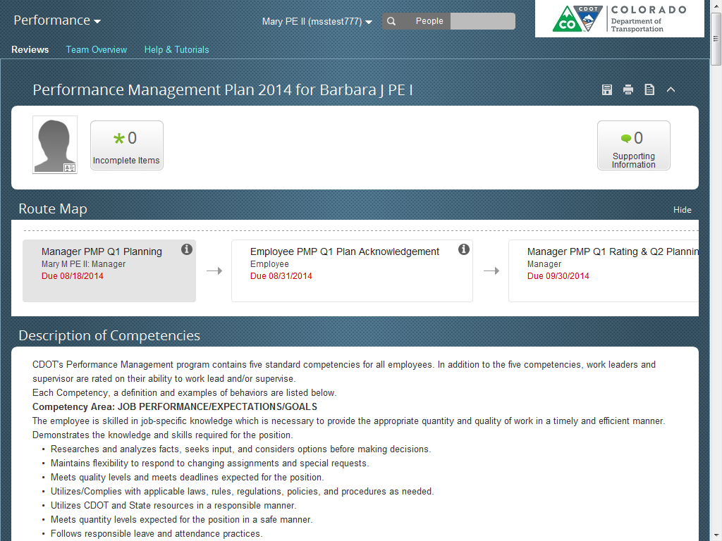 | The 2016 PMP for Barbara displays. Now all we have to do is to scroll down until we see the Add Goal button. Now, let’s click on it so we can go to the Create a New Goal pop-up window.
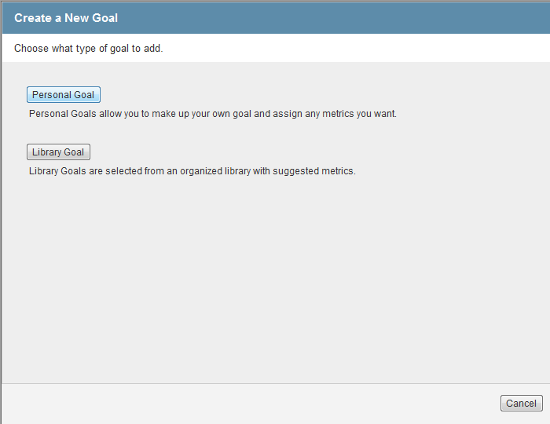 | There are two kinds of goals you can add. A personal goal, which is created from scratch and a library goal which only needs minor modifications.  Now, let’s select the Library goal button.
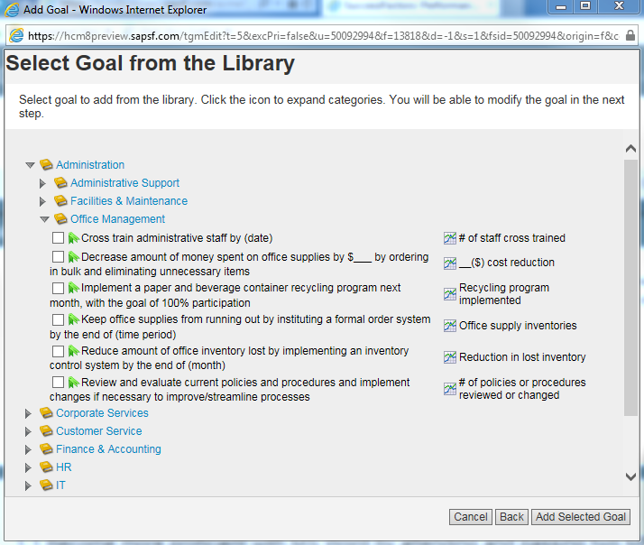 | The select Goal from Library screen displays. Open the folder of the type of goal you want to create. In this case its Communication, so let’s open that folder and then the Effective folder. There are six goals in this section.  Let’s select the first goal by clicking on the checkbox. Don’t worry if it is not perfect, you are able to make modifications on the next screen.  Close the window by clicking the Add Selected Goal button.
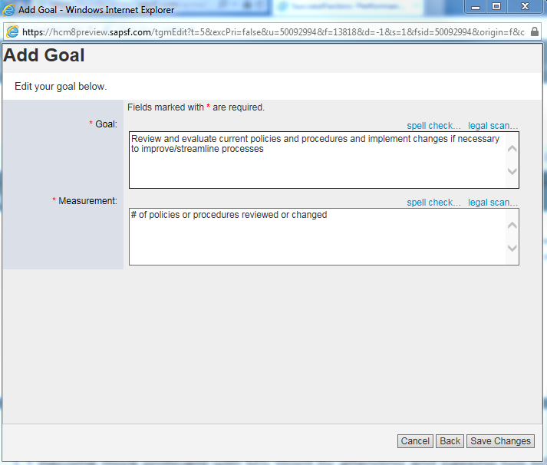 | The Add Goal screen displays with the selected library goal. You are familiar with screen, the goal, “Adapts communication style and delivery method to the audience and situation” reads fine so no changes are required.  So let’s look at the measurement. In this case, we want to write up an example of how the goal is going to be measured. For example, “Take a course called Communicating to Diverse Audiences and write up and discuss with me monthly examples where you have changed your communication style to accommodate a diverse audiences.”  Now all that needs to be done is to click the Save Changes button and the goal has been added to the Performance Plan. You are also returned to the Performance plan screen.
 | The Library goal has been edited. Now let’s check to make sure it is there by scrolling down. Great! There’s the modified library goal.

