Behavioral statements from the 2016 Performance Management Plan Supervisory Competency
Rank order the following statements from 1 – 10; with 1 being the behavior that you demonstrate consistently on a day to day basis and 10 being the behavior that you need some help with.

- Models accountability for behaviors and work product

- Develops and encourages employees; ability to perform job tasks and interacts respectfully through immediate feedback and coaching

- Communicate with employees in an open respectful way to provide frequently and ongoing communication

- Resolves personnel issues, conflicts or work related problems appropriately, keeps supervisor informed

- Completes administrative paperwork accurately and timely

- Conducts timely and effective performance planning meetings with supporting records, forms and documents

- Sets and adjusts performance expectations, assignments, priorities and distribution of work to inspire a shared vision and direction

- Acknowledges and recognizes the positive work efforts and accomplishments of the team

- Collaborates with peers to discuss and resolve mutual supervisory issues

- Uses CDOT values to make ethical decisions when faced with conflicting choices.

The Influencer checklist
☐ Personal motivation: If people don’t find the behavior appealing, how can we get them to try it (or at least have them experience the benefits vicariously) and connect it to other things they value? If someone likes doing it, how can we reinforce the behavior by recognizing their accomplishments and encouraging them to do more?
☐ Personal Ability: How can we make it simpler to start? And how can we provide people with opportunities to practice the behavior and attain achievable goals while giving them immediate feedback on ways to get even better?
☐ Social motivation: Who are influential leaders who can model the vital behavior? And can we identify relevant peer groups who are already behaving in the desired way?
☐ Social ability: How can we develop social ties – e.g., buddy systems, peer support groups, advocate programs – that can help an individual get better at the vital behavior?
☐ Structural motivation: What are extrinsic rewards we can put in place that are immediate, gratifying, and clearly tied to the vital behavior? (Only consider these rewards after intrinsic motivators and social support are in place.)
☐ Structural ability: How can we change the physical environment to make the vital behavior easier or to eliminate the things that pose a risk to that behavior?

Models accountability for behaviors and work product

Defined: When you’re personally accountable, you take ownership of situations that you’re involved in. You see them through, and you take responsibility for what happens – good or bad. You don’t blame others if things go wrong. Instead, you do your best to make things right.
Why: Personal accountability can save time and money, too. People who take responsibility for their actions speak up, and they look for solutions when there's a problem. This not only prevents the situation getting worse, but it stop costs and delays from escalating
When you hold people accountable, you make sure that they achieve the goals you have agreed, to the standards and deadlines you have set.
How:
- Admit you made a mistake and move on
- Do not blame others for your actions
- Say you are sorry
- Do not overcommit; only make promises for things that are within your ability and control
INFLUENCE CHART
 | MOTIVATION (Why) | ABILITY (How)
PERSONAL | What is your Why? | Practice the new skill
SOCIAL | All of CDOT is doing it | Learn with a co-worker
STRUCTURAL | Reward yourself | Change your environment

Group’s idea for actions that would improve this behavior:
______________________________________________________________________________________________________________________________________________________________________________________________________________________________________________________________________________________________________________________________________________________________________________________________________________________________________________________________________________________________________________________________

2. Develops and encourages employees; ability to perform job tasks and interacts respectfully through immediate feedback and coaching

Defined: Provides information such as instruction, resources, tools, manuals, and correction to employees so that they understand expectations, have the motivation, and the ability to perform their job tasks.
Why: Helping employees grow will not only make them happier and more engaged; they will provide better customer service.
When you teach employees how to perform their job functions, you will grow trust in their abilities.
How:
- Deliver verbal messages face to face when you notice the event (both positive and negative)
- Send an email when a milestone is met
- Take the opportunity to show how a task needs to be completed
- Work as a team to perform the task (switch roles so everyone has a turn)
INFLUENCE CHART
 | MOTIVATION (Why) | ABILITY (How)
PERSONAL | What is your Why? | Practice the new skill
SOCIAL | All of CDOT is doing it | Learn with a co-worker
STRUCTURAL | Reward yourself | Change your environment

Group’s idea for actions that would improve this behavior:
______________________________________________________________________________________________________________________________________________________________________________________________________________________________________________________________________________________________________________________________________________________________________________________________________________________________________________________________________________________________________________________________

3. Communicate with employees in an open respectful way to provide frequent and ongoing communication

Defined: Humans communicate to convey information, to establish and maintain a relationship, to conform to social conventions, and to express a need or want.
Why: Disrespectful communication immediately places the listener in an adversarial, and probably hostile frame of mind, and encourages them to disregard or dispute anything that is said.
According to Harvard Business Review; the number one reason employees quit their jobs is because of a poor quality relationship with their direct supervisor.
How:
- Schedule time to meet with each of your employees at least once every two weeks. When you meet with them, find out how you can help them be better at what they do.
- Talk to your employees like you were talking to your grandmother. Do not say things that you would regret or would not want to be repeated.
- Rephrase your statement from a “you screwed-up” to I see that there might be a problem with the …, let us see what we can do.
- Sometimes you just need to say hello to everyone, so that they understand you recognize their presence.
INFLUENCE CHART
 | MOTIVATION (Why) | ABILITY (How)
PERSONAL | What is your Why? | Practice the new skill
SOCIAL | All of CDOT is doing it | Learn with a co-worker
STRUCTURAL | Reward yourself | Change your environment

Group’s idea for actions that would improve this behavior:
______________________________________________________________________________________________________________________________________________________________________________________________________________________________________________________________________________________________________________________________________________________________________________________________________________________________________________________________________________________________________________________________

4. Resolves personnel issues, conflicts or work related problems appropriately, keeps supervisor informed

Defined: Conflict is a normal part of any social and organizational setting. The challenge of conflict lies in how you choose to deal with it.
Why: Supervisors who don’t deal with conflict will eventually watch their good talent walk out the door in search of a healthier and safer work environment.
When issues are ignored or not addressed as soon as possible, they grow into much bigger problems and are harder to resolve.
How:
- Provide clear, concise, accurate, and timely communication of information
- Prevent some issues by defining acceptable behavior so everyone knows the rules prior to high emotional events
- Minimize the severity by addressing the ISSUE immediately, focus on behaviors not emotions
- Understand the perspective of others before communicating (What is it in for me)
- View the conflict and a learning or teaching opportunity
INFLUENCE CHART
 | MOTIVATION (Why) | ABILITY (How)
PERSONAL | What is your Why? | Practice the new skill
SOCIAL | All of CDOT is doing it | Learn with a co-worker
STRUCTURAL | Reward yourself | Change your environment
Group’s idea for actions that would improve this behavior:
______________________________________________________________________________________________________________________________________________________________________________________________________________________________________________________________________________________________________________________________________________________________________________________________________________________________________________________________________________________________________________________________

5. Completes administrative paperwork accurately and timely

Defined: Supervisory paperwork such as timesheets, invoice approvals, project plans, and other tasks related to the management of people and resources are completed correctly and on time as to not cause others extra work.

Why: A delay in completing supervisory approvals can cost CDOT money in terms of late fees and time spent chasing paper.
Submitting mistakes on the paperwork causes you and others to spend more time correcting the mistakes.

How:
- Set calendar reminders to complete tasks on-time
- Request help or have someone double check the work prior to final submittal
- Delegate portions of the task to others that can assist in the process

INFLUENCE CHART
 | MOTIVATION (Why) | ABILITY (How)
PERSONAL | What is your Why? | Practice the new skill
SOCIAL | All of CDOT is doing it | Learn with a co-worker
STRUCTURAL | Reward yourself | Change your environment

Group’s idea for actions that would improve this behavior:
______________________________________________________________________________________________________________________________________________________________________________________________________________________________________________________________________________________________________________________________________________________________________________________________________________________________________________________________________________________________________________________________

6. Conducts timely and effective performance planning meetings with supporting records, forms and documents

Defined: There are two components to performance – performance appraisal and performance management. One is all about compliance by meeting DPA’s and CDOT’s program requirements, the other is about people, communication, dialogue and working together to help employees succeed in their positions.
Why: Clearly set job and performance expectations so that you can reduce your need to micromanage employees.
Provide context and meaning for employees, thus increasing employee engagement and motivation.
How:
- Define the steps, schedule and plan ahead
- Write notes, Performance Documents, or emails throughout the performance year
- Prepare yourself and request your employees to prepare for the performance planning meeting
- Roleplay or practice with another person the delivery of your messages
INFLUENCE CHART
 | MOTIVATION (Why) | ABILITY (How)
PERSONAL | What is your Why? | Practice the new skill
SOCIAL | All of CDOT is doing it | Learn with a co-worker
STRUCTURAL | Reward yourself | Change your environment

Group’s idea for actions that would improve this behavior:
______________________________________________________________________________________________________________________________________________________________________________________________________________________________________________________________________________________________________________________________________________________________________________________________________________________________________________________________________________________________________________________________

7. Sets and adjusts performance expectations, assignments, priorities and distribution of work to inspire a shared vision and direction

Defined: Employees want to feel valued and connected to something. By showing them how their work fits into the overall vision and objectives of the Department, you can create a sense of belonging. Job responsibilities need to be modified to reflex the changes in business direction, new processes and rules, and day to day weather conditions. Work expectations should be communicated and adjusted to meet these needs.
Why: Building in flexibility and adjusting assignments allows an employee to understand priorities and meet assignment deadlines.
Directing employees to changing situations that are accomplished makes you look good when crisis are handled quickly and effectively.
How:
- Communicate the changing situation with clear direction and expected outcome
- Clarify the expected outcome and timeframes and why this has become a priority
- Explain why you have asked the employee to change direction or switch priorities
INFLUENCE CHART
 | MOTIVATION (Why) | ABILITY (How)
PERSONAL | What is your Why? | Practice the new skill
SOCIAL | All of CDOT is doing it | Learn with a co-worker
STRUCTURAL | Reward yourself | Change your environment
Group’s idea for actions that would improve this behavior:
______________________________________________________________________________________________________________________________________________________________________________________________________________________________________________________________________________________________________________________________________________________________________________________________________________________________________________________________________________________________________________________________

8. Acknowledges and recognizes the positive work efforts and accomplishments of the team

Defined: Provide verbal recognition and genuine appreciation towards your employees and team efforts that resulted in a job well done or situation averted.
Why: It takes 5 positive interactions to erase one negative conversation. Ongoing, meaningful rewards and recognition provide an effective, low cost way of raising morale and encouraging higher levels of performance
How:
- Hand write a thank you note
- Greet others by name
- Recognize when an employee does something above and beyond their normal
- Encourage employees to submit their suggestion to the every ideas program
- Have monthly breakfast with groups of employees.
INFLUENCE CHART
 | MOTIVATION (Why) | ABILITY (How)
PERSONAL | What is your Why? | Practice the new skill
SOCIAL | All of CDOT is doing it | Learn with a co-worker
STRUCTURAL | Reward yourself | Change your environment

Group’s idea for actions that would improve this behavior:
______________________________________________________________________________________________________________________________________________________________________________________________________________________________________________________________________________________________________________________________________________________________________________________________________________________________________________________________________________________________________________________________

9. Collaborates with peers to discuss and resolve mutual supervisory issues

Defined: Talk and seek advice from co-workers and managers when faced with handling supervisory issues for the first time.
Why: Using the experience and advice of others who have been through similar situations allows you to save time, resolve issues consistently, and get social support.
How:
- Establish a network of coworkers who you can call to discuss issues
- Be a resources to others, so they are willing when you need help
- Be open to others ideas and suggestions
INFLUENCE CHART
 | MOTIVATION (Why) | ABILITY (How)
PERSONAL | What is your Why? | Practice the new skill
SOCIAL | All of CDOT is doing it | Learn with a co-worker
STRUCTURAL | Reward yourself | Change your environment

Group’s idea for actions that would improve this behavior:
______________________________________________________________________________________________________________________________________________________________________________________________________________________________________________________________________________________________________________________________________________________________________________________________________________________________________________________________________________________________________________________________

10. Uses CDOT Values to make ethical decisions when faced with conflicting choices.

Defined: Safety Integrity People Customer Service Excellence Respect
Why: The success of any institution depends on a clear statement of values. These values must be clearly communicated, broadly understood and accepted. Values must shape individual and corporate behavior.

How:
- When faced with a decision do not make a snap decision
- Evaluate the consequences of the decision prior to deciding
- Ask yourself, what would (person) do in this situation

INFLUENCE CHART
 | MOTIVATION (Why) | ABILITY (How)
PERSONAL | What is your Why? | Practice the new skill
SOCIAL | All of CDOT is doing it | Learn with a co-worker
STRUCTURAL | Reward yourself | Change your environment

Group’s idea for actions that would improve this behavior:
______________________________________________________________________________________________________________________________________________________________________________________________________________________________________________________________________________________________________________________________________________________________________________________________________________________________________________________________________________________________________________________________

20 Annoying Interpersonal Behaviors to Stop
- Winning too much: The need to win at all costs and in all situations--when it matters, when it doesn't, and when it's totally beside the point.
- Adding too much value: The overwhelming desire to add our two-cents to every discussion.
- Passing judgment: The need to rate others and impose our standards on them.
- Making descriptive comments: The needleless sarcasms and cutting remarking that we think make us sound sharp and witty.
- Starting with "No," "But, or "However,": The overuse of these negative qualifiers which secretly say to everyone. "I'm right. You're wrong."
- Telling the work how smart we are: The need to show people we're smarter than they think we are.
- Speaking when angry: Using emotional volatility as a management tool.
- Negatively, or "Let me explain why that won't work.": The need to share our negative thoughts even when we weren't asked.
- Withholding information: The refusal to share information in order to maintain an advantage over others.
- Failing to given proper recognition: The ability to praise and reward.
- Claiming credit that we don't deserve: The most annoying way to overestimate our contribution to any success.
- Making excuses: The need to reposition to our annoying behavior as a permanent fixture so people excuse us for it.
- Clinging to the past: The need to deflect blame from ourselves and onto events and people from our past; a subset of blaming everyone else.
- Playing favorites: Failing to see that we are treating someone unfairly.
- Refusing to express regret: The inability to take responsibility for our actions, admit we're wrong, or recognize how our actions affect others.
- Not listening: The most passive-aggressive form of disrespect for colleagues.
- Failing to express gratitude: The most basic form of bad manners.
- Punishing the messenger: The misguided need to attack the innocent who are usually only trying to help us.
- Passing the Buck: The need to blame everyone but ourselves.
- An excessive need to be "me": Exalting our faults as virtues simply because they're who we are.

Ask for Help ...would you suggest two ideas that I can implement in the future to help me?
Idea | Idea
Idea One
Idea Two

Start with Why
Knowing your WHY is vital, for several reasons:
- Your WHY reminds you why you get out of bed every day to do whatever it is you do.
- Your WHY helps you easily make the decisions that are right for you.
- Your WHY shows you exactly who your right market is, who you should be speaking to, and who you should forget about trying to serve.
- Your WHY makes your marketing make sense.
- Perhaps most important of all, when your WHY connects with other people’s WHY – you can get extreme, irrational, tribal loyalty.

Manager’s Guide to Performance Management
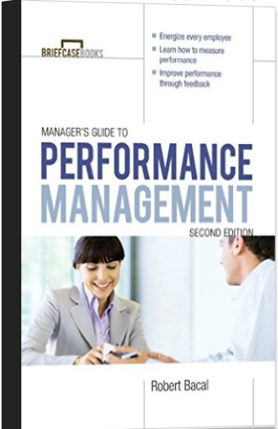
The Manager's Guide to Performance Reviews helps managers instead make reviews both positive and proactive. It provides a step-by-step process for administering an effective performance review, one that will meet the organization's needs for employee appraisal while giving employees an honest sense of how they are performing and where they could improve. Also examined are various approaches to performance reviews, different forms and techniques, and more.

How to Manage Performance

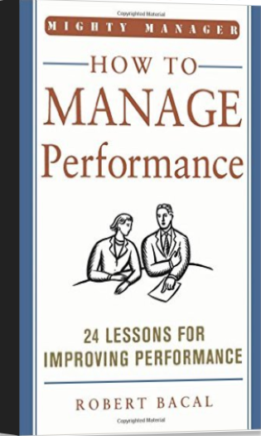
- Modernize your thinking
- Identify the benefits
- Manage Performance
- Work with the employees
- Plan precisely with clear goals
- Align employee goals
- Set performance incentives
- Be approachable all year
- Focus on communication
- Make it face to face
- Avoid ranking people
- Don’t rank employees
- Prepare for the appraisal
- Start reviews on the right foot
- Identify causes
- Recognize success
- Use cooperative communication
- Focus on behavior and results
- Be specific about performance
- Manage conflict with grace
- Use progressive discipline
- Document performance
- Develop employees
- Continuously improve your system

Influencer and Change Anything
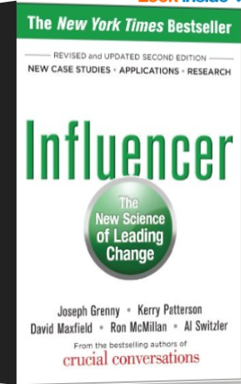

As you read this book you’ll learn how to identify a handful of high-leverage behaviors that lead to rapid and profound change, use vicarious experience to change thoughts and actions, and marshal multiple sources of influence to make change inevitable.

We can affect the influences that govern our behavior and put the power to change back in our control. With a clearer understanding of the science behind personal change, we can become ten times more successful at changing anything. We can affect the influences that govern our behavior and put the power to change back in our control. With a clearer understanding of the science behind personal change, we can become ten times more successful at changing anything.

Joseph Grenny talks about the different books on you tube
https://www.youtube.com/watch?v=lpvskOJZiVE - The introduction
https://www.youtube.com/watch?v=er8zBywSCZA - The six sources
https://www.youtube.com/watch?v=zctC52aqZoI - Change anything

1. Did I do my best to set clear goals today?
2. Did I do my best to make progress toward by goals today?
3. Did I do my best to find meaning today?
4. Did I do my best to be happy today?
5. Did I do my best to build a positive relationships today?
6. Did I do my best to be fully engaged today?

Marshall Goldsmith – Teaching Leaders what to stop
https://www.youtube.com/watch?v=6NHySKiUJfs

Unlocking Potential
Seven Coaching Skills
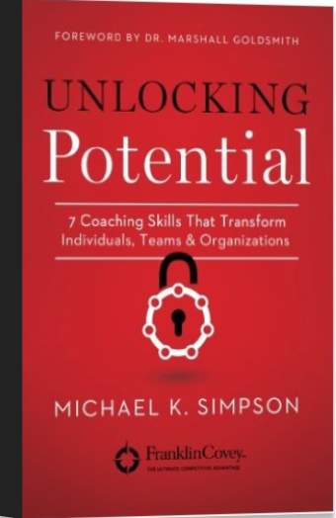
1. Build Trust. This is the foundational competency and skill of all great coaching—without it, individuals will suspect you, question your agenda, slow you down, and possibly reject you as a coach. Thai’s why it’s the first skill in coaching
2, Challenge paradigms. A paradigm is the way we think. An individual who believes they can’t improve is not coachable—until that paradigm changes, you’ll go nowhere. Your individual’s paradigm might become barriers to achievement, and as a coach your task is to challenge them firmly and gently.
3. Seek Strategic clarity. With the coach’s help, the individual choose personal goals and be completely clear about them with measurable endpoints. Without strategic clarity, coaching becomes aimless and endless.
4. Execute flawlessly. Execution might be the toughest chilled of all—the coach can help individuals actually to set, prioritize, and achieve their goals and help to hold them accountable.
5. Give effective feedback. All coaches give feedback. Some of it is effective…. Give feedback that helps create awareness; focus on actions, and achieve the results that people want with whom you’re coaching.
6. Tap into talent. Most people underestimate their own talents. As Dr. Stephen R. Covey would often day, “most people have far more talent than they ever use.” As a coach you need to know how to help people tap into the unique and vast reserve of talents they already have.
7. Move the middle. Coaches usually focused on helping high performers get even better. It is essential to reward and promote top talent. However, the biggest opportunity for performance improvement in any organization IS to “move the middle,’ among those performer s wo are good, but not yet great.

Fred Pryor – Online training:
www.trainingrewards.com

Leadership

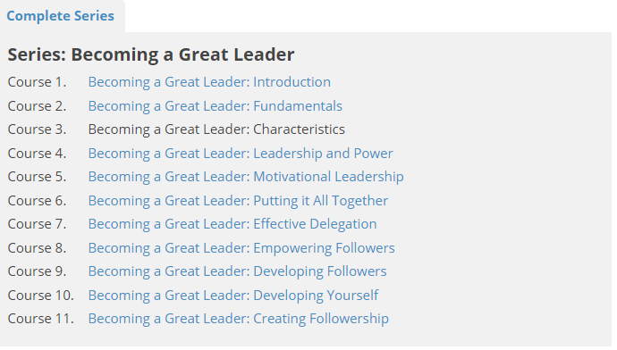
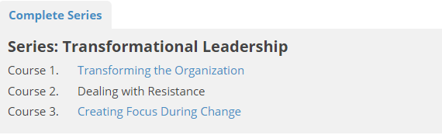

Coaching
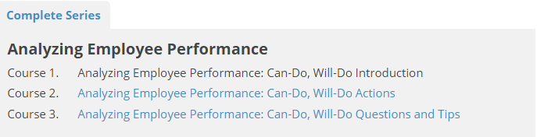
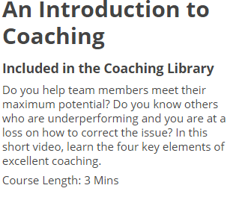
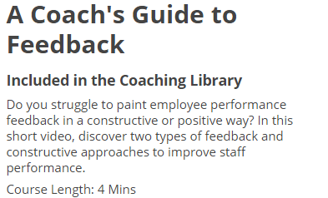
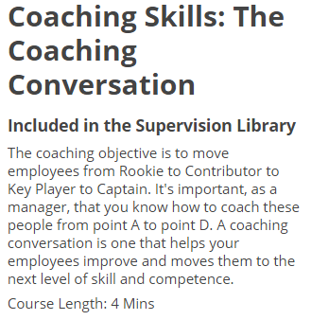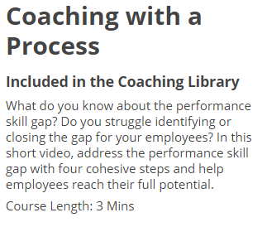

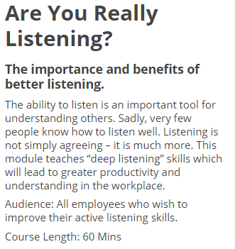
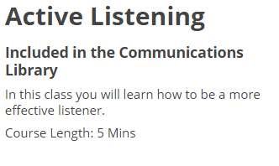
Communication
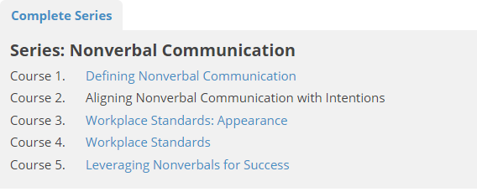

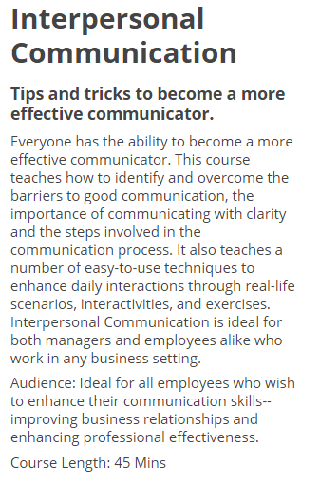
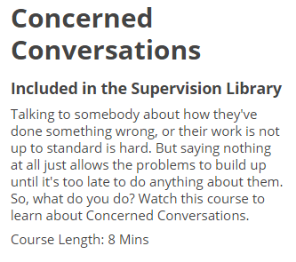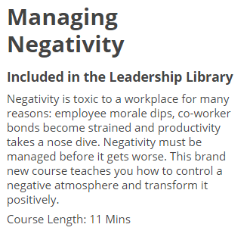

Coping with Change

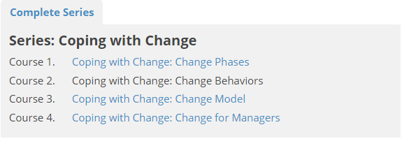

Emotional Intelligence

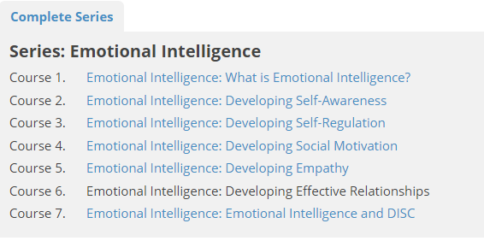

Employee Engagement
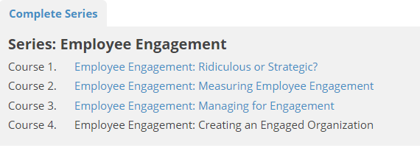

Goal Setting
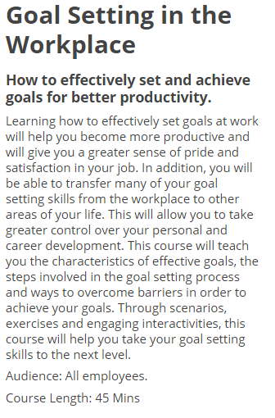

Managing Conflict
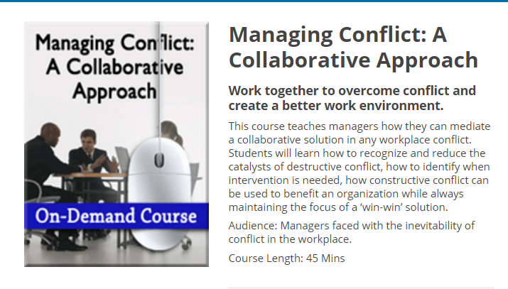
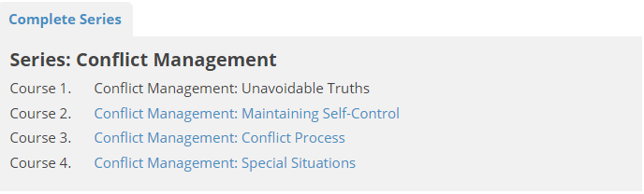
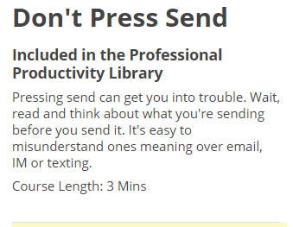
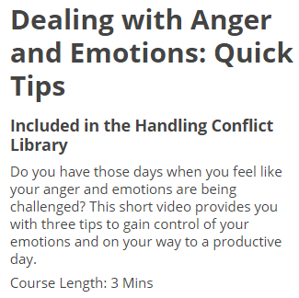

Performance Evaluation

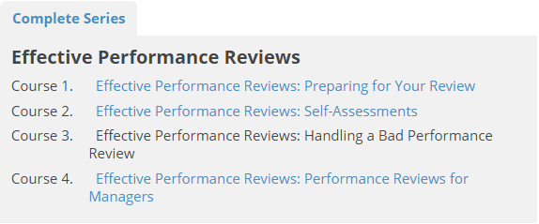
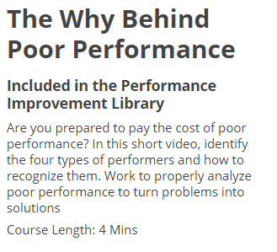

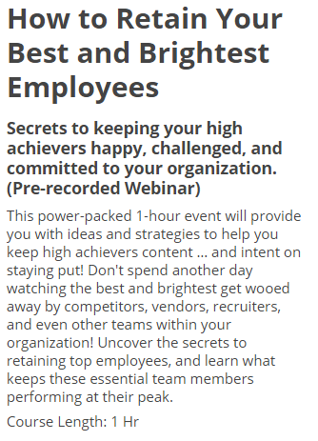
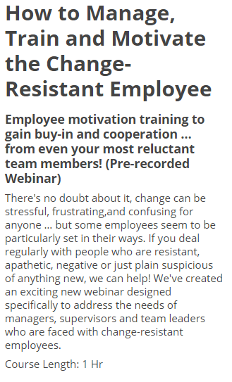
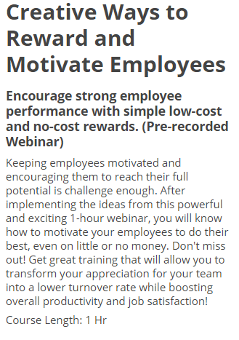
Reward and Motivate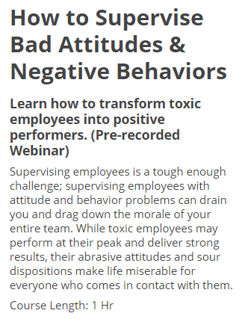

Respect
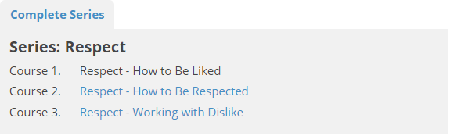

Team Building
