Page | Page Title | Graphic/Slide Text | Audio Script
Learning Logistics
1 | Cover Page | Slide text:  How to Apply for a Job at CDOT | Welcome to the How to Apply for a Job at CDOT course. This course is designed to help you understand how to apply for a job at CDOT.
2 | Learning Logistics | Slide text:  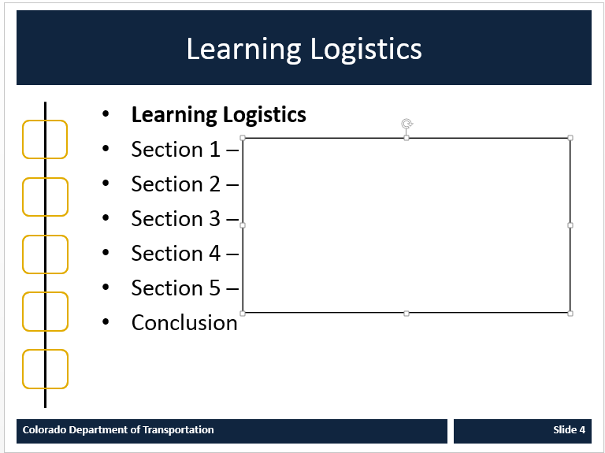 | This course is broken out into six different sections. The first section is an introduction that provides the details of what you need to know about applying for a job at CDOT. In the second section, you will learn about how to search for a job in NEOGOV, the State of Colorado’s Job Application Software. In section three, you will learn how to create an account in NEOGOV. In section four we cover how to read the job announcement and what is important to you as an applicant. In the fifth section you will learn how to use you NEOGOV account to apply for a job at CDOT. In the final section covers what happens to your application, the types of communication and where to go for help. But before you can begin let’s learn how to navigate the course. By the way, if you only want to learn about a specific topic click on the tile of the section you want to review to go directly to that section.
3 | Navigation, Resources and Glossary | Slide graphic:  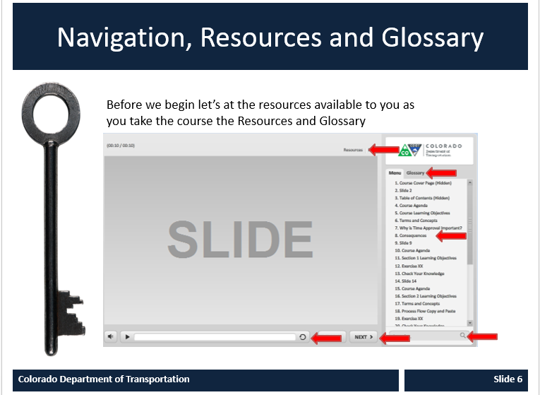 | As you go through the course there are a couple of items you can use to help you learn. The first is the Resources link as indicated by the red arrow. This contains copies of all of the documents referenced in this course.  The Glossary tab displays an alphabetical list of terms that are used throughout the course. Anytime you are uncertain about a term, this is the best place to look. Unlike the resources link clicking on the glossary does not pause the course.  If you want to navigate within the course use the previous or next buttons or click on the slide you want to navigate to under the menu tab. There is also a search field located at the bottom of the Menu tab that brings up all of the slides related to your search.  The progress bar displays your progress within a slide.  If for any reason, you need to close the course before you have completed it, you will be returned to the page you were on once you log back into the course. Now let’s get started by going to the Course Overview.
4 | Course Objectives | Slide Text:  At the end of this course you should be able to:  - Navigate to the State of Colorado job page  - Describe how to search for a job  - Create a NEOGOV account  - Identify sections of the job announcement and how they relate to your application  - Apply for a job using your NEOGOV account  - Describe the post application process | Upon completing this course you should have an understanding of the objectives on this slide. Please take a minute to review these before you continue. When you are done click the next button.
 | Navigation | 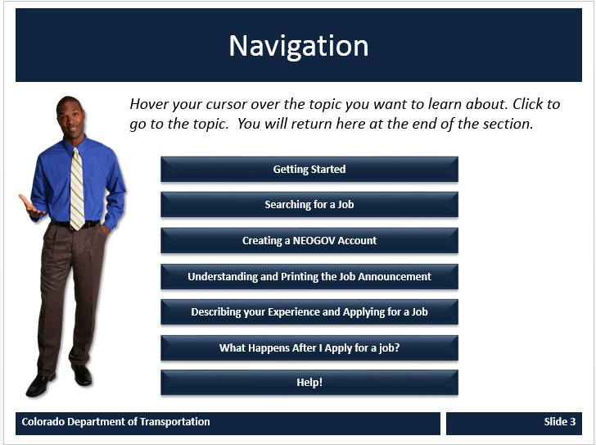 | Button 1 Getting Started – This section provides you with an overview of what you need to know prior to applying for a job at CDOT. Let’s look at what you will learn in detail. Upon completing this section you should be able to:  - Describe what positions exist at CDOT  - How to locate the SOC job page  - Describe Jobs you are able to apply for  - Identify what you need to prepare prior to applying  - Describe what is used to determine residency  - Identify when new Jobs are posted
Section 1 – Course Overview
5 | Section 1 - Overview | Slide graphic: | This section provides you with an overview of what you need to know prior to applying for a job at CDOT. Let’s look at what you will learn in detail.
6 | Section Objectives | Upon completing this section you should be able to:  - Describe why you should work for the State of Colorado  - Locating the SOC job page  - Describe what Jobs are open for all job applicants  - Identify what you need to prepare prior to applying  - Describe what is used to determine residency  - Identify when new Jobs are posted | Take a moment to the objectives for this section of the course. Upon completing this section you should be able to perform each of the listed objectives. When you are done reviewing the section objective click the Next button.  HOVER TEXT:  At the end of this section, you should be able to: Describe what jobs are available at CDOT. Locate the State job page. Describe what jobs are open for all applicants. Identify what you need to prepare prior to applying. Describe what is used to determine residency. Identify when new jobs are posted  This section covers: How to search for job using the search for a job field. Using the filter feature to refine your search by Location, Department, Job Category, and Salary. Identifying what to do if you do not find a Job that matches your skills.
7 | Why you should work for CDOT | Accordion Interaction  - Introduction  - Maintenance  - Engineering  - Technical and Professional | CDOT employs 3,100 employees in a variety of technical and professional to oversee the state’s highways, bridges, and other transportation and aviation programs. CDOT offers job opportunities that match virtually anyone’s background, education and experience.  CDOT also offers meaningful careers, promotional opportunities, professional development, competitive pay, great benefits, and statewide locations. Jobs at CDOT fall into three different categories. Click on the tabs that most closely match your experience to learn more.
7A | Maintenance | Positions in Maintenance include:  - Transportation Maintenance Workers that plow snow and perform roadway maintenance,  - Heavy Equipment Mechanics  - Electrical Tradespeople  - Welders  - Storeroom Workers  - Building Crew Members  - General Laborers  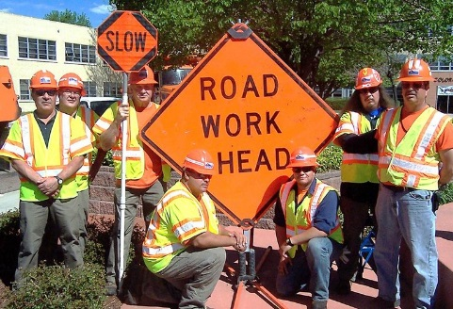 | CDOT offers many opportunities in the field of Maintenance is responsible for maintaining the State’s transportation infrastructure.
7B | Engineering | Positions in Engineering are from entry level to licensed professionals for the following positions:  - Engineering Assistant  - Engineering Technician  - Civil Engineering Project Manager  - Engineer-in-Training  - Licensed Professional Engineer | Engineering activities include design of roadways, runways and bridges; construction project management; hydraulic and geological investigations; materials design and testing; traffic analysis and Intelligent Transportation System integration, among others.
7C | Technical and Professional | Jobs in the Technical and Professional areas include:  - Accounting  - Administrative Support  - Appraisal  - Audit  - Budget  - Business / Management  - Human Resources  - Purchasing/Contracting  - Risk Management and Safety  - And many others | There are also a variety of positions at CDOT other than Maintenance and Engineering. These positions provide services in support of both internal and external customers.
8 | Locating the SOC Job Page | The State of Colorado can be found at www.colorado.gov/dhr/jobs from her you can:  - See all job opportunities for the State, including jobs at CDOT  - Create a Job Interest card to be notified when a position matching you skills becomes available  - Connect with help resources  If you do not know how to create a bookmark click HERE for instructions.  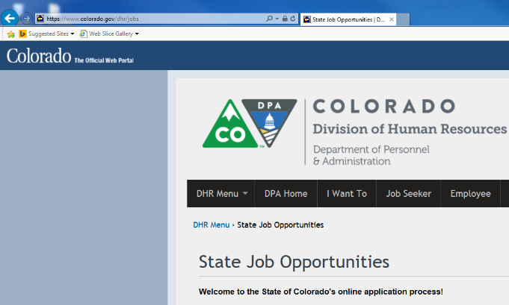 | The State of Colorado job page can be found at www.colorado.gov/dhr/jobs and can be accessed from the link on this page. To make it easy to find create a bookmark open the page and press the Control + D keys. Click on the “here” link if you need help with creating a bookmark.
9 | Jobs open to all applicants | Open Competitive jobs are open to all applicants.  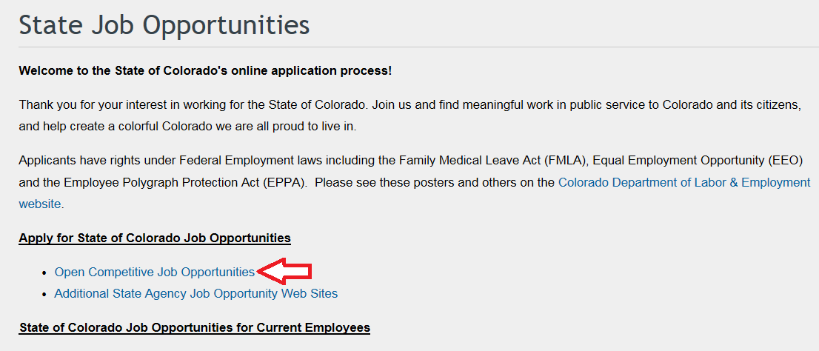 | Open Competitive jobs can be found on the job page under the Apply for State of Colorado Job Opportunities heading as indicated by the red arrow. Once you click on this link you are able to search for job. Promotional and Transfer Job Opportunities are only open to internal applicants. Now let’s look at the residency requirement.
10 | Residency Requirement | The State of Colorado requires all applicants to be a resident of the state of Colorado with the following exceptions:  - Work is primarily performed within 30 miles of the border  - It has been waived by the State Personnel Director of State Personnel Board.  The residency requirement is listed under the job title  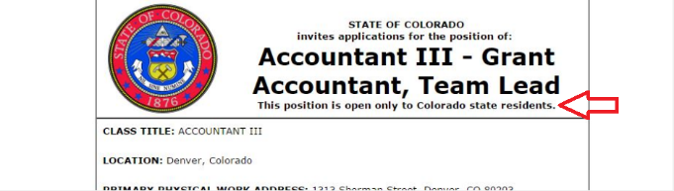 | The Colorado Constitution, Article XII, Section 13 requires that applicants for state classified government jobs be residents of Colorado, unless this requirement is either performing work primarily 30 miles within the state border or waived by the State Personnel Director or the State Personnel Board.  The residency requirements of the position are listed under the job title of the printed job announcement. As shown below.
11 | What to prepare before applying | Checklist interaction  Prior to applying for a position you should prepare the following:  - A resume of you work history  - Your contact details  - Work history  - Education  - Optional Information  - References | To make the most of your time, prepare the following:  Once you create your account, you will be presented the opportunity to import your resume. If you do not have one you will need to create it in the system  Your contact details include your address, phone number, email address and optionally your driver’s license and employment preferences  For work history you need the name, contact details and dates worked  In this section you will need to the name and contact details and dates attended  Depending on the position you are applying for you may be required to enter Certificates and Licenses, skills languages and answers to supplemental questions  You will also be asked to provide the name and contact details for your references  If you do not have the information you need for any of the sections you can always log back into your account. Click on the Resources link for a checklist you can print out of what you may need to apply.
12 | When are New Positions Posted? | Positions may be posted anytime and duration. To increase your chance of finding a position:  - Check the jobs page frequently  - Fill in a Job Interest Card  - Complete the NEOGOV profile | Positons may be posted at any time there is vacancy and may be posted for anywhere from three days to a couple of weeks.  To increase your chances of finding a position that matches your skills check jobs page frequently, submit a Job Interest card and be prepared to apply by completing your NEOGOV profile.
Section 2 – Search for a Job
 | Section 2 – Search for a Job | Slide graphic: | Now let’s get started with the first section. This section explains how to use NEOGOV to search for a position.
13 | Section Objectives | Upon completing this section you should be able to:  - Describe how to search for job using the search for a job field  - Describe how to use the filter feature to refine your search (location, Department, Job Category, and Salary  - Identify what to do if you do not find a Job that matches your skills | Take a moment to review the objectives for this section of the course. When you are done reviewing them, click the Next button.
14 | Searching for a Job | Click on the video below to learn how to search for a job | Now’s let’s get started by searching for a job. You have already seen the main job page so we are going to start here. Click on the Open Competitive Job Opportunities link. This takes you to the Job Opportunities page. Scroll down to the bottom of the page and you will see the search field. Left click on this field and enter the type of work you do, in this example, maintenance. Notice as you type the system makes suggestions about jobs matching your search criteria. Click on the word maintenance and all open maintenance positions in the State display. It looks like there are 55 as shown here. Now let’s filter this to make it more relevant.
15 | Filter a Job Search | Click on the video below to learn how to filter a job search | Now let’s look at filter option to narrow down the job search. Filtering allows you to search for a job by location, a department, job category and even salary. First we want to clear the search. Click on the “X” next to the word maintenance in the search field. Now let’s set up filter by clicking on the Filter button. In this example, we are going to search for Maintenance positions within the Department of Transportation. Click on the filter link and then select department and then Department of Transportation. Note that the grey screen to the left updates and shows XX postings. Now let’s select the job category link and then maintenance. Great! It looks like we are down to nine jobs. Click anywhere to the left, the grey area to display the results of your search. You can combine any of the search criteria to find the right job in the best location. If no jobs display try widening your search.
16 | Create a Job Interest Card | Click on the video to display the process for creating a job interest card. | Now let’s learn how to create a job interest card. This allows you to be notified when a position you want becomes available. Click on arrow to the right of the menu and then Job Categories/Job Interest Cards link. Now, select the categories that match your skills in this example the Building & Grounds Cleaning Maintenance and Maintenance. Now all you need to do now is click the green subscribe button and step is to enter your contact details. Be sure to double check your email address as this is how you will be contacted and click submit. You will now be sent emails about these type of jobs for the next 12 months.
17 | Section 3 – Create a NEOGOV Account | Slide graphic: | Once you have found a position you will need to be able to apply for it. This section covers the creation of the NEOGOV account which is the first step in the application process.
18 | Section Objectives | Upon completing this section you should be able to:  - Create a NEOGOV account  - Log into an existing NEOGOV account | Take a moment to review the objectives for this section of the course. When you are done reviewing them, click the Next button.
19 | What you need to create a NEOGOV account | To create a NEOGOV account you will need the following:  - An email address  - A unique user name  - Password  If you do not have an email address click HERE to create one. | To create your NEOGOV account you need an email address and a unique user name. You must also have a unique password that is 8 characters in length that contains upper and lower case, symbols, and a number. If you do not have an email address click the word here to create one. Now let’s watch a brief video that shows you how to create your account.
20 | Create a NEOGOV account | Engage Process Interaction Arrows  Introduction  Enter https://www.colorado.gov/pacific/dhr/job-opportunities-2 in the taskbar as shown below.  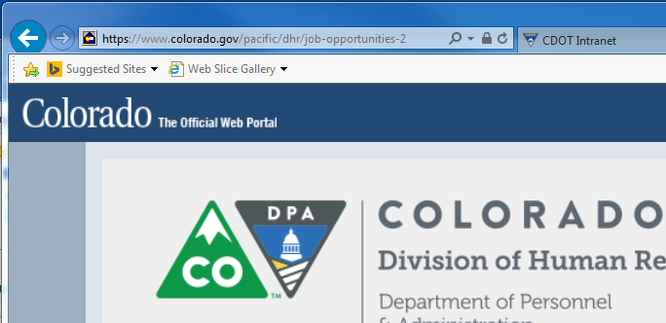  Step 1  Now click on the Sign in link. This displays the Sign in page.  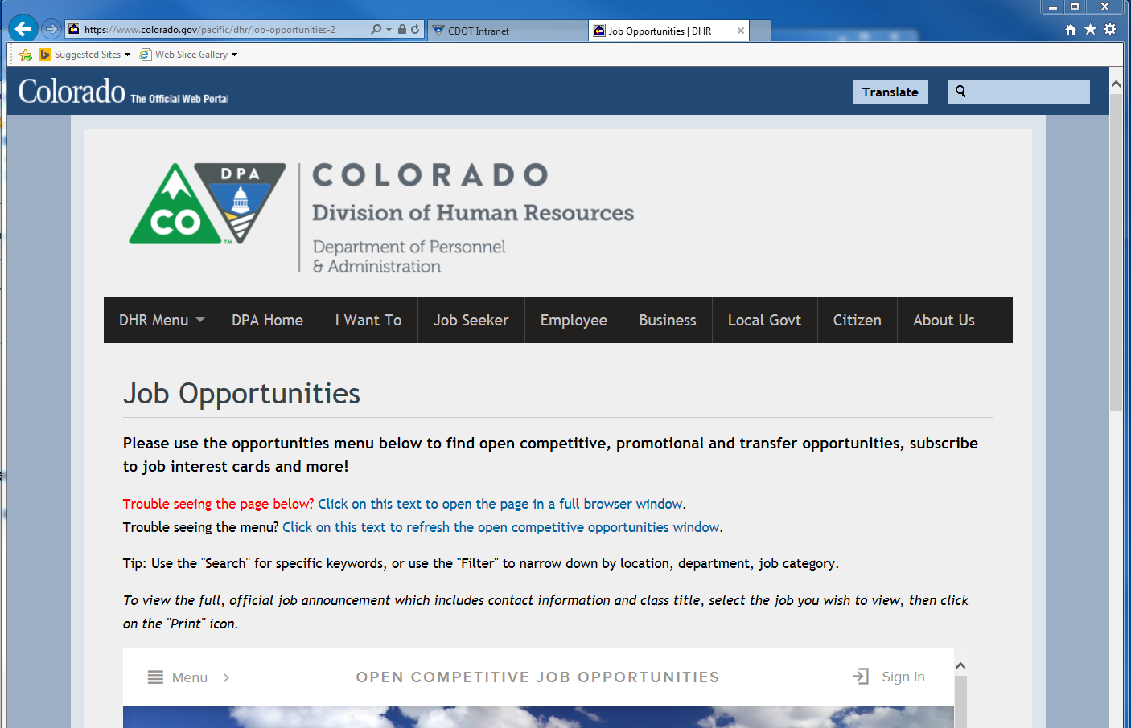  Step 2  Click on the Create an account link.  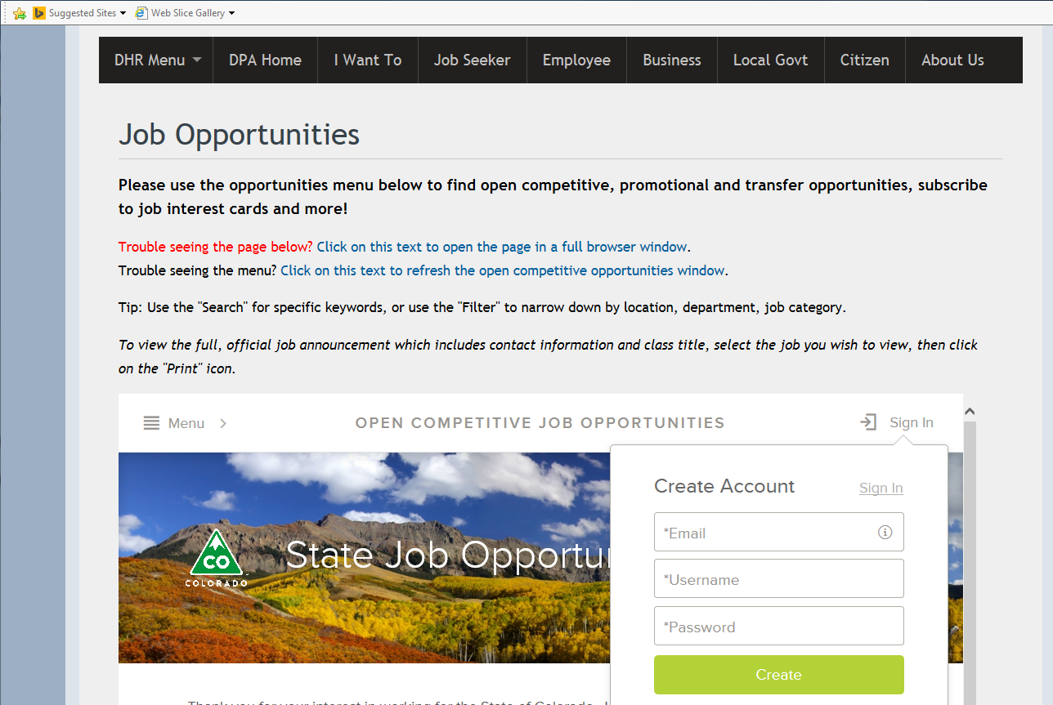 | Introduction 1124 x 844  The process to create a NEOGOV account is simple. Let’s start from an open browser. Start by entering https://www.colorado.gov/pacific/dhr/job-opportunities-2 in the address bar of your browser and press enter. This takes you to the  Step 1  Even though you do not have an account you need to click on the Sign in link to create your account. This is indicated by the red arrow.  Step 2  Click on the create account tab as indicated by the red arrow. You can also sign in with your LinkedIn or Facebook account but it is not covered in this section.  Great! You are now ready to create the account. Let’s get started by clicking on the email field and entering the email you want to use for the account in this example work503522@gmail.com. Next we need to enter a username. In this example, samplejob219 is used to make it easy to remember. Now enter the password you want to use for the account and the create button. #Ry90kl0w  Step 6  Click on the Create button and you have created your NEOGOV account. Next you come to this page all you have to do is click sign in and enter your user name and password.
21 | Log in | To log into your account:  - Go the Job Opportunities page  - Click Sign in  - Enter your user name and password  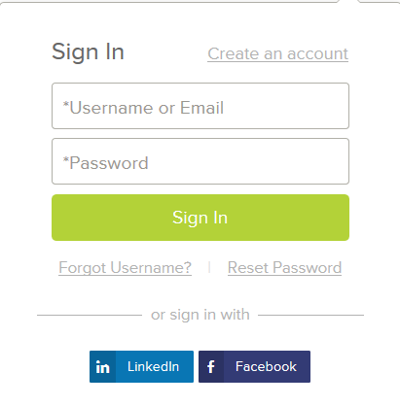 | Let’s start from the Job opportunity page to log into an account, first click on the sign in button. When the sign in screen displays enter your user name and your password. If you forgot your user name or password, use link located below the sign in button and enter your email address when prompted. You will be sent email with the requested information. Now let’s complete the sign in process by clicking on the sign in button. #Ry90kl0w. Now enter the text from the picture and the proceed button. You have successfully logged into your account
22 | Section 4 – Create a NEOGOV Account | Slide graphic: | Once you have found a position you will need to be able to apply for it. This section covers how to read and print a job announcement.
23 | Section Objectives | Upon completing this section you should be able to:  - Printing an announcement  - Describe the what the different sections of the job announcement mean | Take a moment to review the objectives for this section of the course. When you are done reviewing them, click the Next button.
24 | Printing the Job Announcement | Click on the video below to show you how to print the job announcement. | You are able to print a job announcement by clicking on print icon located at the top of any open job announcement. This displays a new window with the job announcement in a printable format. Right click on the window and select print. This displays your print menu. From here all you need to do is click print. Now let’s take a look at what you should be looking at when you read a job announcement.
25 | Reading the Job Announcement | The job announcement is a communication tool. It provides:  - What we want you to know about the position  - What we want you to tell us about your experience  - What you must do to qualify  Section A  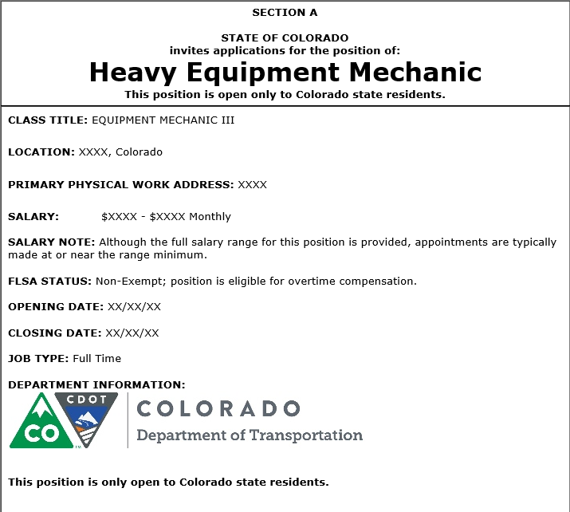  Section B  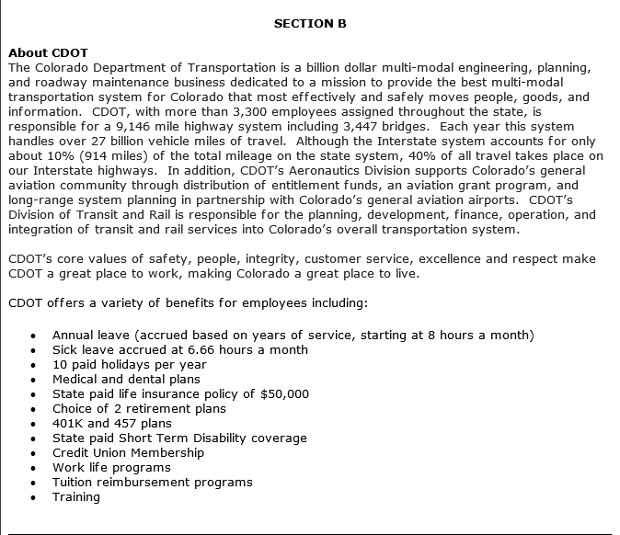  Section C  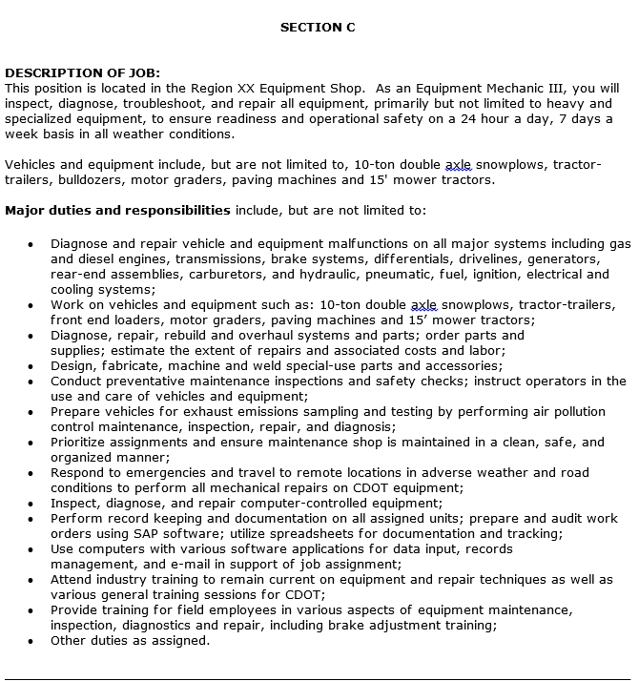Section D  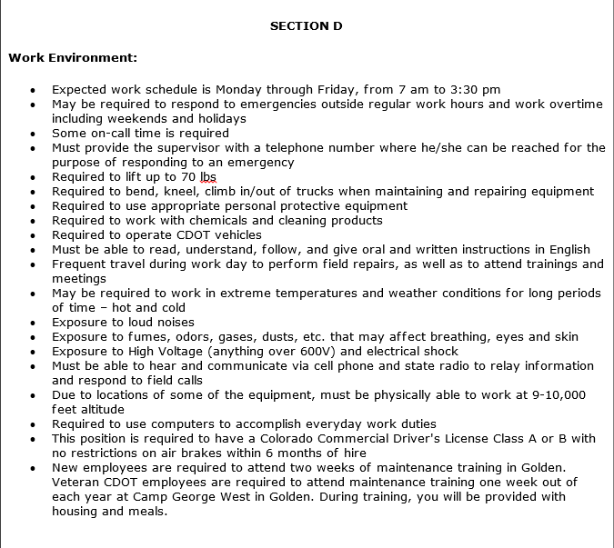  Section E  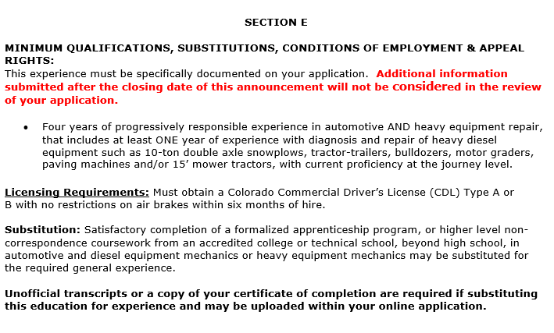  Section F  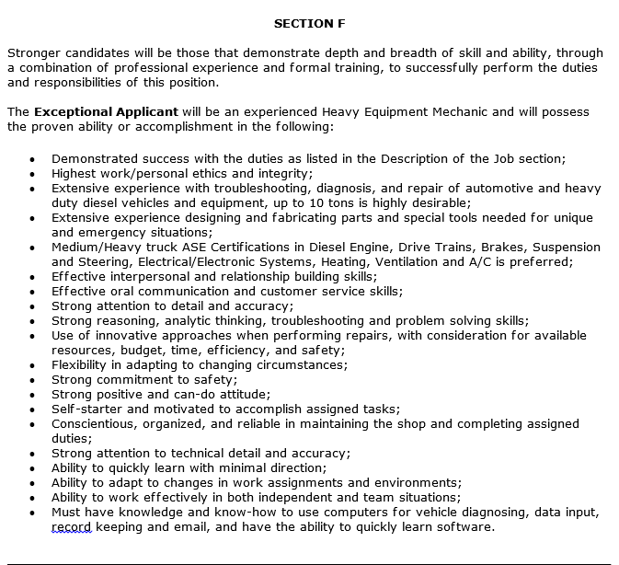  Section G  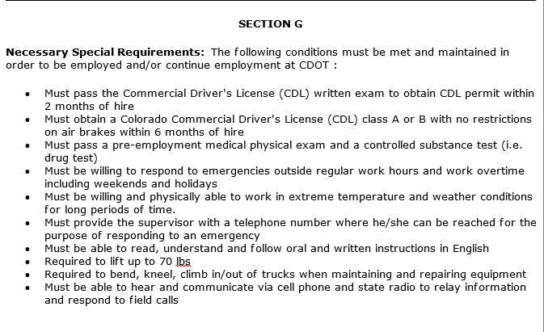  Section H  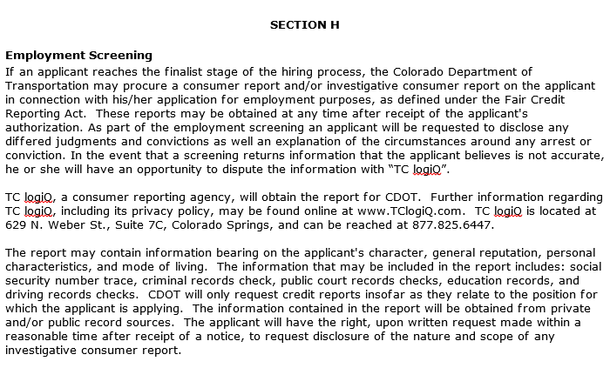  Section I  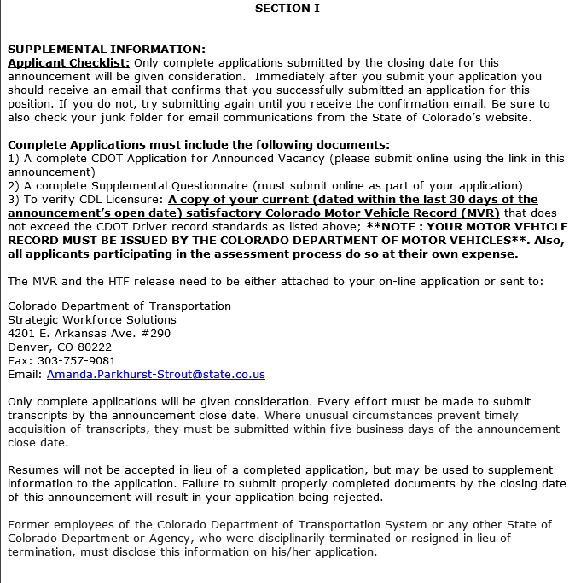  Section J  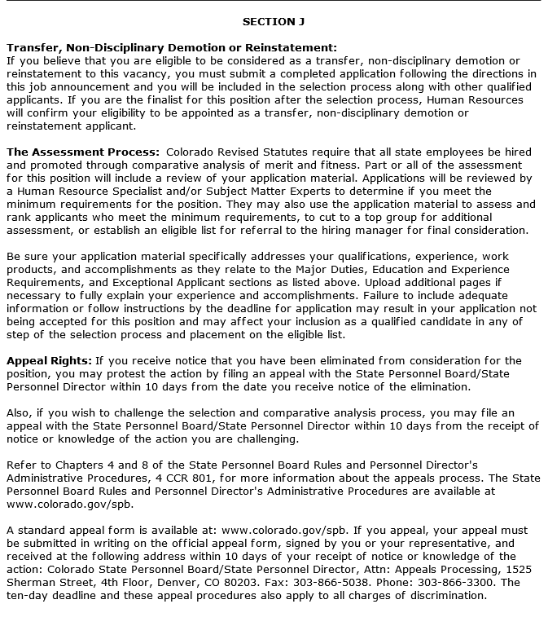  Section K  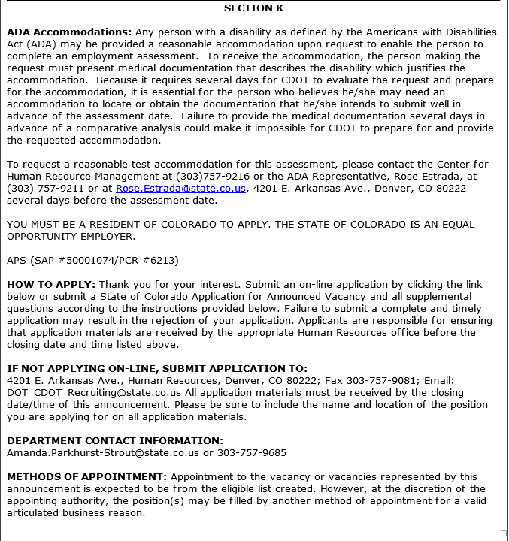  Section L  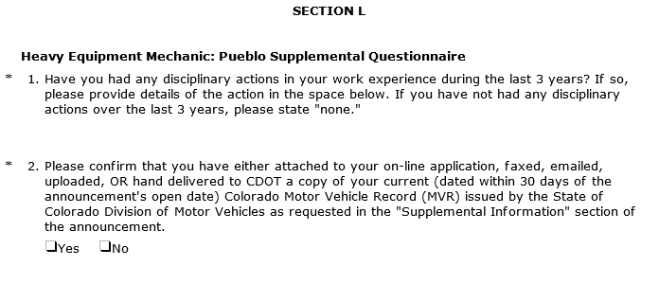  Section M  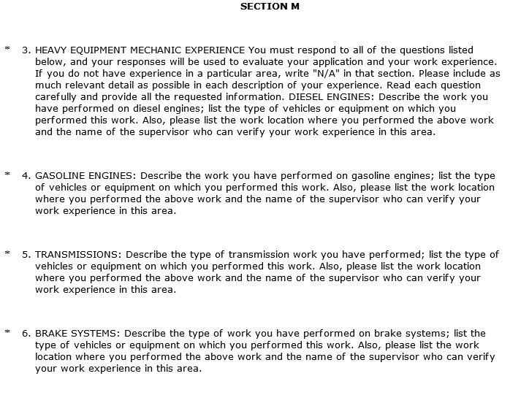 | Introduction  The Job Announcement is a communication tool. We are telling you what we need from you to assess your knowledge, skills and abilities. If you do not tell us in writing how you fit with what we ask then we have no way of knowing your qualifications. Now let’s go through a sample announcement.  Section A  This is the basic details of the position. Pay attention to the location and when the position is closing. You don’t want to miss out.  Section B  This section tells you about who we are as an organization and what we do. If benefits are provided then you will be given the details of the benefits here.  Section C  This section is very important to you because it describes the details of what you will be doing. Take a look at each of the bullets and ask make sure you have the details. Notice the detail of what we are asking match this in your resume and give the years of experience. For example, if your resume only stated you repaired trucks. We wouldn’t have the details we need. What on the truck did you work on and what skills did you learn in your job? Do you have any certifications we need to know about? All of this will help us to understand the skills you bring.  Section D  The details of the position are next. This lists any special travel requirements, physical activities of the job and exposure to hazardous situations and tools you will need to use.  Section E  The minimum qualifications of the job you are applying for a listed next. This section lists the types of equipment. This will help you determine if you are qualified. Pay attention to bold and bulleted information when reading this section. For example the AND between automotive and Heavy Equipment meaning you should have a combination.  Section F  This is what an exceptional applicant would look like and this is how we evaluate you application. We are not trying to trick you, this is what we want you to demonstrate to us in your application. Use this like a checklist when reviewing you application.  Section G  This is an optional section and may or may not show up for your position. In this case, it lists conditions you must maintain to be employed and continue to be employed at CDOT.  Section H  The Employment Screening section describes what kind or background check or employment screening that will be performed. Reading this section will inform you of your rights and the requirements.  Section I  This is another section to pay close attention to when you apply because it lists everything you need to submit to have a complete application. If your application is not complete you will not be considered for the position.  Section J  This section details your rights and the assessment process.  Section K  This section contains more information about your rights, who to contact if you have questions, and how to apply.  Section L  In some cases we need additional information that doesn’t fit into an application. If this is the case, then we will ask supplemental application questions. There are not optional and must be submitted to complete your application.  Section M  In the previous section the questions were yes and no. This section requires more specific answers. When filling this in read the question carefully and answer each part of the question. Typically this is how we determine who is an exceptional applicant.  Conclusion  Although it seems like the announcement is very long it is because we want to give you the information you need to successfully share your knowledge with us.  Now let’s look at how to apply for a job.
26 | Section 5 – How to Apply for a job. | Slide graphic: | Now let’s look at what happens after you apply.
27 | Section Objectives | Upon completing this section you should be able to:  - Describe the best way to frame your experience (using the job duty worksheet  - Describe how to use your NEOGOV profile to apply for a Job  - Identifying if you have a complete application (responding to Questions) | Take a moment to review the objectives for this section of the course. When you are done reviewing them, click the Next button.
28 | Framing your experience | When preparing your resume  - Read the announcement thoroughly  - Change your resume so qualifications can easily be found  - Don’t be shy  - Use the Job Duty worksheet to help you state your experience | Before you are able to frame your experience be sure to read the announcement paying particular attention to the qualifications section and change your resume so each can be easily found. Also, this is not the time to be shy stating what you so is important to you success as an applicant. The Job duty work sheet will help you state your experience. Let’s take a look at that now.
29 | Using the Job Duty Worksheet to frame your Experience | 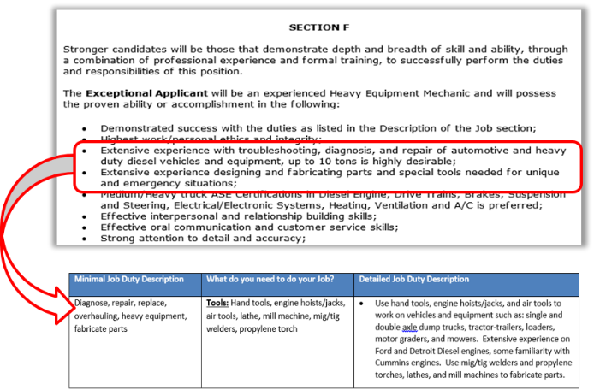 | We have created a Job Duty worksheet to help you describe your experience. To use the worksheet, go to the section that contains the exceptional applicant list. Place the bulleted list in each in the minimal job duty description. Now all you need to do is fill in what you used to perform that task. The last step is to combine the two columns into narrative for your resume, as shown by the third column. Placing this in your resume as a bullet point or in your work experience gives us the detail we need to understand your work experience. A copy of the Job Duty Worksheet can be found by clicking on the resources link.
30 | Describe how to use your NEOGOV account to apply for a Job | Click on the video below to learn how to use your NEOGOV account to apply for a job | Once you are ready to apply you can use your NEOGOV account to apply for a position. You must have the account set up to apply. In this example, we are going to apply for a XXXX position. So let’s open that link. The job displays. We have already reviewed and application and are ready to apply. Let’s start by selecting the Apply button. The Sign in to Apply screen displays. From here enter your user name into the first field followed by your password. Now click the sign in button.
31 | Identifying if you have a complete application (responding to Questions) |  | Remember, we want you to be successful. To help you we describe what you need to submit for a complete application. In addition to a complete application, we may require answers to supplemental questions and verification of licenses. If your application is not complete then you will be not be considered.
32 | Section 6 – What happens after I apply? | Slide graphic: | Now let’s look at what happens after you apply.
33 | Section Objectives | Upon completing this section you should be able to:  - Understand what happens after you apply for a Jobs  - Identify the timeline of the application process  - Describe what the letters from HR mean | Take a moment to review the objectives for this section of the course. When you are done reviewing them, click the Next button.
34 | After you apply | After you apply a comparative analysis of your application occurs. This includes an  - Application/resume review  - Oral board/structured interview  - Optional - Written narrative | After you submit your resume, a comparative analysis is conducted. This is where your application is evaluated against the position requirements. If successful, you will move on to an Oral Board or structured interview with three to five Subject Matter Experts.  Optionally, you may be asked to submit a written narrative. This is where you complete an exercise at home and submit it for review. This is evaluated by Subject Matter Experts. You will notified of all evaluation and the results. Now, let’s take a look at the types of communication you may receive.
35 |  | The following are emails you may receive by step in the application process:  - Automatic NeoGov email Application Submitted  - Application Received  - Met Minimum Qualifications  - Did Not Minimum Qualifications  - Application Review FYI  - Oral Board Assessment FYI  - Oral Board Scheduling  - Did not Pass Assessment  - Referral Email  - Eligible List Email (Not Referred)  - Not Selected | It is our goal to keep you informed about your application. The first communication you will receive is that you applied. After that you will receive emails based on whether or not you have passed onto the next stage of the application process.  Click on the list of letters to display a sample.
36 | Conclusion | Slide graphic:  This concludes the course for help:  - With a specific job contact the HR Analyst listed in the job anncouncement  - With general HR questions contact the CDOT HR at 303-757-9216  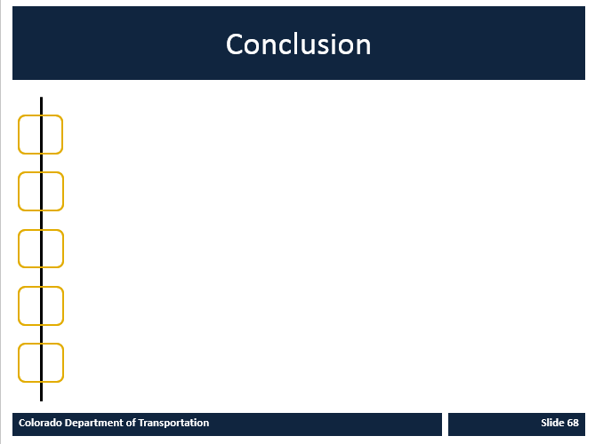 | This concludes the How to Apply for a Job at CDOT course. If you need help on a specific job then contact the HR Analyst responsible for recruitment.  Best of luck on your job search and thank you considering CDOT as an employer!

