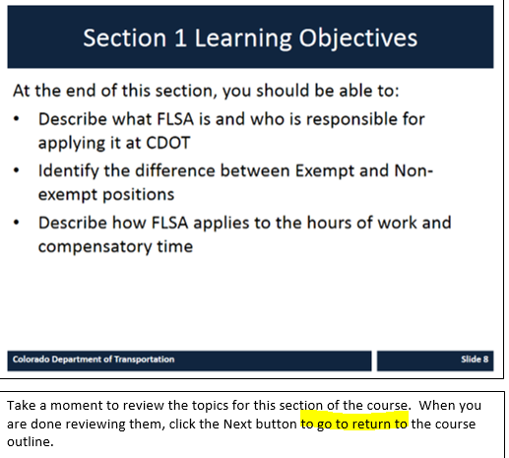
NOTES: ????? highlighted area needs correction. Not sure what should be said here.
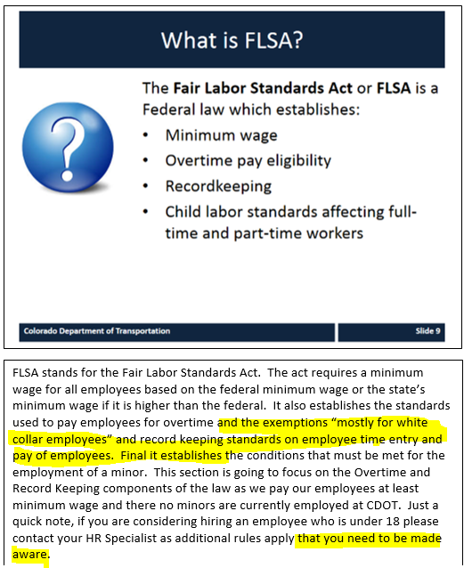
Add “Equal pay for equal work” bullet point in slide?
NOTES: FLSA stands for the Fair Labor Standards Act. The act requires employers to pay all employees at least the federal minimum wage, or the state’s minimum wage if it is higher than the federal. It establishes the standards used to pay employees for overtime and recordkeeping standards of employee time entry and pay. It also establishes the conditions that must be met for the employment of a minor. Finally, it mandates equal pay for equal work. For this class we will focus on the Overtime and Recordkeeping components of the law as we pay our employees equally and at least minimum wage, and no minors are currently employed at CDOT. Just a quick note, if you are considering hiring an employee who is under 18 please contact your HR Specialist as additional rules apply.
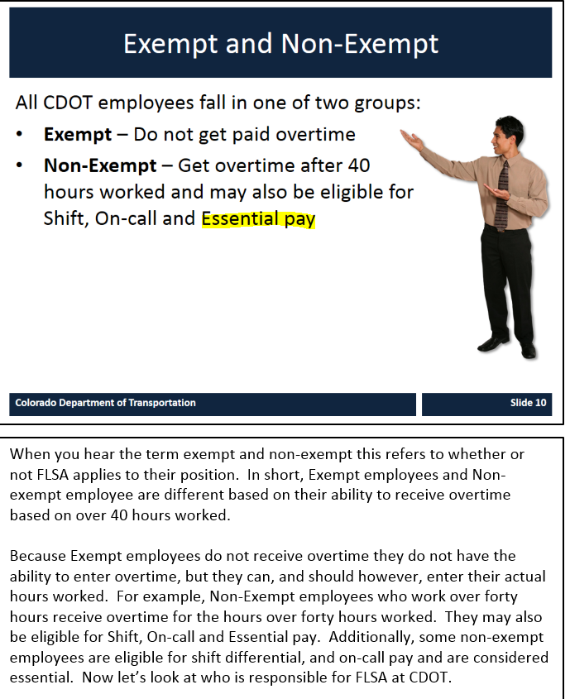
Should be “fall ‘into’”
What is “Essential pay?”
NOTES: When you hear the terms exempt and non-exempt, they refer to whether or not the FLSA rules apply to an employee’s position. Non-exempt employees are subject to FLSA overtime pay rules. For example, a non-exempt employee who works 42 hours in a work week would receive two hours of overtime pay. They may also be eligible for Shift and On-call pay.
Exempt employees are not subject to FLSA overtime pay rules. Because exempt employees do not receive overtime pay, they do not have the ability to enter overtime on their time sheet. However, they can, and should, enter their actual hours worked.
Now let’s look at who is responsible for FLSA at CDOT.
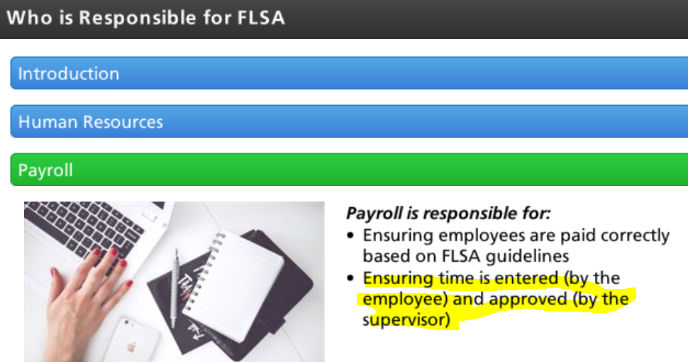
Remove second bullet point.
First bullet point: Ensuring employees are paid correctly based on FLSA guidelines and the hours that are coded on their time sheets.

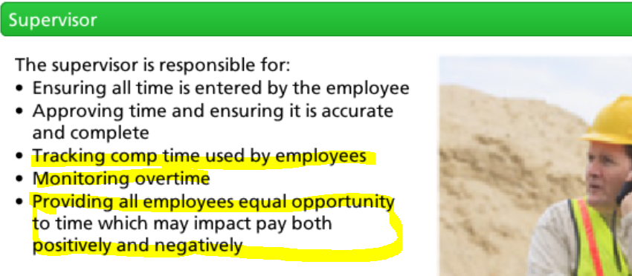
Remove comp time bullet
Add “and comp time” to “Monitoring overtime” bullet
Does the last bullet point have to be included? No I removed it from the slide and the script.

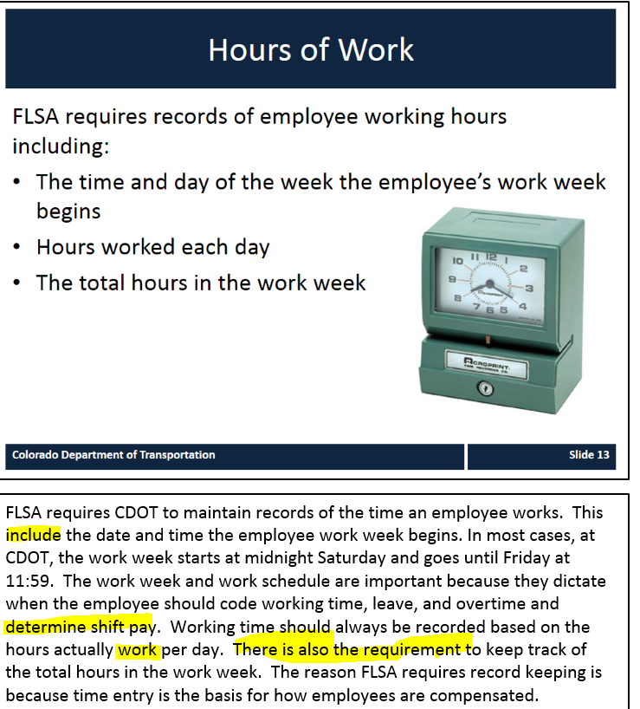
NOTES: FLSA requires CDOT to maintain records of the time an employee works. This includes the date and time the employee work week begins. In most cases at CDOT, the work week is Saturday through Friday. The work week and work schedule are important because they dictate when the employee should code working time, leave and overtime. The work schedule determines how shift pay is calculated. Working time should always be recorded based on the hours actually worked per day. FLSA also requires employers to keep track of the total hours in the work week. The reason FLSA requires recordkeeping is because time entry is the basis for how employees are compensated.
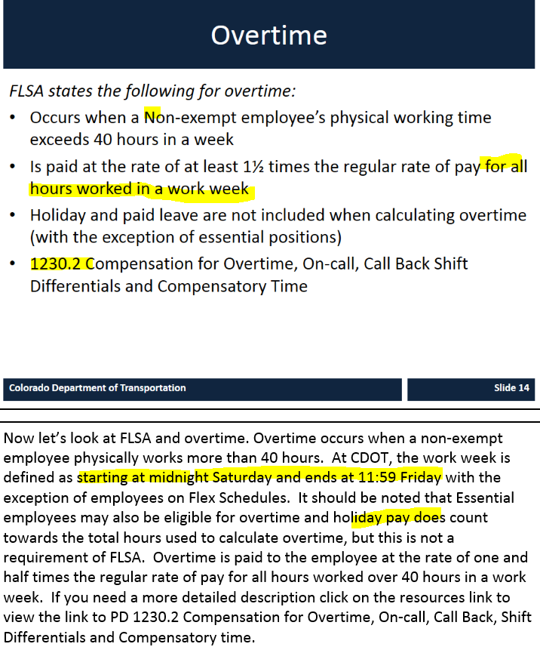
Non-italicized font.
Non-exempt – not capitalized
Remove “for all hours worked in a work week” from 2nd bullet
Add “PD” to beginning of last bullet
NOTES: Now let’s look at FLSA and overtime. Overtime occurs when a non-exempt employee physically works more than 40 hours in a work week. At CDOT, the work week is Saturday through Friday with the exception of employees on Monday or Friday Flex work schedules. It should be noted that for Essential employees, holiday and paid leave does count towards the total hours used to calculate overtime pay in a work week, but this is not a requirement of FLSA. Comp time-used does not count towards overtime pay calculation. Overtime pay is paid to the employee at the rate of at least one-and-a-half times the regular rate of pay. If you need a more detailed description, click on the resources link to view PD 1230.2: Compensation for Overtime, On-call, Call Back, Shift Differentials and Compensatory time.
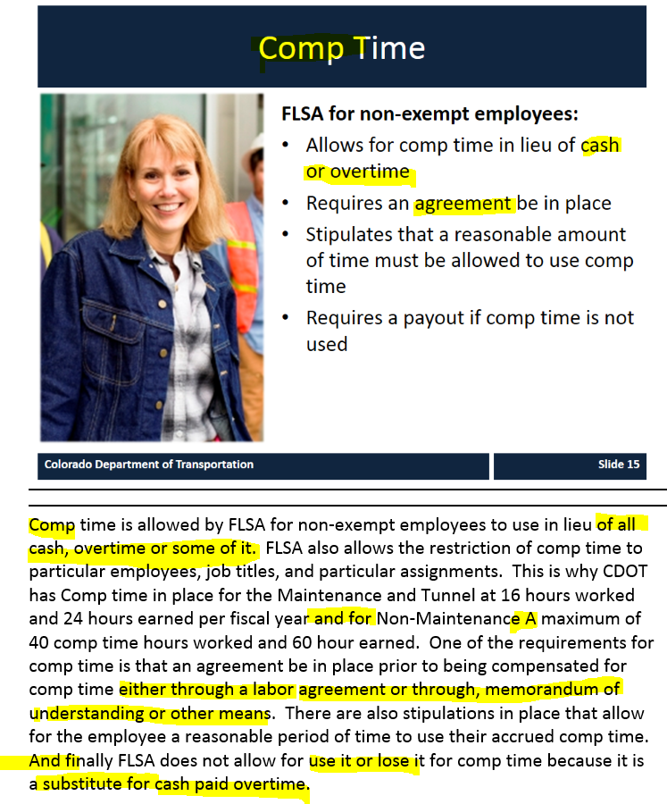
Title of page: Compensatory (Comp) Time
NOTES: Compensatory time, or comp time, is allowed by FLSA for non-exempt employees to use in lieu of overtime pay. FLSA also allows the restriction of comp time to particular employees, job titles, and particular assignments. CDOT’s comp time policy for the Maintenance and Tunnel employees allows for 16 hours worked and 24 hours earned per fiscal year. Non-Maintenance employees have a maximum of 40 comp time hours worked and 60 hours earned. One of the requirements for comp time is that a written agreement must be in place prior to an employee accruing comp time. There are also stipulations in place that allow for the employee a reasonable period of time to use their accrued comp time. Finally, FLSA does not allow use-it-or-lose-it for comp time because it is compensation earned.

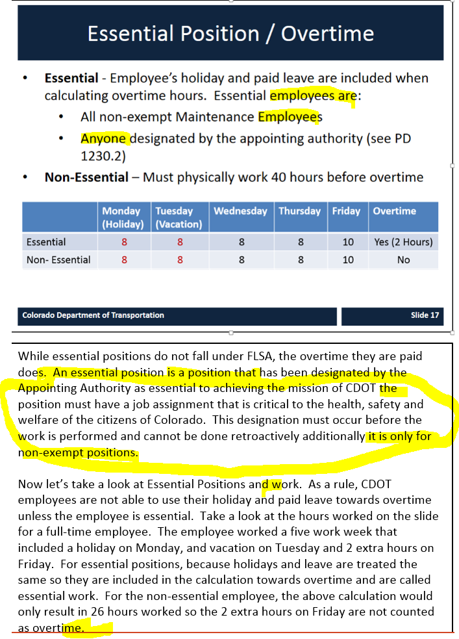
1st bullet: Essential positions are:
2nd (sub) bullet: All non-exempt Maintenance positions
3rd (sub) bullet: Positions designated by…
NOTES: While essential positions are not defined in FLSA, the overtime paid to employees in these positions is. An essential position must have a job assignment that is critical to the health, safety and welfare of the citizens of Colorado. All non-exempt Maintenance positions are essential. The Executive Director, RTDs or Division Directors may designate other non-exempt positions as essential if the positions meet the essential criteria. This designation must occur before the work is performed and cannot be done retroactively.
Now let’s take a look at essential positions and work. As a rule, holiday and paid leave does not count towards overtime unless the employee’s position is essential. Take a look at the hours worked on the slide for a full-time, non-exempt essential employee. The employee worked a five day work week that included a holiday on Monday, and vacation on Tuesday and 2 extra hours on Friday. For essential positions, holidays and leave are treated the same as worked time and therefore are included in the calculation towards overtime. For the employee in the non-essential position on the second line, the calculation would only result in 26 hours worked so the 2 extra hours on Friday are not counted as overtime. It is worth mentioning that unpaid leave and Comp Time-used do not count toward overtime, even for essential positions.

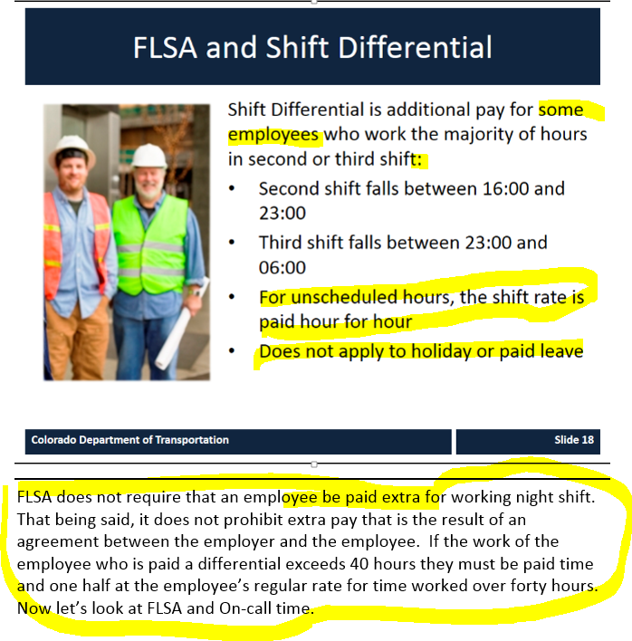
Image is blurry. Is that intentional?
Shift Differential is additional pay for employees in certain non-exempt positions who work the majority of their scheduled hours in second or third shifts:
- 2nd shift falls between 16:00 and 23:00
- 3rd shift falls between 23:00 and 6:00
For unscheduled hours, shift rate is paid hour-for-hour
Does not apply to holiday or leave
NOTES: FLSA does not require that an employee be paid extra for working night shifts. That being said, it does not prohibit extra pay that is the result of an agreement between the employer and the employee. For scheduled hours, if 50% or more of the hours fall into a shift, then all scheduled hours will pay at that shift’s rate. If scheduled hours are split 50-50 over two shifts, the higher shift rate will be paid for all scheduled hours worked. For hours worked outside of scheduled time, shift differential is paid hour-for-hour at the rate in which the time is worked. Now let’s look at FLSA and on-call time.

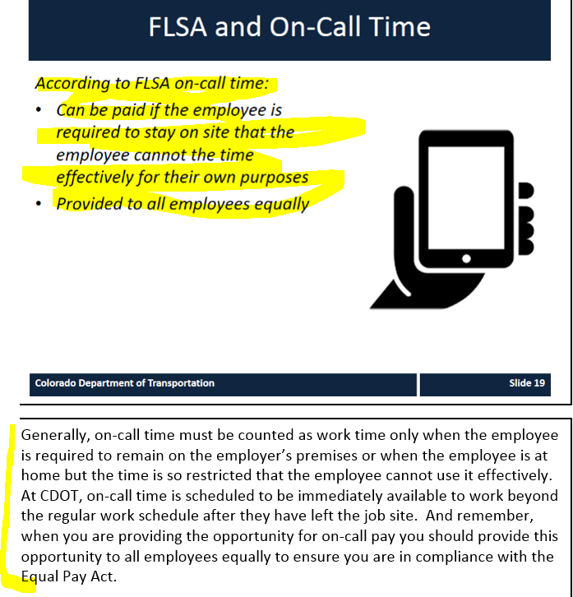
(non-italicized font and format like other slides) According to FLSA, On-call time:
- Can be paid if the employee is required to stay on-site or so close thereto that he or she cannot use the time effectively for his or her own purposes
- Provided to all eligible employees equally
- Is not considered hours worked
NOTES: Employees in eligible positions are in on-call status when they are scheduled to be immediately available to work beyond the regular work schedule. On-call pay ends when an employee is asked to return to work. And remember, when you are providing the opportunity for on-call pay, you must provide this opportunity to all employees equally to ensure you are in compliance with the Equal Pay Act.

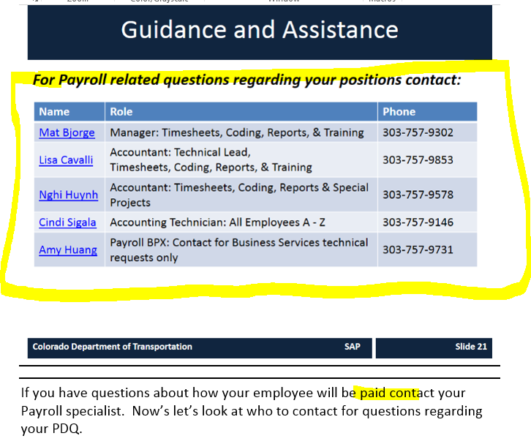
For Payroll-related questions regarding your positions, contact:
Change to Mat Bjorge only. No role info is necessary, just his phone number.
NOTES: If you have questions about how your employee will be paid, contact your Payroll specialist.

