Qualifications
Items: 4 Panels (Including Introduction)
Duration: 20 seconds

Introduction
5 seconds
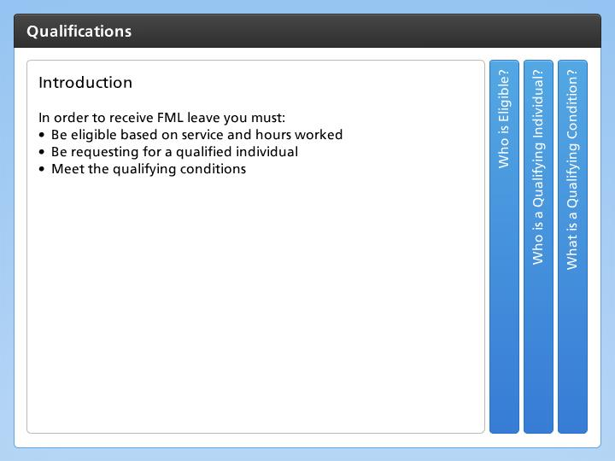

Step Text
In order to receive FML leave you must:
- Be eligible based on service and hours worked
- Be requesting for a qualified individual
- Meet the qualifying conditions

Narration Script
There are three factors that are considered to determine if an employee is eligible for Family Medical Leave. The first is determining if the employee qualifies the second looks at the qualifying individual, the third is the qualifying conditions. Now, let's look at each of these in a little more detail.

Who is Eligible?
5 seconds
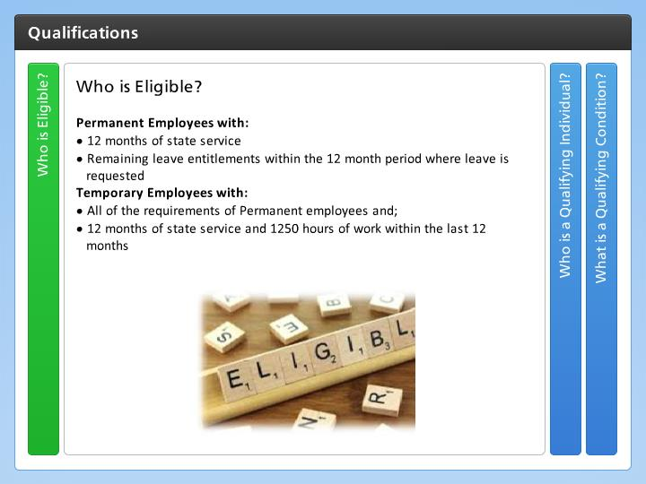

Step Text
Permanent Employees with:
- 12 months of state service
- Remaining leave entitlements within the 12 month period where leave is requested
Temporary Employees with:
- All of the requirements of Permanent employees and;
- 12 months of state service and 1250 hours of work within the last 12 months

Narration Script
Both permanent and temporary employees are eligible for FML as long as the met the requirements of 12 months of state service and have leave entitlements remaining in the twelve month period in which the leave is requested. The same conditions exist for temporary employees, but they must also have worked 1,250 hours within the 12 month period prior to the date Family Leave was requested. Now let’s the conditions the must be met for an individual to qualify.

Who is a Qualifying Individual?
5 seconds
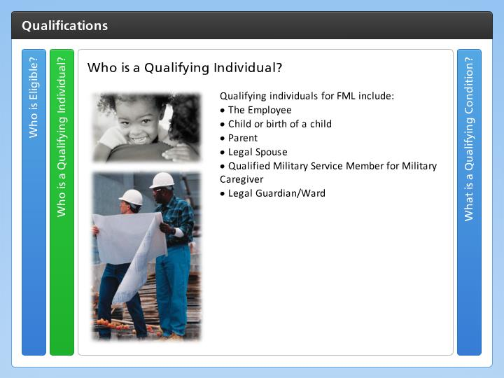

Step Text
Qualifying individuals for FML include:
- The Employee
- Child or birth of a child
- Parent
- Legal Spouse
- Qualified Military Service Member for Military Caregiver
- Legal Guardian/Ward

Narration Script
In order for FML to apply, it must be requested for a qualifying individual. The most common qualifying individual is the employee who is unable to work because of their own serious health condition. But FML may also be used by an employee when they need to care for an immediate family member such as a child which includes the employee’s biological, adopted or foster child, stepchild, legal ward, or a child for whom the employee taking on the responsibilities of a parent a parent or spouse of the employee and for qualified military service members or military caregivers. There are some additional nuances to who is qualified, but this is the determination of the FML Liaison and not you as a supervisor. So if you are uncertain, pass the information on the your FML Liaison who is trained to make the right determination. Now let’s look at what is a qualifying condition.

What is a Qualifying Condition?
5 seconds
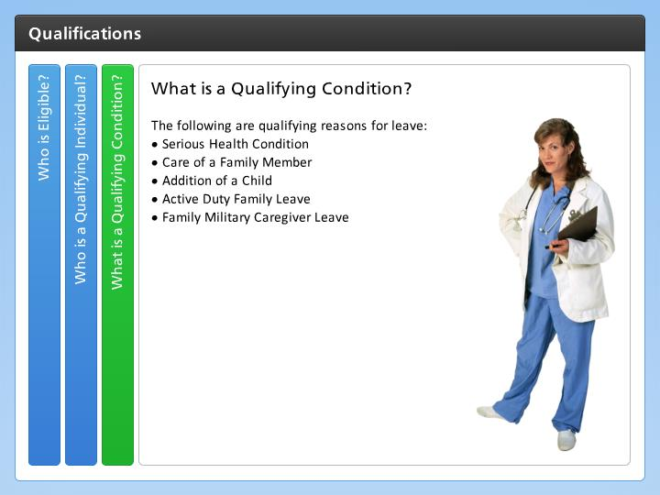

Step Text
The following are qualifying reasons for leave:
- Serious Health Condition
- Care of a Family Member
- Addition of a Child
- Active Duty Family Leave
- Family Military Caregiver Leave

Narration Script
The qualifying condition must also be considered. Family medical leave may only be approved for the serious health condition of the employee or a qualifying member of their family. The addition of a child, including adoption and care for a newborn. For active duty FML leave may be taken for non-medical reasons, but it must meet certain conditions, such as a short notice deployment. In addition, there is also family military caregiver leave for the care of an injury incurred or aggravated in the line of duty while the employee was deployed in a foreign country. This is in addition to Family Medical Leave. Because of the complexity it is best to contact your FML coordinator, who is trained to identify if the employee qualifies for this kind of leave.

