Exercises
Introduction to SAP for Maintenance
P
CDOT

Exercise One – Log On to SAP Portal and Access Work Order UI
Scenario
You completed some "unexpected" work. You need to create a DOT1 Work Order in the SAP Portal using the Work Order User Interface. Log on to the system and access the Work Order UI.

Instructions
When you complete the exercise Do NOT log off of the system.

User-Specific Data
This section provides the user-specific data required to complete this exercise.
User | Username*
Instructor | sapuser102
1 | sapuser51
2 | sapuser52
3 | sapuser53
4 | sapuser54
5 | sapuser55
6 | sapuser56
7 | sapuser57
8 | sapuser58
9 | sapuser59
10 | sapuser60
11 | sapuser61
12 | sapuser62
13 | sapuser63
14 | sapuser64
15 | sapuser65
16 | sapuser66
17 | sapuser67
18 | sapuser68
19 | sapuser69
20 | sapuser70
21 | sapuser71
22 | sapuser72
23 | sapuser73
24 | sapuser74
25 | sapuser75
26 | sapuser76
27 | sapuser77
28 | sapuser78
29 | sapuser79
30 | sapuser80
31 | sapuser81
32 | sapuser82
33 | sapuser83
34 | sapuser84
35 | sapuser85
36 | sapuser86
37 | sapuser87
38 | sapuser88
39 | sapuser89
40 | sapuser90
41 | sapuser91
42 | sapuser92
43 | sapuser93
44 | sapuser94
45 | sapuser95

Procedure

1. | Open the SAP Training Portal.

SAP NetWeaver Portal - Windows Internet Explorer
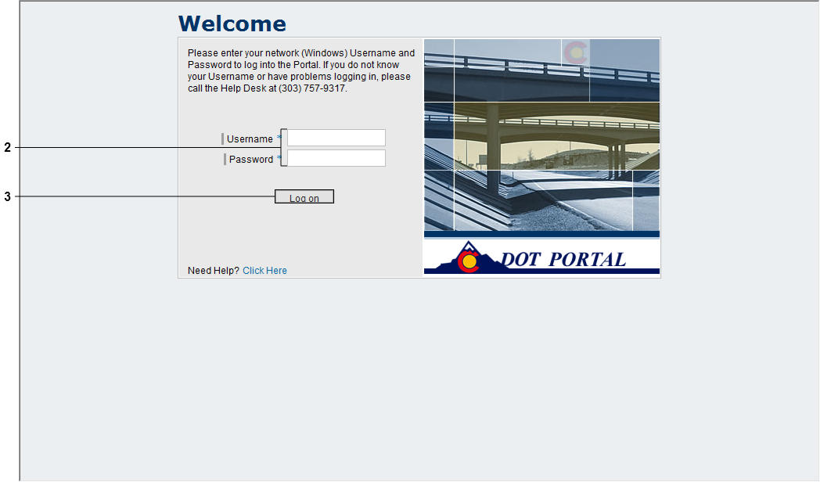

2. | Enter the following:  - Username*: To be supplied by instructor  - Password*: Colorado1

3. | Click Log on button .

Overview - SAP NetWeaver Portal - Windows Internet Explorer
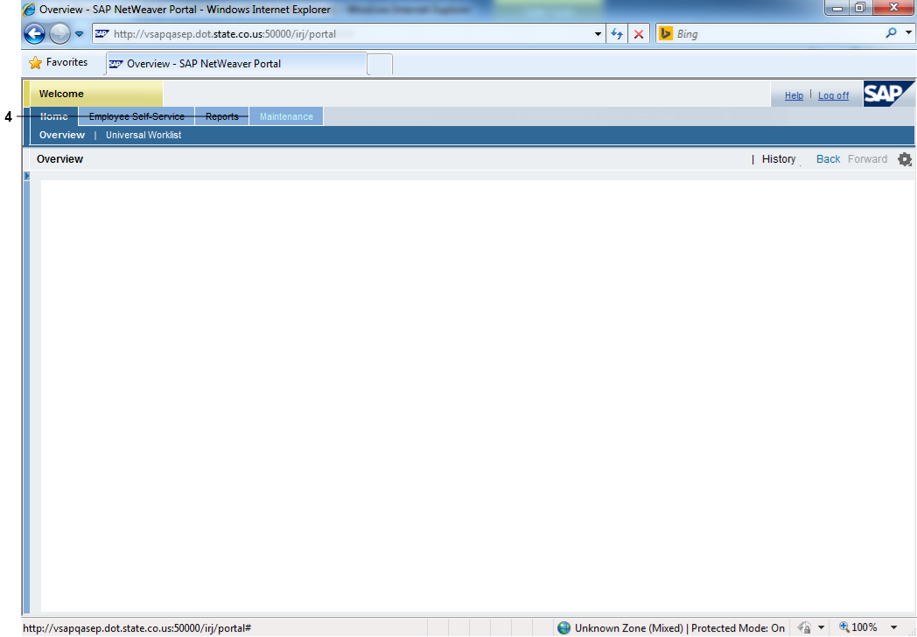

4. | Click Maintenance tab .

Overview - SAP NetWeaver Portal - Windows Internet Explorer
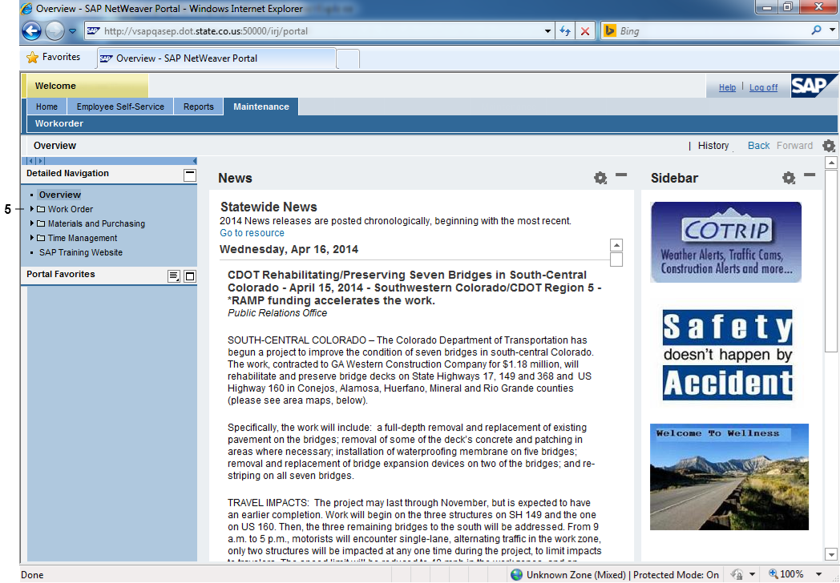

5. | Click Expand button beside Work Order folder in Detailed Navigation pane.

Overview - SAP NetWeaver Portal - Windows Internet Explorer
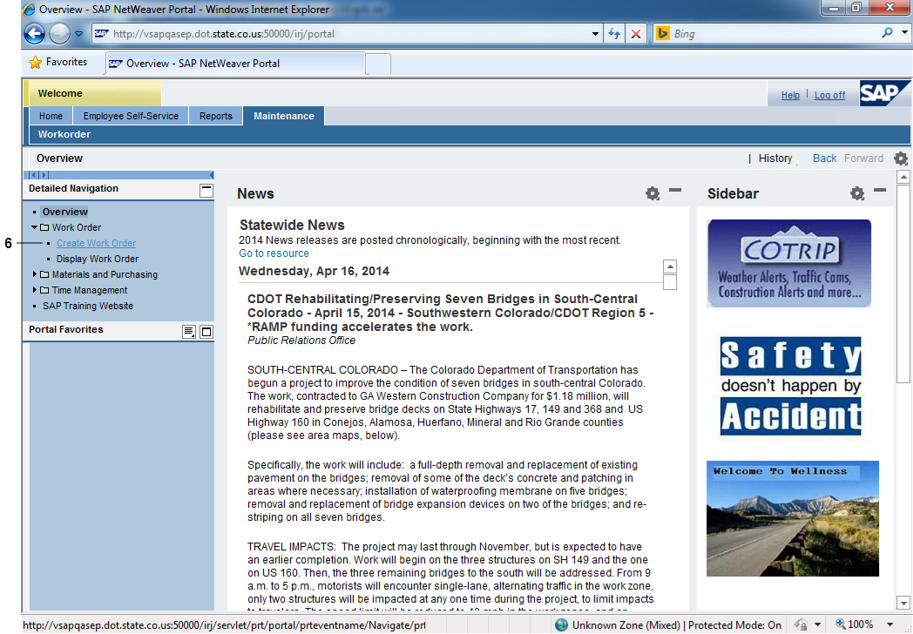

6. | Click Create Work Order link.

Overview - SAP NetWeaver Portal - Windows Internet Explorer

Questions
Answer the question(s).
What user name and password do you use to access the Work Order UI through the SAP Portal?

Under which tab do you find the Work Order UI?

Exercise Two – Create DOT1 Work Order

Exercise Scenario
There were some potholes on Route 92A that needed to be repaired. Yesterday, you spent seven hours repairing them. You have access to the SAP Portal today. Create a DOT1 CDOT Maintenance Work Order using the Work Order UI for yesterday’s work.

Instructions

When you complete the exercise Do NOT log off of the system.

Procedure

1. | Return to the Create Work Order screen from Exercise One.

Create Work Order - SAP NetWeaver Portal - Windows Internet Explorer

2. | Click Collapse navigation panel button .

Application For Work Order Creation
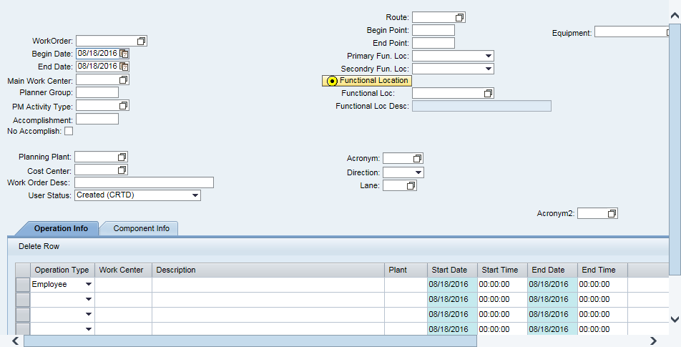

3. | Click Calendar Matchcode button for Begin Date field.

Application For Work Order Creation
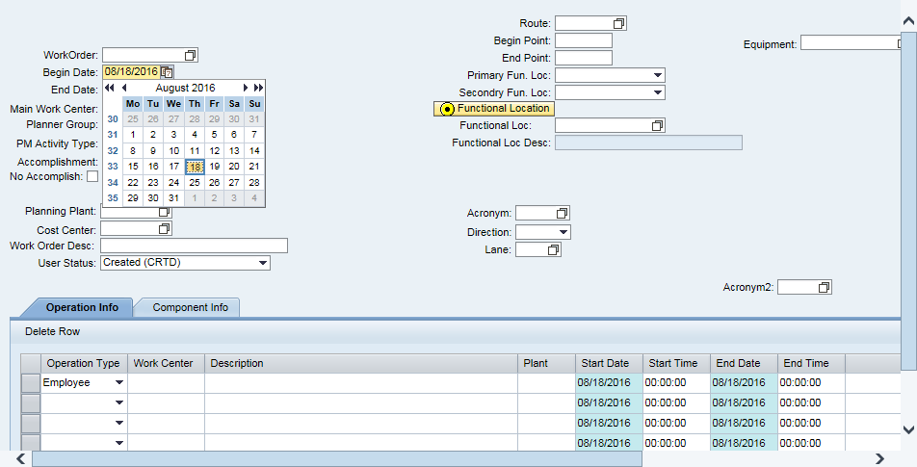

4. | Select Yesterday's Date from the Calendar.

Application For Work Order Creation
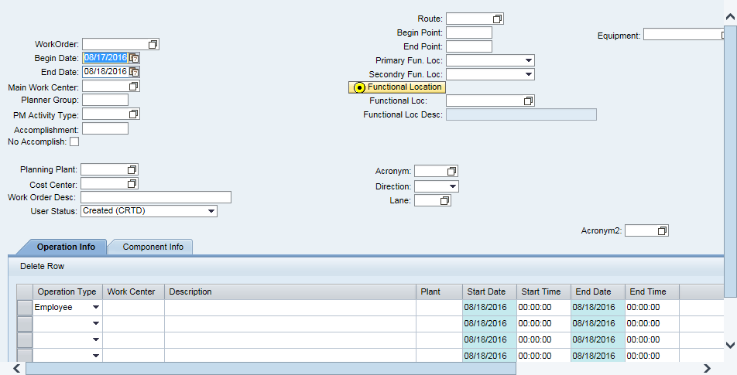

5. | Enter the following:  - End Date Yesterday’s Date

6. | Press "Enter" on your keyboard.

You must press "Enter" when you are in the Date field to transfer the new dates to the Operation Info tab.

Application For Work Order Creation
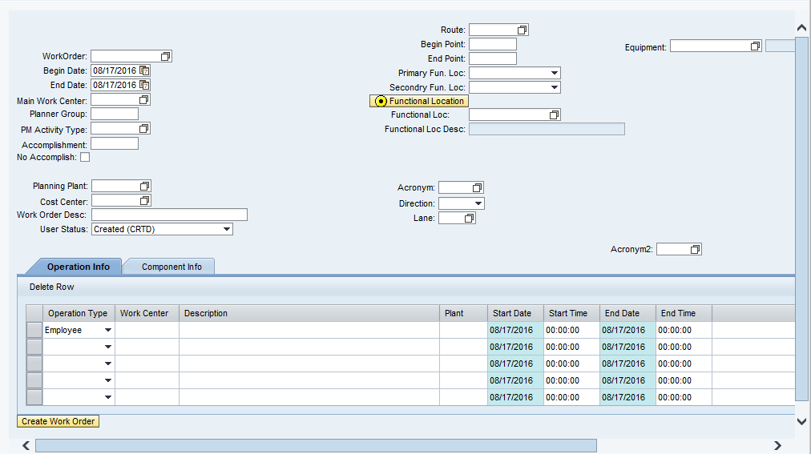

7. | Enter the following:  - Main Work Center R3S02P30  - Planner Group 02L  - PM Activity Type 152

Application For Work Order Creation
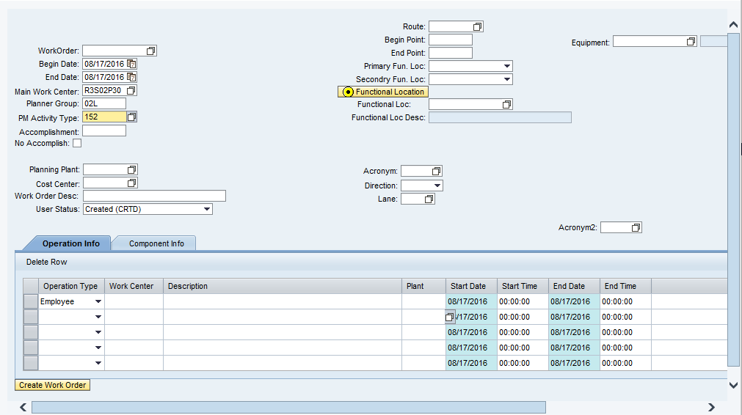

8. | Press "Enter" on your keyboard.  You must press "Enter" to autopopulate additional fields in the Work Order.

The WBS Element is composed of the Region, the Section, the PM Activity Type Group (MPA) and the Supervisor’s Area. In this example, that makes is Region 3, Section 2, 150 Maintenance Program Area and Lincoln L or R3S02150L.

Application For Work Order Creation
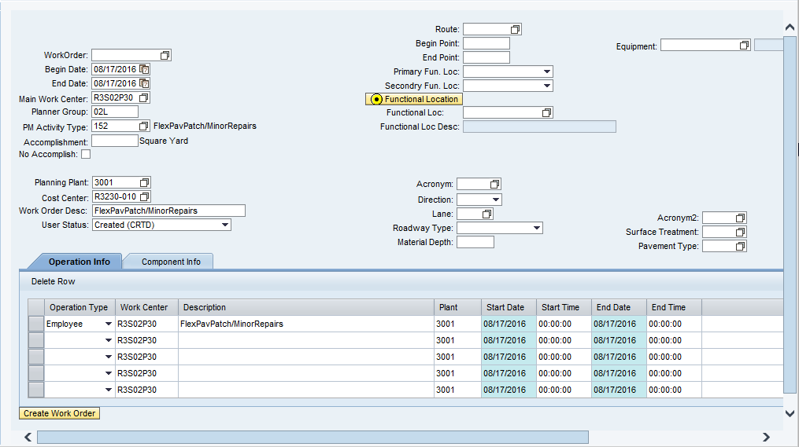

9. | Enter the following:  - Route: 092A  - Begin Point 6  - End Point 6.5

10. | Click Functional Location button .

This automatically calculates the Functional Location for the entered Route and Begin/End Points.

Depending on the selected PM Activity Type, additional data may be required. Consult the PM Field Manual to determine if additional data is required. In this example, no additional data is required.

11. | Click Operation Info tab .  On the Operation Info tab, the Operation Type in the first line defaults to Employee. If needed, use the Operation Type drop-down menu to change this field to Patrol or Equipment.

Application For Work Order Creation
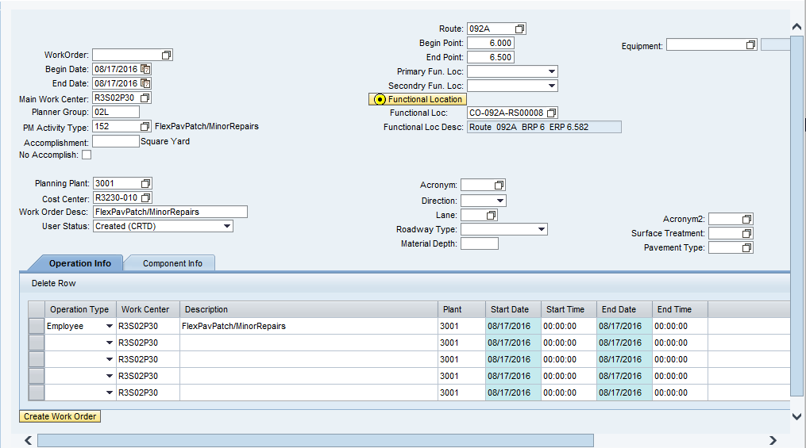

12. | Enter the following:  - Work Center 50001563  - Description Chris – Repair Pothole

The Description field autopopulates from the selected PM Activity Type. Change this field to identify the selected Work Center.
You may need to use the Vertical and Horizontal Scrollbar to view the Create Work Order button.

Application For Work Order Creation
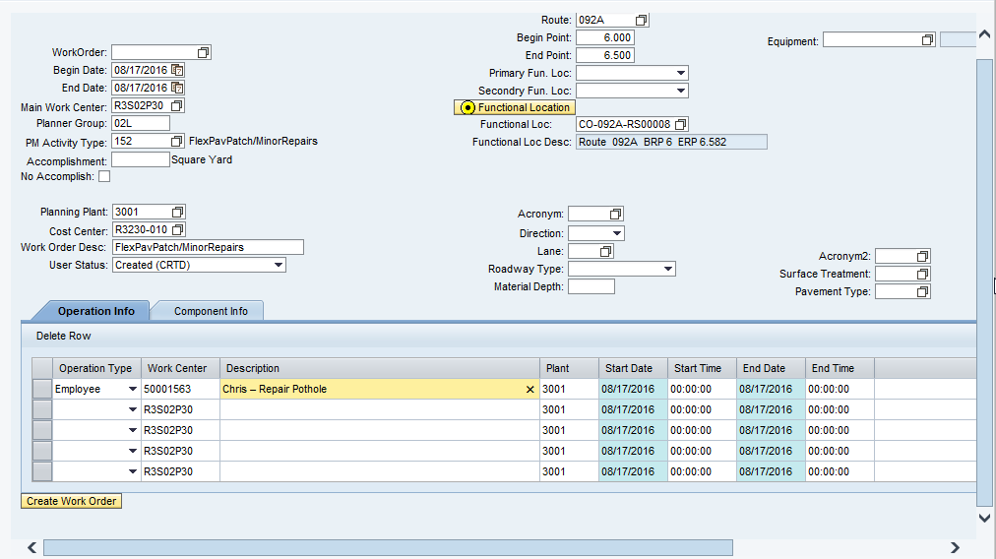

13. | Enter the following:  - Start Time 0900  - End Time 1630

The Start/End Times must be entered for all employees listed in the Work Order. CDOT uses military time to record Start/End Times.

14. | Click Horizontal Scrollbar at the bottom of the table, if required.

Application For Work Order Creation
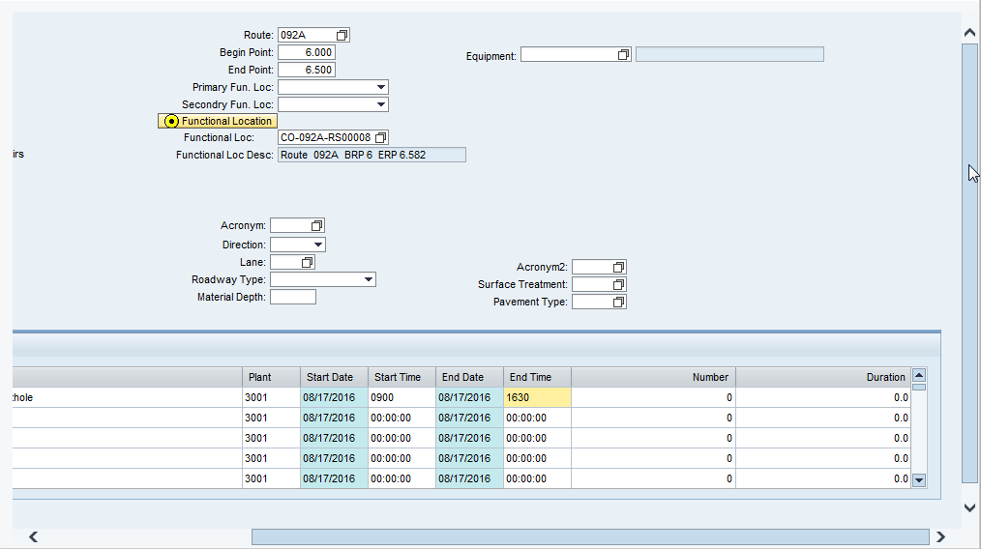

15. | Enter the following:  - Number 1  - Duration 7

The Number field identifies how many people there are in the Work Center (usually one) and the Duration field identifies how long each of them worked.

Application For Work Order Creation
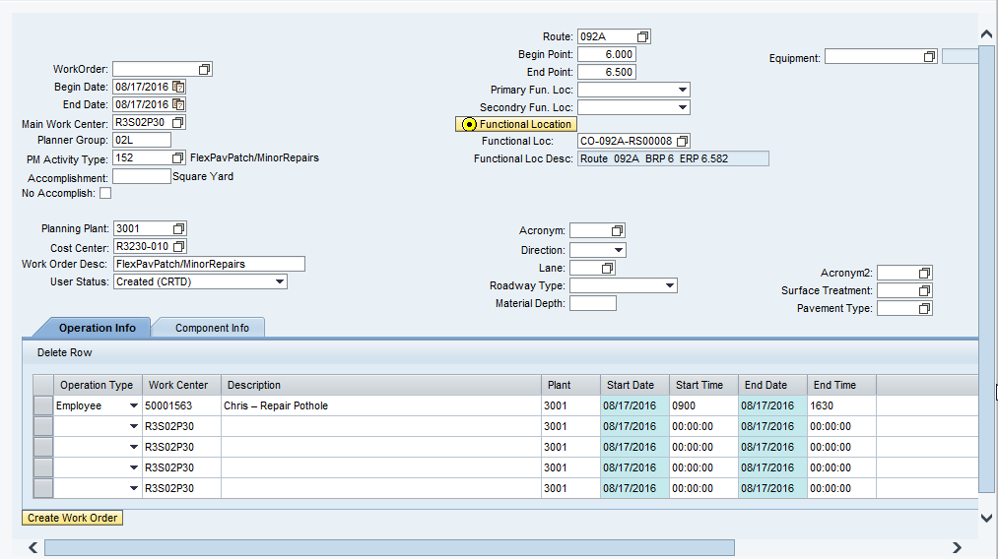

16. | Click Create Work Order button .

Application For Work Order Creation
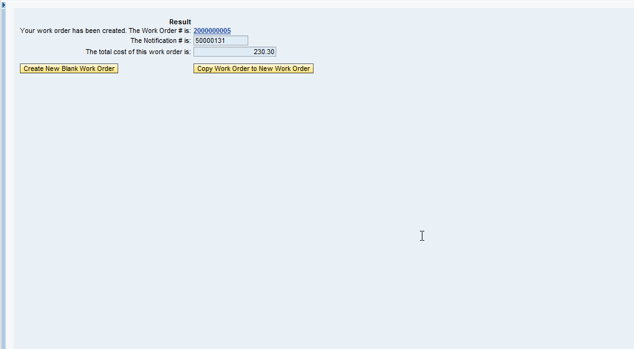

17. | You have entered data in the Work Order UI and created a DOT1 Work Order.  Do NOT LOG OFF of the system.

Exercise Questions
Questions
Answer the following question(s).
Why do you press "Enter" after entering a new start or end date?

To search for data in the system, what button must you select?

What symbol is used for a "wildcard" search in SAP?

What is the purpose of a drop-down button?

What is the number of your Work Order

Exercise Three – Enter and Release Time in Timesheet (CAT2)
Exercise Scenario
You created a Preventive Work Order in the Work Order UI. As with all TM1’s, you must enter all your working time to a Work Order in CAT2. Enter your first hour of the day to a Preventive Work Order set up for inspection.

One other thing, you’re going to the doctor on Thursday. You’re going to take two hours of sick leave, enter this in your Timesheet too.

Instructions

Do NOT LOG OFF of the system when you complete this Exercise.

Procedure
Create Work Order - SAP NetWeaver Portal - Windows Internet Explorer

1. | Click Expand navigation panel button .

Create Work Order - SAP NetWeaver Portal - Windows Internet Explorer

2. | Click Expand button beside Time Management folder.

Create Work Order - SAP NetWeaver Portal - Windows Internet Explorer

3. | Click Time Sheet Entry link.

Time Sheet Entry - SAP NetWeaver Portal - Windows Internet Explorer
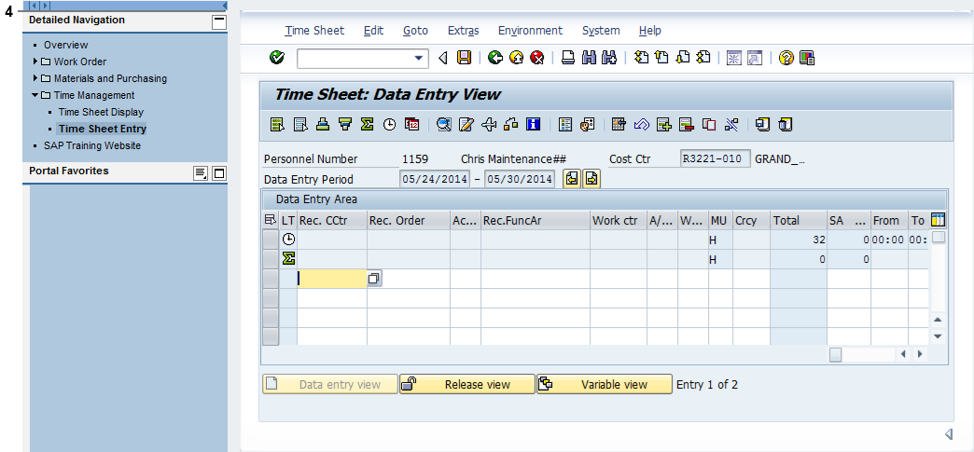

4. | Click Collapse navigation panel button .

Time Sheet: Data Entry View
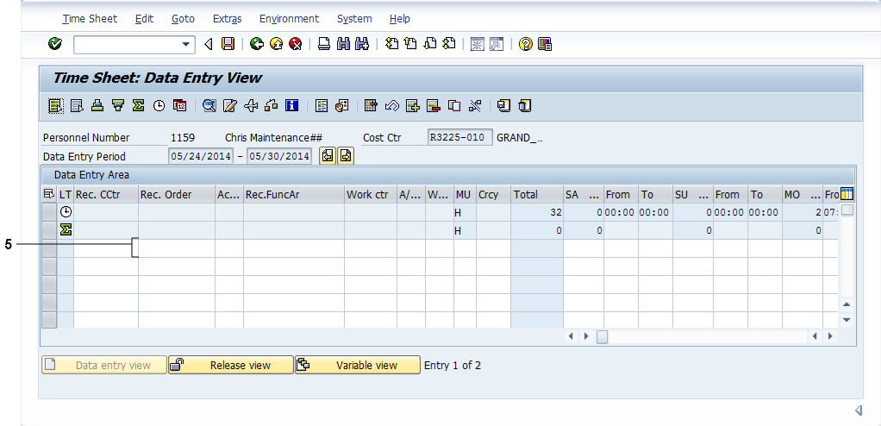

5. | Enter the following:  - Rec. Order 1000016400

Time Sheet: Data Entry View

6. | Click Ac... (Activity) field.

Time Sheet: Data Entry View

7. | Click Matchcode button for Ac... field.

The Matchcode button ONLY displays if the field is selected.

Operation/Activity (1) 4 Entries found

8. | The Operation/Activities dialog box displays. Double-click Op/Ac (Operation Activity) - 0010 - Inspection - Chris.

If the selected Work Order has multiple Operation Activities, they all display. Select the correct one for your Work Center or Patrol. If your Work Center or Patrol does not display, double-check your Work Order number.

Time Sheet: Data Entry View

9. | Enter the following:  - Work cr 50001563  - A/ … (Attendance/Absence Type) 010N

Time Sheet: Data Entry View

10. | Place cursor over Horizontal Scrollbar until Wednesday displays (WE MM/DD). Click in Horizontal Scrollbar.

This takes you directly to the displayed day/date in the Data Entry Area.

Time Sheet: Data Entry View

11. | Enter the following:  - From (Start time on WE) 7  - To (End time on WE) 8

12. | Click Enter button .

Time Sheet: Data Entry View

 |  |  | SAP calculates the total hours for the line item entry and the work week (in the Σ row) in the Total column.
13. | Click A/ ... (Absence/Attendance Type) field for next line item.

Time Sheet: Data Entry View

14. | Enter the following:  - A/ … (Attendance/Absence Type) 120P  - From (Start time on TH) 15:30  - To (End time on TH) 17:30

You ONLY need to enter the Absence/Attendance type for a Leave entry.

SAP automatically identifies, but does not display, the correct Cost Center and Functional Area for your entry. This information does not display on your Timesheet.
15. | Click Enter button .

Time Sheet: Data Entry View

16. | Click Check Entries button .

Information
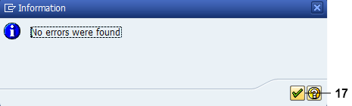

17. | Click Continue button .

If errors were found in your Timesheet, the system would display them. You would not be able to release and save your Timesheet until these errors had been corrected.

Time Sheet: Data Entry View

 |  |  | The system displays the message "No errors were found" in the status bar.
18. | Click Release view button .

Time Sheet: Release View

19. | Click Select All button .

Your unreleased time entries display in blue.

Time Sheet: Release View

 |  |  | Your selected entries are highlighted in orange.
20. | Click Release button .

Time Sheet: Release View

 |  |  | The system displays the message “2 times were released” in the status bar.
21. | Click Save button .

SAP Screen
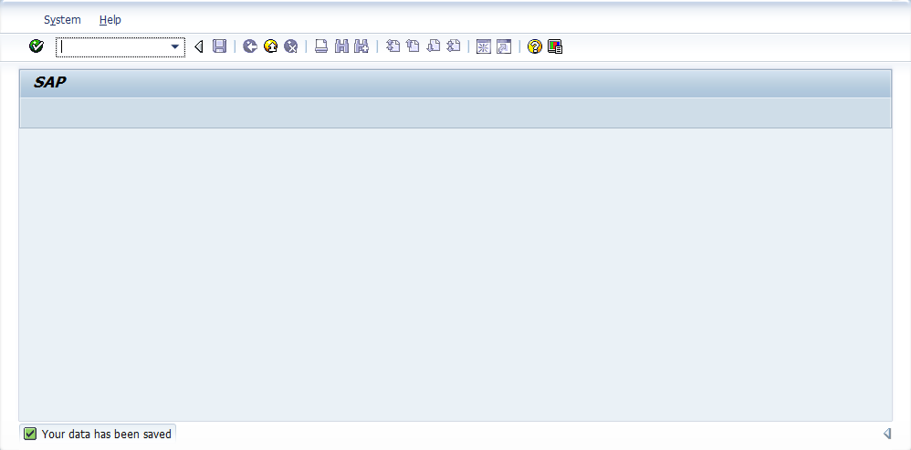

 |  |  | The system displays the message "Your data has been saved" in the status bar.
22. | You have entered and released time in an SAP Timesheet.  LOG OFF of the system.

Exercise Questions
Questions
Answer the following question(s).
When a Work Order is entered in the line item, what displays when you click the Matchcode button for the A … (Activity) field?

What happens when you place your cursor over the Horizontal Scrollbar?

True or False. You do NOT need to enter the Cost Center and Functional Area for a Leave entry.

