Exercises
Introduction to SAP for Maintenance
P

Exercise 1 – Log On to SAP Portal and Access the Time sheet
Scenario
You are entering your time for the week and need to access your time sheet through the SAP Portal. Log on to the system and access your time sheet.

Instructions
- Circle or highlight your user. This will be needed if you have to log back into the system.
- When you complete the exercise DO NOT log off of the system.

User-Specific Data
This section provides the user-specific data required to complete this exercise.
User | Username* | Password
Instructor | sapuser102
1 | sapuser51 | Colorado1
2 | sapuser52 | Colorado1
3 | sapuser53 | Colorado1
4 | sapuser54 | Colorado1
5 | sapuser55 | Colorado1
6 | sapuser56 | Colorado1
7 | sapuser57 | Colorado1
8 | sapuser58 | Colorado1
9 | sapuser59 | Colorado1
10 | sapuser60 | Colorado1
11 | sapuser61 | Colorado1
12 | sapuser62 | Colorado1
13 | sapuser63 | Colorado1
14 | sapuser64 | Colorado1
15 | sapuser65 | Colorado1
16 | sapuser66 | Colorado1
17 | sapuser67 | Colorado1
18 | sapuser68 | Colorado1
19 | sapuser69 | Colorado1
20 | sapuser70 | Colorado1
21 | sapuser71 | Colorado1
22 | sapuser72 | Colorado1
23 | sapuser73 | Colorado1
24 | sapuser74 | Colorado1
25 | sapuser75 | Colorado1
26 | sapuser76 | Colorado1
27 | sapuser77 | Colorado1
28 | sapuser78 | Colorado1
29 | sapuser79 | Colorado1
30 | sapuser80 | Colorado1
31 | sapuser81 | Colorado1
32 | sapuser82 | Colorado1
33 | sapuser83 | Colorado1
34 | sapuser84 | Colorado1
35 | sapuser85 | Colorado1
36 | sapuser86 | Colorado1
37 | sapuser87 | Colorado1
38 | sapuser88 | Colorado1
39 | sapuser89 | Colorado1
40 | sapuser90 | Colorado1
41 | sapuser91 | Colorado1
42 | sapuser92 | Colorado1
43 | sapuser93 | Colorado1
44 | sapuser94 | Colorado1
45 | sapuser95 | Colorado1

Procedure

1. | Open the SAP Training Portal: http://vsaptrnep2.dot.state.co.us:50000/irj/portal

SAP NetWeaver Portal - Windows Internet Explorer
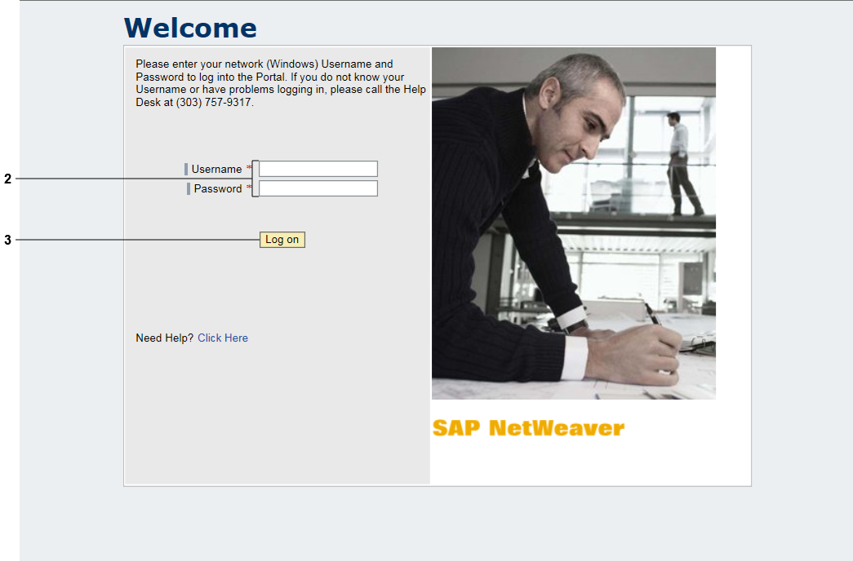

2. | Enter the following:  - Username*: To be supplied by instructor  - Password*: Colorado1

3. | Click .

Overview - SAP NetWeaver Portal - Windows Internet Explorer
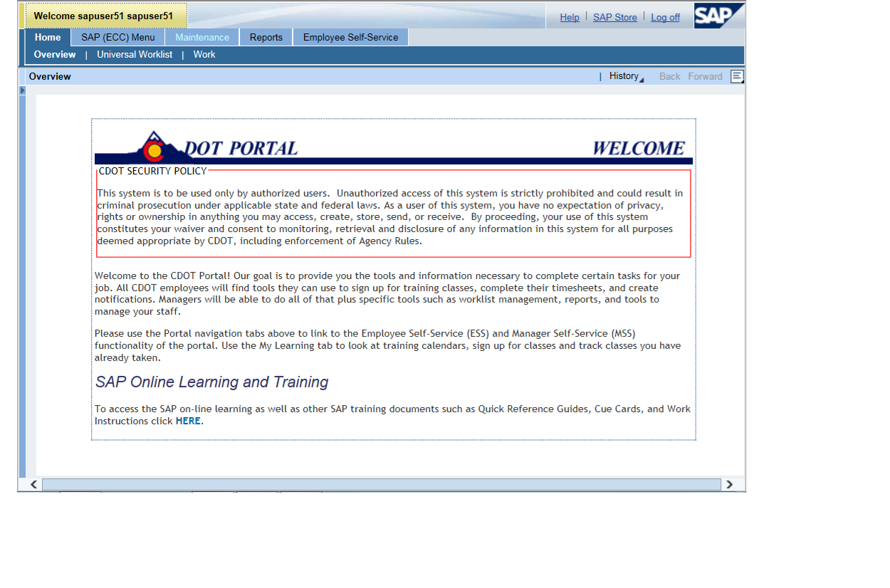

4. | Click tab.

Overview - SAP NetWeaver Portal - Windows Internet Explorer
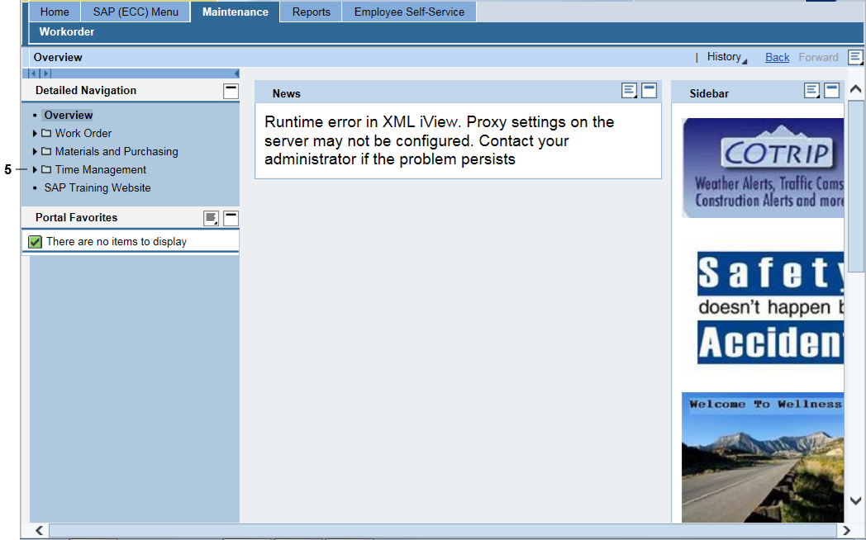

5. | Click Expand button beside Time Management folder in Detailed Navigation pane.

Overview - SAP NetWeaver Portal - Windows Internet Explorer

 | 6. | Click Time Sheet Entry link.
7. Click Allow if the Internet Explorer Security pop-up screen displays.
8. Click Allow if the SAP GUI Security pop-up screen displays.

Time Sheet Entry - SAP NetWeaver Portal - Internet Explorer
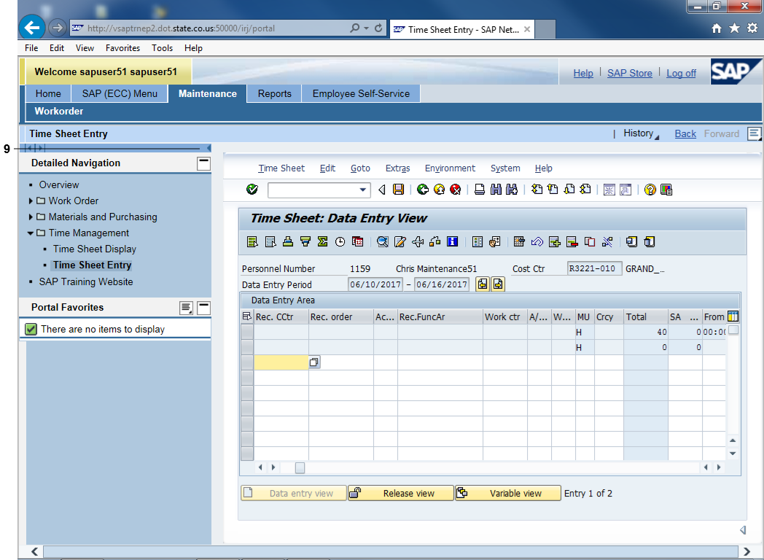

9. Click Collapse navigation panel .

Questions
Answer the question(s).
What user name and password do you use to access the time sheet through the SAP Portal?

Under which tab do you find your time sheet?

Exercise 2 – Verify and Change Work Order Hours in the Time Sheet

Exercise Scenario
A DOT1 work order populated to your time sheet on Monday and Tuesday. Tuesday’s time shows 9 hours worked instead of 8 hours worked and 1 hour of overtime. You are changing the last hour of the Tuesday’s time to overtime and then changing the existing work order to 8 hours to match your work schedule.

When you complete the exercise DO NOT log off of the system.

Procedure

1. | Start from the first open row of the time sheet as indicated by the red arrow below.
Time Sheet: Data Entry View
2. | Enter the following data on the second line of the time sheet (Field – Data)  - Rec Order – 2000000001  - Activity – 0010  - Work Center – 50001563  - A/A Type - 014N  - Tuesday – 1  - From (for Tuesday) – 0030  - To (for Tuesday) - 0130

Time Sheet: Data Entry View
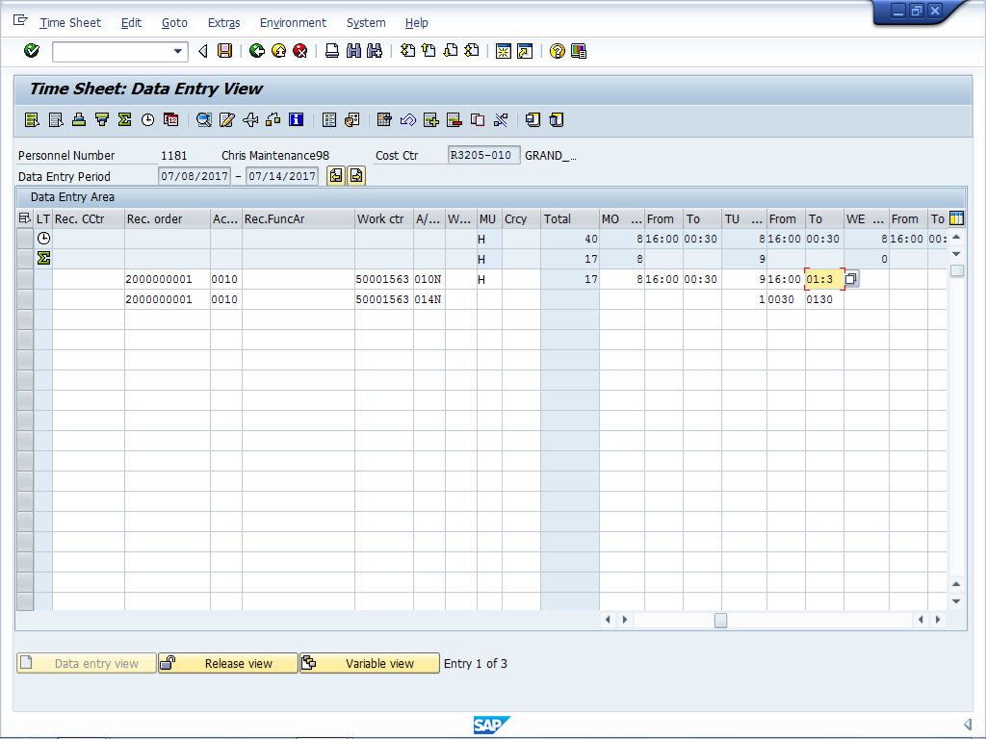

3. | Change the time in the first row to match your work schedule, as indicted by the red arrow.  - To (for Tuesday) - 0030

4. Click Enter .

Questions
Answer the question(s).
Why do you think we entered the overtime first instead of correcting the entry?

Are you able to correct the time for a DOT1 work order that has not been transferred to your time sheet correctly?

Exercise 3 – Enter Preventive Work Order Hours

Exercise Scenario
On Wednesday and Thursday you worked towards a preventive work order.

When you complete the exercise DO NOT log off of the system.

Procedure

 | 1. | Start from the first open row of the time sheet as indicated by the red arrow below.
Time Sheet: Data Entry View
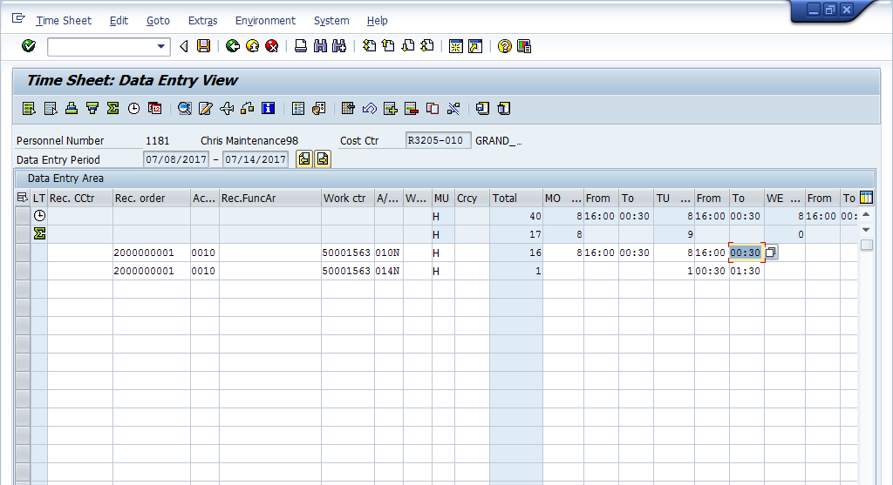
 | 2. | Enter data on the third line of the time sheet for the following fields (Field – Data):  - Rec Order – 1000016400  - Activity – 0010  - Work Center – 50001563  - A/A Type - 010N

In order to see the rest of the time sheet you will have to scroll over to the day using the scroll bar in the time entry section.

- Wednesday – 8
- From (for Wednesday) – 1600
- Thursday – 8
- From (for Thursday) – 1600

Time Sheet: Data Entry View
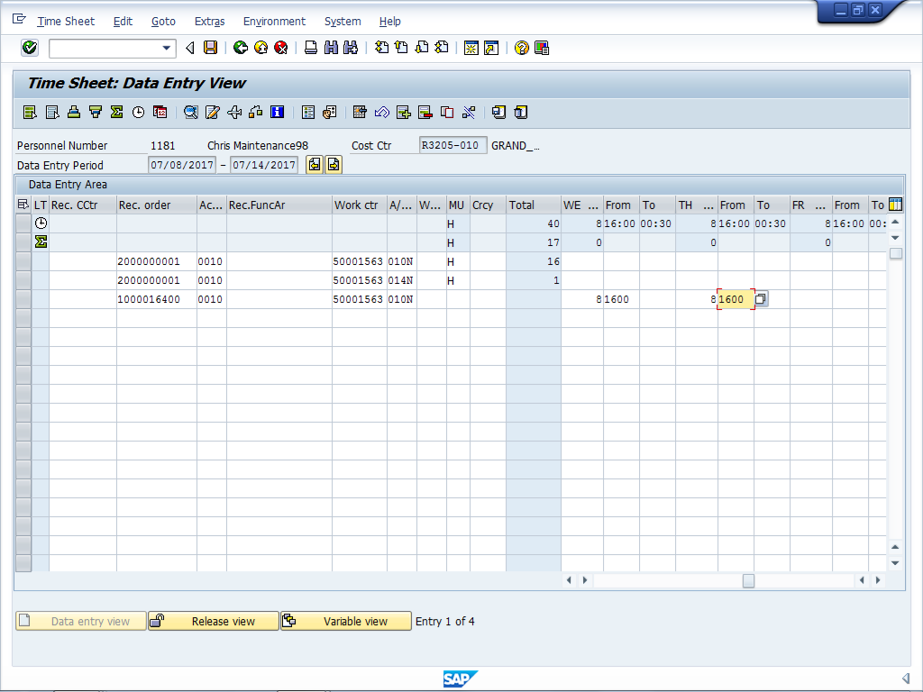

3. Click Enter .

Questions
Answer the question(s).
How do you navigate to days that are not displaying on the time sheet?

What is the A/A type for regular working time?

Exercise 4 – Enter On-call Time

Exercise Scenario
On Thursday you were asked by your supervisor to work on-call for one hour before your shift because of an absence of a co-worker.
When you complete the exercise DO NOT log off of the system.

Procedure

 | 1. | Start from the first open row of the time sheet as indicated by the red arrow below.
Time Sheet: Data Entry View
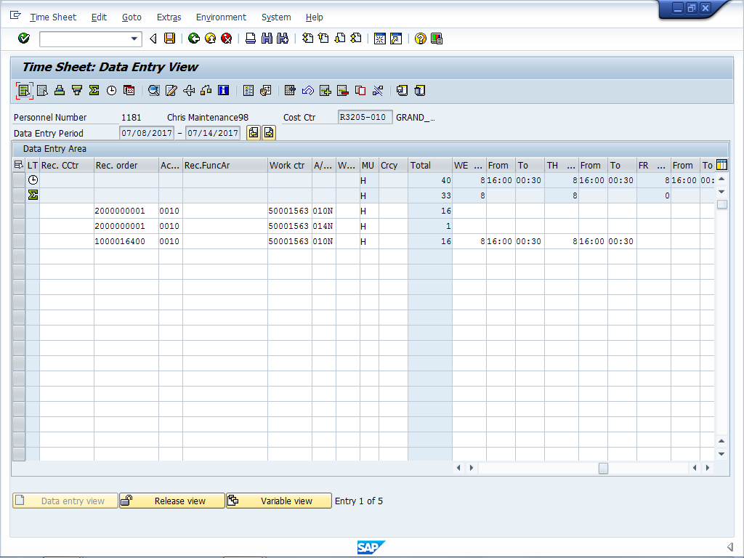
 | 2. | Enter data on the fourth line of the time sheet for the following fields (Field – Data):  - Rec Cost Center – Use the cost center from your time sheet (ask if you don’t know)  - Rec. Functional Area – 1100  - A/A Type - 4099

To see the rest of the time sheet, you may have to use the Time Entry scroll bar.

- From (for Thursday) – 1500
- To (for Thursday) – 1600

Time Sheet: Data Entry View
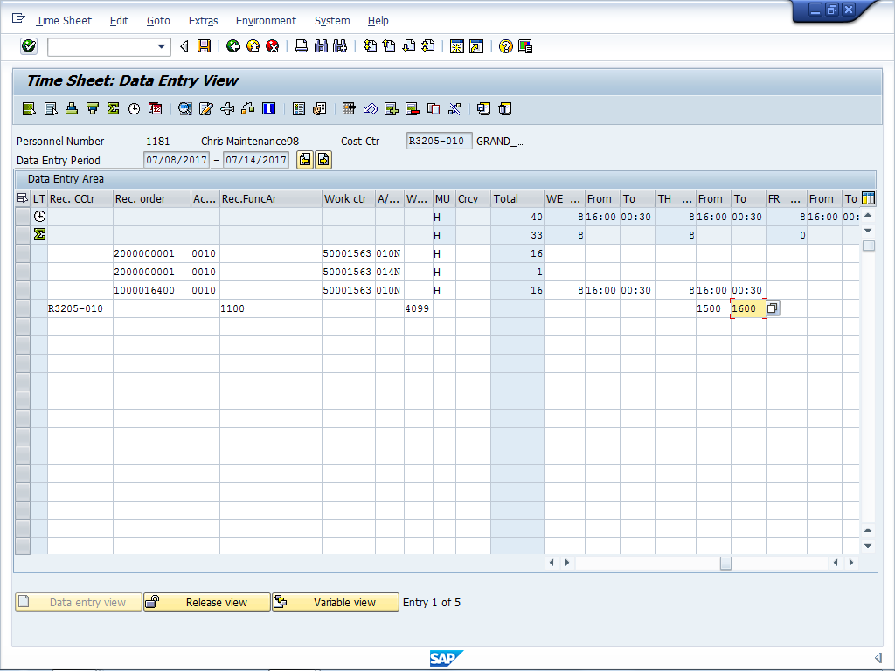

9. Click Enter .

Questions
Answer the question(s).
What is the Wage Type for On-call?

Can you enter on-call time during regular working hours?

Exercise 5 – Enter Time to a Cost Center

Exercise Scenario
On Friday, you attended a mandatory training on first shift for 8 hours.

When you complete the exercise DO NOT log off of the system.

Procedure

 | 1. | Start from the first open row of the time sheet as indicated by the red arrow below.
Time Sheet: Data Entry View
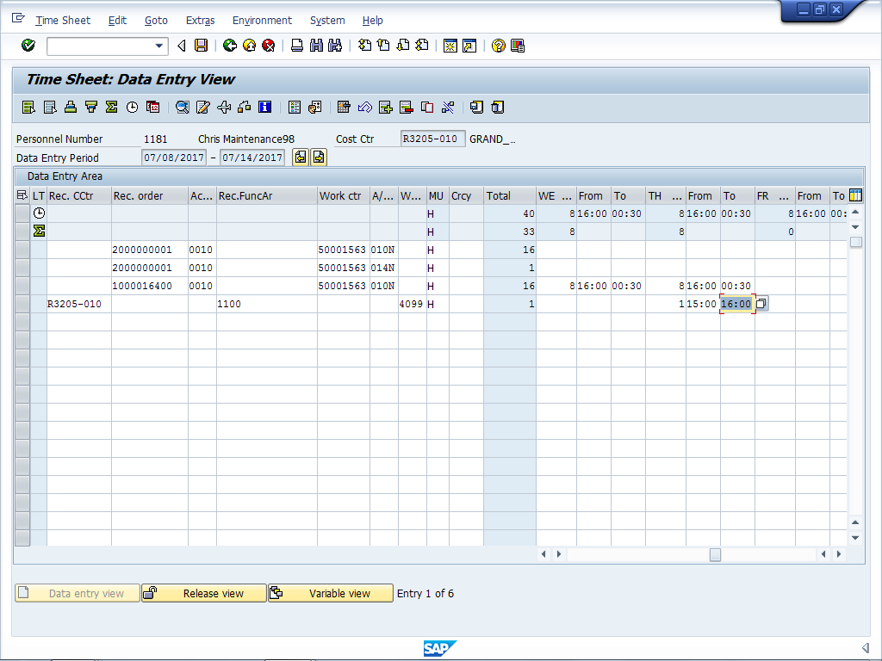
 | 2. | Enter data on the fifth line of the time sheet for the following fields (Field – Data):  - Rec Cost Center – Use the cost center from your time sheet (ask if you don’t know)  - Rec. Functional Area – 3927  - A/A Type - 010N

To see the rest of the time sheet, you may have to use the Time Entry scroll bar

- Friday – 8
- From (for Friday) – 0700

Time Sheet: Data Entry View
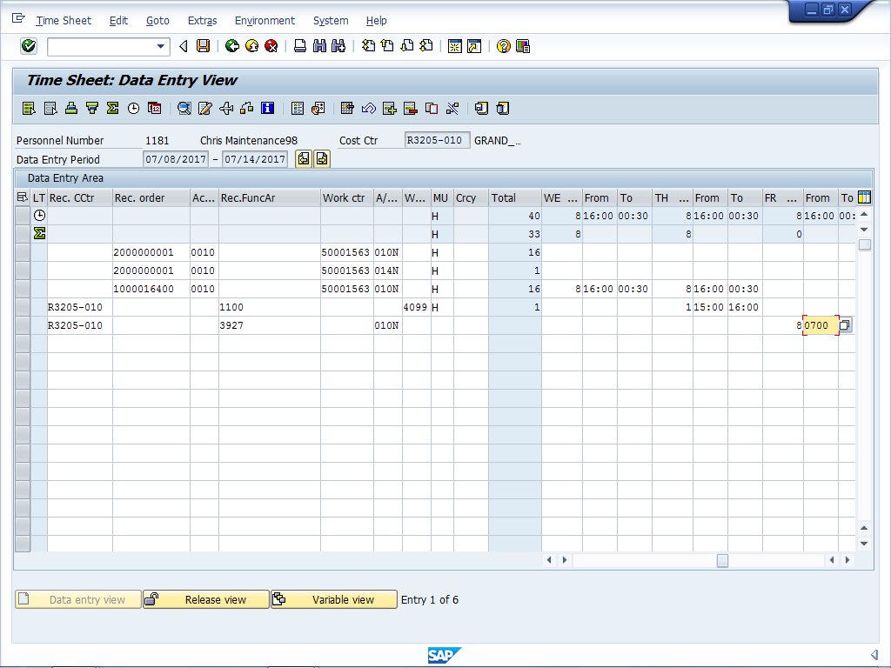

3. Click Enter .

Questions
Answer the question(s).
When do you enter time to a cost center?

Why would you not enter this time as overtime?

Exercise 6 – Enter 2nd Shift Wage Type

Exercise Scenario
On Friday you had a safety meeting on 1st shift from 07:00 to 15:00 and are entering your time using the second shift wage type 7002, because you are assigned to second shift and are working first shift. You are also releasing and saving your time for the week.

When you complete the exercise DO NOT log off of the system.

Procedure
- Start from the first open row of the time sheet, as indicated by the red arrow below.
Time Sheet: Data Entry View
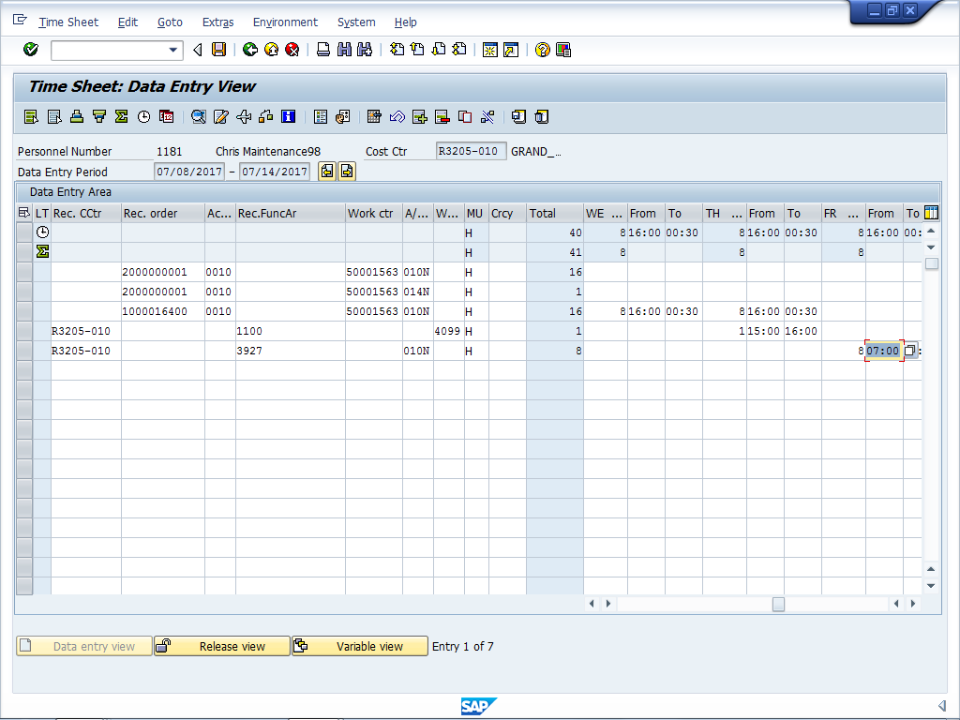

2. | Enter data on the sixth line of the time sheet for the following fields (Field – Data):  - Wage Type - 7002

In order to see the rest of the time sheet you will have to scroll over to the day using the scroll bar in the time entry section.

- Friday - 8

Time Sheet: Data Entry View
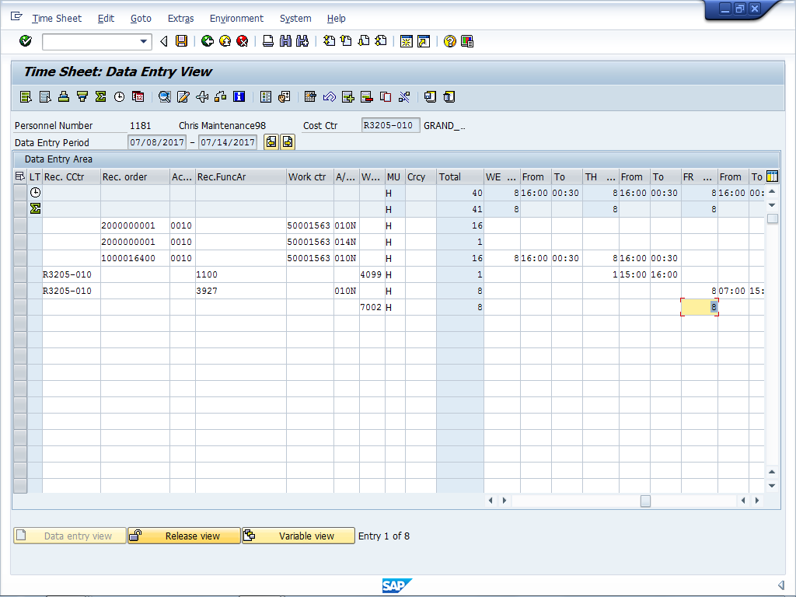

3. Click Enter .
4. Click . The Time sheet: Release View screen displays.

Time Sheet: Release View
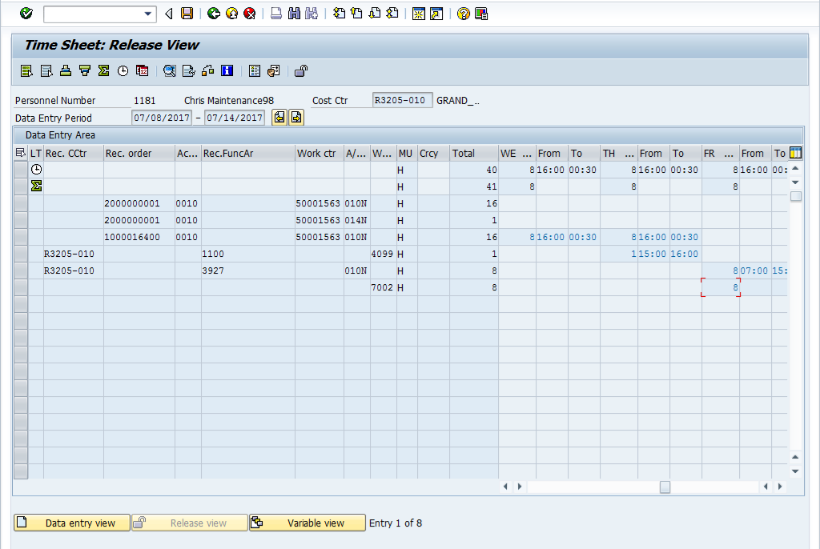

5. Use Select all button to release all lines for approval. If you only want to select one or
more rows, use Select Row .

6. Click Release .

7. Click Save .

Display Messages

8. Click Enter to continue.

SAP Easy Access
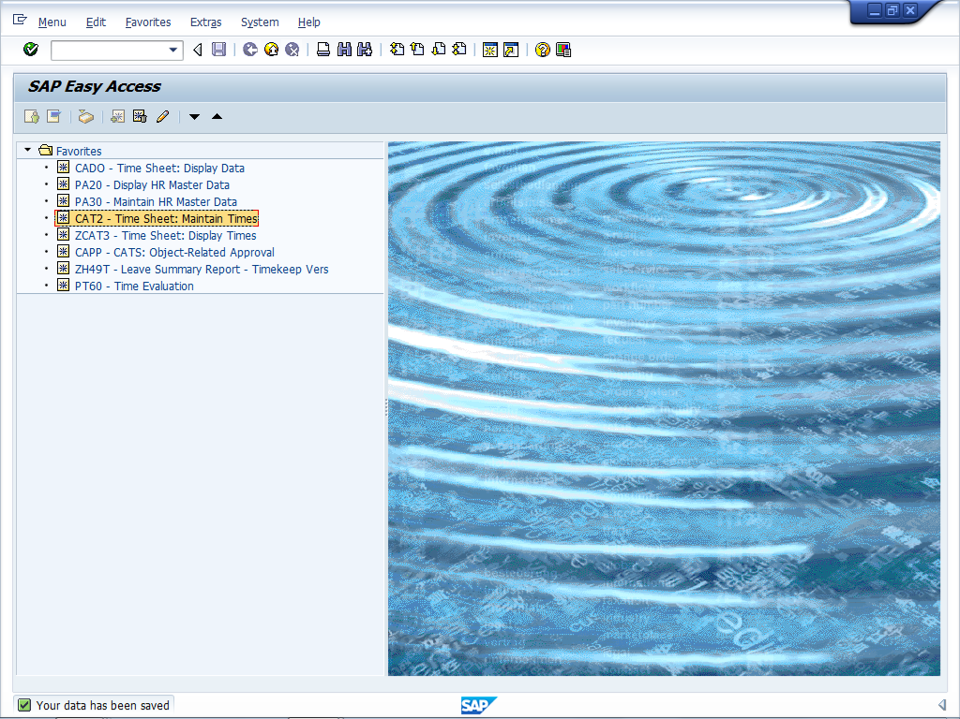

9. You are returned to the SAP Easy Access screen.

Questions
Answer the question(s).
Why are you entering a Wage Type instead of an A/A type?

Can time to a Wage Type ever result in Overtime?

Exercise 7 – Enter Comp Time Worked

Exercise Scenario
Your supervisor reminded you that you worked more than eight hours on last Wednesday’s preventive work order. You were approved to enter the one hour of overtime as comp time worked.

When you complete the exercise DO NOT log off of the system.

Procedure
1. | Start the transaction by entering CAT2 in the transaction code field.
SAP Easy Access
2. | Click Enter .
3. | Start from the first open row of the time sheet, as indicated by the red arrow below.

Time Sheet: Data Entry View
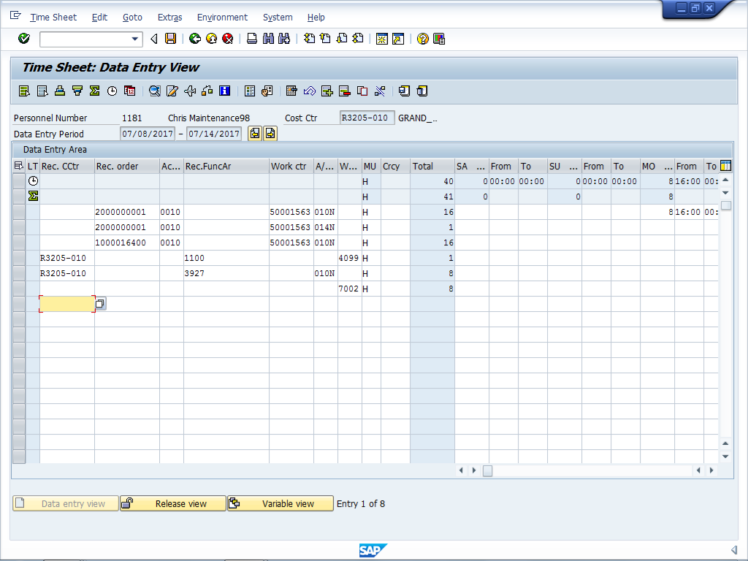

4. | Enter data on the seventh row of the time sheet for the following fields (Field – Data):  - Rec Order – 1000016400  - Activity – 0010  - Work Center - 50001563  - A/A Type - 031N

To view the rest of the time sheet you may have to use the Time Entry scroll bar.

- Wednesday – 1
- From (for Friday) – 0030
Time Sheet: Data Entry View
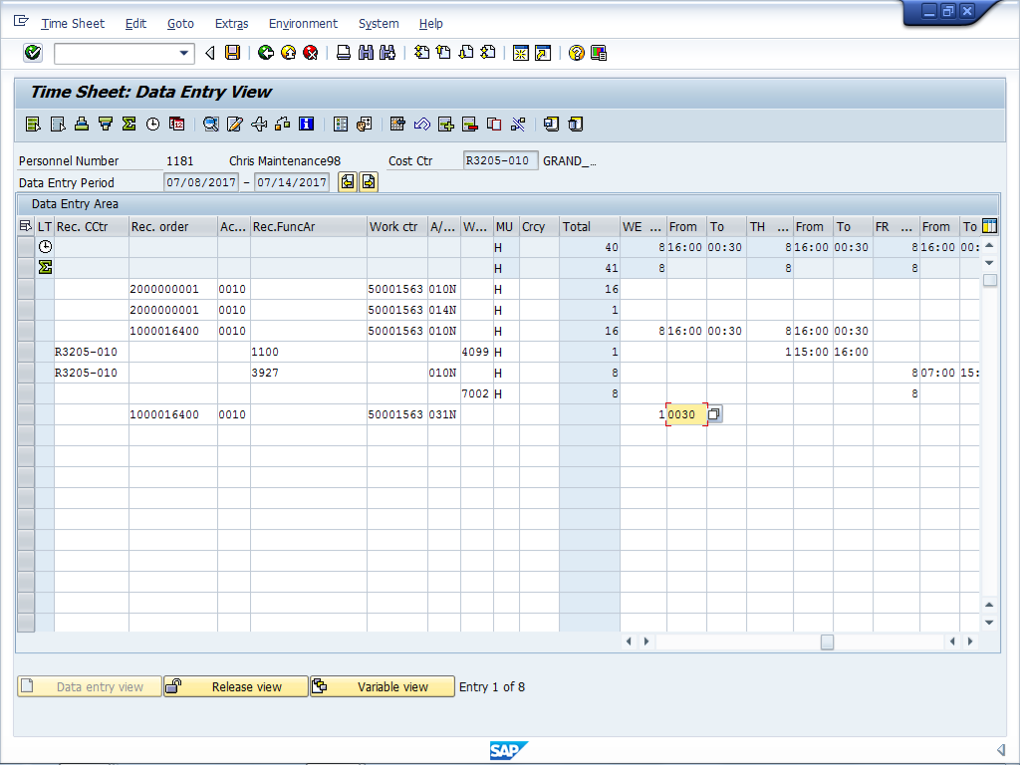

5. Click Enter .
6. Click . The Time sheet: Release View screen displays.

Time Sheet: Release View
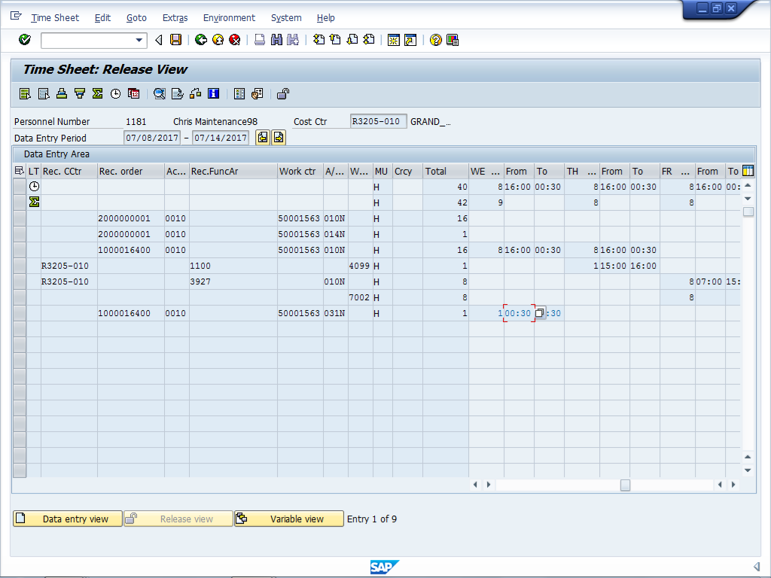

7. Use Select all button to release all lines for approval. If you only want to select one or
more rows, use Select Row .

All times selected for release display as blue. Previously released entries remain black.

8. Click Release .

9. Click Save .

Display Messages

10. Click Enter to continue.

SAP Easy Access

11. You are returned to the SAP Easy Access screen.

The system displays the message, "Your data has been saved".

Questions
Answer the question(s).
What A/A type do you enter when you earn Comp time?

What does the Comp time agreement allow?

Exercise 8 – Enter Comp Time Used

Exercise Scenario
You entered 2 hours Comp Time Used for leave on the Monday of a week in which you also worked 2 hours over on Friday. You are approved for overtime but are unsure how to code the week to be paid for the overtime on Friday.

When you complete the exercise DO NOT log off of the system.

Procedure
1. Start the transaction enter CAT2 in the transaction code field.

SAP Easy Access

2. | Click Enter

Time Sheet: Data Entry View

3 | Click Next Screen to go to the next week of time.
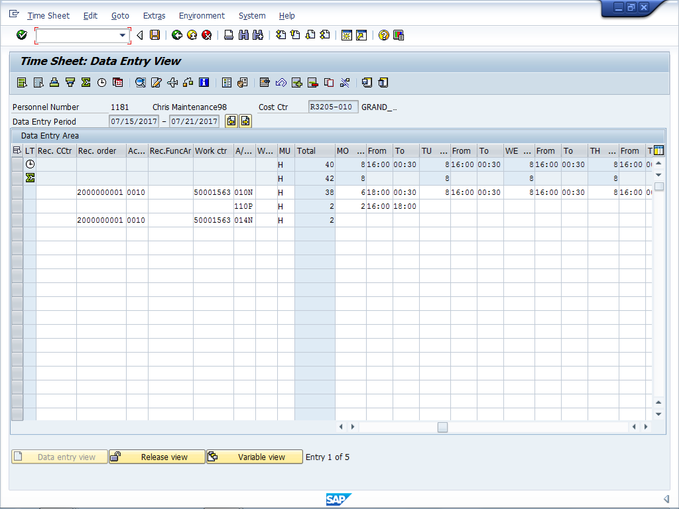
4. | Double-click on the Monday 16:00 to determine leave entry has been approved and needs to be zeroed out.
Cell Information
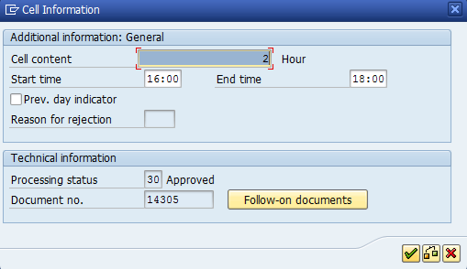
5. | The leave entry has been approved and must be zeroed out. Click Continue .
Time Sheet: Data Entry View

6. | Replace the data on the second line of the time sheet for the following fields (Field – Data):  - Monday – Replace 2 with 0  - From (for Monday) Remove 16:00  - To (for Monday) Remove 18:00

If time entered is not correct it must be zeroed out by replacing the total hours for that entry with zero and removing the From and To times.

Time Sheet: Data Entry View
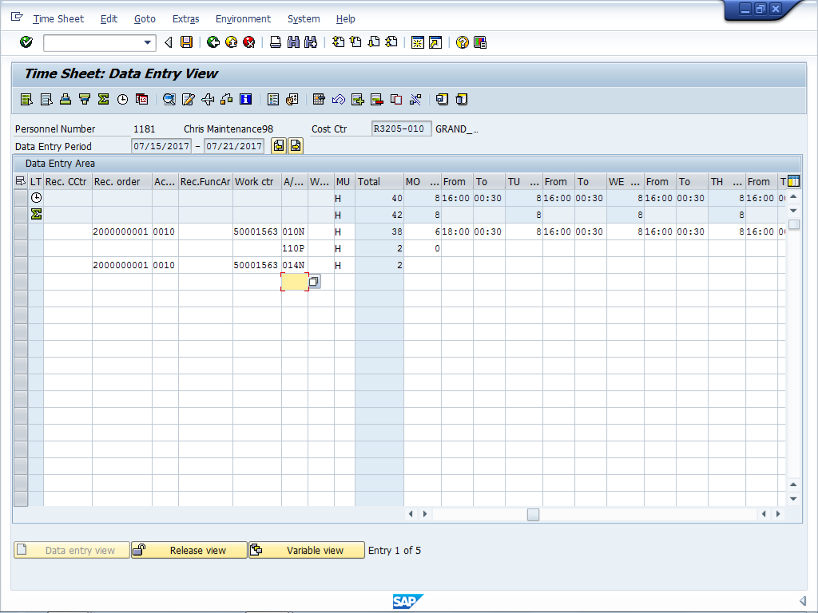
7. | Enter data on the fourth line of the time sheet for the following fields (Field – Data):  - A/A Type – 130P  - Monday – 2  - From (for Monday) - 16:00

Time Sheet: Data Entry View
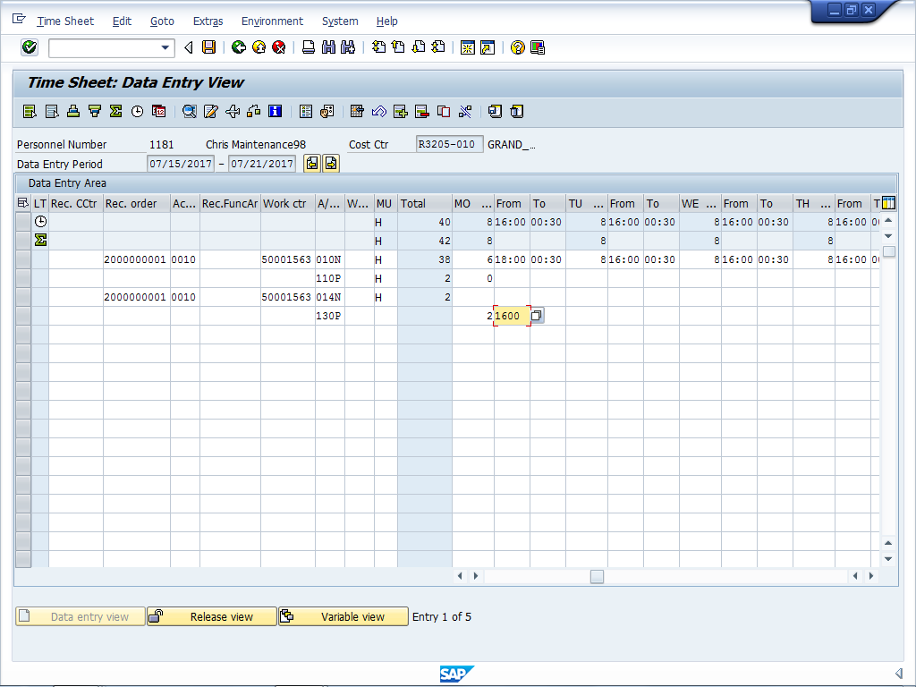

8. Click Enter .
9. Click . The Time sheet: Release View screen displays.

Time Sheet: Release View
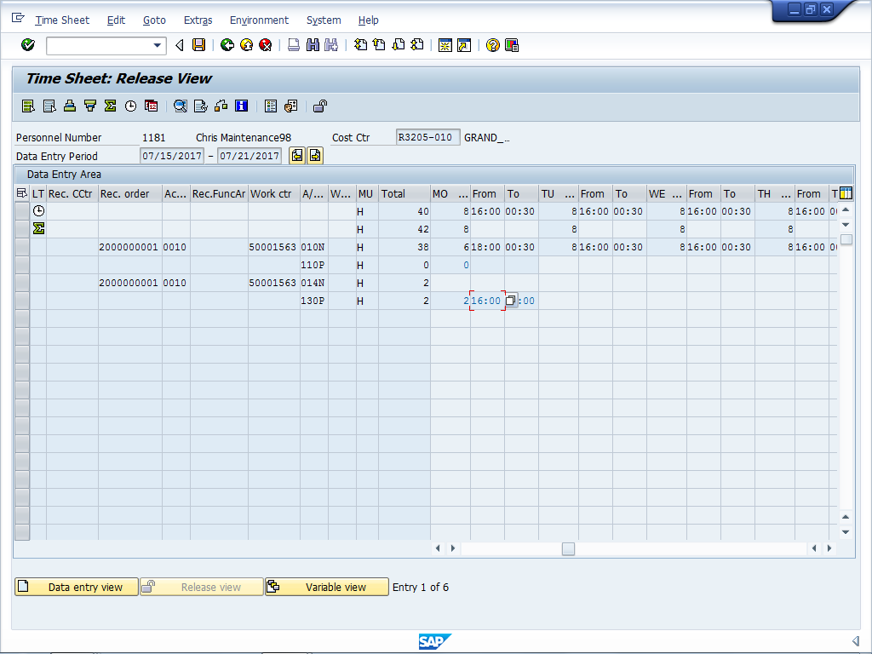

10. Use Select all button to release all lines for approval. If you only want to select one or
more rows, use Select Row .

All times selected for release will display as blue. All times that have been previously released, will remain black.

11. Click Release .

12. Click Save .

SAP Easy Access

13. You are returned to the SAP Easy Access screen. Click Exit to leave SAP.

Questions
Answer the question(s).
Can Comp time be used in the same week it is earned?

Does Comp time count towards determining overtime for the week?

