Section XX Check Your Knowledge
Quiz Settings
Property | Setting
Passing Score | 0%
Randomize Questions
Question Group 1 | No
Total Number of Questions | 2
Total Number of Questions to Ask | All

Questions
Question Group 1
1. Time entry is important to you because: (check all that apply)
(Multiple Response, 0 points, 1 attempt permitted)
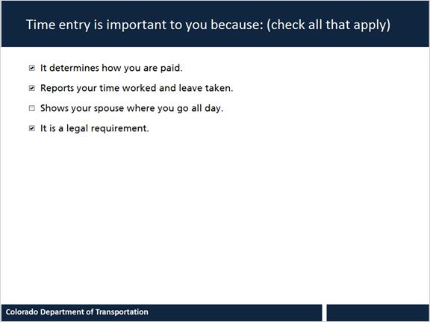
Correct | Choice
X | It determines how you are paid.
X | Reports your time worked and leave taken.
 | Shows your spouse where you go all day.
X | It is a legal requirement.

Feedback when correct: That's right! You selected the correct response.
Feedback when incorrect: You did not select the correct response.

2. Select all that apply to the following statement. Time entry is important to CDOT because it is:
(Pick Many, 0 points, 1 attempt permitted)
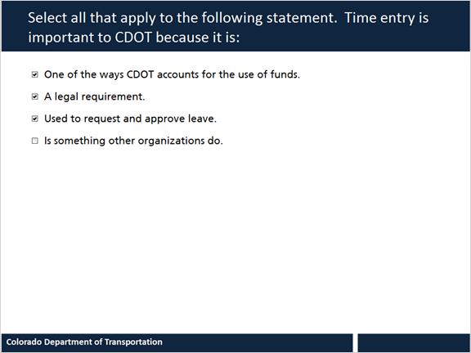
Choice
One of the ways CDOT accounts for the use of funds.
A legal requirement.
Used to request and approve leave.
Is something other organizations do.

Feedback: The first three answers are correct.

