Time Entry Policies
Items: 5 Questions (Including Introduction)
Duration: 25 seconds

Introduction to Time and Leave Policy
5 seconds
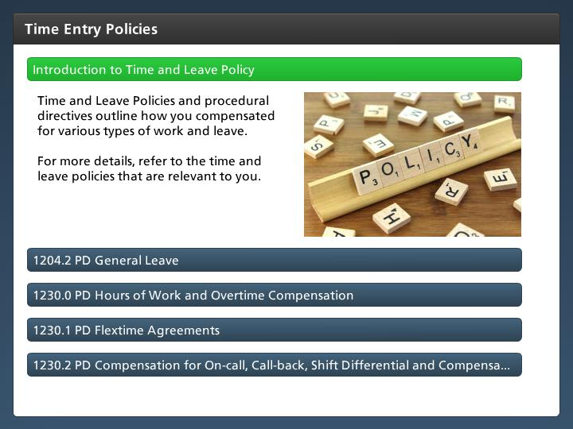

Step Text
Time and Leave Policies and procedural directives outline how you compensated for various types of work and leave.

For more details, refer to the time and leave policies that are relevant to you.

Narration Script
While we don't think about it very much there are policies and procedural directives on how you are able to enter your time and leave. These polices and procedural directives impact pay, work schedules and leave and form the base of time entry. Click on the tabs for a description of each policy.

1204.2 PD General Leave
5 seconds
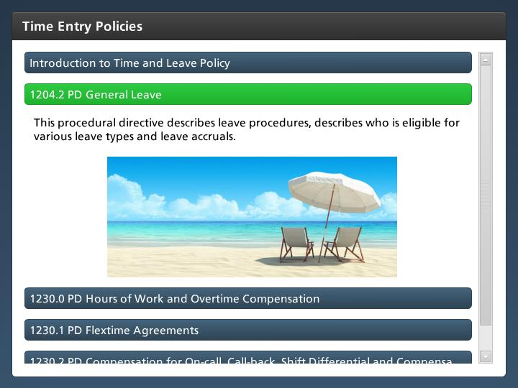

Step Text
This procedural directive describes leave procedures, describes who is eligible for various leave types and leave accruals.

Narration Script
Procedural Directive1204.2 is describes leave procedures, accruals and the types of leave available to you. If you have a question about a leave type this is your best resource.

1230.0 PD Hours of Work and Overtime Compensation
5 seconds
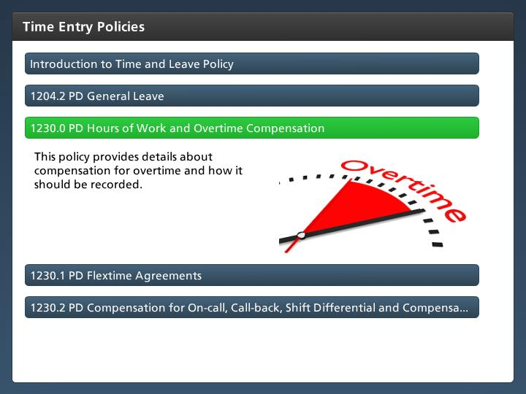

Step Text
This policy provides details about compensation for overtime and how it should be recorded.

Narration Script
This policy describes the process used to calculate overtime and who is eligible for overtime and the rate at which it is paid.

1230.1 PD Flextime Agreements
5 seconds
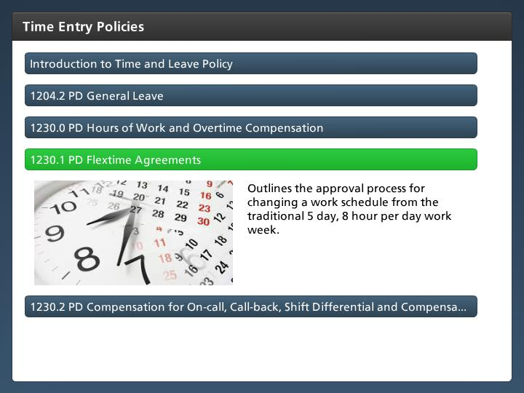

Step Text
Outlines the approval process for changing a work schedule from the traditional 5 day, 8 hour per day work week.

Narration Script
This procedural directive describes the process for changing a work schedule from the traditional 5 day, 8 hour per day work week to a less traditional one such as a flex Monday, flex Friday or 4 ten hour days.

1230.2 PD Compensation for On-call, Call-back, Shift Differential and Compensatory Time
5 seconds
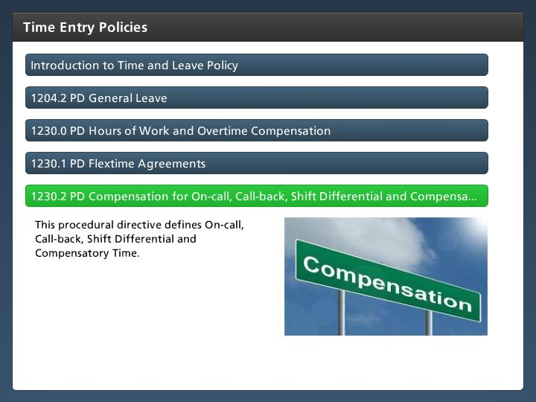

Step Text
This procedural directive defines On-call, Call-back, Shift Differential and Compensatory Time.

Narration Script
This broad procedural directive outlines the guidelines that describe how On-call, Call-back, Shift Differential and Compensatory Time apply at CDOT. This will be discussed in more detail in a later section.

