Why Time Entry is Important
Items: 5 Items (Including Introduction)
Duration: 25 seconds

Introduction
5 seconds
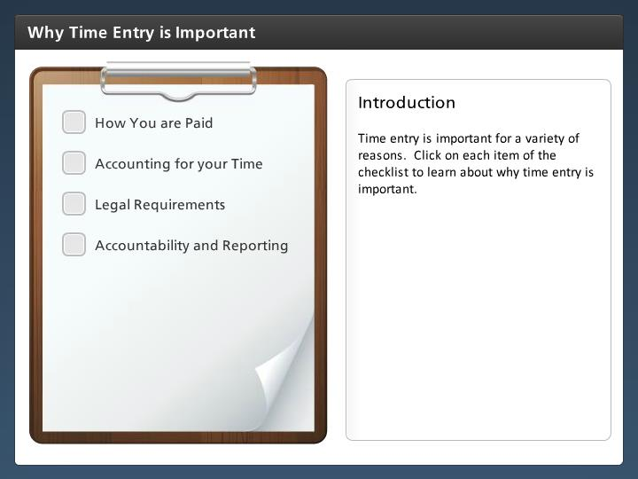

Step Text
Time entry is important for a variety of reasons. Click on each item of the checklist to learn about why time entry is important.

Narration Script
As an employee entering time and leave is important because CDOT must account for the time you work to pay you. It is also how CDOT meets its legal requirements to report to the public and other governmental agencies about how funds are used. Click in the checklist to learn more.

How You are Paid
5 seconds
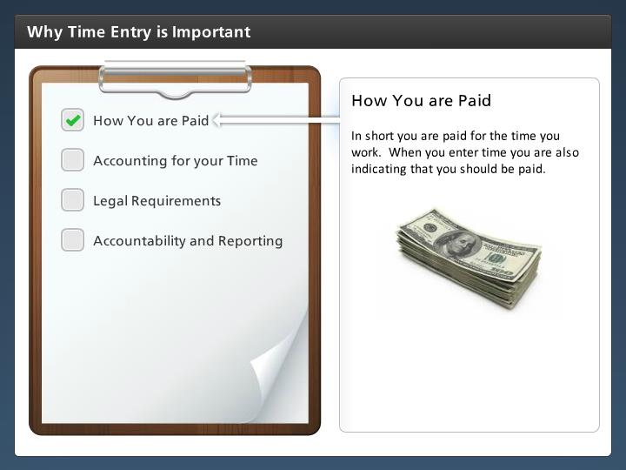

Step Text
In short you are paid for the time you work. When you enter time you are also indicating that you should be paid.

Narration Script
In short your time entry is how you are paid. CDOT will not know what to pay you if you do not enter all of your time. For example, if you worked overtime and it was not coded correctly on your timesheet, then you would not be paid for the time you worked.

Accounting for your Time
5 seconds
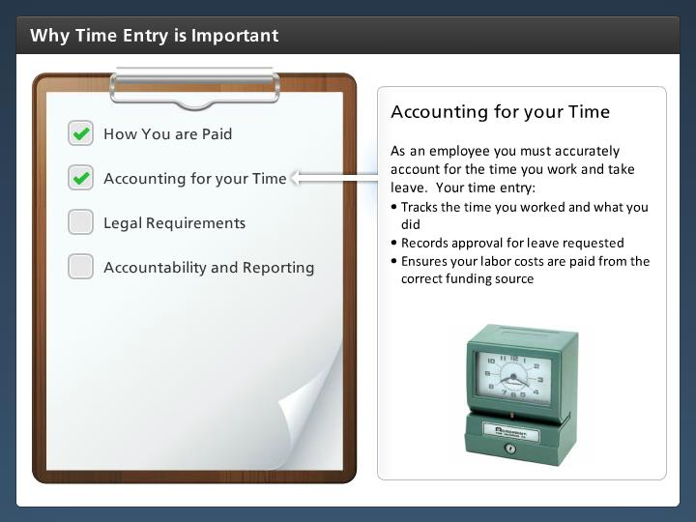

Step Text
As an employee you must accurately account for the time you work and take leave. Your time entry:
- Tracks the time you worked and what you did
- Records approval for leave requested
- Ensures your labor costs are paid from the correct funding source

Narration Script
As a Employee, you are responsible for accounting for the time you work.

Legal Requirements
5 seconds
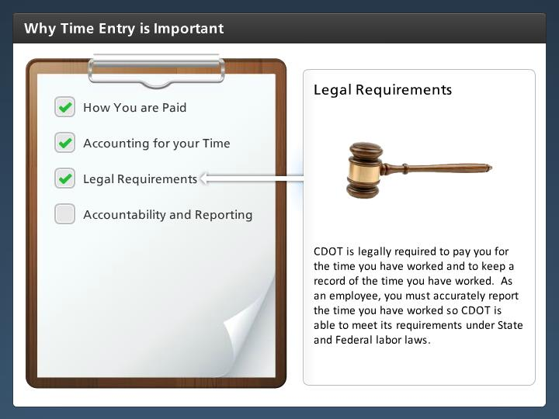

Step Text
CDOT is legally required to pay you for the time you have worked and to keep a record of the time you have worked. As an employee, you must accurately report the time you have worked so CDOT is able to meet its requirements under State and Federal labor laws.

Narration Script
Although we don't often think about it this way, when we submit time we are telling CDOT this is what we should be paid. It is a requirement under State and Federal law that CDOT keep records of the time you have worked.

Accountability and Reporting
5 seconds
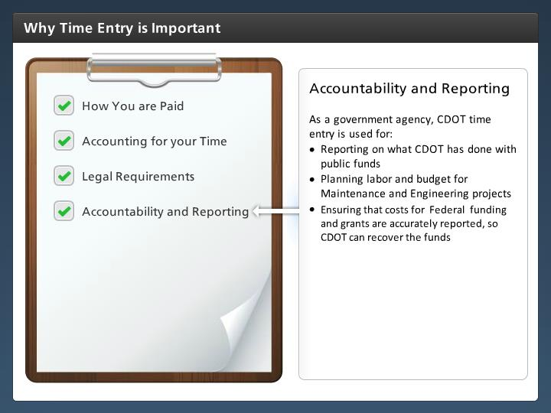

Step Text
As a government agency, CDOT time entry is used for:
- Reporting on what CDOT has done with public funds
- Planning labor and budget for Maintenance and Engineering projects
- Ensuring that costs for Federal funding and grants are accurately reported, so CDOT can recover the funds

Narration Script
Time entry is also used for reporting, budgeting and reimbursements on Maintenance and Engineering
projects.

