Required Work Time Data
Items: 7 Labels (Including Introduction)
Duration: 35 seconds

Introduction
5 seconds
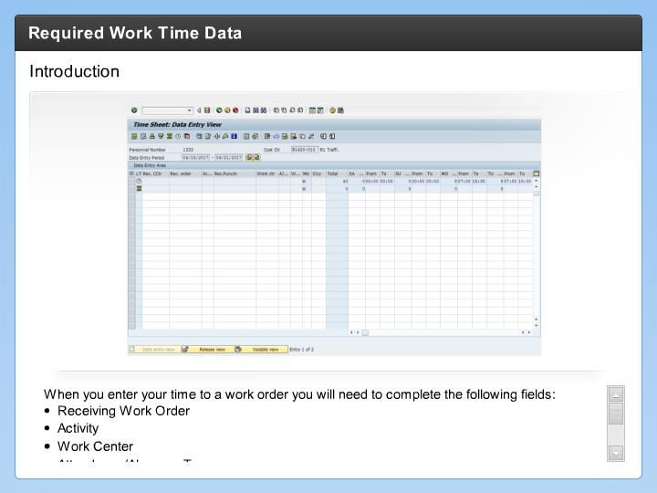

Step Text
When you enter your time to a work order you will need to complete the following fields:
- Receiving Work Order
- Activity
- Work Center
- Attendance/Absence Type
- Day/Date (Total Hours)
- From (Start Time)
- To (End Time)

Narration Script
Now let's look at the fields you need to enter on your timesheet as a Maintenance or Tunnel employee. As a Maintenance or Tunnel Employee, you will typically enter your time to a work order. Entering the information in correctly means you will be paid correctly for the time you work. Now let's look at the required data in more detail. And one last thing, there is not audio for this interaction.

Receiving Work Order
5 seconds
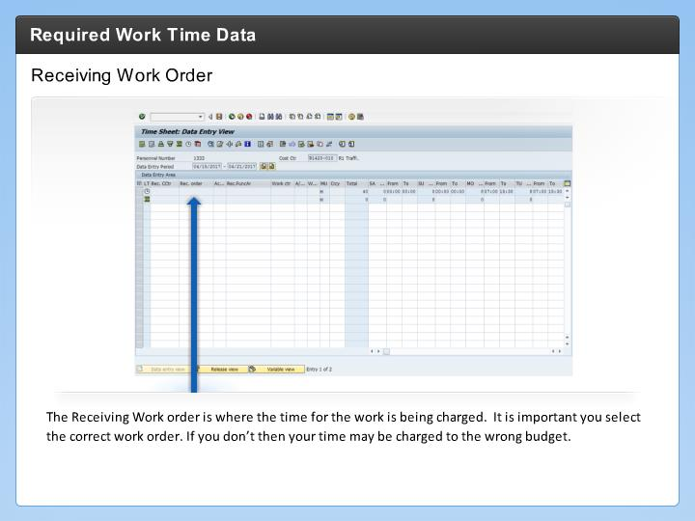

Step Text
The Receiving Work order is where the time for the work is being charged. It is important you select the correct work order. If you don’t then your time may be charged to the wrong budget.

Narration Script

Activity
5 seconds
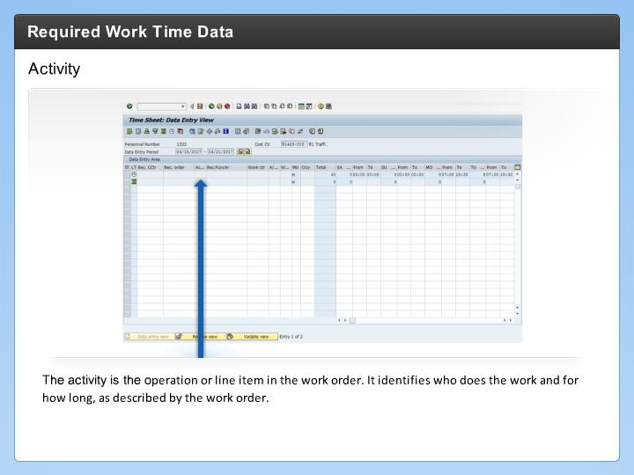

Step Text
The activity is the operation or line item in the work order. It identifies who does the work and for how long, as described by the work order.

Narration Script

Work Center
5 seconds
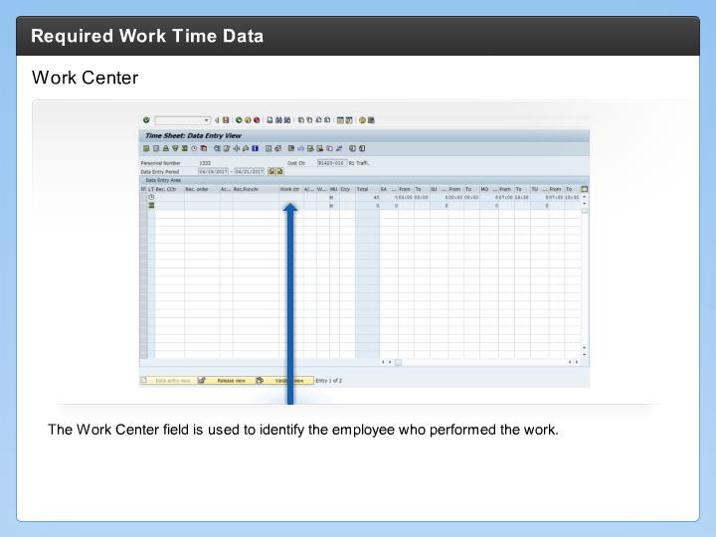

Step Text
The Work Center field is used to identify the employee who performed the work.

Absence/Attendance Type
5 seconds
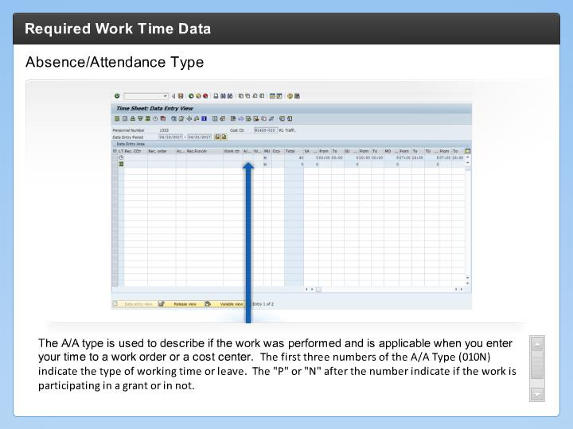

Step Text
The A/A type is used to describe if the work was performed and is applicable when you enter your time to a work order or a cost center. The first three numbers of the A/A Type (010N) indicate the type of working time or leave. The "P" or "N" after the number indicate if the work is participating in a grant or in not.

Narration Script

From (Start Time)
5 seconds
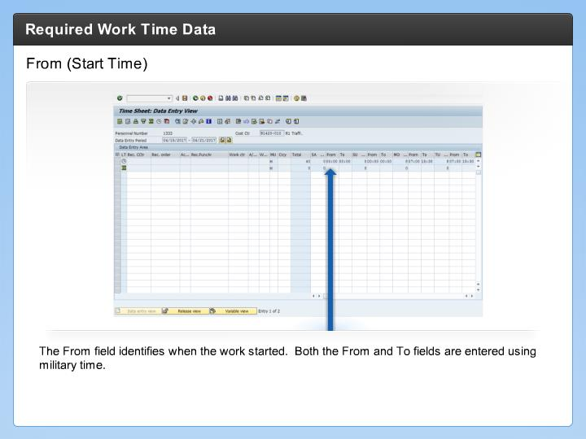

Step Text
The From field identifies when the work started. Both the From and To fields are entered using military time.

Narration Script

To (End Time)
5 seconds
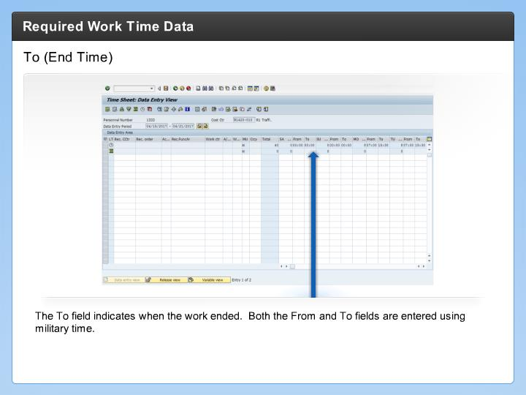

Step Text
The To field indicates when the work ended. Both the From and To fields are entered using military time.

Narration Script

