Section XX Check Your Knowledge
Quiz Settings
Property | Setting
Passing Score | 0%
Randomize Questions
Question Group 1 | No
Total Number of Questions | 2
Total Number of Questions to Ask | All

Questions
Question Group 1
1. Time entry is important to you as an employee because it impacts your pay.
(Pick One, 0 points, 1 attempt permitted)
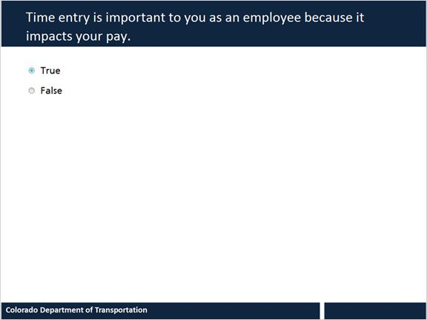
Choice
True
False

2. Select all that apply to the following statement. Time entry is important to CDOT because it is:
(Pick Many, 0 points, 1 attempt permitted)
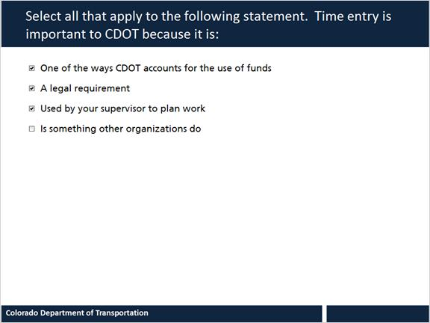
Choice
One of the ways CDOT accounts for the use of funds
A legal requirement
Used by your supervisor to plan work
Is something other organizations do

Feedback: The first three answers are correct.

