Why Time Entry is Important
Items: 5 Items (Including Introduction)
Duration: 25 seconds

Introduction
5 seconds
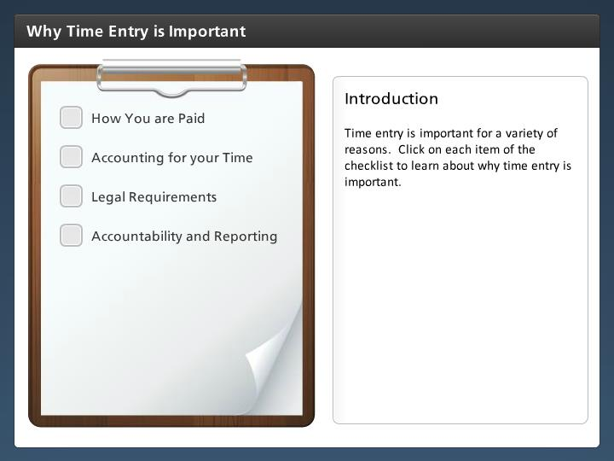

Step Text
Time entry is important for a variety of reasons. Click on each item of the checklist to learn about why time entry is important.

Narration Script
As an employee entering time and leave is important because CDOT must account for the time you work to pay you. It is also how CDOT meets its legal requirements to report to the public and other governmental agencies about how funds are used. Click in the checklist to learn more.

How You are Paid
5 seconds
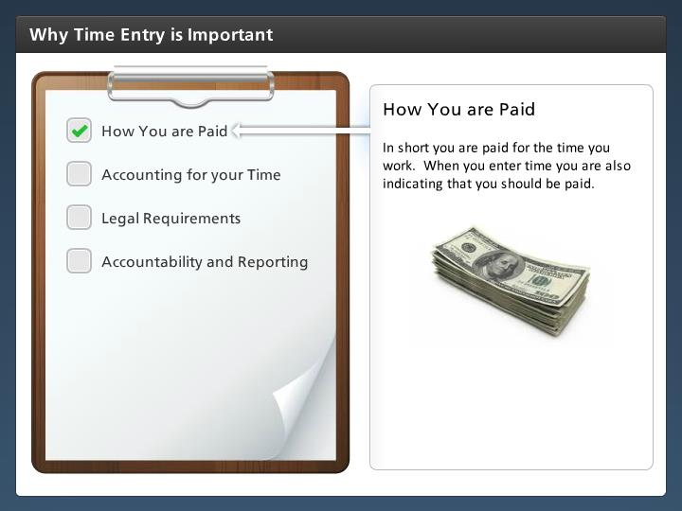

Step Text
In short you are paid for the time you work. When you enter time you are also indicating that you should be paid.

Narration Script
In short your time entry is how you are paid. For example if you are a new temporary employee and started on Monday and enter your time until two weeks after you started you would have to wait two extra weeks for your pay. Or if you entered overtime you ended up not working then your pay would be deducted the next pay period for the amount of the overtime.

Accounting for your Time
5 seconds
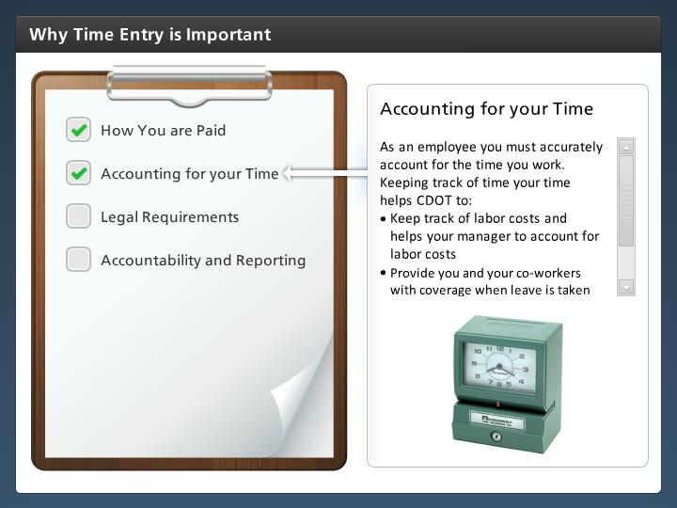

Step Text
As an employee you must accurately account for the time you work. Keeping track of time your time helps CDOT to:
- Keep track of labor costs and helps your manager to account for labor costs
- Provide you and your co-workers with coverage when leave is taken
- Ensure that funds for grants and FHA are accurately reported

Narration Script
As a Employee, you are responsible for accounting for the time you work. Keeping track of time also helps CDOT to account for labor costs, helps to provide coverage when leave is taken and ensures we accurately report on how grant funds are used.

Legal Requirements
5 seconds
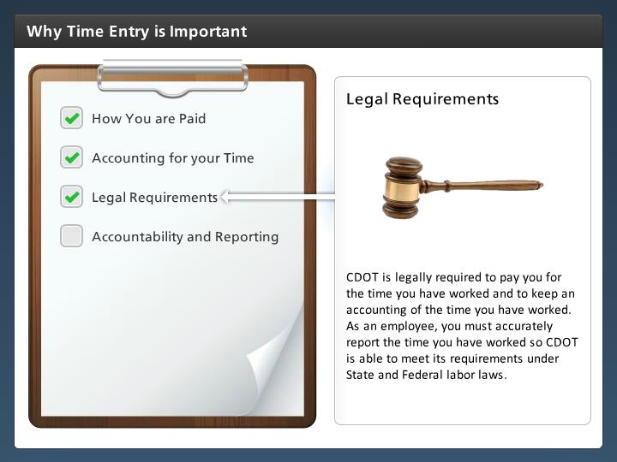

Step Text
CDOT is legally required to pay you for the time you have worked and to keep an accounting of the time you have worked. As an employee, you must accurately report the time you have worked so CDOT is able to meet its requirements under State and Federal labor laws.

Narration Script
Although we don't often think about it this way when we submit time we are telling CDOT this is what we should be paid. It is a requirement under State and Federal law that CDOT keep records of the time you have worked.

Accountability and Reporting
5 seconds
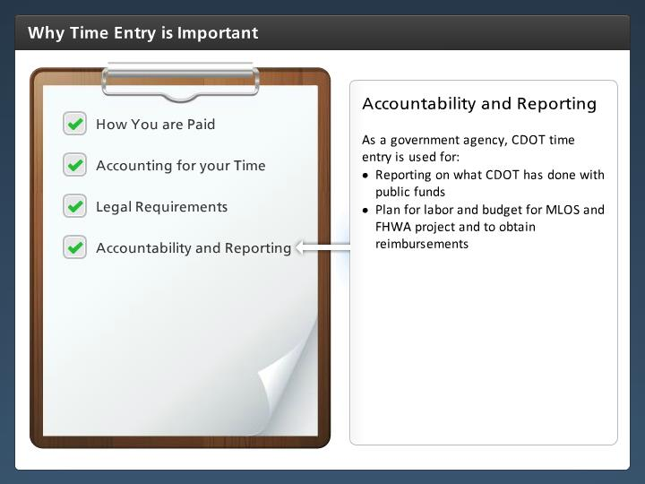

Step Text
As a government agency, CDOT time entry is used for:
- Reporting on what CDOT has done with public funds
- Plan for labor and budget for MLOS and FHWA project and to obtain reimbursements

Narration Script
Time approval is also used for reporting, budgeting and reimbursements on projects. Now that you know why it important let's look at the consequences of not entering time.

