Employee Time Entry Worksheet

The Employee Time Entry Worksheet is used throughout the course and must be completed before you continue with the course. If you need help click HERE to find your Time Admin (Timekeeper).
Instructions on how to complete the Employee Time Entry Worksheet:
- Click HERE and enter your Username and Password and then select Log on Employee Self-Service Time Statement Current month Display Report
- Using your Time Statement and the sample below, enter YOUR details on the Employee Time Entry Worksheet.
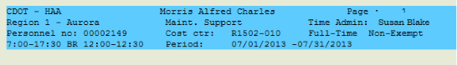
- I am in Personnel Area Choose an item. | - I am in Personnel Subarea (Select One)
- My Time Admin is: | - My Personnel no is:
- My Cost ctr (Center) is: | - I am (Select One)
- I am a/an (select One) employee | - My work schedule is:
- Non-exempt Maintenance employees only (All others skip this question and go to question 10)
If you are a Non-exempt Maintenance employee Select All of the following and go to question 10
☐ I am eligible for on-call
☐ I am eligible for shift differential
☐ I am in an essential position
- Review the processing eligibility section of the Time Statement as shown by the red arrow below. If you do not see an item listed then you are not eligible
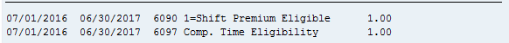
☐ I am eligible for Shift Differential because I see 1=Shift Premium list
☐ I am in an Essential position
☐ I am eligible for on-call
☐ I am eligible for Compensatory time
- Payroll Deadlines and Payment:
☐ I am a Full Time Employee
  - Paid monthly (Click HERE to see the monthly pay schedule)
  - All entries and revisions must be approved by 5:00pm on the second business day of the following month
☐ I am a Temporary, Winter Part-time, or Permanent Part-time Employee
  - Paid Bi-weekly (Click HERE to see the Bi-weekly Pay Schedule)
  - Timesheet is released by Monday 10:00am
  - All timesheets must be approved by 5:00pm Monday
After the class talk to your supervisor or timekeeper to answer the following:
- When I enter regular working time I use A/A code: _______________
- What do I charge my time to (Cost Center, WBS Element, CE Pool, Work Order)?
- What is the expectation of when/How to request leave?

