Create and Maintain Accordion Interactions

Exploring the Editor
The Accordion editor has three columns with the following panels:
- Steps: Located on the left side of the screen, this panel is used to manage panels for the Accordion.
- Text: Located in the middle of the screen, this panel is used to add text to each panel.
- Audio: Located in the upper right corner of the editor, this panel is used to add and edit audio.
- Media: Located in the lower right corner, this panel is used to add pictures, characters, videos, and Flash files.
Here are some tips for working with the editor:
- Change the width of a column by dragging its boundary with your mouse.
- Click the triangle in the upper right corner of the Audio panel to collapse it if you need more room to work with the Media panel. Click it again to reopen the panel.
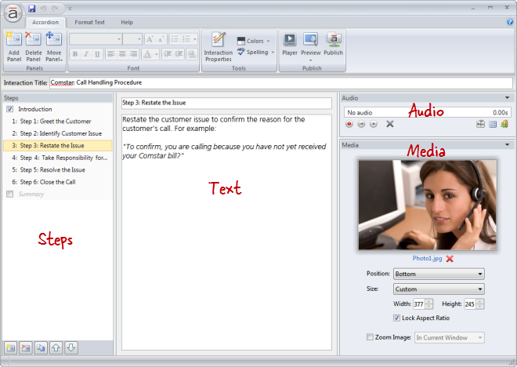

Adding Panels
Each step in an Accordion interaction is called a panel. To add a panel, do any of the following:
- Press Ctrl+M.
- Go to the Accordion tab on the ribbon, and click Add Panel. 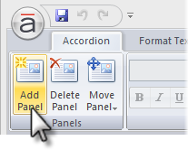
- Click the Create a new step button in the lower left corner of the Steps panel. 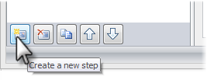
- Click the Duplicate button at the bottom of the Steps panel to copy the currently selected panel(s). 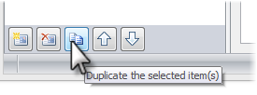
New panels get added just below the panel that's currently selected in the Steps panel—unless the summary is selected, in which case new panels get added above it.
Tip: An Accordion interaction can have up to eight panels (not counting the introduction and summary).

Renaming Panels
To rename a panel, do either of the following:
- Double-click the panel in the Steps panel to open it for editing. Enter the new name, and press the Enter key. 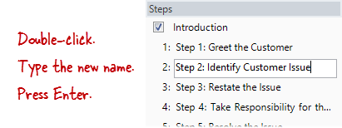
- Select the panel in the Steps panel, and type the new name in the title field at the top of the text panel. 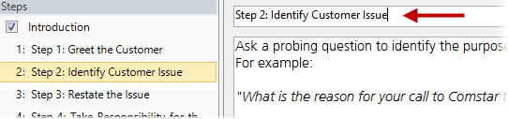
Tip: You can rename the introduction or summary in the same way.

Rearranging Panels
To change the order of panels, select one or more panels in the Steps panel, and do any of the following:
- Drag them to a new location. An orange line will move with your mouse to indicate where the panels will be when your mouse is released. 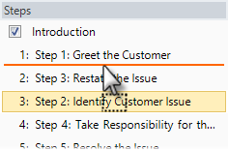
- Go to the Accordion tab on the ribbon, click Move Panel, and select either Up or Down. 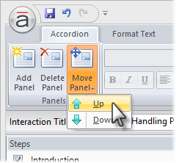
- Use the Up and Down arrows at the bottom of the Steps panel. 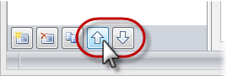
Note: The introduction and summary can't be moved.

Deleting Panels
To delete a panel, select it in the Steps panel, and do any of the following:
- Press the Delete key on your keyboard.
- Go to the Accordion tab on the ribbon, and click Delete Panel. 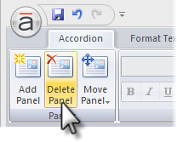
- Click the Delete button at the bottom of the Steps panel. 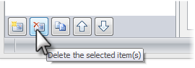
Tip: You can't delete the introduction or summary, but you can hide them.

