Create and Maintain Conversation Interactions

Exploring the Editor
The Conversation editor has three columns with the following panels:
- Steps: Located on the left side of the screen, this panel is used to manage steps for the Conversation.
- Text: Located in the middle of the screen, this panel is used to switch characters and add text to each step.
- Audio: Located in the upper right corner of the editor, this panel is used to add and edit audio.
- Media: Located in the lower right corner, this panel is used to add pictures, characters, videos, and Flash files.
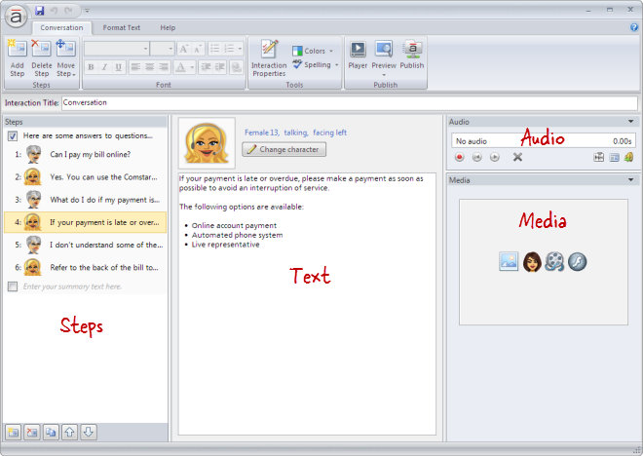

Adding Steps
To add a step to the Conversation, do any of the following:
- Press Ctrl+M.
- Go to the Conversation tab on the ribbon, and click Add Step. 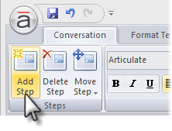
- Click the Create a new step button in the lower left corner of the Steps panel. 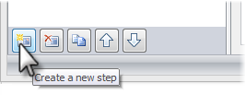
- Click the Duplicate button at the bottom of the Steps panel to copy the currently selected step(s). 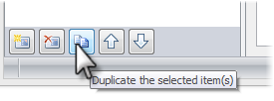
New steps get added just below the step that's currently selected in the Steps panel—unless the summary is selected, in which case new steps get added above it.
Tip: A Conversation interaction can have an unlimited number of steps.

Changing Characters
To change the character that's speaking, select a step in the Steps panel. Then click the Change character button at the top of the text panel, and choose one of the following options.
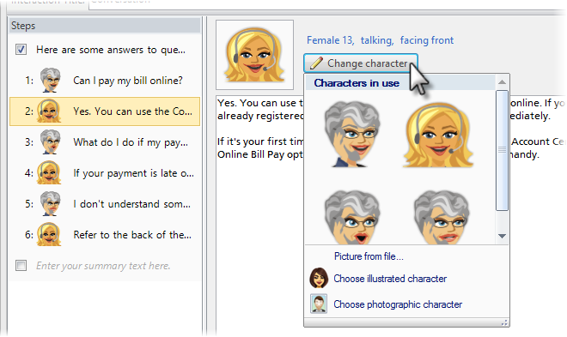
- Characters in use: Characters that have already been added to the interaction will appear at the top of the list. If you want to reuse one of them, simply click its avatar.
- Picture from file: Select this option if you want to choose an image from your computer. Browse to the image, and click Open.
- Choose illustrated character: Select this option to use one of the illustrated characters that comes bundled with Articulate Engage. When the Characters window opens, choose a character, expression, pose, and perspective. As you make selections, the character preview pane on the right side of the window will update to reflect your choices. When you're finished, click Insert. 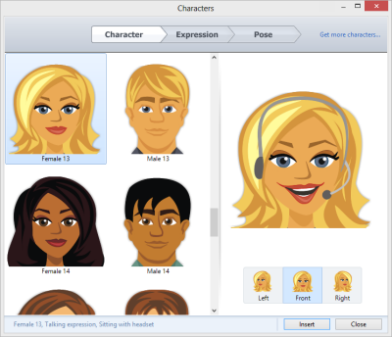
- Choose photographic character: Select this option to use a photographic character. (Engage comes with one photographic character, but you can purchase additional characters in the Articulate Store.) When the Characters window opens, choose a character and pose. As you make selections, the character preview pane on the right side of the window will update to reflect your choices. When you're finished, click Insert. 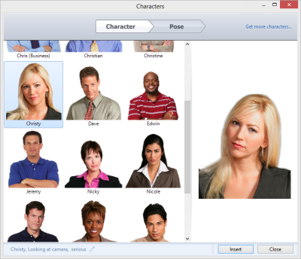
Note: Characters will always display on the left side of the conversation.

Rearranging Steps
To change the order of steps, select one or more steps in the Steps panel, and do any of the following:
- Drag them to a new location in the list. An orange line will move with your mouse to indicate where the steps will be when your mouse is released. 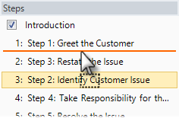
- Go to the Conversation tab on the ribbon, click Move Step, and select either Up or Down. 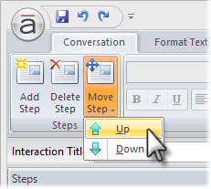
- Use the Up and Down arrows at the bottom of the Steps panel. 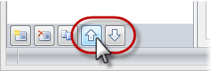
Note: The introduction and summary can't be moved.

Deleting Steps
To delete a step, select it in the Steps panel, and do any of the following:
- Press the Delete key on your keyboard.
- Go to the Conversation tab on the ribbon, and click Delete Step. 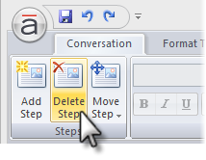
- Click the Delete button at the bottom of the Steps panel. 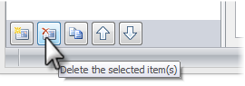
Tip: You can't delete the introduction or summary, but you can hide them.

