Create and Maintain Tab Interactions

Exploring the Editor
The Tabs editor has three columns with the following panels:
- Steps: Located on the left side of the screen, this panel is used to manage tabs for your interaction.
- Text: Located in the middle of the screen, this panel is used to add text to each tab.
- Audio: Located in the upper right corner of the editor, this panel is used to add and edit audio.
- Media: Located in the lower right corner, this panel is used to add pictures, characters, videos, and Flash files.
Here are some tips for working with the editor:
- Change the width of a column by dragging its boundary with your mouse.
- Click the triangle in the upper right corner of the Audio panel to collapse it if you need more room to work with the Media panel. Click it again to reopen the panel.
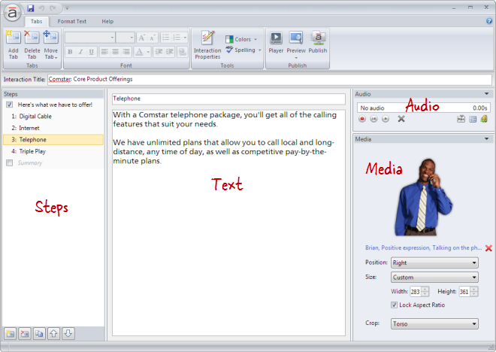

Adding Tabs
Each step in a Tabs interaction is called a tab. To add a tab, do any of the following:
- Press Ctrl+M.
- Go to the Tabs tab on the ribbon, and click Add Tab. 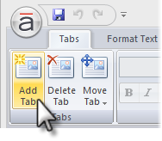
- Click the Create a new step button in the lower left corner of the Steps panel. 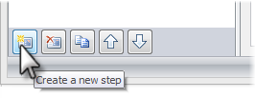
- Click the Duplicate button at the bottom of the Steps panel to copy the currently selected tab(s). 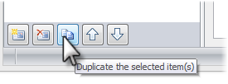
New tabs get added just below the tab that's currently selected in the Steps panel—unless the summary is selected, in which case new tabs get added above it.
Tip: A Tabs interaction can have up to eight tabs (not counting the introduction and summary).

Renaming Tabs
To rename a tab, do either of the following:
- Double-click the tab in the Steps panel to open it for editing. Enter the new name, and press the Enter key. 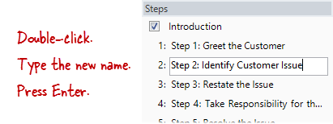
- Select the tab in the Steps panel, and type the new name in the title field at the top of the text panel. 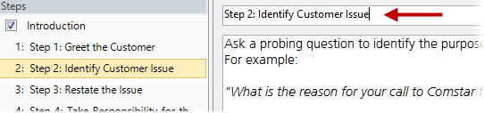
Tip: You can rename the introduction or summary in the same way.

Rearranging Tabs
To change the order of tabs, select one or more tabs in the Steps panel, and do any of the following:
- Drag them to a new location in the list. An orange line will move with your mouse to indicate where the tabs will be when your mouse is released. 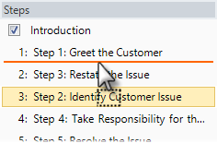
- Go to the Tabs tab on the ribbon, click Move Tab, and select either Up or Down. 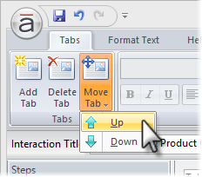
- Use the Up and Down arrows at the bottom of the Steps panel. 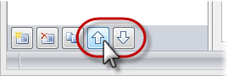
Note: The introduction and summary can't be moved.

Deleting Tabs
To delete a tab, select it in the Steps panel, and do any of the following:
- Press the Delete key on your keyboard.
- Go to the Tabs tab on the ribbon, and click Delete Tab. 