Understanding Interaction Types
The following is a list of all of the interaction types available for you to use. When you are working with an interaction be sure to use the templates. The templates match the style and theme of the presentation. A copy of the all of the templates can be found on your thumb drive.

Sample | Description and Best Use
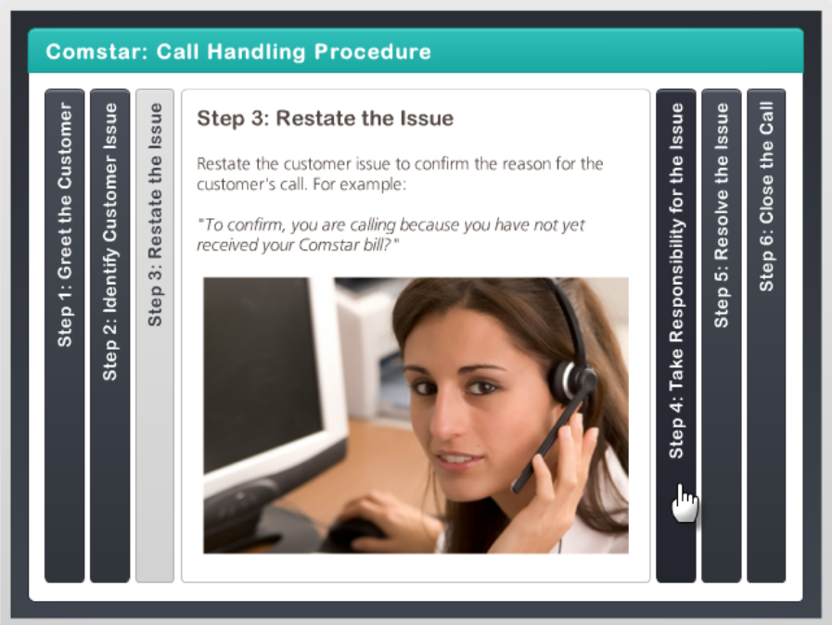 | Accordion  The Accordion interaction lets learners explore a group of related items in a horizontal layout. Use the Accordion interaction to:  - Walk through a list of related concepts.  - Identify members of a group.  - Compare several objects.
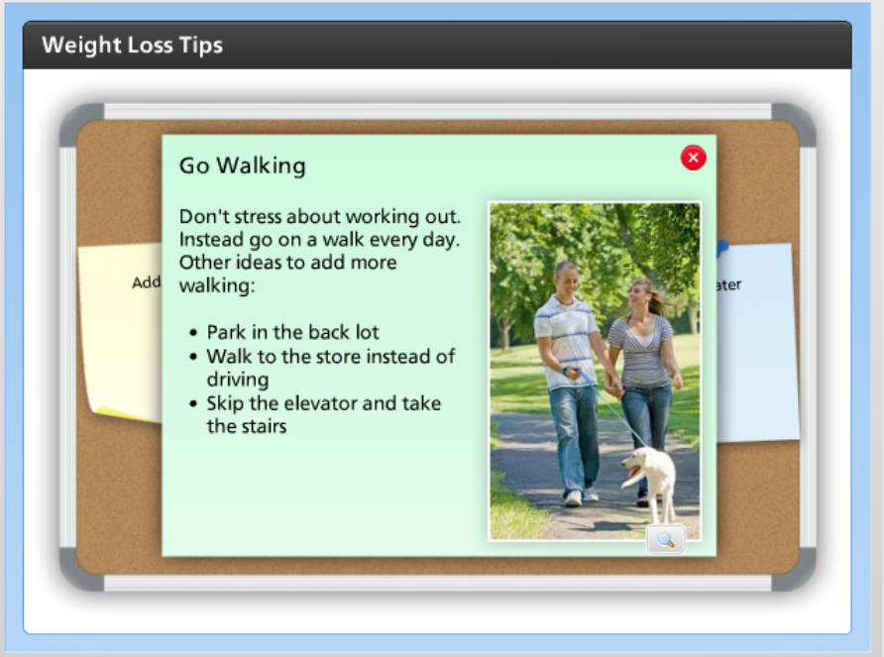 | Bulletin Board  The Bulletin Board interaction lets learners explore a series of items in a freeform manner. Use the Bulletin Board interaction to:  - Make announcements.  - Provide instructions or reminders.  - Establish the details of a scenario.
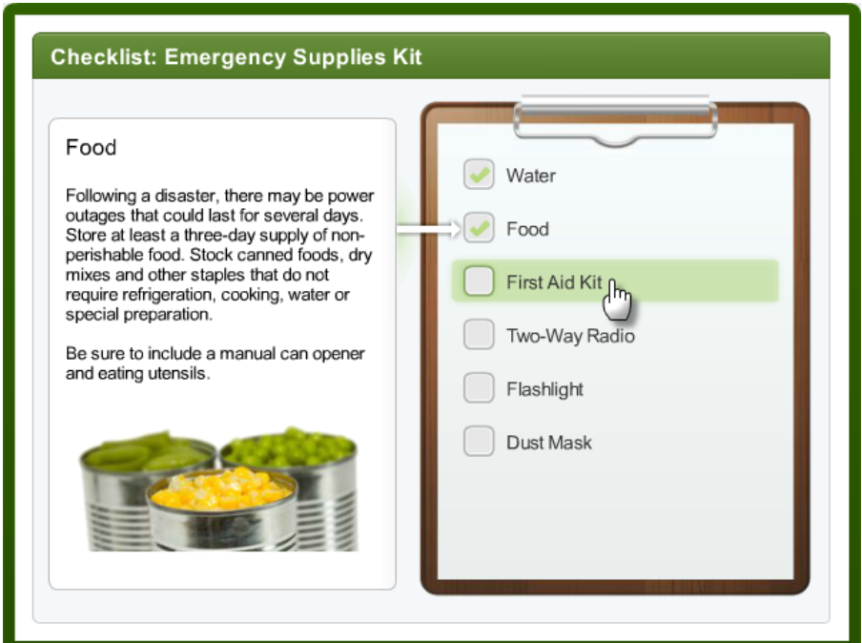 | Checklist  The Checklist interaction lets learners explore a list of related items. Use the Checklist interaction to:  - Walk through a list of related concepts.  - Provide instructions or reminders.  - Identify a to-do list.
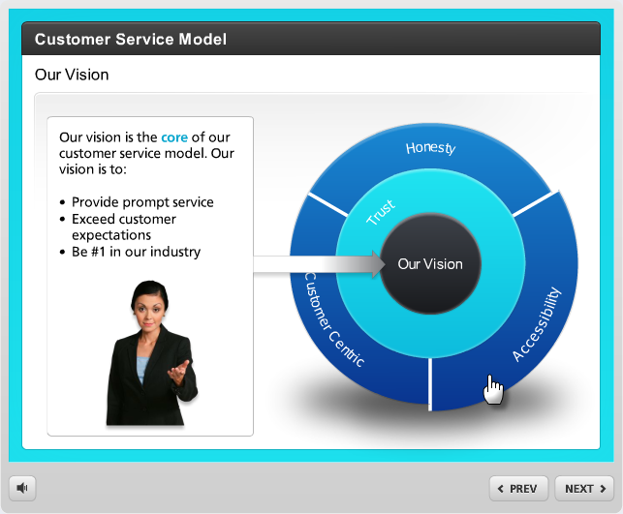 | Circle Diagram  The Circle Diagram interaction lets learners examine the relationship of items in a circular hierarchy. Use the Circle Diagram interaction to:  - Show related items within a hierarchy.  - Organize concepts into segments and layers.  - Graphically depict a philosophy or approach.
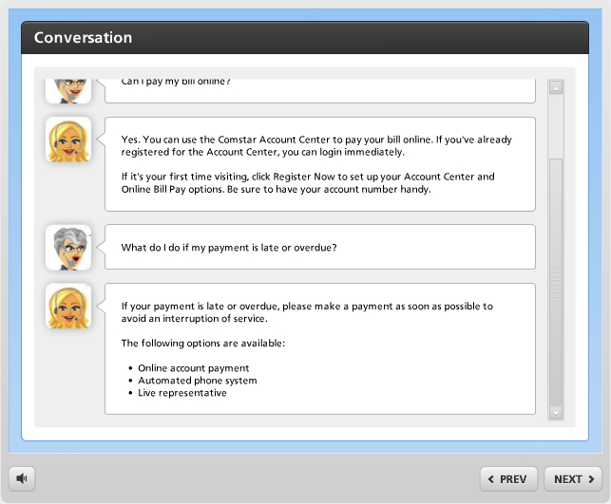 | Conversation  The Conversation interaction lets learners step through a social media dialog. Use the Conversation interaction to:  - Set up a scenario.  - Critique an interview.  - Teach interpersonal skills.
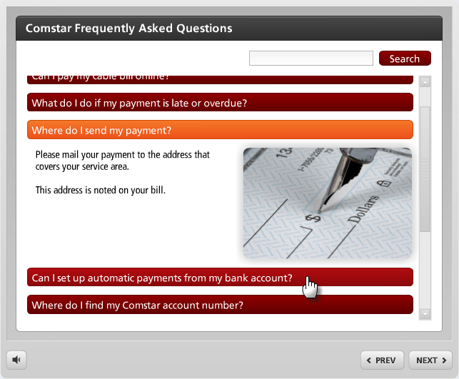 | FAQ  The FAQ interaction allows users to find the answers to frequently asked questions. Use the FAQ interaction to:  - Answer commonly asked questions.  - Let learners search for solutions to problems.  - Review subject matter in a question-and-answer format.
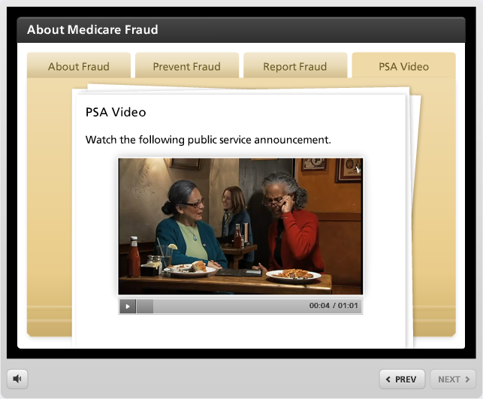 | Folders  The Folders interaction lets learners explore the contents of a series of folders. Use the Folders interaction to:  - Walk through a list of related concepts.  - Identify members of a group.  - Compare several objects.
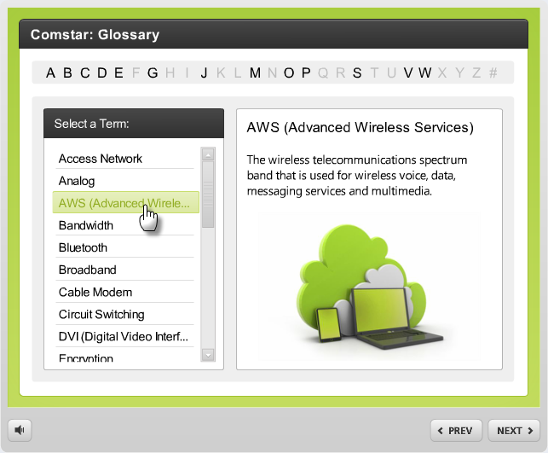 | Glossary  The Glossary interaction lets learners reveal definitions of words, terms, and phrases. Use the Glossary interaction to:  - Define commonly used terms.  - Explain technical acronyms.  - Provide understanding of cultural phrases.
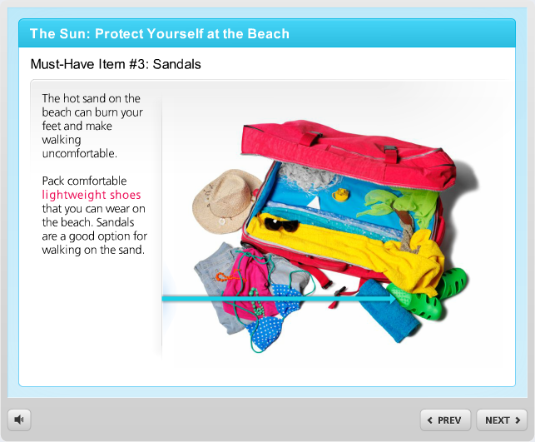 | Guided Image  The Guided Image interaction lets learners examine important parts of an image or diagram. Use the Guided Image interaction to:  - Step through details of an image.  - Explain significant parts of a graphic.  - Describe the steps in a process.
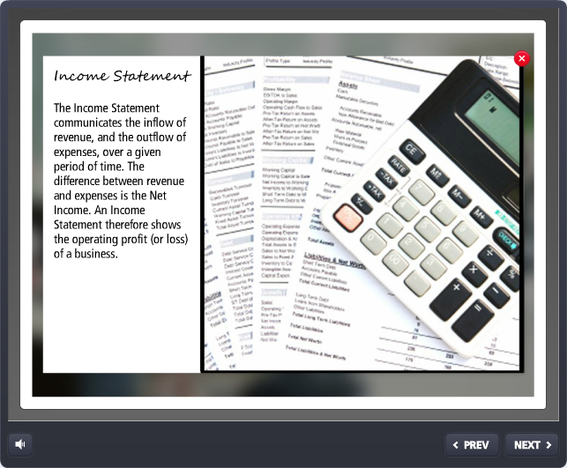 | Image Zoom  The Image Zoom interaction lets learners zoom into important parts of an image or diagram. Use the Image Zoom interaction to:  - Step through details of an image.  - Explain significant parts of a graphic.  - Describe the steps in a process.
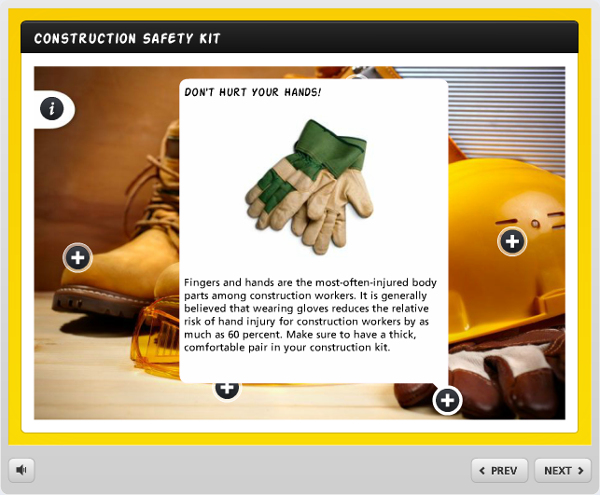 | Labeled Graphic  The Labeled Graphic interaction lets learners identify the key elements of an image. Use the Labeled Graphic interaction to:  - Highlight details of an image.  - Call out relevant parts of a graphic.  - Explain features of a software screenshot.
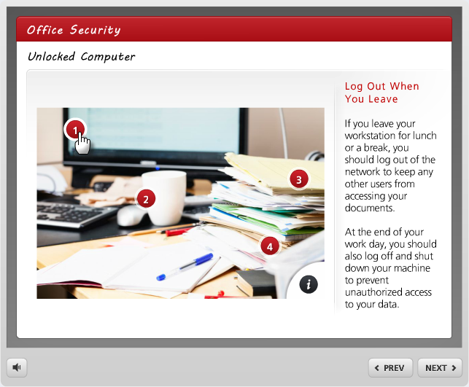 | Labeled Panel  The Labeled Panel interaction lets learners identify the key elements of an image. Use the Labeled Panel interaction to:  - Highlight details of an image.  - Call out relevant parts of a graphic.  - Explain features of a software screenshot.
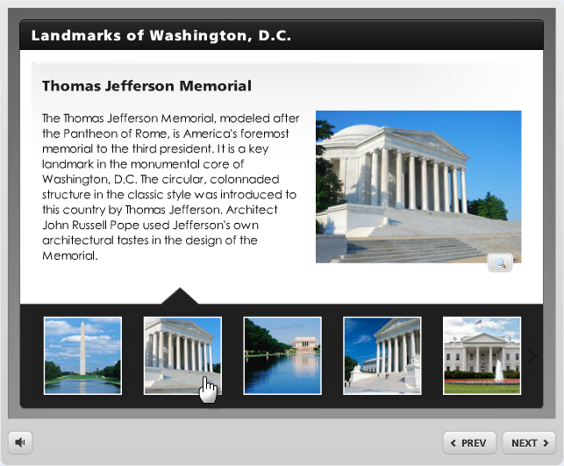 | Media Panel  The Media Panel interaction lets learners explore a series of related images, videos, and Flash files. Use the Media Panel interaction to:  - Explain a process with images and videos.  - Walk through screenshots of a software application.  - Create a multimedia tour from photographs and videos.
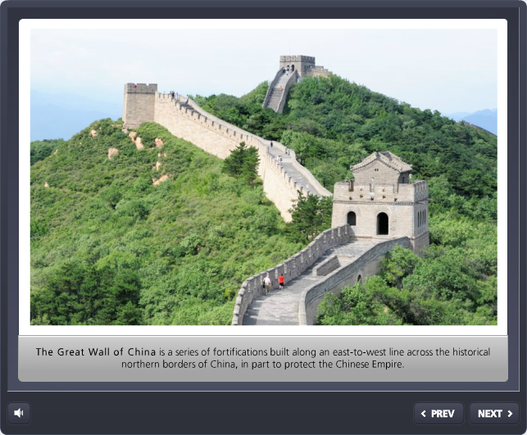 | Media Tour  The Media Tour interaction lets learners step through a series of related images, videos, and Flash files. Use the Media Tour interaction to:  - Explain a process with images and videos.  - Walk through screenshots of a software application.  - Create a multimedia tour from photographs and videos.
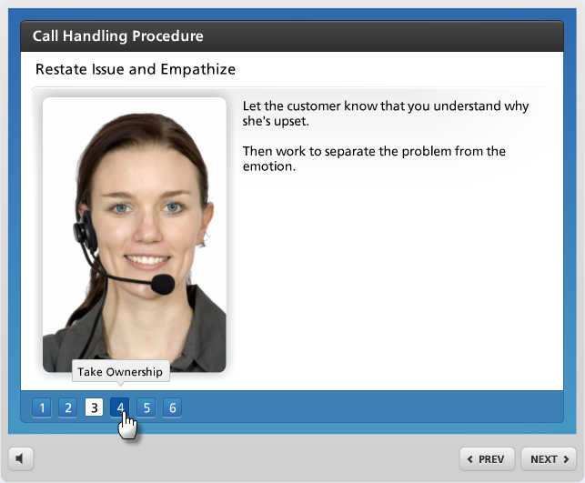 | Process  The Process interaction lets learners discover the steps of a linear process. Use the Process interaction to:  - Illustrate the steps of a process.  - Walk through a series of related items.  - Explain a workflow or procedure.
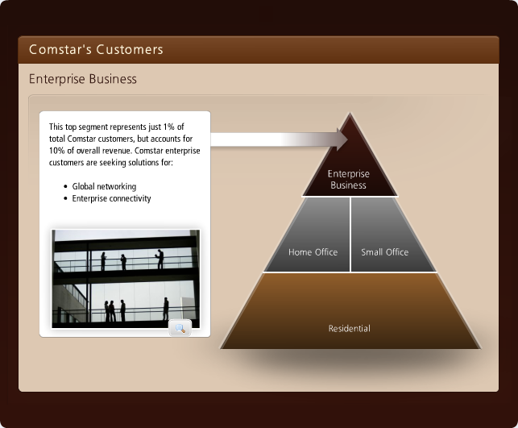 | Pyramid  The Pyramid interaction lets learners explore a hierarchical relationship of concepts. Use the Pyramid interaction to:  - Show relationships within a hierarchy.  - Compare levels of importance in related concepts.  - Detail steps in a process or methodology.
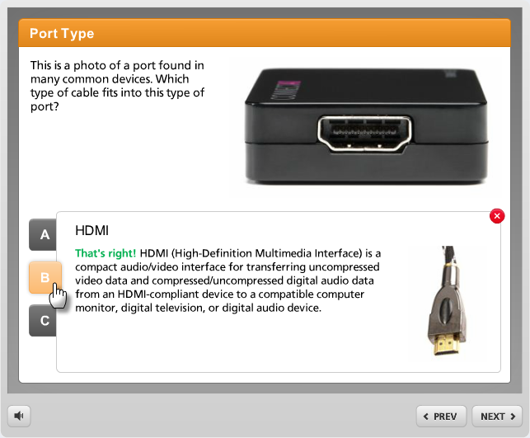 | Quick Choice  The Quick Choice interaction lets learners find information through self-directed discovery. Use the Quick Choice interaction to:  - Teach interpersonal skills.  - Differentiate true and false information about a subject.  - Test knowledge of a subject in an ungraded format.
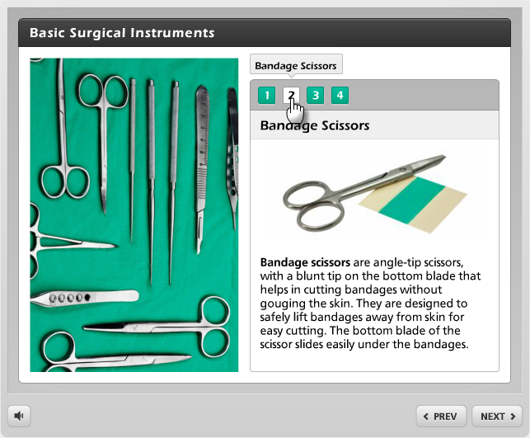 | The Tabbed Image interaction lets learners explore a series of items related to an image or diagram. Use the Tabbed Image interaction to:  - Walk through a list of related concepts.  - Explain significant parts of a graphic.  - Identify members of a group.
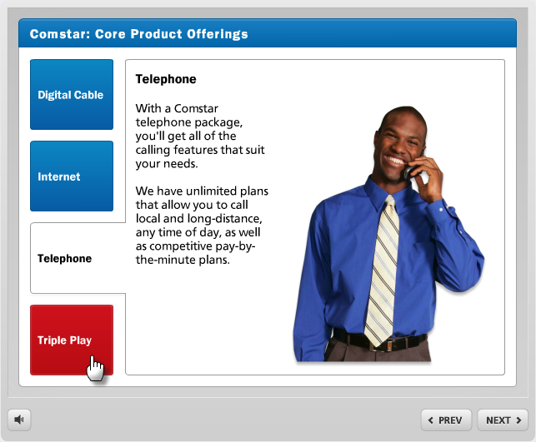 | Tabs  The Tabs interaction lets learners explore a group of related items. Use the Tabs interaction to:  - Walk through a list of related concepts.  - Identify members of a group.  - Compare several objects.
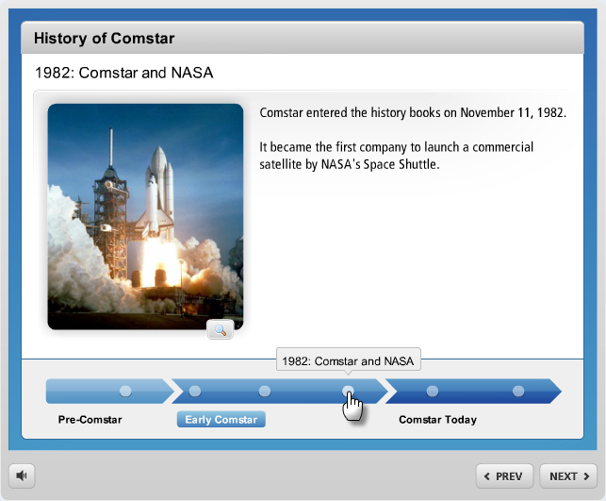 | Timeline  The Timeline interaction lets learners discover the events on a timeline. Use the Timeline interaction to:  - Walk through a series of periods and events.  - Highlight key milestones in a schedule.  - Explain the steps in a sequence.

