Import a Slide into the Template
- Open PowerPoint and the file you wish to import slides into.
- Select the “Home” menu.
- Choose “New Slide” > “Reuse Slides…“.
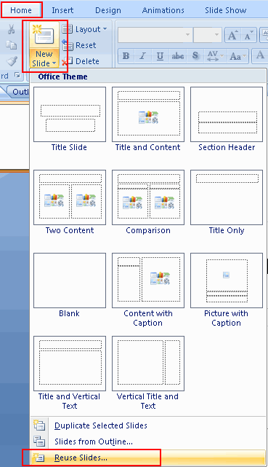
- The “Reuse Slides” options will appear on the right side. Select “Browse…” > “Browse File…“.
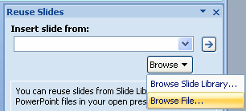
- Navigate to the file that you wish to import slides from. Select it, then choose “Open“.
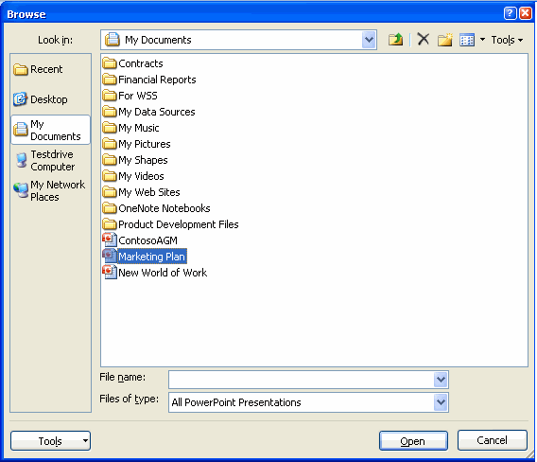
- Locate and select the slide(s) you wish to import. If you wish to keep the formatting of the imported slides, select the “Keep source formatting” check box.
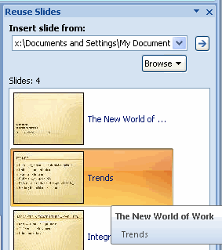
If you accidentally import an unwanted slide, use the CTRL + X keyboard shortcut to undo the last change or right-click the slide and select “Delete Slide“.
NOTE: You may still have to use the Layout and Reset buttons to format the slide.

