Captivate Course Checklist
Purpose:
The checklist is designed to assist you with checking a Captivate course sent to you from a novice developer.
Prior to Publishing the course
- Confirm the Import Slides, Move Title Slide and Delete this Slide has been removed from the course.
- Confirm there is a Title slide for the course.
- Verify the Optional File Download Slide “Yes” and “No” buttons work and link to any additional files
- or if it is not being used it is removed by right clicking on the “Yes” and “No” button properties.
- Review each of the slides and verify there are no spelling or grammatical errors.
- Verify that the Acknowledgment slide is the second to last slide in the course.
- Verify the Quiz results slide is hidden and/or has not been removed from the course by accident.
- Select the Acknowledgement slide and then Quiz -> Quiz Preferences and validate the following settings.
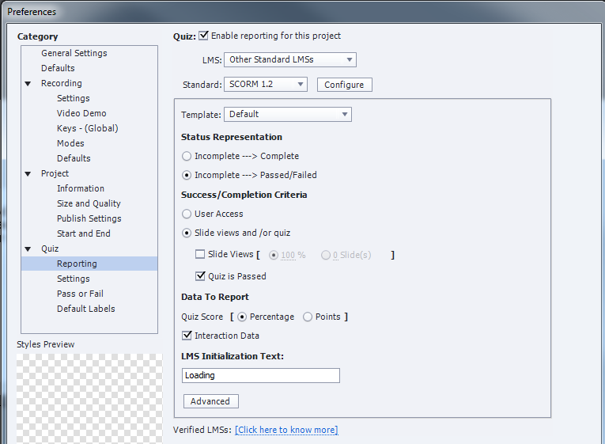

After Publishing the Course (Publish -> Publish to Computer)
- Verify that the course publishes and the performance of the course is as expected.
- Confirm that the slides with sound are not cut-off and are timed correctly.
- Verify the Optional File Download Slide “Yes” and “No” buttons work and link to any additional files or if it is not being used it is removed.
- Play the entire course through to verify the sound and videos perform as expected.
- Confirm the Acknowledgment and Quiz Results are located at the end of the course.
- Validate that the Quiz results slide is hidden.

Open the published Zip File and conform the following:
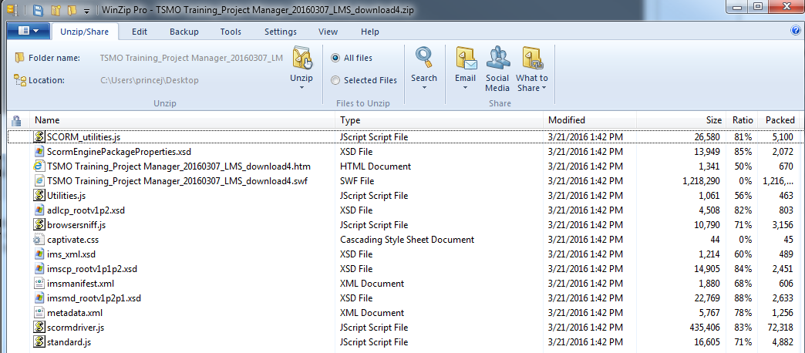

- Validate there a files in the zip file folder.
- Confirm there is one HTML Document in the zip file containing the title of your course
- Confirm there is one SWF File Document in the zip file containing the title of your course
- Confirm there is one captivate.css (Cascading Style Sheet Document in the zip file.
- Validate the zip file does not exceed 175MB
Note: if any of the above conditions exist for this section, seek help from Jason or Michael.

