Add Video to a Captivate Slide
Prerequisites:
Prior to performing this task you must have the following:
- A PowerPoint course that has been uploaded into Captivate with or without video.
Overview:
The following steps guide you through the process of adding video to a Captivate file. If you have added sound, or video to the PowerPoint Presentation then it is imported into Articulate when you import the slides and you do not have to follow this process.
Steps:
- Start this process from an open Captivate file.

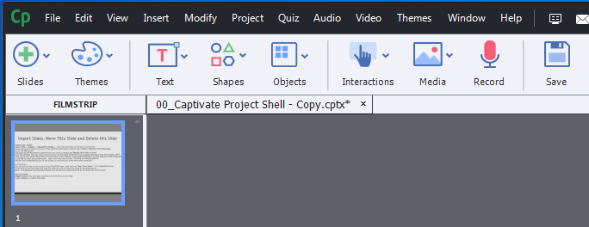

- On this left side of the screen is the FILMSTRIP view. Select the slide you want to add and video file. Once selected, it is highlighted blue.

Note: To insert a slide select the Slides button and then the type of slide you want to import into the Captivate course.

- Select Video -> Insert Video from the menu bar at the top of the screen. The Insert Video screen displays.
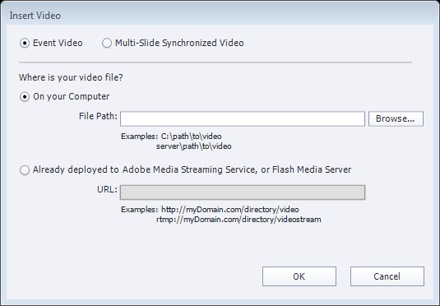
- Click the Browse button. The Browse window displays.

- Navigate to the video file you want to import and Double-left click on the file to select. The Audio Import Options screen displays. The Browse window closes and Insert Video screen displays.

Note: Be PATIENT, this may take some time.

- Click the OK button. The Insert Video window closes and the video file is associated with the slide.

Note: The video will display on the selected slide.

- Click the Play button to test the video file.

- Repeat steps two through seven until you have added all of the video files you want to the course.

Conclusion:
You have added video to a slide within a Captivate course.
Next Steps:
- None

