Add Sound to a Captivate Slide
Prerequisites:
Prior to performing this task you must have the following:
- A PowerPoint course that has been uploaded into Captivate with or without sound.
Overview:
The following steps guide you through the process of adding sound to a Captivate file. If you have added sound, or video to the PowerPoint Presentation then it is imported into Articulate when you import the slides and you do not have to follow this process. If the sound file are associated with the individual slide, as opposed to the presentation, then this can be used to replace a sound file.
Steps:
- Start this process from an open Captivate file.

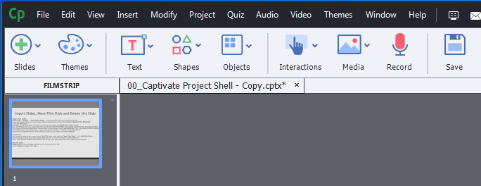

- On this left side of the screen is the FILMSTRIP view. Select the slide you want to add and sound file. Once selected it is highlighted blue.

- Select Audio -> Import to -> Slide from the menu bar at the top of the screen

- Navigate to the Audio file you want to import and Double-left click on the file to select. The Audio Import Options screen displays.

Note: Be PATIENT, this may take some time and the Microsoft PowerPoint has stopped working screen may display.

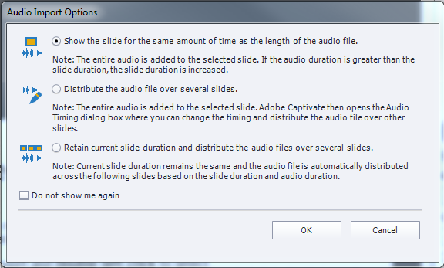

- Confirm the Show the slide for the same amount of time as the length of the audio file option is selected.

Note: If you are importing a corrected audio file and one is already associated with the file a window displays asking “Are you sure you want to change the audio for Slide XX?” If you want to change the sound click “yes”.

- Click the OK button. The audio Import Options window closes and the sound file is associated with the slide.

Note: To confirm the sound has been associated with the slide click on the audio icon no located below the slide.

- Repeat steps two through six until you have added all of the sound files you want to the course.

Conclusion:
You have added sound to a slide within a Captivate course.
Next Steps:
- None

