CDOT University Manual
Version 1.1
Revised: 6.14.2016

VERSION HISTORY

Version  # | Implemented  By | Revision  Date | Approved  By | Approval  Date | Reason
Draft A | Muszynski, M | 9.15.2014 | CDOTU Deans | 9.15.2015
Version 1 | Muszynski, M | 6.09.2015 | mjm | 6.09.2015 | No Changes to Manual;  Repeal of PD 1260.1
Version 1.1 | Muszynski, M | 6.14.2016 | mjm | 6.14.2016 | Update of New Training Coordination Process and Form

ACCOUNTABILITY

Executive Sponsor: Heidi Humphreys, Director Department of Administrative Services
CDOTU Administrator Contact Information:
Name: Michael Muszynski
Work Unit Address: CDOT Office of Employee Development (OED)
Work Phone: 303 757-9167
E-mail address: Michael.Muszynski@state.co.us
Subject Matter Experts who Collaborated on the Content: OED Staff and CDOTU Council of Deans (CoD)

OED
Morgan Murphy
James Leuenberger
Bryon Hays
Gayle Rafferty
Lorna Rickard
Michael Muszynski

CoD
MTA Curriculum Steering Committee
Ryan Sorensen
Scott Young
Charles Meyer

Physical/Virtual Location for this Courseware: CDOT/SWS T: Drive and the CDOTU Intranet Site

Table of Contents
1. VERSION HISTORY 2
2. ACCOUNTABILITY 2
3. Authority for CDOTU 6
Authority 6
Rules Regarding Changes to this Manual 6
The Role of a Corporate University 6
4. A Brief History of CDOTU 7
5. Terms and Definitions 8
6. CDOTU Vision, Mission and Goals 9
Vision…………………………………………………………………...……………………9
Mission…………………………………………………………………………………...….9
Goals and Strategies 9
Goal 1: Create a Learning Culture 9
Strategies 10
Goal 2: Design Learning that Meets Organizational Strategies and Needs 10
Strategies 10
Goal 3: Deliver Learning Programs with Effectiveness and Efficiency 10
Strategies 11
Key Metrics and Measures of Progress 11
Employment of Common Core Services 11
Climate Assessment of Organizational Learning 11
Comparison of Average Annual Training Investment Per Employee 12
Employees with Completed Learning Plans 12
Certification of CDOTU Curricula by External Educational Entities 12
7. CDOTU Structure and Administration 13
CDOTU STRUCTURE 13
CDOTU Administration 14
(1.) CDOTU Council of Deans: Roles and Responsibilities 14
(2.) CDOTU Administrator: Roles and Responsibilities 14
Functions and Roles Common to all Colleges of CDOTU (See Figure at right.) 15
CDOTU College Dean: Roles and Responsibilities 15
Selection and Appointment of College Deans 16
Appointment Procedures for each College Dean 16
Training Program Leaders 17
SMEs and Content Developers 17
Adjunct Instructors 17
LMS Training Coordinators and Enrollers 17
8. Curriculum Design 17
Design Philosophy: Business Need Drives Curriculum 17
Instructional System Design (ADDIE Model) 18
Curriculum Development 18
Sponsorship and Approval 18
Training Required by Statute, Policy, Legal Action 19
Procedure/Process for eLearning Development & Adoption 19
Waiver Process for buying/contracting training and educational services 19
Purchasing Training Products 19
9. Curriculum Management 20
CDOTU Curriculum Management 20
Course Director 20
Training Equivalency Waiver 21
CDOTU Document Versioning 22
Version Control 22
Versioning Conventions: Draft Documents 22
Versioning Conventions: Final Documents 22
Versioning Changes: Major and Minor 22
Major Changes to a Final Document: indicated by increasing the whole number 23
Minor changes to a Final document: indicated by increasing the decimal figure* 23
Examples and Locations of Version Control 23
Uniformity of Versioning (Document Sets) 24
Adjunct Instructors: Qualification and Standards 24
Curriculum Developers 24
Learning Management Systems 24
Training and Courseware Evaluation 25
Purpose of Training Evaluation 25
Training Evaluation Levels 25
Level 1: Reaction 25
Level 2: Learning 25
Step 3: Behavior 26
Step 4: Results 26
CDOTU Branding 26
CDOTU Communications 26
10. Appendix A: Policy and Procedural Directives 1260/1260.1 27
Policy Directive 1260 27
Procedural Directive 1260.1 32
11. Appendix B: Memorandum of Understanding: CDOTU Dean Appointments 37
12. Appendix C: Career Development Worksheet 41
13. Appendix D: Request to Develop a New Training Activity 42
14. aPPENDIX E: pROCUREMENT MEMORanDUM (pURCHASING) 45
15. aPPENDIX F: tRAINING eQUIVALENCY WAIVER 47
16. APPENDIX G: mOU for ADJUNCT INSTRUCTOR APPOINTMENT 48
17. aPPENDIX H: cdotu bRANDING cONVENTIONS 52
18. Approved CDOTU Logos 53
19. APPENDIX I: References 54
20. List of Supplements 55
Supplement 1: eLearning Content Publishing Standards 55
Supplement 2: CDOTU Curriculum Development Guide 55

Authority for CDOTU

Authority
Authority for CDOTU is established by Policy Directive 1260 (Policy Governing CDOT University) and Procedural Directive 1260.1 (CDOT University Administration). Additionally, PD 1260.1 provides the authority for the CDOTU Manual as guidance for the administration of CDOTU and its constituent Colleges and training units.

Rules Regarding Changes to this Manual
The intent to this manual is to be a “living document” that is directive in nature to provide guidance on the structure, processes and procedures for the administration of CDOTU. Changes to this manual will be responsibility of the CDOTU Administrator and made by majority consent of the Council of Deans.

The Role of a Corporate University
The role of a Corporate University is to provide a centralized organizational learning function focused on the strategic and integrated development of employees in alignment with the organization's values, mission and business needs. Corporate Universities differ significantly from traditional institutions of higher learning. One of the goals of a corporate university is to take a “long view” on employee development and use pro-active strategy to anticipate what employees will need to be successful in the future as well as today.

Unlike traditional colleges, Corporate Universities train only those specific skills and aptitudes that employees need for success in their professions. Example: American Literature, which is a commonly required core course in a college or university, is not offered in a corporate university curriculum. Instead, a corporate university will offer training in business writing skills. The focus of a corporate university is on defined job skills, rather than a broad educational experience provided by a traditional college.

Another major distinction between corporate universities and public institutions of higher learning is in how the curriculum is organized and managed. In a public institution, courses are organized by discipline, i.e. Earth Sciences, Social Sciences, Humanities, etc. In a corporate university, training curricula are organized around business units and designed to meet the specific needs of those units.

How curriculum is designed is also different in a corporate university, where training is designed to build clearly defined competencies and skills that support strategic organizational development through defined employee development plans or “roadmaps”. The training and educational requirements specified in these organizational and employee development plans drive the development of curriculum. As organizational needs change, the development maps and curriculum change to meet those needs.

A Brief History of CDOTU
Interest in creating a strategic and comprehensive organizational learning function for CDOT began as early as 2006, when the Office of Organizational Learning and Development (OL&D) began research on the topic of corporate universities and how they typically are organized and function.

In 2008, CDOT obtained approval from the transportation commission for the organization of a corporate university (CDOTU) and in Feb. 2010 authored Policy and Procedural Directives (1260/1260.1) to establish a structure for the program. Along with approval for CDOTU was an authorization for an additional 1.5 FTE to assist its creation and administration. The authorization to hire the additional FTE was delayed until 2011 due to the fiscal constraints created by the recession of 2008 and a governor-mandated state-wide hiring freeze.

In the meantime the OL&D staff, without the benefit of the additional FTE, continued with the planning and organization of CDOTU until early 2011, when the effort lost momentum and was temporarily shelved. An independent consultant specializing in Corporate University planning and operations was brought in to conduct an analysis of the program. The consultant’s report recommended some 32 actions steps to move forward.

In August of 2012, CDOT hired a dedicated CDOTU Program Administrator and the development of CDOTU resumed. Based on the new administrator’s recommendations, the structure for the organization and governance of CDOTU was redesigned along with Policy and Procedural Directives 1260/1260.1, which were approved by the Transportation Commission and the CDOT Senior Management Team in February of 2013.

The re-start of CDOTU followed a phased standup plan of four constituent colleges, beginning with the Colleges of Transportation Maintenance and Engineering in the summer and fall of 2013 and the Colleges of Administration and Transportation Operations and Development in the spring of 2014.

Terms and Definitions

“CDOT Colleges” shall mean the branches of training within CDOT University that align with the major business functions of CDOT.

“CDOT University” (CDOTU) shall mean the corporate university structure for CDOT.

“CDOT University Administrator” shall mean the dedicated Project Manager for administration of CDOTU.

“CDOTU Manual” shall mean the authoritative compilation of operating procedures, standards, and other guidance for CDOTU.

“CDOTU Training Program Leader” shall mean a CDOTU point of contact that assists College Deans by providing subject matter expertise, content and instructional materials that are developed according to established ISD standards for their respective college.

“Competencies” shall mean observable, measurable patterns of knowledge, skills, abilities, behaviors, and other characteristics that CDOT employees need to successfully perform work-related tasks.

“Core Services” shall mean the functions, procedures and processes which are common and essential to all constituent colleges. Examples include learning management system administration, common training calendar, curriculum development procedures and standards, and trainer certification.

“Corporate University” shall mean a centralized organizational learning function focused on the strategic and integrated development of employees in alignment with the organization's values, mission and business needs.

“Council of Deans” shall mean the group comprised of CDOTU College Deans.

“Course Director” shall mean a Subject Mater Expert who is responsible for the overall development and maintenance of a course or a series of courses (curriculum) to meet a clearly-defined learning outcome.

“Dean” shall mean the designated authority for training administration and development for each constituent college within CDOT University.

“Development” shall mean any activity that focuses upon the skills and abilities that the organization employing the individual, or that the individual, may require in the future.

“Evaluation” shall mean the systematic determination of merit, value, and significance of a learning or training process by using criteria against a set of standards.

“Instructional Systems Design” (“ISD”) shall mean the systematic process of planning instructional systems so that the appropriate resources can be developed, evaluated, and modified to demonstrably attain desired instructional goals and outcomes.
“Learning” shall mean the process of acquiring new knowledge, behaviors, skills, values, preferences or understanding as a result of training.

“Learning Objectives” shall mean a statement of desired outcomes expected as a result of training.

“Learning Solution” (“LSo”) shall mean CDOT’s learning management system of record in SAP.

“Learning Strategies” shall mean the elements of learning and training design, incorporating many aspects such as methods of instruction, learning activities, sequencing of objectives, types of support materials, and evaluation and retention methods.

“LSo Training Coordinator” shall mean the individual who performs LSo functions as specified in the OL&D LSo Guide for Training Coordinators and Enrollers.

“LSo Training Enroller” shall mean the individual who assists the LSo Training Coordinator in their duties as specified in Office of Organizational Learning & Development LSo Guide for Training Coordinators and Enrollers.

“Training” shall mean the acquisition or delivery of knowledge, skills, and competencies as a result of instruction

CDOTU Vision, Mission and Goals

Vision
A learning culture across CDOT of continuous improvement and professional development focused on fulfilling the mission with safety, innovation and proactive solutions.

Mission
To promote and deliver consistent, quality learning experiences that are strategically aligned with professional needs of CDOT’s workforce. This mission directly supports CDOT employee engagement strategies for knowledge management, succession preparation, management training, employee retention and promotion of CDOT as an employer of choice.

Goals and Strategies

Goal 1: Create a Learning Culture
A learning culture is one in which personal improvement and professional development is continuous and encouraged because it is part of an organization’s values. It is intentional and purposeful in its goals of developing in its people knowledge, skills and competencies geared to specific organizational needs. It is a culture in which knowledge acquisition, transfer and application is valued at all levels. It is characterized by perpetual improvement in order to innovate and find new and better ways to fulfill its mission. Such an organization is committed to providing learning opportunities for its people. Similarly, in a learning culture, employees share this vision and take personal responsibility for their development.

Strategies
- Governance Structure – Implement an agile, empowered and purpose-driven university administration that maximizes cross-functional collaboration, creates synergy and builds shared vision and partnership in organizational learning.
- Performance Management – Develop in conjunction with the Senior Director of Human Resources a knowledge management strategy that supports the tailored professional development of both a skills-based and a knowledge-based workforce within an organizational plan for succession. Included in this is the development of both Organizational and Individual Learning Plans as part of a greater performance management and succession preparation framework.
- Comprehensive Training Policy – Conduct a study to determine the “who, what, where, when, why and how” in the current state of training. Based on that study, build a unified and comprehensive training policy that coordinates how training is funded, accomplished, tracked and reported.
- Communication Plan – Craft and implement a communications plan that supports the change management process and creates shared vision.

Goal 2: Design Learning that Meets Organizational Strategies and Needs
Currently, much of CDOT’s training is fragmented, inconsistent and duplicates effort. Create coordinated, congruent and comprehensive learning programs that enhance organizational performance and are aligned with CDOT’s strategic priorities and values.

Strategies
- Training Needs Analysis – Conduct a needs assessment CDOT-wide to identify gaps in skills and competency needs now and in the future.
- Curriculum Standards – Develop and formalize curriculum design and assessment standards based on Instructional Systems Design principles. Create processes to guide content development to those professional standards.
- Competency and Skills Based Learning Activities – Create or purchase curriculum that meets design standards and builds the needed competencies for our workforce.
- Evaluation Standards - Measure the effectiveness and consistency of training and delivery with emphasis on continuous evolution and improvement in meeting training objectives.

Goal 3: Deliver Learning Programs with Effectiveness and Efficiency
Learning Programs that are effective and efficient in delivery are characterized by quality instruction and economies of effort and scale.

Strategies
- Quality Instruction – Build a network of certified instructors skilled in developing and delivering training to adult learners that is focused on knowledge retention and practical application.
- Centralized Administration – Implement processes to coordinate, track and report CDOT’s training investments. Coordinate the administration for a Learning Content Management System to coordinate, track and report all CDOT training.
- Synchronized Curriculum - Synchronize learning programs across CDOT to ensure each employee obtains the best training available while achieving economies of scale and effort. Align and deliver content to meet both the short-term goals of specific CDOT workgroups as well as strategic workforce development in support of CDOT’s mission and values
- E-Learning – Establish an e-learning strategy that seeks to leverage evolving technologies to transform learning delivery. The goal is not technology for technology’s sake, but to reduce costs of development and delivery while at the same time create on-demand training that is free from constraints in scheduling and geography. E-learning development strategy must take into account the various learning styles of our workforce.

Key Metrics and Measures of Progress
Progress in this knowledge management enterprise will be gauged through the measures listed below. As this is the first truly comprehensive learning strategy undertaken at CDOT, one of the goals in the first year will be to gather baseline or benchmark data for each measure. This data will be used to set performance targets for subsequent years.

Employment of Common Core Services
Coordination of common cores services is a central feature of a Corporate University. Implementation of a common Learning Content Management System, course catalog, training calendar and certification programs for curriculum and instructors will be tangible and easily recognized milestones for the development of CDOTU.

Climate Assessment of Organizational Learning
A questionnaire will be created and administered to capture workforce understanding and attitudes towards a learning culture in public service so that shifts in thinking can be measured over time.

Comparison of Average Annual Training Investment Per Employee
The study listed above under “Comprehensive Training Policy” will provide the baseline data for assessing the current CDOT investment in training. From this baseline, future economies of scale and effort may be measured.

Employees with Completed Learning Plans
As part of an integrated employee performance management and development planning process, individual learning plans will be produced and action taken to meet them. Collecting this data would provide an important indication of progress at the operational level.

Certification of CDOTU Curricula by External Educational Entities

A key metric that differentiates a corporate university is development of curriculum to a standard that is recognized by external entities for academic credit at an accredited institution of higher learning. The American Council of Education is among several entities that are recognized for certification of curricula for a network of Colorado institutions of higher learning.

CDOTU Structure and Administration

CDOTU STRUCTURE

CDOTU is organized into four virtual constituent colleges, which are grouped by sets of business unit and unified around common processes and a core administration.
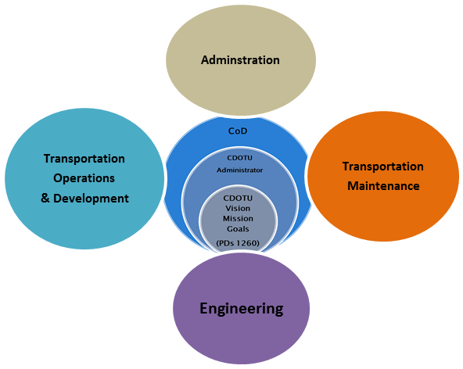

The Colleges of Administration and Transportation Operations and Development serve a collection of related business units:
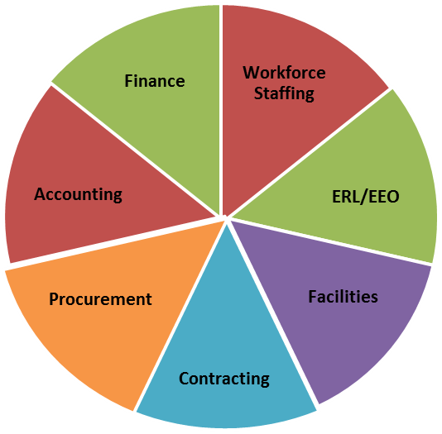
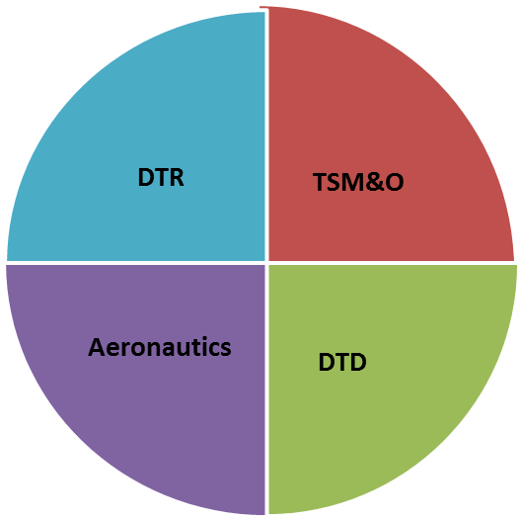

College of Transportation Ops and Development
College of Administration

CDOTU Administration

CDOTU Core Administration is comprised of three elements:
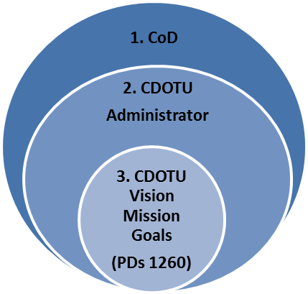

(1.) The Council of Deans (CoD)
(2.) CDOTU Administrator
(3.) PDs 1260/1260.1

(1.) CDOTU Council of Deans: Roles and Responsibilities
The Deans of CDOTU make up Council of Deans (CoD). The CoD ensures consistency and information sharing, coordination of resources, and execution of CDOTU policy, procedures and standards. Specifically, the Council of Deans is responsible for:
- Recommending and reviewing standards for materials, facilities, and instructors
- Providing feedback to the Administrator concerning CDOTU policy and procedures
- Coordinating with others in CDOTU to ensure consistency in the application of standards
- Providing a forum to discuss the allocation and sharing of resources within CDOTU Seeking recommendations and other input from the business units they represent

(2.) CDOTU Administrator: Roles and Responsibilities

The CDOTU Administrator’s primary roles are to develop the strategic vision and planning for CDOTU and to lead and assist the Council of Deans in coordinating resources, plans, policies and processes to transform CDOTU vision into action. The Administrator is the primary advocate and liaison for CDOTU to executive leadership. The Administrator is a voting member of the Council of Deans as well as the representative for core services to the constituent colleges. Specifically, the Administrator is responsible for:
- Strategic planning for the development and sustainment of CDOTU
- Promoting CDOTU services and initiatives
- Scheduling, organizing agenda and facilitating meetings of the Council of Deans
- Identifying action items and tracking the progress on those actions
- Developing, maintaining and disseminating the CDOTU Manual
- Orchestrating CDOTU core services
- Coordinating training needs assessments in the constituent colleges and assisting the colleges in meeting those needs efficiently and effectively
- Identifying best practices in learning and training and promoting those practices throughout CDOT
- Identify and report CDOT-wide training investments expenditures and benchmarks
- Developing strategic partnerships beyond CDOT
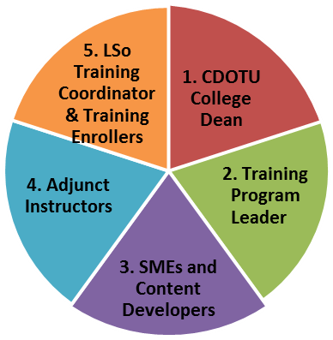

Functions and Roles Common to all Colleges of CDOTU (See Figure at right.)

CDOTU College Dean: Roles and Responsibilities

CDOTU College Deans will serve as the designated authorities for training administration and development for their respective colleges.
As a college coordinator within the university structure, each Dean has the following roles and responsibilities:
- Serve as a member of the CDOTU Council of Deans
- Oversee their college’s training programs and course offerings according to CDOTU policies, processes and standards
- Comply with all State training requirements to include Colorado Department of Personnel Administration (DPA) policies
- Adhere to CDOT vision, mission, goals, and values
- Conduct, together with the CDOTU Administrator and fellow Deans, a systematic training analysis to identify gaps and future need;
- Build a college training plan to develop training courses and related materials in coordination with subject-matter experts and OED curriculum and training specialists
- Present his/her training plan to the Council of Deans and the CDOTU Administrator for collaboration and potential points of integration to achieve economies of scale and effort
- Manage a training budget according to the college’s plan
- In cooperation with the appropriate Business Office(s), accurately rack training investments and associated costs and provide the information in a timely fashion to the Administrator
- Identify resource needs (personnel, inventory, and/or monetary) and communicate those needs to the Council of Deans and the Administrator for consideration;
- Prioritize curriculum development based on urgency/importance of training needs and available resources;
- Work with the Administrator, other college Deans and CDOTU training program leaders to develop course offerings and approve course content;
- Align learning objectives to clearly-defined outcomes and adherence to CDOTU standards to include purchased materials;
- Coordinate annual content reviews (for sufficiency, currency, and relevancy) and ensure changes are made as required; and
- Participate in the selection of training vendors in coordination with OED.

Selection and Appointment of College Deans

The role of a CDOTU College Dean is a critical position that requires established professional credibility and organizational authority to effect change and drive the overall success of the university. Deans must be empowered decision makers with the ability effectively implement CDOTU procedures, policies and standards. Deans must be able to influence training budgets and expenditures for their respective colleges.

While each college of CDOTU will have its own unique functional emphasis, size and scope, typical positions suitable for consideration for Dean’s duties include: directors or managers of business units, business process owners, Program Engineers and Maintenance Superintendents. In short, a Dean must have the level of authority in his or her college to direct and effect change. As such, the following additional qualities, skills and aptitudes to serve as a Dean include, but are not limited to:
- A champion for training
- A strategic understanding of the major functions performed in their respective college
- An understanding of basic ISD principles or willingness to learn them
- Access to LMS Coordinator support
- Superior organizational skills, including customer service and communication, both oral and written
- Ability to identify and prioritize training needs for their colleges
- Ability to collaborate with fellow Deans
- Ability and willingness to commit required time and effort to the success of CDOTU.

Appointment Procedures for each College Dean

The appointment process for a College Dean will include the following:
- Recommendation by a Senior Manager or Executive within CDOT
- Concurrence through the supervisory chain of nominee
- Approval in writing by Appointing Authority in nominee’s chain

While there is no set term limit for a College Dean, appointments will be reviewed annually. Each college will have a designated Appointing Authority. The Appointing Authority retains the right to rescind an appointment at his/her discretion.

Training Program Leaders
CDOTU points of contact that assist college deans by providing content, materials, subject matter experts and instructor preparation for training content specific to their respective college; depending on the size of the program in a respective college, the dean may serve in this role.

SMEs and Content Developers
Subject Matter Experts in their fields support organizational learning by providing the content for training curriculum. SMEs and developers work with OED to develop courseware and assessments using Instructional Systems Design principles for structure and instructional best practices in delivery methods and techniques.

Adjunct Instructors
Adjunct instructors are SMEs within each college who are trained and/or certified through OED Adjunct Faculty Program to effectively deliver training in their areas of expertise.

LMS Training Coordinators and Enrollers
LMS Coordinator: Performs the course and personnel administration function in LMS for their respective regions and or functions; LMS Training Coordinator makes arrangements for training events, acts as a liaison with the college dean(s) to schedule training classes; works with the Training Enrollers to determine the enrollment process for a particular class, publishes course announcements, reserves training/conference rooms, ensures the set-up of classroom tables and chairs.

LMS Training Enroller: Assists the LMS Training Coordinator in enrollment duties as specified in OED LMS Guide for Training Coordinators and Enrollers. (Source: PD 1260).

Curriculum Design

Design Philosophy: Business Need Drives Curriculum
In a corporate university structure, business outcomes define the required job skills and competencies for success. Development of these specific skills and competencies drives curriculum development and delivery. To provide clarity, consistency and focus to employee development, CDOTU uses Career Development Maps to provide a clear development path for each major job classification in CDOT. These maps are intend as a guide for both employee and supervisor for creating a multi-year plan to develop skills and competencies needed not only in the employee’s current position, but to also prepare them for opportunities to advance. Career Development Maps are posted on the CDOTU Intranet page. (See Appendix C for a sample Career Development Worksheet.)

Instructional System Design (ADDIE Model)

The Instructional Systems Design (ISD) methodology is the standard for training design at CDOT. ISD employs the ADDIE Model for the analysis, design, development, implementation and evaluation of training. ISD methodology is ideally suited for training specific skills, procedures and similar behaviors. ISD and the ADDIE model comprise the core of the CDOT Curriculum Design Handbook. Should the Course Director/Designer feel that the ISD method is not optimal for the desired learning outcome, they are to consult with the OED staff for possible alternative methods or approaches to the curriculum design.

Curriculum Development

Sponsorship and Approval
To maintain accountability and integrity of curriculum across CDOTU, all proposals for new training will follow the process detailed in the Request to Develop a New Training Activity form. As part of this process, requests to develop a new training activity require a management-level, or in some cases, an executive-level sponsor for the training. The process also requires a clearly-stated business case for the training, to include desired learning outcome, learning objectives and statement of potential negative impact to the business unit if the learning activity is not approved.

Included in the approval chain is OED, who checks for potential duplication/redundancy in the existing training in both the CDOTU and Colorado/DPA course catalogs. In those cases where similar training already exists, but is not available or is not a suitable substitute, OED approves the required training development waivers. In cases where the learning activity is to be required for all CDOT personnel, or the training requires purchase outside of Colorado/DPA channels, the CDOT Sr. Director of HR must approve the request.

Training Required by Statute, Policy, Legal Action

Training that is required by statute, policy or legal action will include in the course description this requirement to include which employee population(s) are subject to the training and any other mandates such as completion deadlines and special reporting requirements. In situations where the appropriate Approving Authority is not the sponsor of the training, the requirement will be reported to the Sr Director of HR for coordination with the appropriate Approving Authority.

Procedure/Process for eLearning Development & Adoption
While the request and approval process is the same as for instructor-led content, development and delivery of eLearning material requires its own standards for technical compatibility and has its own development process. Once an eLearning activity is approved, the SME for the development of the training must contact OED to obtain the most up to date technical compatibility specifications for hosting the content in the CDOTU LMS. (See Supplement 1 for Process to Establish a New eLearning Course.)

Waiver Process for buying/contracting training and educational services
Purchase of training resources and educational resources requires a training waiver from both CDOT/OED and State of Colorado Department of Personnel Administration. Contact CDOT/OED for guidance on the waiver process.

Purchasing Training Products

Once a waiver to purchase training or educational services has been approved, the purchaser must adhere to standard CDOT purchasing guidance and thresholds. (See Appendix F, Procurement and Contract Services Memorandum, dated June 25, 2012.) For purchases in excess of $4,999.00, contact the CDOT Procurement Office for guidance.

Curriculum Management

CDOTU Curriculum Management
Each college of CDOTU will have a centralized repository for all courseware master files and associated documents. The preferred location for that repository is the CDOTU SharePoint site., On this site, each college will maintain a folder marked “Curriculum”. Within that folder will be two folders, marked “Active” and “Historical”. Example of folder nesting structure:

COLLEGE OF TRANSPORTATION MAINTENANCE
CURRICULUM
ACTIVE
HISTORICAL

Within the “Active” and “Historical” will be a spreadsheet detailing the contents of the folder, or in the case of courseware housed in another location, the details of storage. (See the CDOTU SharePoint site for an example.)

Ideally, the curriculum folders will be updated to reflect changes as they occur. This may not always be feasible. At a minimum, the curriculum folders will be updated annually.

Course Director

Every course in the CDOTU catalog will have a Course Director. The course director is a Subject Mater Expert who is responsible for the overall development and maintenance of a course or a series of courses (curriculum) to meet a clearly-defined learning outcome. The Course Director is required to design and maintain courseware in accordance to the standard procedures and processes detailed in the CDOTU Manual and other applicable guidance from the appropriate CDOTU College Dean, the Office of Employee Development, and the Sr. Director of HR. Specific responsibilities include:

- Documenting a needs assessment that clearly identifies the skill or knowledge gap and the desired business outcome(s) to address those gaps.
- Use the appropriate processes to obtain management –level or executive-level sponsorship and any required training waivers for development of the training.
- Establishing learning objectives to support the desired learning outcome(s).
- Defining the educational method and modality (ILT, eLearning, blended learning) appropriate for setting, objectives, and desired results of the activity
- Appropriate content to match learners’ current or potential scope of professional activities
- Designing the training in accordance to the CDOTU Curriculum Development Guide
- Following all appropriate contracting and purchasing rules, policies and guidelines in developing and delivering the training activity.
- Maintaining control over content, versioning and required learning resources to conduct the activity, to include syllabi, participant workbooks, instructor guides and learning aides.
- Adhering to all copy write restrictions regarding the use of third-party materials and sources to include:
  - Required disclosures for those with control over the content
  - Permissions to use duplicate or derivative material
  - Proper citation/recognition for other’s work or intellectual property
  - Maintenance of budgetary constraints for course development, maintenance and delivery.
  - Ensuring that the learning activity meta-data and attendance records are maintained in the CDOTU LMS.
  - Reviewing of course critiques/feedback on a regular basis and appropriate response to trends in the feedback and lessons learning from the instructors.
  - Supporting instructors delivering the course through maintenance of adequate course materials and supplies, as well as scheduling of an appropriate space and equipment for the training.
  - Advising instructors of any changes to the courseware or its delivery and active solicitation for instructor feedback.

Training Equivalency Waiver

In instances where an employee has received training that is equivalent to that proscribed by CDOT, the employee may apply for a waiver to receive equivalency credit for that training. The waiver requires proof of previous training, to include learning objectives for that training, validation by an SME in the course subject matter and approval by the appropriate CDOTU Dean. (See Attachment G for CDOTU Training Equivalency Waiver.)

CDOTU Document Versioning

Version Control

A document typically goes through several revisions before it becomes the final. Once the document goes final, it is often subject to more revision. Without clear versioning control, it can become difficult to follow a document’s development sequence, or worse still, to clearly identify which of multiple versions of a document is most current. Courseware and associated documents in CDOTU will follow the versioning conventions detailed below to the maximum extent possible. (See footnote 14. for typical exclusions to these versioning conventions.)

Versioning Conventions: Draft Documents
The standard versioning convention for draft documents will follow an alphabetical sequence beginning with “Version A”, followed by a Revised Date.

Example: CDOTU Manual Draft Version A; Revised: 10.29.2014

Any change to a draft document will be reflected by increment to the next letter. Examples:

CDOTU Manual Draft Version A (first version of draft)
CDOTU Manual Draft Version B (second version of draft)
CDOTU Manual Draft Version C (third version of draft)

Versioning Conventions: Final Documents
The standard versioning convention for final documents will follow a numerical sequence beginning with “Version 1.0”, followed by a revision date in parenthesis.

Example: CDOTU Manual Version 1.0 Revised: 11.30.2014

Versioning Changes: Major and Minor

Major Changes are recorded when significant changes to the document are made that require the document to be re-approved (either by individuals or groups) or significant changes to a learning objective and/or to assessment tools or criteria. Major changes to the document are reflected by incrementing the whole number by 1.

Minor Changes are recorded when small changes are made to the document, such as spelling corrections, changes to contact numbers, etc. Minor changes to final documents are reflected by incrementing the decimal number by “.1”. Examples:

Major Changes to a Final Document: indicated by increasing the whole number

CDOTU Manual Version 1.0 (first approved version)
CDOTU Manual Version 2.0 (second approved version)
CDOTU Manual Version 3.0 (third approved version)

Minor changes to a Final document: indicated by increasing the decimal figure*

CDOTU Manual Version 1.0 (first approved version)
CDOTU Manual Version 1.1 (minor change of first approved version)
CDOTU Manual Version 2.4 (fourth minor change of second approved version)
(*That does not require re-approval of the changes

Examples and Locations of Version Control

The version number will be clearly indicated on the front page of the document and in the footer of each page. In cases of Curriculum Guides, Course Guide, Lesson Plans, Manuals and similar documents, a Version History will be included on the second page. See the table below and the second page of this guide for examples:

Version  # | Implemented  By | Revision  Date | Approved  By | Approval  Date | Reason
1.0 | Muszynski,M | 10.29.2014 | CDOTU Council  of Deans | 11.20.2014 | Adoption of CDOTU Manual
1.1 | Muszynski,M | 12.17.2014 | Muszynski,M | 12.17.2014 | Change of document location on intranet
2.0 | Muszynski,M | 02.02.2015 | CDOTU Council  of Deans | 02.28.2014 | New procedure to request a training  waiver.

Uniformity of Versioning (Document Sets)

Versioning will be uniform among elements of a common “document set.” (A course guide, participant guide, and associated worksheets and aids would be considered a “document set.”)

For example, the course below is updated to version 2.0. All supporting materials for this course would update to “Final Version 2.0” to match the versioning of the course guide:

- Defensible Documentation Course Guide Final Version 2.0; Revised 10.29.2014
- Defensible Documentation Participant Guide Final Version 2.0; Revised 10.29.2014

This versioning convention provides clarity regarding when multiple documents support the same course or learning activity.

Adjunct Instructors: Qualification and Standards

To advance the standards for quality and uniformity in training and facilitation, CDOTU has adopted a formal process to approve adjunct instructors for training duties. This process is captured in Memorandum of Understanding between the adjunct instructor and the approving CDOTU Dean. The MOU outlines the responsibilities and expectations for an adjunct instructor, as well as the criteria for appointment to instructor duties. (See Appendix H, CDOTU Adjunct Instructor MOU for details.)

Curriculum Developers

For training to be effective, it must designed and developed with clear learning outcomes and well-designed learning objectives to support those outcomes. To assist in this process, CDOTU has created a Curriculum Development Guide. It is expected that curriculum developers, particularly those with no formal training in courseware development, will use the guide to create design and develop courseware, to include assessments and evaluations. (See Appendix I, CDOTU Curriculum Development Guide.

Learning Management Systems
As proscribed in Policy Directive 1260, CDOTU will have one Learning Management System of Record for CDOT Employees. This is to ensure that all employee training is captured in a single repository. Organization of the LMS master course catalog will mirror the structure of CDOTU, with courses organized by college. Administration of the LMS (to include enroller, coordinator and administrator-level permissions for LMS transactions) will be under the control of CDOT/OED.

Training and Courseware Evaluation

Purpose of Training Evaluation
Employee development provides many benefits to both employees and the organization. However, it is essential that training and development are implemented strategically in order to gain the greatest benefit for the organization. Rather than allowing workers to determine which training programs they would prefer to take advantage of, effective organizations implement strategies designed to evaluate and enhance the core competencies that will best drive the business to success.

The purpose of a training evaluation is to identify the appropriate measures that must be put in place in order to achieve optimal results from the training initiative or program. Training assessment and analysis is commonly used to determine how much of a gap exists between the organization's current situations and where it envisions itself in the future. This is an essential tool for the strategic evaluation of training.

Training Evaluation Levels

The best known evaluation methodology for judging learning processes is Donald Kirkpatrick's Four Level Evaluation Model. His four levels are a cornerstone in the learning industry. Below is a summary explanation of the four levels.

Level 1: Reaction
Lowest level of training evaluation. (Learners respond - did the learners like the learning environment and process.) Data collected through a feedback form at the completion of class.

Level 2: Learning
Did the student learn in the classroom (learning) environment? Including virtual- synchronous or asynchronous; to the extent to which the learners gained knowledge and skills. Typically this data is collected through instructor observation of student discussion, role play, problem solving scenarios, exercises, or written assessments built into the material content.

Step 3: Behavior
Addresses what changes in job performance resulted from the learning process. Did the learner have capability to perform the newly learned skills while on the job? Level 3 of the Kirkpatrick training evaluation model involves evaluating the extent to which the training participants have applied their new knowledge and skills back at their work and what effect this has had on their work performance.

Step 4: Results
What are the tangible results of the learning process in terms of reduced cost, improved quality, increased production, efficiency, etc. (For further guidance and templates for evaluations, see Supplement 2: CDOT Curriculum Development Guide, Attachment 7.)

CDOTU Branding

In recognition of the department-wide role, CDOTU has a unique branding that is approved by the CDOT Office of Communications, which includes five approved logo variations. As per Office of Communications guidance, CDOTU logos may not be further modified or customized. Additionally, all CDOT branding conventions apply to CDOTU and its constituent colleges. CDOTU courseware will follow a standard branding convention as well. (See Appendix J for further branding and formatting guidance.)

CDOTU Communications

Communications regarding CDOTU is primarily the responsibility of the CDOTU Administrator. The Administrator will coordinate with the Council of Deans and training leads for other major training programs (OED, Safety and Risk Management) to align the overall communications strategy for CDOTU.

The CDOTU SharePoint site is the primary vehicle for coordination between the CDOTU CoD.

Appendix A: Policy and Procedural Directives 1260/1260.1

Policy Directive 1260

Procedural Directive 1260.1

Appendix B: Memorandum of Understanding: CDOTU Dean Appointments

Appendix C: Career Development Worksheet

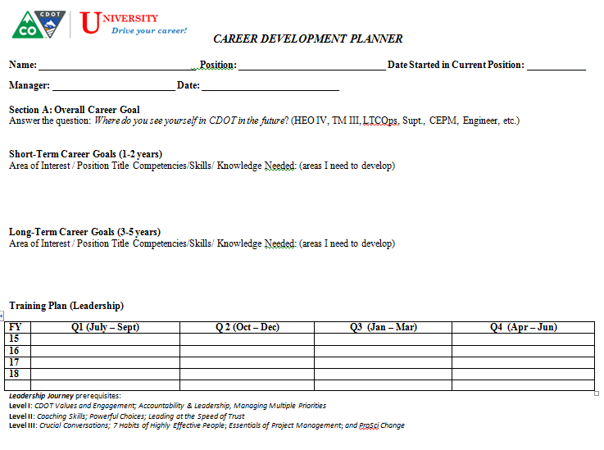

Appendix D: Request to Develop a New Training Activity
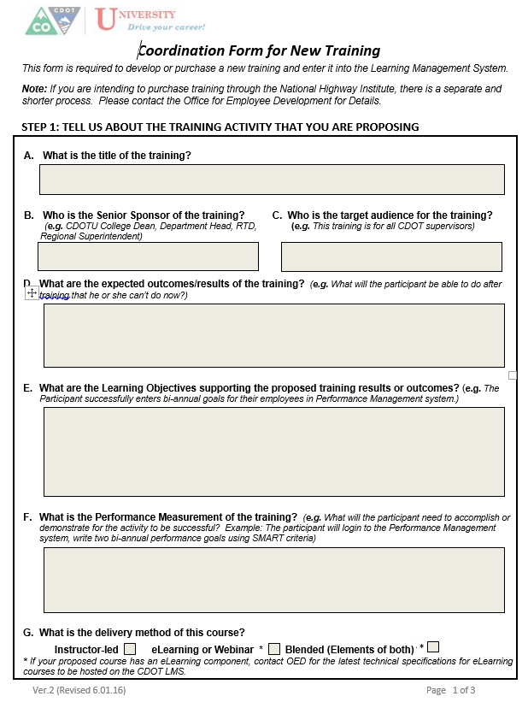

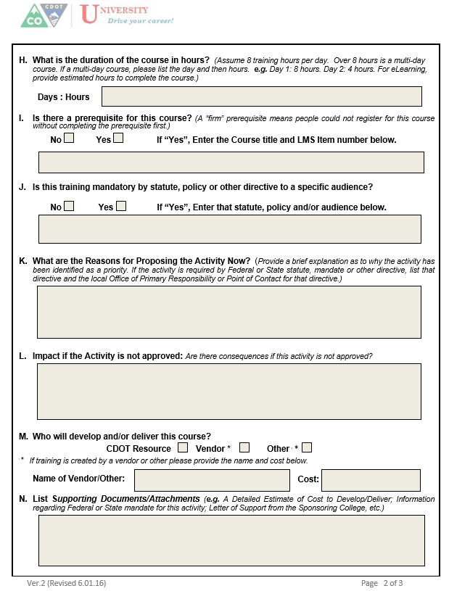

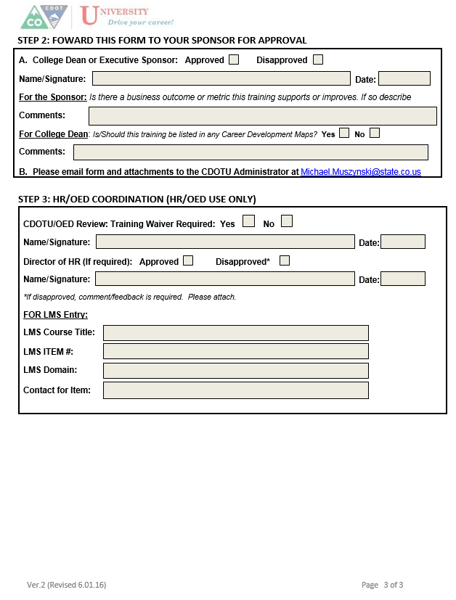

aPPENDIX E: pROCUREMENT MEMORanDUM (pURCHASING)
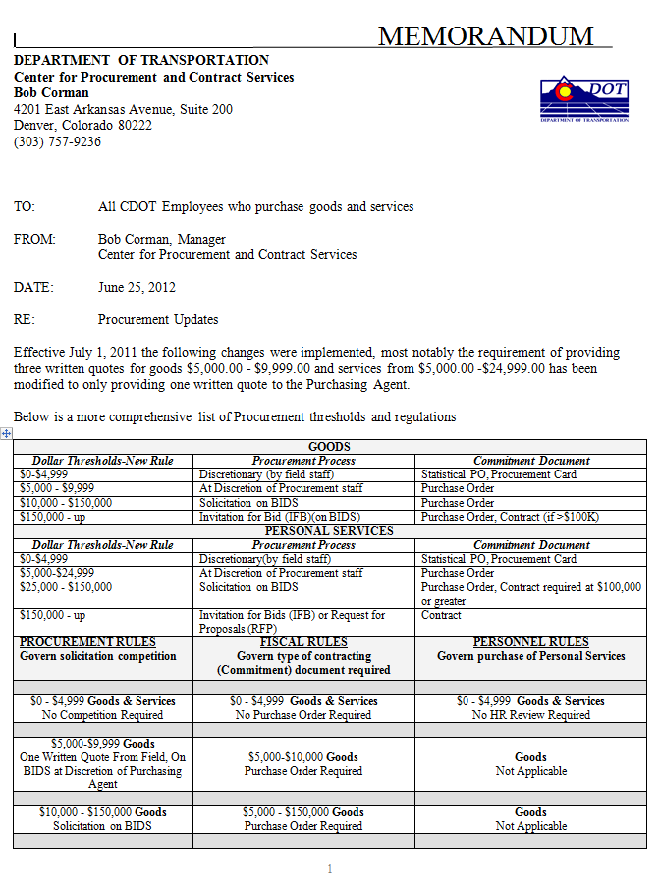

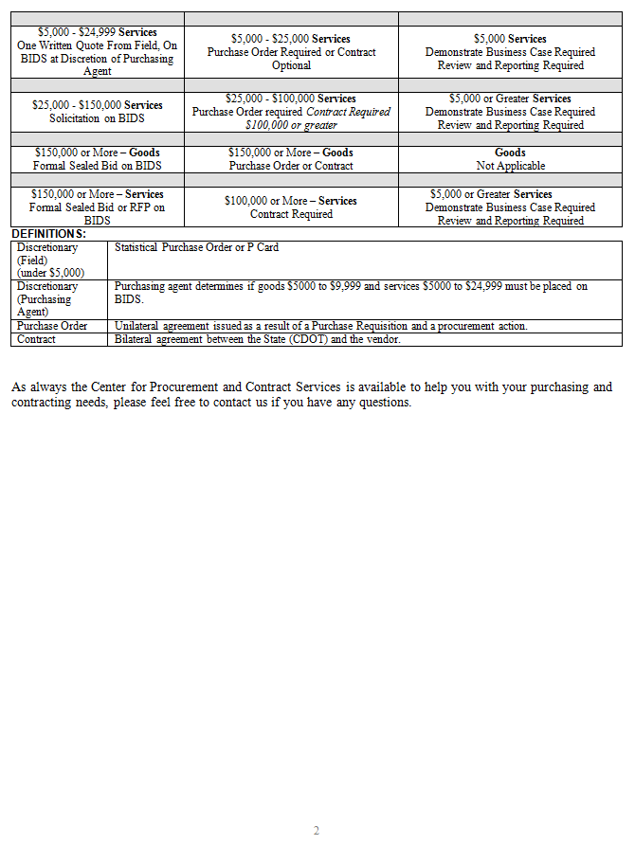

aPPENDIX F: tRAINING eQUIVALENCY WAIVER
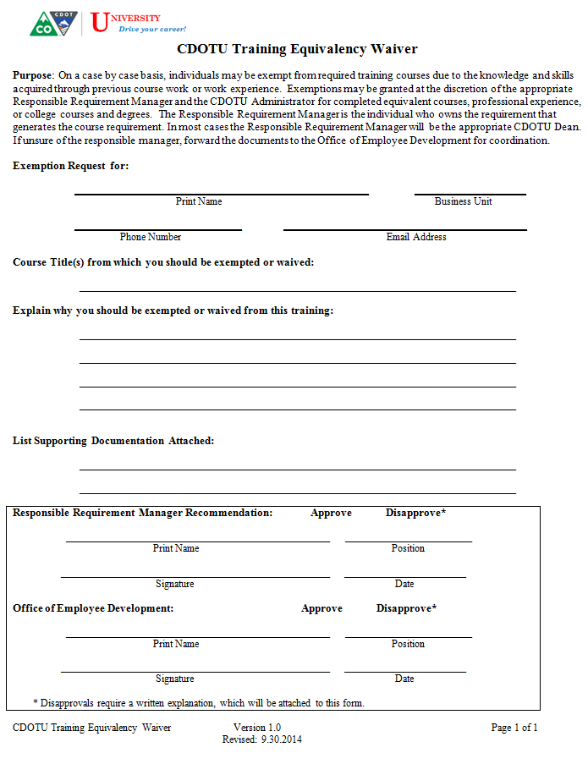

APPENDIX G: mOU for ADJUNCT INSTRUCTOR APPOINTMENT

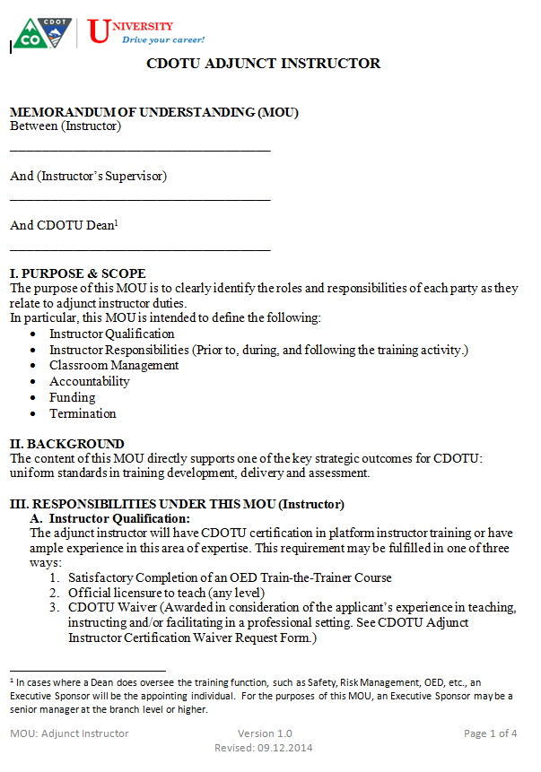
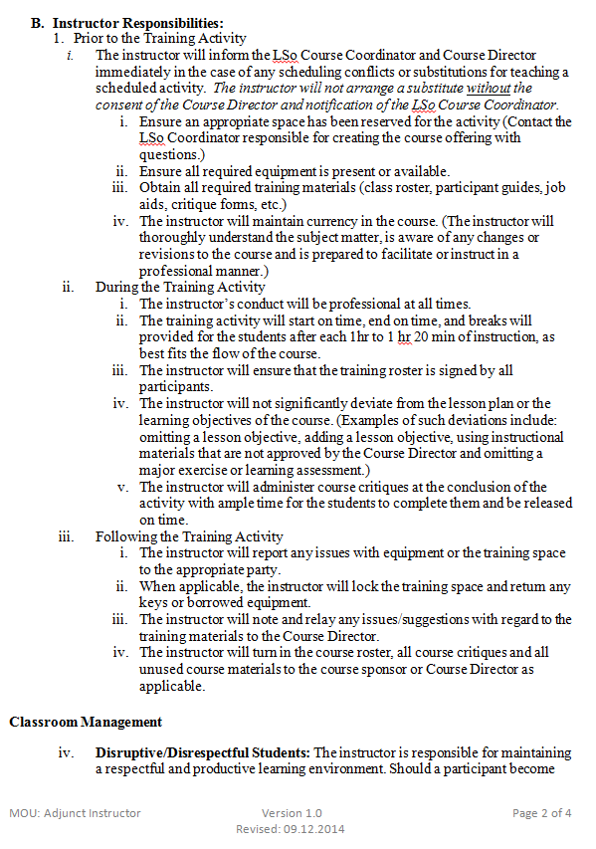
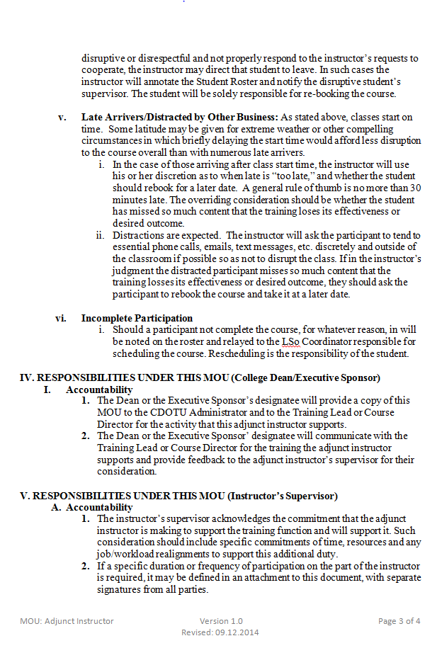
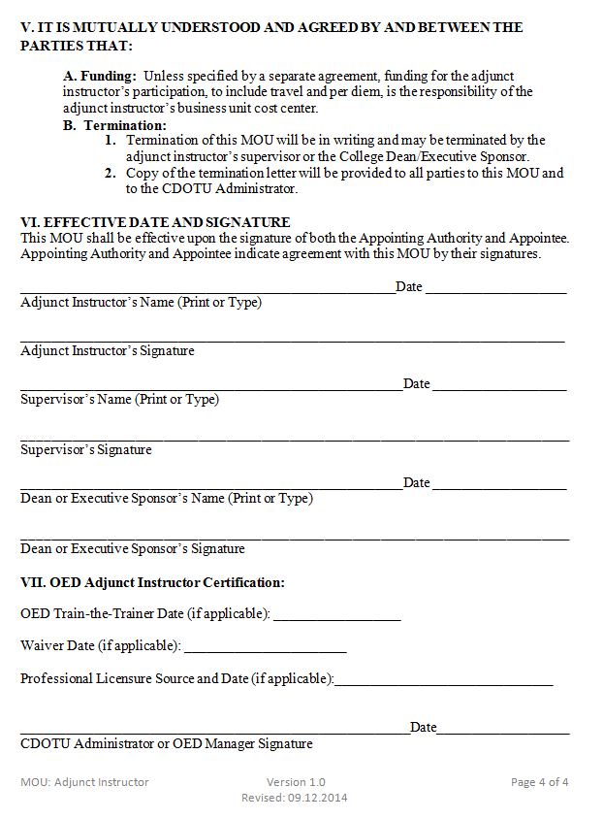

aPPENDIX H: cdotu bRANDING cONVENTIONS

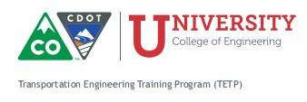
Branding and Logos
CDOTU has five logos approved for use by the CDOT Office of Communications. There is one logo for CDOTU and one for each of the colleges. (See Appendix XX.) As per guidance from the Office of Communications, logos may not be modified.

Addition of some “subsidiary” branding is allowable. In the example below, TETP listed below the logo for the College of Engineering. Subsidiary branding must be approved by the respective dean and coordinated with the CDOTU Administrator. Subsidiary brand will follow the color palate and font conventions of the college logo. Default fonts are:

- Museo Slab 500/Museo Slab 500 Italic
- Trebuchet MS (alternate)

The CDOTU branding conventions will be followed wherever practical. Branding conventions include the appropriate college logo in the top left hand corner of the cover page or first page of the document. Also wherever practical, CDOTU documents will have a footer on each page. The footer of each page will include the following:
- Document short Title (upper left corner)
- Document Version and Date (middle of footer, two lines)
- Pagination (“Page X of X”)
(See footer on this page for examples.)

Should the document contain material covered under a CDOT copywrite, it will be annoted on the lower left hand corner, as in the example below:

Applied Roadway Design Version 8.1 Participant Guide
©CDOT 2012 Revised: 10.25.2012 Page 1 of 16

An accent line between header and footer are allowable. Full borders and other embellishments are discouraged.

Approved CDOTU Logos

APPENDIX I: References

The following table summarizes the documents referenced in this document.
Document Name and Version | Description | Location
<Document Name and Version Number> | [Provide description of the document] | <URL or Network path where document is located>

List of Supplements

Supplement 1: eLearning Content Publishing Standards

Supplement 2: CDOTU Curriculum Development Guide

See the Appendix A of this manual for copies of PDs 1260 and 1260.1.
As per PD 1260.1, (Section XIII) it is the intent that the CDOTU Manual supersede PD 1260.1 as the guidance for the administration of CDOTU.
Karen Barley, Corporate University Enterprise, CDOT Survey, Oct 2011
Corporate Universities are generally characterized by four distinct levels of development. For a description of characteristics of these levels and examples of those characteristics in context for CDOT, see “The Four Levels of a Corporate University”
The American Council of Education is among several entities that are recognized for certification of curricula for a network of Colorado institutions of higher learning.
See Appendix B, MOU for CDOTU Dean Appointments.
The sample Career Development Worksheet provides a basic planning guide for a multi-year employee development plan. It is not intended to be definitive. Business units may use other planning templates that are tailored to the particular development requirements and opportunities to that unit or work center.
See Request to Develop a New Training Activity form (Appendix D).
The CDOTU Program Administrator is responsible for organization of the CDOTU SharePoint Site or similar business collaboration site.
Housing all courseware masters may not be feasible for all training units. Example: Courseware already housed on ProjectWise. In such cases, the college will maintain a detailed listing on the CDOTU SharePoint Site of the courseware and location.
A Course Director should have a background or recent experience in training development. In cases where the Course Director does not have previous experience, it is expected that he or she contact OED for consultation prior to designing the learning activity.
The Request for Development of New Training form in (Appendix D) meets this requirement.
All new training development requires a sponsor. In most cases the CDOTU Dean would provide the appropriate level of sponsorship, whose signature is usually required on the Request for Development of New Training form (Appendix D). For courses that are intended to be required for all CDOT employees, or require purchase from outside of Colorado State/DPA curriculum resources, the Sr Director for HR must sign off on the request form as well.
Note: This guidance excludes all documents and courseware that are e-based or archived in a system with automatically controlled versioning. Examples include electronic document repositories, databases, and electronic courseware authoring tools that use internal version control conventions.
If it is not appropriate to have a front page (for example on a procedure, flow chart, etc.), it may be omitted, but still must appear clearly on the footer or elsewhere on the document.
See Policy Directive 1260, Policy Governing CDOT University, page 4, Section V., Part C “Administration”
See CDOT Brand Guidance, accessible from then intranet at: http://intranet.dot.state.co.us/resources/cdot-branding-guidance/cdot-brandguidelines-3-2014.pdf/view.
For a full complete template for a CDOTU Course Guide, see Supplement 2, Attachment 7.

