Crosswalk between Instructor Led and eLearning Templates
Instructor Led Template | eLearning Template | Difference
Hidden Title Slides  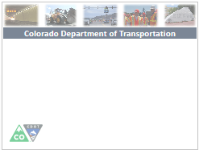 | N/A remove | - All hidden Title slides need to be removed from the eLearning template  - Keep the course and section descriptions for the eLearning script
Title Slide  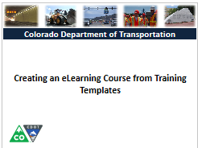 | Title Slide | - Different cover for the eLearning course
Course Agenda  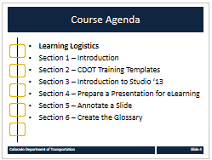 | Course Agenda  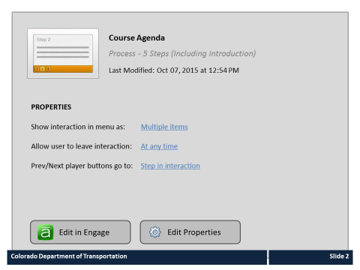 | - Remove only the course agenda and replace with the engage interaction  - KEEP THE SECTION AGENDAS ONLY REMOVE THE COURSE AGENDA  - Change the notes section to a narrative script if you are doing an eLearning with audio
Course Learning Objectives  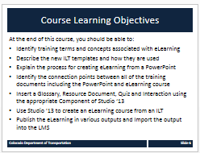 | Course Learning Objectives  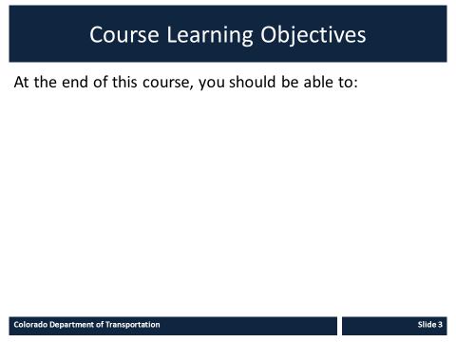 | - Slides are the same in each course
Paticpant Introductions  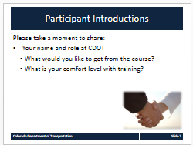 | N/A | - Removed from the eLearning only applicable to the Instructor Led
Learning Logistics  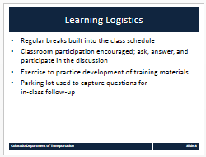 | N/A | - Removed from the eLearning only applicable to the Instructor Led
Your Contribution to Learning  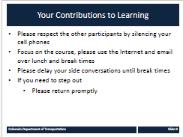 | N/A | - Removed from the eLearning only applicable to the Instructor Led
Did you know…  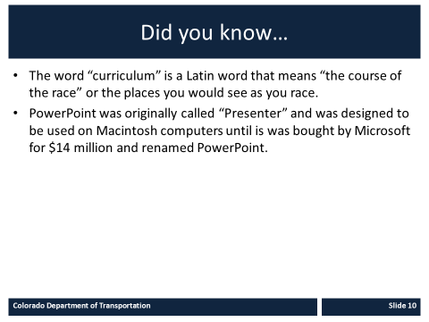 | N/A | - Removed from the eLearning only applicable to the Instructor Led
Course Agenda (Section)  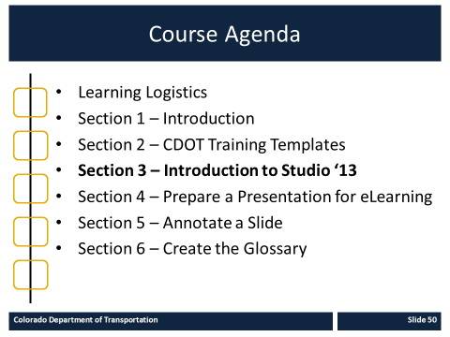 | Course Agenda (Section)  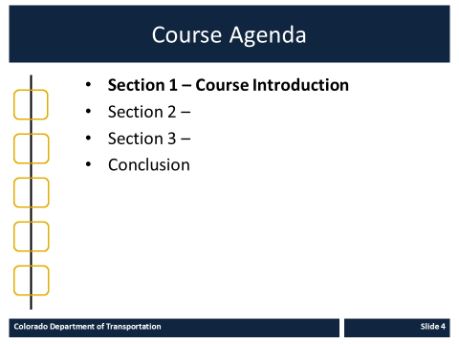 | - Keep each of the section agenda in both the eLearning and ILT  - Change the Course Agenda Notes section in the eLearning if you are doing a script
Section Learning Objectives  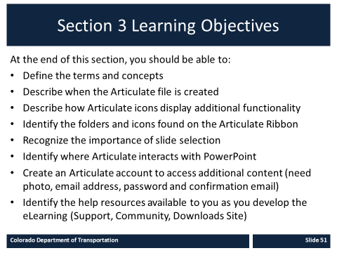 | Section Learning Objectives | Same in both
Terms and Concepts  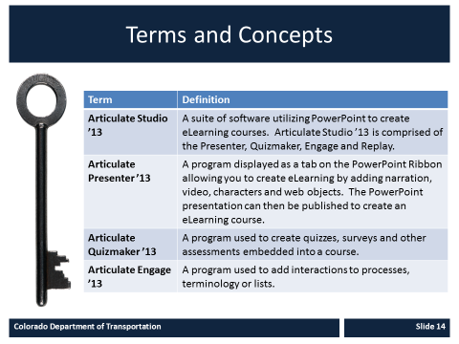 | Terms and Concepts  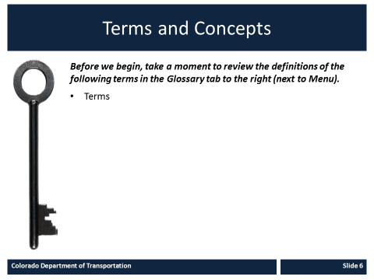 | - In eLearning list only the terms and reference to the glossary  - In ILT list all terms and definitions
Content Slide  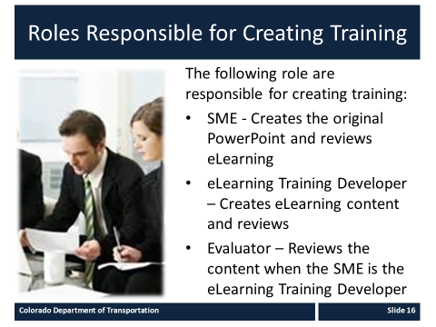 | Content Slide  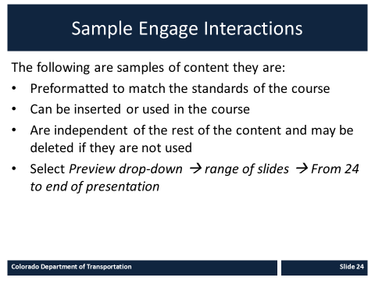 | - Same in both  - eLearning may contain the interactions and other eLearning supported content as required
Check your knowledge | Check your Knowledge  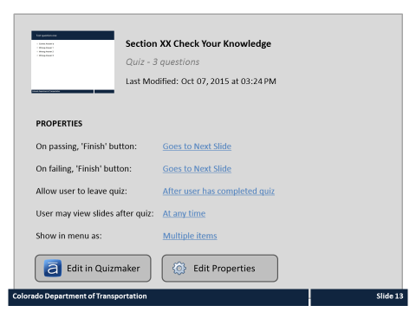 | - Use the same questions for both  - Insert the questions for the knowledge check sections into the template for the section  - Be sure not to use the Course Assessment. Only one section can be a graded quiz
Conclusion  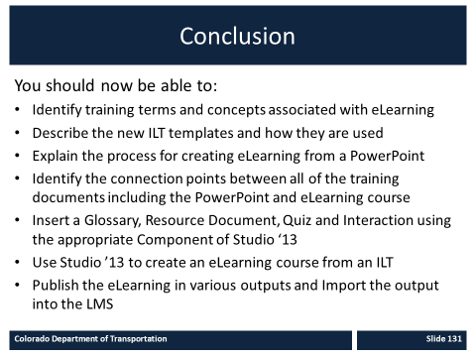 | Conclusion  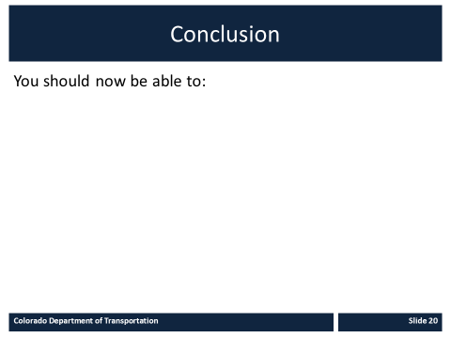 | Same in both.
Where Can I Get Help | Where Can I Get Help | - Consolidated into one slide add additional as required
Questions  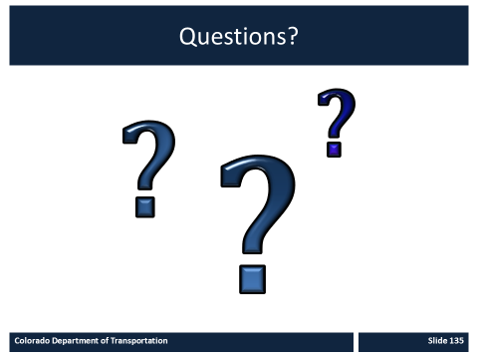 | N/A | - Removed from the eLearning course
N/A | Course Assessment  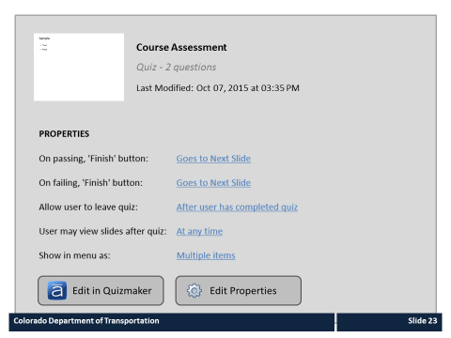 | - Use the Course Assessment template for the eLearning

