The Records Management Web Page
Items: 5 Labels (Including Introduction)
Duration: 25 seconds

The Records Management Web Page
5 seconds
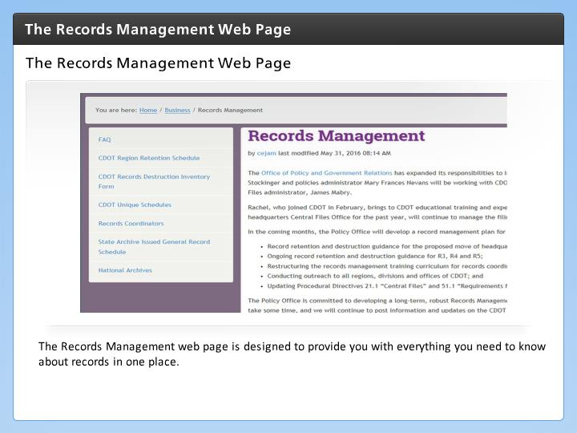

Step Text
The Records Management web page is designed to provide you with everything you need to know about records in one place.

Narration Script
The best place to start to look for answers to you questions is the Records Management web page.
The Records Management web page has been designed to provide you with all of the information you need about records management in one place, and is the best place to go if you need help. Let's take a look at the individual pages on the site by clicking on the next button

FAQ
5 seconds
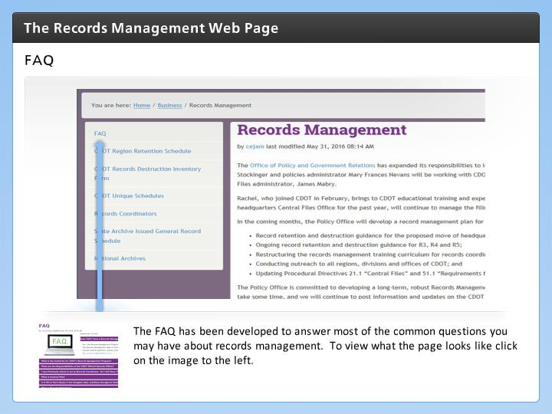

Step Text
The FAQ has been developed to answer most of the common questions you may have about records management. To view what the page looks like click on the image to the left.

Narration Script
The FAQ web page provides answers to many of the most common questions you may have such as, how does records management apply to me, what is a record and when can I destroy a record. To view the web page in more detail, click on the image to the left.

CDOT Region Retention Schedule
5 seconds
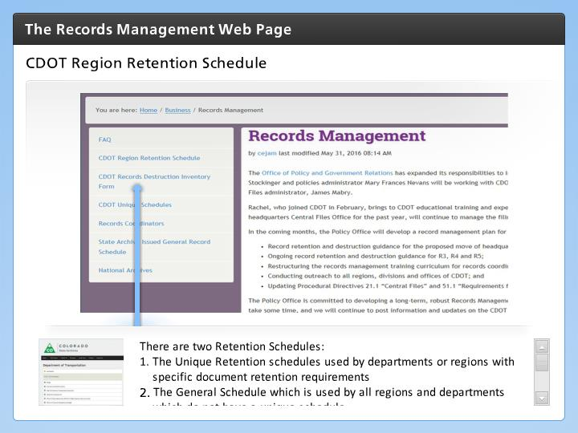

Step Text
There are two Retention Schedules:
- The Unique Retention schedules used by departments or regions with specific document retention requirements
- The General Schedule which is used by all regions and departments which do not have a unique schedule

Regardless of the schedule you may use they can be downloaded from the Records Management web page. Click the image to the to see a an example of the unique

Narration Script
A retention schedule is a control document that sets the timeline for when records are to be reviewed, how long specific records must be held, and how they must then be destroyed or archived. It applies to records in all formats, including paper and electronic media. The records retention schedule must meet the requirements of state and federal law. There are two retention schedules on the web page the Unique, which is specific to a department or a region and the General which is used by any department that does not have their own unique schedule.

CDOT Records Destruction Inventory Form
5 seconds
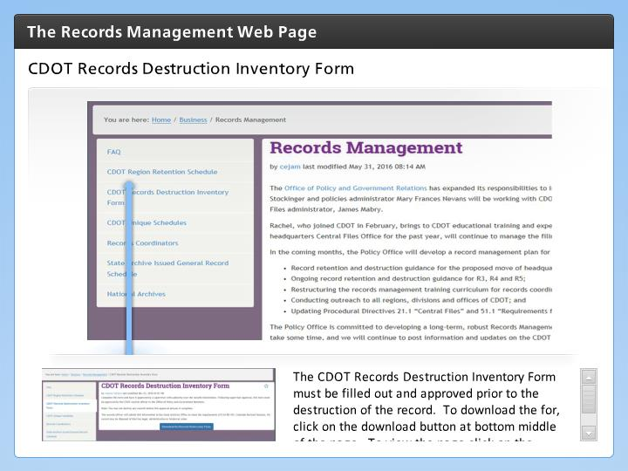

Step Text
The CDOT Records Destruction Inventory Form must be filled out and approved prior to the destruction of the record. To download the for, click on the download button at bottom middle of the page. To view the page click on the image to the left.

Narration Script
The CDOT Records Destruction Inventory form can also be found and downloaded on the Records Management page. The form must be completed prior to destroying a record. Because forms may change it is best you pull the form from the web page when you need it. We will go into more detail about how to complete this form in the next section of the course.

Record Coordinators
5 seconds
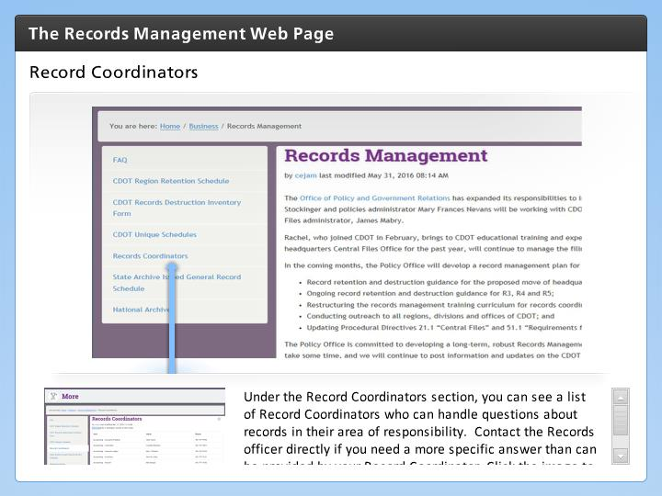

Step Text
Under the Record Coordinators section, you can see a list of Record Coordinators who can handle questions about records in their area of responsibility. Contact the Records officer directly if you need a more specific answer than can be provided by your Record Coordinator. Click the image to the left to see a sample of the web page.

Narration Script
The final section is the Records Coordinators. Record Coordinators are responsible for answer questions about records in their area of responsibility. If your record coordinator is not able to help you, let's look at who is your next level of support.

