The Records Management Web Page
Items: 7 Labels (Including Introduction)
Duration: 35 seconds

The Records Management Web Page
5 seconds
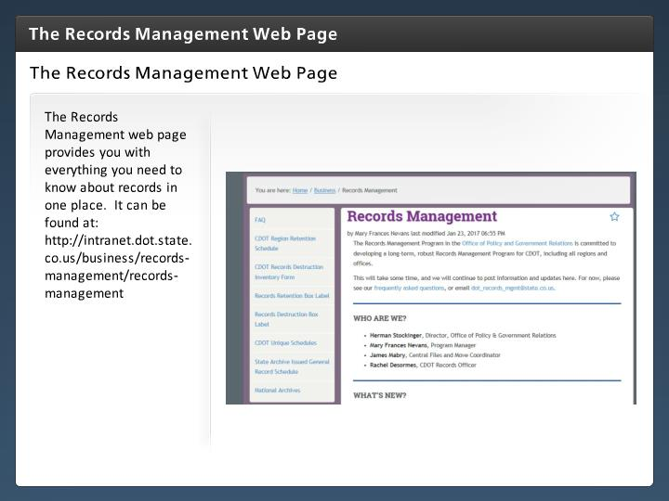

Step Text
The Records Management web page provides you with everything you need to know about records in one place. It can be found at: http://intranet.dot.state.co.us/business/records-management/records-management

Narration Script
The best place to start looking for answers to your questions is the Records Management web page.
The web page is designed to provide you with all of the information you need about records management in one place including the retention schedules, forms and Frequently Asked Questions. Let's take a look at the individual pages on the site by clicking on the next button.

FAQ
5 seconds
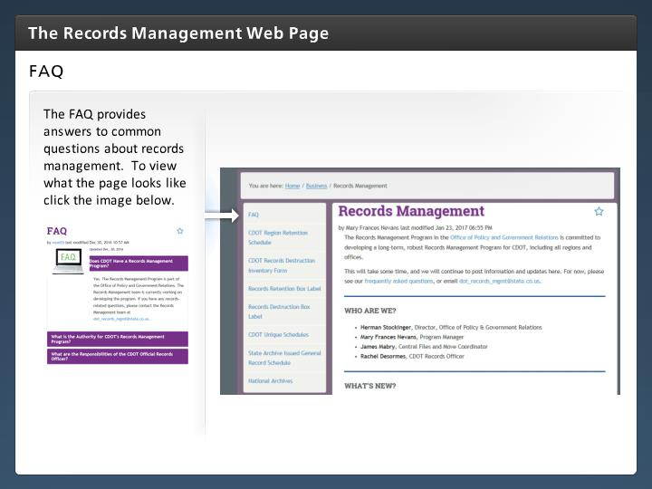

Step Text
The FAQ provides answers to common questions about records management. To view what the page looks like click the image below.

Narration Script
The Frequently Asked Questions or FAQ page provides answers to the most common records management questions such as, how does records management apply to me, what is a record and when can I destroy a record. To view the web page in more detail, click on the image below.

CDOT Records Destruction Inventory Form
5 seconds
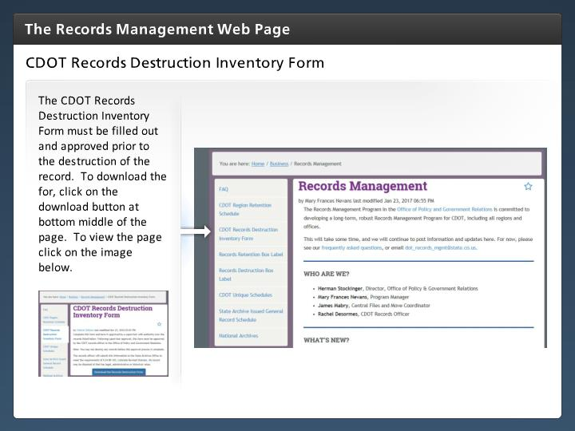

Step Text
The CDOT Records Destruction Inventory Form must be filled out and approved prior to the destruction of the record. To download the for, click on the download button at bottom middle of the page. To view the page click on the image below.

Narration Script
The CDOT Records Destruction Inventory form can be found and downloaded from this page. The form must be completed prior to destroying a record. Because forms may change it is best you pull the form from the web page when you need it. We will go into more detail about how to complete this form in the next section of the course.

Records Retention Box Label
5 seconds
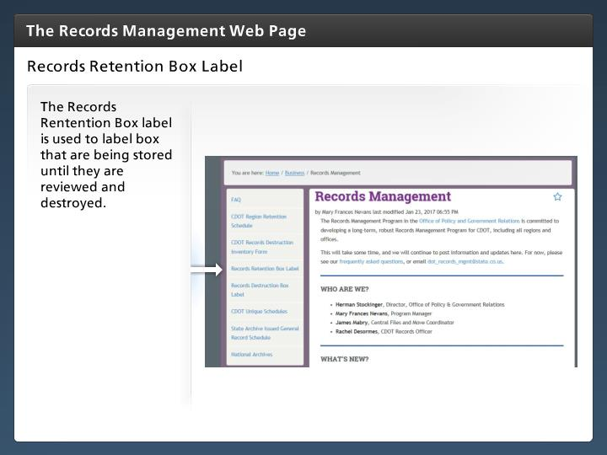

Step Text
The Records Rentention Box label is used to label box that are being stored until they are reviewed and destroyed.

Narration Script
The Records Rentention Box label is used to label box that are being stored until are reviewed and destroyed. When printing, be sure to print this

Records Destruction Box Label
5 seconds
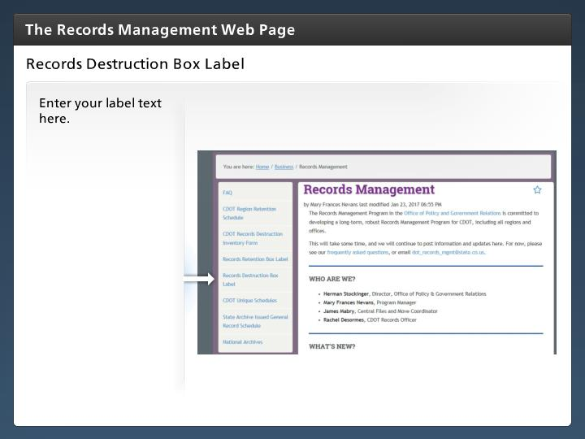

Step Text
Enter your label text here.

CDOT Unique Schedules
5 seconds
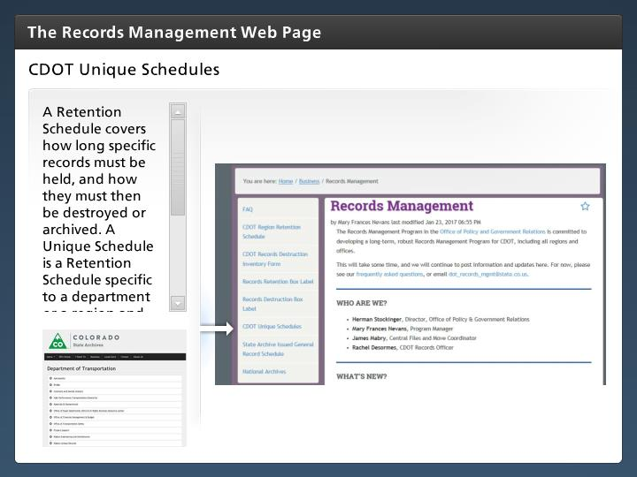

Step Text
A Retention Schedule covers how long specific records must be held, and how they must then be destroyed or archived. A Unique Schedule is a Retention Schedule specific to a department or a region and as such, should only be used the department or region it covers. Click the image below to see an example of the CDOT Unique Schedules page.

Narration Script
The Unique Record Retention Schedule is a control document that sets the timeline for when records are to be reviewed, how long specific records must be held, and how they must then be destroyed or archived. It applies to records to all formats, including paper and electronic media. The Unique Schedule is specific to a department or a region and as such, should only be used the department or region it covers.

General Record Schedule
5 seconds
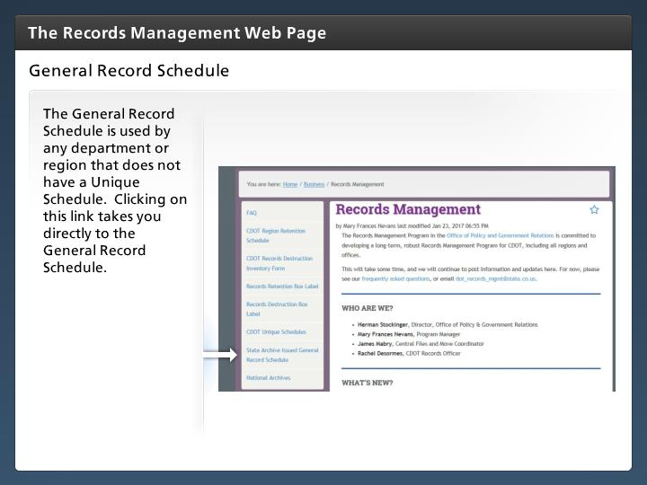

Step Text
The General Record Schedule is used by any department or region that does not have a Unique Schedule. Clicking on this link takes you directly to the General Record Schedule.

Narration Script
The General Retention Schedule is a control document that sets the timeline for when records are to be reviewed, how long specific records must be held, and how they must then be destroyed or archived. It applies to all records formats, including paper and electronic media. The General Schedule is used by a department or region that does not have a Unique Schedule.

